Your University / Engineering School
Computer Science / Software Engineering

Smart Email Incident Analytics
& SLA Monitoring
CG Mail Journey & Log Intelligence System

End-of-Study Internship Report (PFE)

Author: Ahmed
Host Company: Orange Tunisia
Location: Tunis, Tunisia
Period: Academic Year 2025–2026
Academic Supervisor: Academic Supervisor
Company Supervisor: Company Supervisor

Keywords: SMTP, Elasticsearch 8.12, FastAPI, React, log analysis, mail journey correlation, DNSBL, JWT, Docker, Orange Tunisia
April 16, 2026

Dedication

To my family,
who have always believed in me and supported me
throughout my academic journey.

To my friends and colleagues,
whose encouragement kept me motivated.

To all those who contributed,
near or far, to the success of this work.

Acknowledgments

First and foremost, I would like to express my sincere gratitude to Orange Tunisia for providing me with the opportunity to conduct my end-of-study internship within its Technical Operations Department. This experience has been invaluable in bridging the gap between academic knowledge and real-world engineering practice.
I am deeply grateful to my company supervisor, Company Supervisor, for their continuous guidance, technical insight, and patience throughout the duration of this internship. Their expertise in telecommunications infrastructure and willingness to share knowledge made this project possible.
I would also like to thank my academic supervisor, Academic Supervisor, for their mentorship, constructive feedback, and support in ensuring that this work met both academic and professional standards.
My sincere appreciation goes to the entire Support Data Team and the N1/N2 support engineers at Orange Tunisia who generously shared their time during interview sessions, provided feedback during sprint reviews, and tested early versions of the platform. Their operational insights were essential in shaping a tool that genuinely addresses their daily challenges.
I extend my thanks to the faculty and staff of Your University / Engineering School for the solid academic foundation they provided, which equipped me with the skills necessary to undertake this project.
Finally, I wish to thank my family and friends for their unwavering support, encouragement, and understanding throughout this demanding period.

Abstract

Modern telecommunications operators rely on intricate, distributed infrastructures to process millions of electronic messages each day. At Orange Tunisia, the corporate SMTP infrastructure spans a heterogeneous fleet of edge servers, routing nodes, antivirus appliances, and inbound mail exchangers — each producing its own stream of plain-text log files independently, without a central collection or correlation mechanism. When a message delivery problem occurs, support engineers are compelled to manually open dozens of log files across twenty or more server directories, search for queue identifiers by hand, mentally reconstruct multi-hop message paths, and interpret cryptic SMTP status codes from memory. This process is slow, error-prone, and fundamentally unscalable as mail traffic volumes continue to grow.
This report describes the design, architecture, and full implementation of the CG Mail Journey & Log Intelligence Platform — an end-to-end solution developed during an internship at Orange Tunisia's Technical Operations Department. The platform automates the complete pipeline from raw distributed log ingestion through intelligent mail journey correlation, to a searchable, authenticated web interface that empowers support staff to diagnose delivery issues in seconds rather than hours.
The core contribution is a pair of specialized Python log parsers that implement a journey correlation algorithm: they read log files from FES (front-end submission) servers, map downstream delivery identifiers across VIP, GP, and ML relay nodes using a next-hop routing table, and construct a single canonical JSON document per mail journey that captures the complete end-to-end path, timing, Kaspersky antivirus/antispam verdicts, error details, and recipient outcomes. Inbound journeys on MX servers are similarly correlated using a two-phase Kaspersky identifier bridging mechanism. All normalized documents are bulk-indexed into Elasticsearch 8.12.0 under daily indices, enabling sub-second full-text and structured searches across millions of records.
A FastAPI backend with JWT-based authentication exposes a stable REST API consumed by a React single-page application that presents a guided operator workflow: date-based search, multi-field filtering, KPI aggregation dashboards, spam/virus detection summaries, and an integrated DNS Blacklist (DNSBL) monitoring panel with email alert dispatch. A complementary Kibana interface provides ad-hoc exploratory analytics on the same indices.

Main Contributions
- A two-pass, regex-driven log parsing pipeline with automatic cross-server journey correlation.
- A production-quality Elasticsearch composable index template with deliberate indexing/storage separation.
- A FastAPI REST API with JWT/PostgreSQL authentication and background DNSBL monitoring.
- A React SPA with guided operator workflows, KPI dashboards, and a DNS blacklist security panel.
- Performance benchmarks demonstrating 2–8 s full-day ingestion and sub-200 ms query latency.

List of Acronyms

Acronym | Full Name
API | Application Programming Interface
ASGI | Asynchronous Server Gateway Interface
CSS | Cascading Style Sheets
DNSBL | DNS-based Blocklist
DSC | Direction du Service Client (Customer Service Department)
DRS | Direction Réseau et Systèmes (Network and Systems Department)
ELK | Elasticsearch, Logstash, Kibana
ES | Elasticsearch
FES | Front-End Submission (server)
GP | General Population (relay server)
HTML | HyperText Markup Language
HTTP | HyperText Transfer Protocol
IDE | Integrated Development Environment
ILM | Index Lifecycle Management
IP | Internet Protocol
JSON | JavaScript Object Notation
JWT | JSON Web Token
KPI | Key Performance Indicator
KQL | Kibana Query Language
ML | Mail Layer (relay server)
MTA | Mail Transfer Agent
MTTD | Mean Time To Diagnose
MX | Mail Exchanger
N1 | Level 1 Support (Customer Service)
N2 | Level 2 Support (Service Management Center)
N3 | Level 3 Support (Expert Investigation)
NOC | Network Operations Center
PFE | Projet de Fin d'Études (End-of-Study Project)
POP | Post Office Protocol
QID | Queue Identifier
RBL | Real-time Blackhole List
REST | Representational State Transfer
SLA | Service Level Agreement
SMC | Service Management Center
SMTP | Simple Mail Transfer Protocol
SOC | Security Operations Center
SPA | Single-Page Application
SQL | Structured Query Language
SSL | Secure Sockets Layer
TLS | Transport Layer Security
UI | User Interface
UML | Unified Modeling Language
VIP | Very Important Person (high-priority routing server)
WSGI | Web Server Gateway Interface

Table of Contents

Acknowledgments
Abstract
List of Acronyms
General Introduction
Project Objectives
Document Structure
Chapter 1 — General Context
1.1 Introduction
1.2 Host Company
1.2.1 Presentation of Orange Tunisia
1.2.2 Orange Tunisia Activities
1.2.3 Organizational Structure
1.2.4 The Technical Operations Department
1.2.5 Strategic Challenges in Telecom Log Management
1.3 Project Overview
1.3.1 Context and Background
1.3.2 The SMTP Infrastructure at Orange Tunisia
1.3.3 The Problematic: Distributed Log Fragmentation
1.3.4 Economic and Operational Impact
1.4 Work Methodology
1.4.1 The Agile Scrum Framework
1.4.2 Sprint Planning and Deliverables
1.5 Overview on SMTP and Log Analysis
1.5.1 SMTP Protocol Fundamentals
1.5.2 SMTP Status Codes
1.6 SMTP Log Analysis in Telecommunications
1.6.1 The CommuniGate Pro Mail Platform
1.6.2 Kaspersky Security Integration
1.6.3 DNS Blacklist (DNSBL) Systems
1.7 Conclusion
Chapter 2 — Analysis and Design
2.1 Introduction
2.2 Existing System Study
2.2.1 Description of the Manual Investigation Process
2.2.2 Limitations of the Current System
2.3 Data Types and Description
2.3.1 Source Data: Log File Formats
2.3.2 Normalized Data: Journey Document Schema
2.3.3 Regular Expressions for Data Extraction
2.4 Requirements Analysis
2.4.1 Identification of System Actors
Level 1 (N1) — Customer Service (DSC)
Level 2 (N2) — Service Management Center (SMC)
Level 3 (N3) — Support Data Team
System Administrators
2.4.2 Functional Requirements
2.4.3 Non-Functional Requirements
2.4.4 Threat Model
2.5 Solution Proposed and Underlying Architecture
2.5.1 High-Level Architecture
2.5.2 Why Elasticsearch? Comparison with RDBMS
2.5.3 Use Case Diagram
2.5.4 Sequence Diagram: Log Ingestion
2.5.5 Activity Diagram: Troubleshooting Workflow
2.6 Conclusion
Chapter 3 — Implementation
3.1 Introduction
3.2 Work Environment
3.2.1 Operating System and Tooling
3.2.2 Containerization with Docker Compose
3.3 Technological Choices
3.3.1 Backend: FastAPI and Python Ecosystem
3.3.2 Frontend: React and Tailwind CSS
3.4 Implementation Steps
3.4.1 Step 1: Outbound Journey Parser (sent_parser.py)
3.4.2 Step 2: Inbound Journey Parser (received_parser.py)
3.4.3 Step 3: Backend API (FastAPI)
3.4.4 Step 4: Frontend (React SPA)
3.4.5 KPI Monitoring and Visualization Dashboards
3.5 Software Architecture
3.5.1 Application Startup Lifecycle
3.5.2 Performance Benchmarks
3.5.3 Testing Strategy
3.5.4 Environment Configuration
3.6 Conclusion
General Conclusion and Perspectives
Summary of Work
Project Limitations
Future Perspectives and Recommendations
Bibliography

General Introduction

The daily operation of a large-scale telecommunications infrastructure generates an enormous volume of machine-generated text data. For Orange Tunisia's mail platform, this translates to hundreds of thousands of log lines per day distributed across more than twenty server directories organized by role: front-end submission servers (FES01, FES02), VIP routing servers (VIP01, VIP02), general-population relay servers (GP01, GP02), mail-layer servers (ML01, ML02), and inbound mail exchangers (MX01 through MX04). Each server writes independent plain-text .log files, sometimes time-sliced into multiple files per day for high-volume periods.
The critical problem is distributed log fragmentation combined with cross-server identifier churn. A single outbound email begins its journey with a Postfix-style queue identifier on an FES server. When that message is successfully relayed to a downstream node, the downstream system assigns a completely different numeric delivery identifier visible in its own logs. Without automated linkage, support engineers cannot answer the fundamental question: "What happened to message X from the moment it was submitted until it was delivered or rejected?"
They are forced to open multiple log files manually, search for related IDs by intuition, and mentally reconstruct a coherent timeline — a process that can take 30 minutes to 2 hours per incident and is highly susceptible to human error.

Project Objectives
The primary objective of this internship project is to design and implement a comprehensive log investigation platform that:
- Automates log aggregation and normalization — reads plain-text log files from all server families, parses structured fields using regular expressions, and produces canonical JSON documents.
- Implements cross-server journey correlation — links FES queue identifiers to downstream delivery identifiers and assembles the complete multi-hop path into a single searchable document.
- Provides real-time search and filtering — exposes an authenticated REST API enabling support engineers to retrieve any mail journey by sender, recipient, queue ID, status, spam verdict, time range, or any combination thereof.
- Delivers operational KPI dashboards — aggregates key metrics into a React-based operator interface.
- Integrates infrastructure security monitoring — continuously scans outbound mail server IP addresses against major DNS blocklists and alerts administrators.
- Maintains scalability and operational simplicity — leverages Docker Compose for deployment and Elasticsearch for horizontal scalability.

Document Structure
Chapter 1 presents the general context: the host company, its organizational structure, the project overview, and the work methodology adopted. Chapter 2 covers the analysis and design phase: the study of the existing system, data types involved, requirements analysis, and the proposed solution architecture with UML models. Chapter 3 details the implementation: the work environment, technological choices, step-by-step development process, and the resulting software architecture with performance evaluation.

Chapter 1 — General Context

1.1 Introduction
This chapter introduces the organizational context in which the Smart Email Incident Analytics & SLA Monitoring platform was designed and developed. It presents Orange Tunisia, its organizational structure and activities, describes the project background, and outlines the work methodology adopted for the development process.

1.2 Host Company

1.2.1 Presentation of Orange Tunisia
Orange S.A. is a French multinational telecommunications corporation and one of the world's largest operators of mobile and internet services, serving approximately 296 million customers across 26 countries as of 2024. Founded in 1988 as France Télécom and rebranded as Orange in 2013, the group positions itself as a digital services provider extending beyond traditional connectivity into cloud computing, cybersecurity, financial services, and enterprise data solutions.
Orange Tunisia operates as a fully branded Orange subsidiary in the Tunisian market since 2010, when the Tunisian operator Divona Telecom was acquired and rebranded. The subsidiary serves millions of customers across Tunisia and operates a modern, carrier-grade network infrastructure that includes a complex email and messaging backbone serving both corporate clients (B2B) and consumer clients (B2C) with large-scale transactional mail flows.
Orange's strategic roadmap — Engage 2025 — places digital transformation, network modernisation, and customer experience at the centre of its global priorities. In Tunisia, this translates to investments in network quality, digital platforms, and internal operational tooling — the context in which this internship project was initiated.
Key facts about Orange Group:
- Founded: 1988 (as France Télécom); rebranded 2013.
- Headquarters: Paris, France.
- Presence: 26 countries across Europe, Africa, and the Middle East.
- Customers: ~296 million worldwide.
- Employees: ~136,000 globally.
- Revenue: €43.5 billion (2023).

1.2.2 Orange Tunisia Activities
Orange Tunisia provides a comprehensive portfolio of telecommunications services:
- Mobile services: Prepaid and postpaid voice, SMS, and 4G/4G+ data packages for consumer and business markets.
- Fixed internet services: ADSL, VDSL, and fiber-to-the-home (FTTH) broadband for residential and corporate clients.
- Enterprise solutions: Dedicated connectivity (MPLS, VPN), cloud hosting, managed security services, and corporate email infrastructure (CommuniGate Pro).
- Digital services: Orange Money (mobile financial services), content platforms, and value-added applications.
- Customer support: Multi-channel support infrastructure including call centers, retail stores, and digital self-service portals.

1.2.3 Organizational Structure
Orange Tunisia's organizational structure follows a hierarchical model with several key departments:
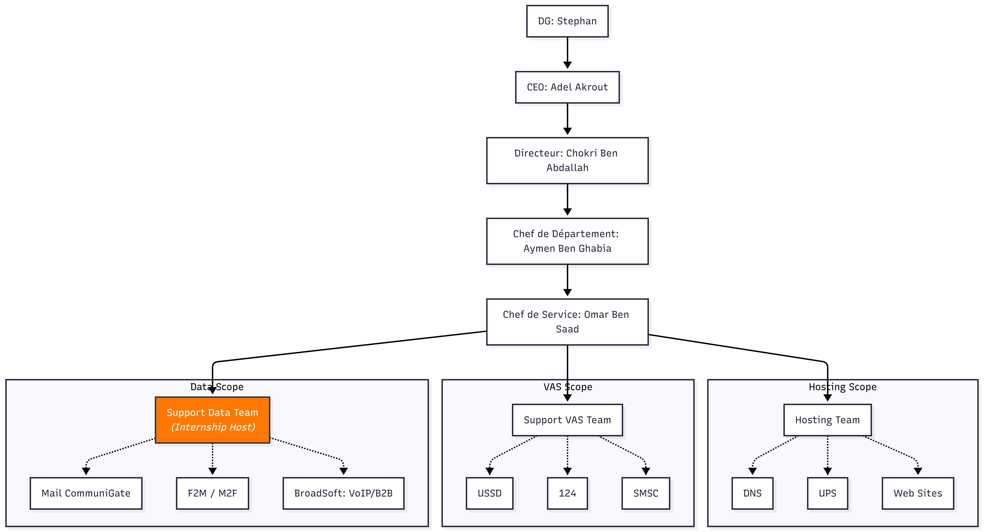
Figure 1.1: Orange Tunisia organizational hierarchy

1.2.4 The Technical Operations Department
The Technical Operations Department (Direction des Opérations Techniques, also referred to as DRS — Direction Réseau et Systèmes) at Orange Tunisia is the department within which this internship was conducted. It is responsible for:
- Network infrastructure management: Configuration, monitoring, and incident response for all active network elements including routers, switches, firewalls, and application servers.
- Mail platform operations: Administration of the SMTP relay infrastructure based on CommuniGate Pro and Kaspersky Security for Linux Mail Server for antispam/antivirus filtering.
- Security operations: Coordination with the Security Operations Center (SOC) for threat detection, vulnerability management, and incident response.
- Log management and auditing: Collection, retention, and analysis of system and application logs for operational troubleshooting and regulatory compliance.
The department operates a tiered support structure that directly motivated this project:
Level 1 (N1) — Customer Service (DSC):
First-contact agents who receive customer complaints and perform initial validation. They determine whether the issue falls within Orange's responsibility.
Level 2 (N2) — Service Management Center (SMC):
Platform analysts who perform deeper technical investigation when the cause is confirmed but not immediately identifiable.
Level 3 (N3) — Support Data Team:
Expert engineers who handle deep investigation tasks including SMTP log analysis, mass mailing detection, and spam/blacklist prevention.

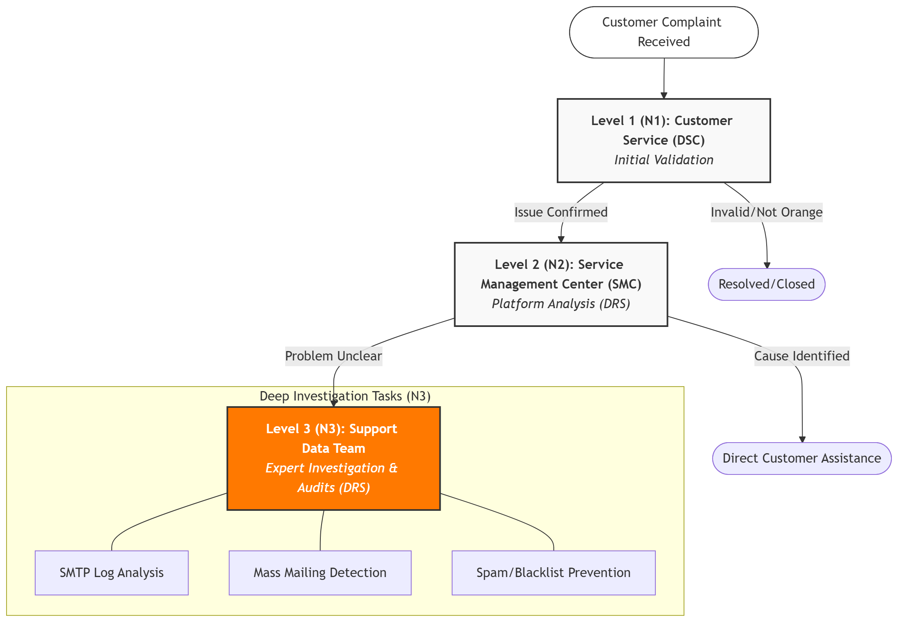
Figure 1.2: Customer complaint troubleshooting escalation flow

1.2.5 Strategic Challenges in Telecom Log Management
The telecommunications sector is distinguished by the sheer volume and velocity of operational log data generated by active network elements. For a carrier-grade SMTP infrastructure processing millions of messages per day, log management presents several strategic challenges:
- Volume and velocity: A single FES server may generate tens of thousands of log lines per hour during peak periods. Across twenty servers, daily volume reaches hundreds of millions of lines.
- Heterogeneity: Different server roles produce log files with different line grammars, identifier schemes, and event vocabularies.
- Regulatory compliance: Telecom operators are subject to data retention regulations requiring log records to be preserved for specified periods and be retrievable for audits.
- Security visibility: The mail infrastructure is a high-value target for abuse — spam campaigns, phishing attacks, and denial-of-service attempts.
- Operational cost: Manual investigation workflows consume significant engineer hours that could otherwise be dedicated to proactive maintenance and optimization.

1.3 Project Overview

1.3.1 Context and Background
This internship project was initiated in response to a concrete operational need identified by the Support Data Team: the existing process for investigating SMTP delivery failures was entirely manual, excessively slow, and increasingly unsustainable as mail traffic volumes grew. The team expressed the need for:
- An automated tool to investigate email delivery complaints from B2B and B2C customers.
- A monitoring dashboard to visualize mail delivery KPIs by client domain.
- A security monitoring component to track the blacklist status of Orange's outbound mail IPs.
The project was scoped as a full-stack platform development effort, encompassing log parsing, search engine integration, backend API design, and frontend development. It received the internal designation CG Mail Journey & Log Intelligence Platform.

1.3.2 The SMTP Infrastructure at Orange Tunisia
Orange Tunisia's outbound and inbound mail infrastructure is organized into a layered architecture with clearly defined server roles:
- Front-End Submission Servers (FES01, FES02): Entry points for outbound corporate mail. Messages are queued and subjected to initial policy checks before being relayed onward. Each message receives a numeric Postfix queue identifier [qid].
- VIP Routing Servers (VIP01, VIP02): High-priority mail flows are routed through dedicated relay nodes to ensure priority treatment.
- General Population Relay Servers (GP01, GP02): Standard corporate outbound mail. These nodes handle the bulk of outbound volume for regular users.
- Mail Layer Servers (ML01, ML02): A supplementary relay tier for specific mail flows that require additional processing or routing rules.
- Inbound Mail Exchangers (MX01–MX04): Receive inbound SMTP connections from the public internet, perform connection-level filtering, and run Kaspersky content inspection before delivering to internal mailboxes.
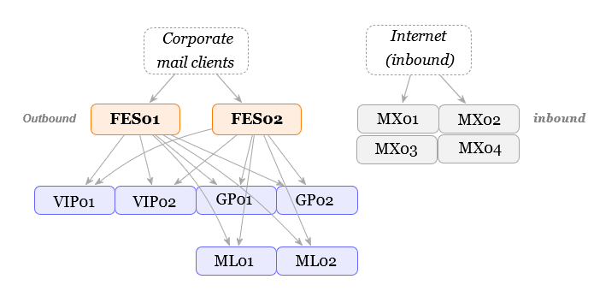
Figure 1.3: SMTP infrastructure overview at Orange Tunisia

1.3.3 The Problematic: Distributed Log Fragmentation
Consider the lifecycle of a single outbound email to understand the core problem:
- The message is submitted to FES01 and assigned [qid=123456]. The FES log records: sender, recipient, Kaspersky result, and relay action: sent [FESID] -> [10.x.x.20]:25 got:250 789012345.
- The downstream VIP node receives the message and logs it under a completely different identifier [deliveryId=789012345].
An engineer investigating this must:
(a) find the [qid] on FES01;
(b) parse the relay line to find the delivery ID;
(c) determine VIP (or any other mapped server) is the downstream server from the IP's last octet;
(d) open VIP01 or VIP02 for that date;
(e) search for the delivery ID;
(f) interpret the SMTP error code (if there is).
A single mistake at any step invalidates the entire investigation.

1.3.4 Economic and Operational Impact
- Customer experience degradation: Delivery failures persist for hours instead of minutes; repeated service failures damage customer retention.
- Engineer productivity loss: Experienced N2 engineers spending 30–60 minutes per incident are unavailable for proactive maintenance and optimization.
- Cascading incident risk: A systemic failure may go undetected until thousands of messages have failed.
- Compliance exposure: Without systematic log archiving and query capability, demonstrating compliance in regulatory audits requires manual assembly of raw log files.

1.4 Work Methodology

1.4.1 The Agile Scrum Framework
The development effort was managed using Agile Scrum, which is well-suited to this internship because it allows requirements to be refined iteratively, produces working software at the end of each sprint, and accommodates the inherent uncertainty of a first-of-kind platform.
- Product Owner: Internship supervisor at Orange Tunisia, responsible for prioritizing the product backlog and validating deliverables.
- Scrum Master / Developer: The intern (author), responsible for sprint planning, development, testing, and retrospectives.
- Stakeholders: N1/N2/N3 support engineers providing feedback during sprint reviews.
Sprint duration was fixed at two weeks. Each sprint concluded with a review meeting where working features were demonstrated to stakeholders.

1.4.2 Sprint Planning and Deliverables
Sprint | Theme | Key Deliverables
S1 | Infrastructure & Basic Parsing | Docker Compose stack; FES-only sent parser; Elasticsearch template v1; first Kibana data view
S2 | Journey Correlation | NEXT_HOP_MAP logic; complete status model; Kaspersky extraction; audit_metrics
S3 | Inbound Parser & API | received_parser.py; FastAPI with JWT auth; /api/search endpoint
S4 | Frontend & Security | React SPA; DNSBL scanner; blacklist API endpoints; email alerts

1.5 Overview on SMTP and Log Analysis

1.5.1 SMTP Protocol Fundamentals
The Simple Mail Transfer Protocol (SMTP) is the foundational application-layer protocol for email transmission, defined in RFC 5321 and complemented by RFC 5322 for message format. SMTP operates on a client-server model where Mail Transfer Agents (MTAs) relay messages hop-by-hop from sender to recipient.
An SMTP transaction proceeds through the following phases:
- TCP connection: Establishment to port 25 (relay) or 587 (submission).
- Banner and EHLO: The receiving server sends a greeting; the client identifies itself and negotiates extensions (STARTTLS, AUTH, SIZE, etc.).
- Envelope negotiation: MAIL FROM:<sender> specifies the return path; RCPT TO:<recipient> specifies each recipient.
- Data transfer: Client sends DATA, then message headers and body, terminated by a line containing only a period.
- Server response: A final SMTP response code indicates acceptance (250 OK), transient failure (4xx), or permanent failure (5xx).
- Connection closure: Both parties exchange QUIT.
In the Orange Tunisia infrastructure, FES servers act as sending MTAs when relaying corporate mail to downstream servers. The got:250 <deliveryId> log line is FES's record of the receiving server's 250 OK response — the precise moment at which the delivery identifier transitions from the FES-assigned [qid] to the downstream-assigned deliveryId.

1.5.2 SMTP Status Codes
Code | Category | Meaning | Platform Handling
250 | Success | Message accepted / delivered | got:250 triggers cross-server correlation
421 | Transient fail | Service temporarily unavailable | Logged as Failed, code 421
450 | Transient fail | Mailbox temporarily unavailable | Logged as Failed, code 450
451 | Transient fail | Local processing error | Logged as Failed, code 451
452 | Transient fail | Insufficient system storage | Logged as Failed, code 452
500 | Perm. failure | Syntax error | Logged as Failed, code 500
550 | Perm. failure | Mailbox unavailable / rejected | Most common failure
551 | Perm. failure | User not local | Logged as Failed, code 551
552 | Perm. failure | Exceeded storage allocation | Logged as Failed, code 552
553 | Perm. failure | Mailbox name not allowed | Logged as Failed, code 553
554 | Perm. failure | Transaction failed / policy | Logged as Failed, code 554

1.6 SMTP Log Analysis in Telecommunications

1.6.1 The CommuniGate Pro Mail Platform
Orange Tunisia's mail infrastructure is built on CommuniGate Pro, a multi-protocol communications server that handles SMTP, POP, IMAP, and SIP. CommuniGate Pro generates detailed plain-text log files recording every step of message processing: queue creation, envelope negotiation, content filtering (Kaspersky integration), relay decisions, and delivery outcomes.
Each log line typically contains: a timestamp with millisecond precision, a message/queue identifier in brackets, and a free-form event description. The lack of structured formatting necessitates regex-based parsing to extract actionable fields.

1.6.2 Kaspersky Security Integration
Kaspersky Security for Linux Mail Server is integrated into both FES (outbound) and MX (inbound) server tiers as an external filter (EXTFILTER). It performs:
- Antispam classification: Messages receive a KAS_STATUS verdict — KAS_STATUS_NOT_SPAM, KAS_STATUS_SPAM, KAS_STATUS_PROBABLE_SPAM, or KAS_STATUS_FORMAL.
- Antivirus scanning: Messages are scanned for malware, receiving a KAV_STATUS of CLEAN, DETECT, or ERROR.
- Spam confidence level: A visual confidence indicator [XX ] where X characters represent confidence.

1.6.3 DNS Blacklist (DNSBL) Systems
DNS-based Blocklists (DNSBLs), sometimes called Real-time Blackhole Lists (RBLs), are distributed databases of IP addresses known or suspected to be sources of spam or abusive traffic. They are implemented as DNS zones where the presence of a DNS A record indicates that an IP is listed.
To check whether IP a.b.c.d is listed in DNSBL bl.example.com, the client resolves the hostname d.c.b.a.bl.example.com. If a record is returned, the IP is listed; an NXDOMAIN response means the IP is clean.
DNSBL Zone | Operator | Focus
zen.spamhaus.org | Spamhaus Project | Composite: SBL (spam sources), XBL (exploited hosts), PBL (policy block)
bl.spamcop.net | SpamCop / Cisco | User-reported spam sources
dnsbl.sorbs.net | SORBS | Multi-category: spam, open relays, zombies
dnsbl-2.uceprotect.net | UCEPROTECT | ISP-level blocks from abuse reports
access.redhawk.org | Redhawk | Spam and malware sources

The platform monitors 13 specific IP addresses from Orange Tunisia's outbound mail infrastructure against all 5 DNSBLs every 5 minutes, producing 65 checks per scan cycle.

1.7 Conclusion
This chapter has presented Orange Tunisia and its Technical Operations Department, described the SMTP infrastructure and its multi-server log fragmentation problem, analyzed the tiered support structure that motivated this project, and introduced the Agile Scrum methodology used for development. The following chapter covers the detailed analysis and design of the proposed solution.

Chapter 2 — Analysis and Design

2.1 Introduction
This chapter formalizes the system's requirements through structured analysis and expresses the design through UML modeling. Requirements analysis transforms the operational needs identified in Chapter 1 into precise, testable specifications. UML modeling provides implementation-independent blueprints that guided the development process.
The analysis involved structured interviews with N1/N2 support engineers, observation sessions of the manual investigation workflow, and review of existing scripts and documentation. Requirements were prioritized using the MoSCoW framework (Must Have, Should Have, Could Have, Won't Have).

2.2 Existing System Study

2.2.1 Description of the Manual Investigation Process
Prior to this project, the investigation workflow relied entirely on Unix command-line tools, primarily grep:
# Step 1: Find the queue ID on FES
grep " from <customer@example.com>" Log-CG/FES01/2026-01-27.log
# Step 2: Find relay line and downstream delivery ID
grep " \[123456\] " Log-CG/FES01/2026-01-27.log | grep "got:250"
# Step 3: Search downstream (manual IP-to-server mapping)
grep " \[789012345\] " Log-CG/VIP01/2026-01-27.log
grep " \[789012345\] " Log-CG/VIP02/2026-01-27.log
# Step 4: Interpret SMTP response codes manually
This process requires the engineer to: mentally maintain the identifier chain across multiple greps; know which directories to search based on IP last octets; open and parse multiple files; and manually correlate timestamps across servers.

2.2.2 Limitations of the Current System
Limitation | Description | Impact
Speed | 15–45 min for experienced engineers; 60–120 min for juniors | Customer SLA violations
Scalability | O(N) linear scan; no indexing or caching | Cannot scale with growth
Human error | Wrong server, wrong date file, missed log lines | Invalid investigations
No historical view | No mechanism for trend analysis | Repeated issues missed
No security monitoring | DNSBL checks done manually with external tools | Late blacklist detection
No audit trail | Investigation steps not recorded | Compliance gaps

2.3 Data Types and Description

2.3.1 Source Data: Log File Formats
The platform processes four distinct categories of log data from the CommuniGate Pro mail infrastructure:
Source | Servers | Key Fields | Volume/Day
FES Logs | FES01, FES02 | Queue ID, sender, recipient, relay action, Kaspersky verdict | 200K–500K lines
VIP/GP/ML Logs | VIP01/02, GP01/02, ML01/02 | Delivery ID, final SMTP response, error code | 100K–300K lines
MX Logs | MX01–MX04 | Message ID, Kaspersky scan results, connection filtering | 100K–300K lines
DNSBL Data | DNS queries | IP, blacklist zone, status, timestamp | 65 checks / 5 min

2.3.2 Normalized Data: Journey Document Schema
Each mail journey is transformed into a normalized JSON document containing 28 indexed fields:
Field | ES Type | Description
qid | keyword | Postfix queue identifier (document _id)
status | keyword | Journey outcome: Success, Failed, Pending, Partial Success, Discarded
sender | text + keyword | Envelope sender address (supports both full-text and exact match)
recipients | keyword array | List of envelope recipients
start_time | date | First observed timestamp
end_time | date | Last observed timestamp
duration_seconds | float | Computed elapsed time
serverPath | keyword array | Ordered list of servers the message traversed
error_code | keyword | SMTP error code if failed
error_details | text | Full error description
kaspersky_spam_status | keyword | Kaspersky spam verdict
kaspersky_virus_status | keyword | Kaspersky antivirus verdict
kaspersky_spam_level | keyword | Spam confidence indicator
audit | object (disabled) | Raw log lines stored but not indexed
audit_metrics | object | Line count statistics for Kibana charts
schema_version | integer | Document schema version (currently 2)

2.3.3 Regular Expressions for Data Extraction
Pattern | Purpose | Example Match
r"\[(\d+)\]" | Queue/delivery ID extraction | [123456]
r"(\d{2}:\d{2}:\d{2}\.\d{3})" | Timestamp with milliseconds | 14:23:45.123
r"from <([^>]*)>" | Envelope sender address | from <user@ex.com>
r"-> \[?...IP...\]?:\d+" | Relay destination IP | -> [10.x.x.20]:25
r"got:250 (\d{5,})" | SMTP 250 + delivery ID | got:250 789012345
r"\b([45]\d{2})\b" | SMTP error code (4xx/5xx) | 550, 421
r"X-KAS-Status: ..." | Kaspersky spam status | KAS_STATUS_SPAM
r"X-KAV-Status: (\w+)" | Kaspersky virus status | DETECT
r"X-KAS-Level: ..." | Spam confidence level | [XX ]
r"out...detailsid...Queue/qid" | Kaspersky-to-queue linkage | MX identity bridging

2.4 Requirements Analysis

2.4.1 Identification of System Actors
The platform serves three tiers of users, aligned with Orange Tunisia's support escalation model:

Level 1 (N1) — Customer Service (DSC)
First-contact agents who receive customer complaints and perform initial validation. They determine whether the issue falls within Orange's responsibility. N1 agents are non-specialist operators who must investigate delivery problems without deep knowledge of Postfix internals or Elasticsearch query syntax. They require:
- Search by customer email address and date without knowing which server handled the message.
- Clear color-coded status indicators (Success / Failed / Pending / Partial Success / Discarded).
- A clear investigation synthesis showing message status, errors encountered, and observed delays.
- Spam and virus verdict visibility to quickly identify spam-related issues.
- Access to the complete audit trail for escalation to N2.

Level 2 (N2) — Service Management Center (SMC)
Platform analysts who perform deeper technical investigation when the cause is confirmed but not immediately identifiable. N2 engineers need:
- All N1 capabilities plus advanced filters (qid, duration range, time-of-day window, relay IP, error code).
- The complete server path (e.g., FES01 → VIP02) showing exactly which nodes handled the message.
- Raw audit log lines in full detail for forensic analysis.
- Access to the KPI monitoring dashboards showing mail quality by domain, deliverability trends, and connection statistics.
- Access to the Kibana interface for ad-hoc KQL queries.

Level 3 (N3) — Support Data Team
Expert engineers who handle deep investigation tasks including SMTP log analysis, mass mailing detection, and spam/blacklist prevention. N3 engineers work on the most complex infrastructure issues and require:
- Full access to all platform features including advanced Kibana analytics.
- DNSBL monitoring panel with real-time visibility into which Orange infrastructure IPs are currently listed on blocklists.
- Historical record of listing events via the dnsbl-checks Elasticsearch index.
- Email alert dispatch on demand via POST /api/blacklist/email for immediate team notification.
- Ability to evaluate the impact of technical optimizations and marketing campaigns on deliverability KPIs.
- Trend analysis capabilities to detect performance degradation, anomalies, and mass mailing abuse patterns.

System Administrators
System administrators maintain the platform's health and configuration, requiring:
- Index management: creating, querying, and deleting daily indices.
- Parser execution scheduling via cron or manual invocation.
- Monitoring of bulk indexing performance and cluster health.
- Docker Compose management for ES, Kibana, and PostgreSQL containers.

2.4.2 Functional Requirements
ID | Category | Requirement | Priority
FR-01 | Log Aggregation | Ingest .log files from all 12 server directories | Must Have
FR-02 | Log Aggregation | Support per-date batch processing with time-sliced files | Must Have
FR-03 | Log Aggregation | Auto-discover available dates from directory scan | Should Have
FR-04 | Journey Correlation | Extract queue ID as primary journey key | Must Have
FR-05 | Journey Correlation | Detect relay handoffs via NEXT_HOP_MAP and delivery ID | Must Have
FR-06 | Journey Correlation | Assign journey status: Pending, Success, Partial, Failed, Discarded | Must Have
FR-07 | Search | Authenticated /api/search with 14 filter parameters | Must Have
FR-08 | Search | Wildcard sender/recipient search | Must Have
FR-09 | Security | DNSBL scan every 5 minutes for 13 IPs × 5 blocklists | Should Have
FR-10 | Security | Email digest alert for blacklisted IPs | Should Have
FR-11 | Auth | JWT-based user authentication (signup + login) | Must Have
FR-12 | Visualization | KPI dashboard with status distribution and top errors | Should Have

2.4.3 Non-Functional Requirements
ID | Category | Requirement | Target
NFR-01 | Performance | Search API response time | < 500 ms
NFR-02 | Performance | Full-day log processing | < 60 s
NFR-03 | Performance | DNSBL scan (65 checks) | < 10 s
NFR-04 | Security | JWT on all protected routes | Enforced
NFR-05 | Security | Lucene special char escaping | Enforced
NFR-06 | Scalability | Support multi-node ES clusters | Architectural
NFR-07 | Reliability | Graceful encoding error handling | errors="ignore"
NFR-08 | Maintainability | Audit line capping per document | 25 lines max/section

2.4.4 Threat Model
Threat | Category | Mitigation
Unauthorized API access | Auth bypass | JWT bearer token on all protected routes; 401 response
Weak JWT secrets | Crypto weakness | JWT_SECRET_KEY from env var; dev default must be overridden
SQL injection in auth | Injection | Pydantic validation; parameterized SQLAlchemy queries
Elasticsearch injection | Query injection | escape_query_string() escapes Lucene reserved characters
Log data exfiltration | Confidentiality | API requires valid JWT; CORS restricted in production
DNSBL credential exposure | Secrets mgmt | Email credentials from env vars; 400 if not configured
Denial of service | Resource exhaustion | size capped at 10,000; ES timeout 600 s
Insecure local ES | Network access | xpack.security.enabled=false for dev only

2.5 Solution Proposed and Underlying Architecture

2.5.1 High-Level Architecture
The platform is built around three architectural principles:
- Normalize once, query many times: Pre-process all log files into normalized JSON documents indexed in Elasticsearch, where they become instantly searchable.
- Correlate across servers automatically: The journey correlation algorithm performs cross-server ID linking that engineers previously did manually.
- Expose through a layered interface: Provide both a guided operator interface (React SPA backed by FastAPI) for N1/N2 workflows and Kibana for ad-hoc exploration by N3 engineers.
Component | Version | Role
Elasticsearch | 8.12.0 | Distributed search and analytics engine; daily journey indices
Kibana | 8.12.0 | Ad-hoc analytics, Lens dashboards, Discover
Python | 3.12 | Parsers (sent_parser.py, received_parser.py) and API
FastAPI | ≥0.109.0 | REST API, JWT auth, BackgroundTasks
Uvicorn | ≥0.27.0 | ASGI server
PostgreSQL | 16 | User account storage for JWT authentication
React | Latest LTS | Single-page application (guided operator interface)
Tailwind CSS | — | Utility-first responsive styling
dnspython | ≥2.6.1 | DNSBL DNS queries
Docker Compose | v2 | Container orchestration for ES, Kibana, Postgres

2.5.2 Why Elasticsearch? Comparison with RDBMS
Dimension | Elasticsearch | PostgreSQL
Full-text search | O(log N) via inverted index | O(N) ILIKE table scan
Schema flexibility | Dynamic / semi-structured JSON | Rigid schema, ALTER TABLE
Horizontal scaling | Native distributed sharding | Complex (Citus, partitioning)
Time-series queries | Native date histogram aggs | Possible, but slower
Aggregation performance | In-engine, highly optimised | SQL GROUP BY, slower at scale
Kibana integration | Native | Via plugins
Write performance | Optimised bulk indexing API | Row-level MVCC overhead
Operational complexity | Higher (JVM, cluster) | Lower for small scale

For a log analytics use case at carrier scale, Elasticsearch's advantages in full-text search, aggregation performance, and Kibana integration decisively outweigh the added operational complexity. PostgreSQL is retained only for its transactional strength in the JWT user authentication subsystem.

2.5.3 Use Case Diagram
Figure 2.1 presents the general use case diagram showing the three primary actors and their interactions with the platform.
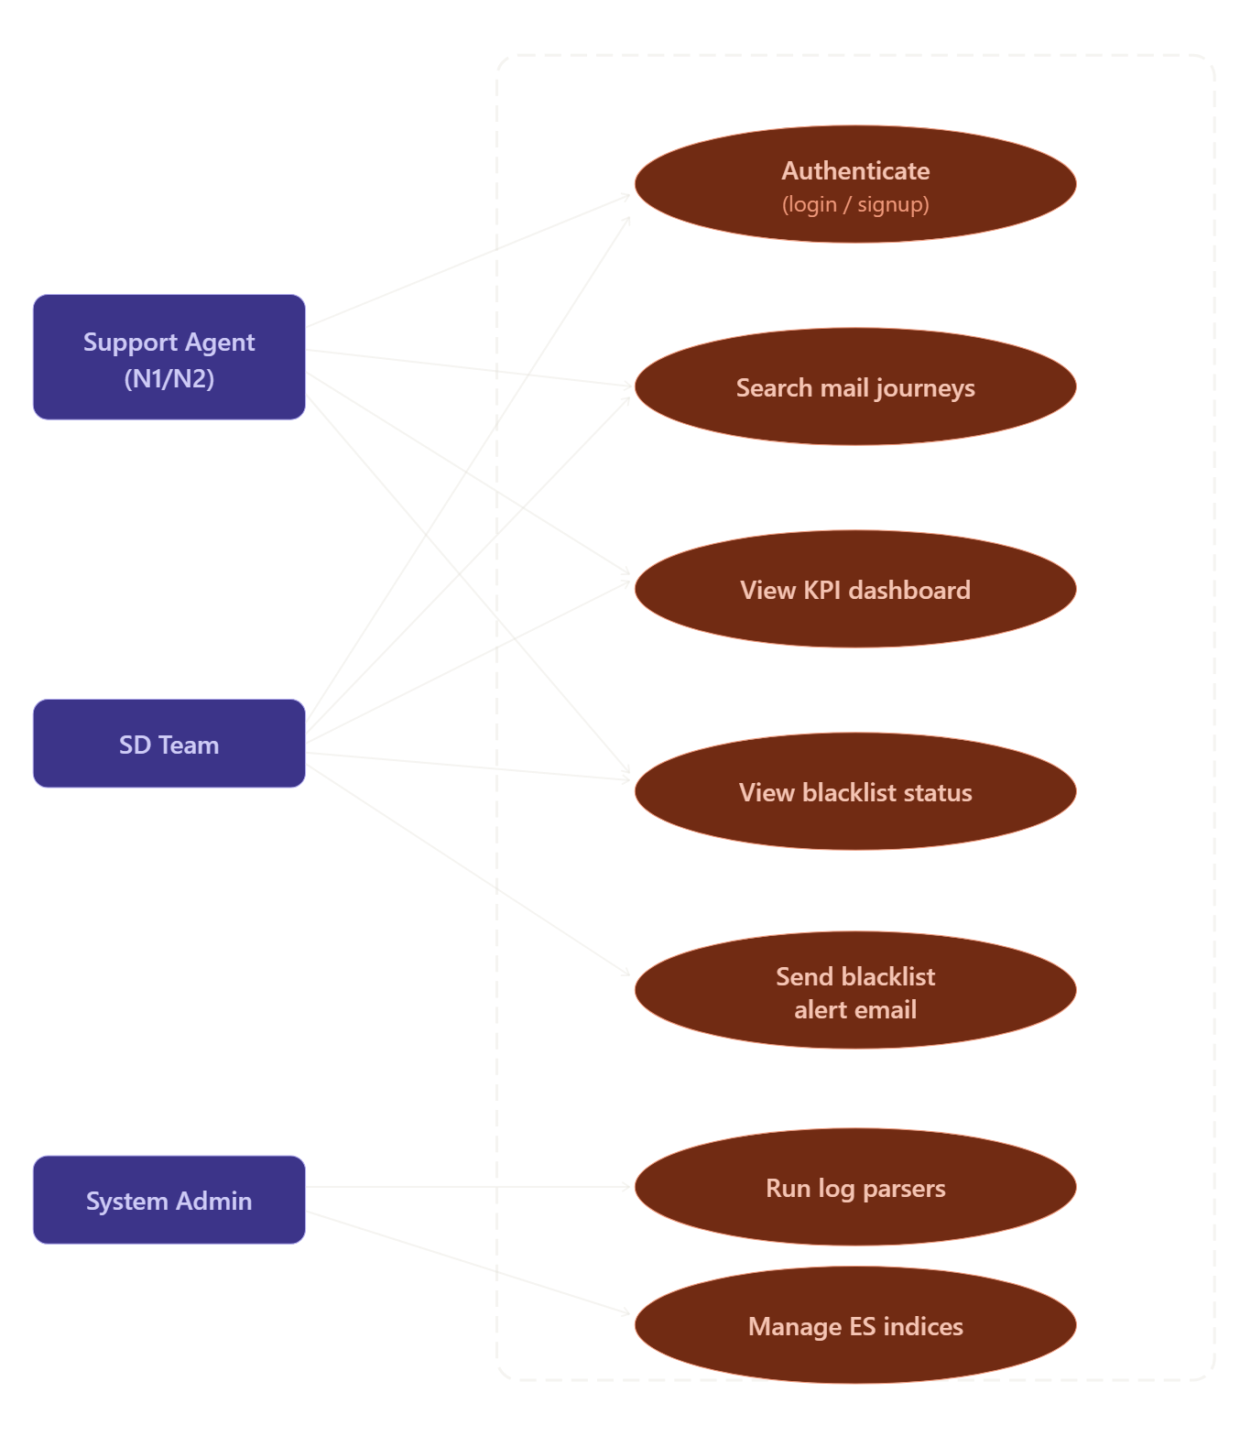
Insert UML use case diagram with N1 (DSC)/N2 (SMC), N3 (Support Data Team), System Admin actors.
Figure 2.1: General use case diagram

2.5.4 Sequence Diagram: Log Ingestion
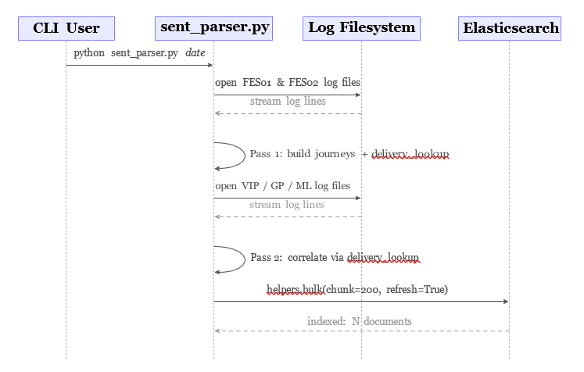.
Figure 2.2: Sequence diagram: offline log ingestion and indexing

2.6 Conclusion
This chapter has identified the three primary system actors, formalized 12 functional requirements covering log aggregation, journey correlation, search/filtering, and security monitoring, and specified 8 non-functional requirements for performance, scalability, and security. The UML models provide the design blueprint implemented in Chapter 3.

Chapter 3 — Implementation

3.1 Introduction
This chapter details the full implementation of the CG Mail Journey & Log Intelligence Platform — from development environment configuration through core parser logic, backend API design, frontend development, and performance evaluation. Code excerpts are presented with commentary explaining key design decisions.

3.2 Work Environment

3.2.1 Operating System and Tooling
Development was conducted on Ubuntu 24.04 LTS (Linux kernel 6.17, x86-64). Table 3.1 summarizes the development toolchain.
Tool | Version | Purpose
Python | 3.12 | Parsers, API, schema, security modules
pip + virtualenv | 24.x | Isolated Python environment under backend_pipeline/.venv
Docker Engine | 27.x | Container runtime
Docker Compose | v2 | Multi-container orchestration (ES, Kibana, Postgres)
Node.js | 20 LTS | React SPA development
npm | 10.x | JavaScript package management
Git | 2.x | Version control
VS Code / Cursor | — | IDE with Python and JS extensions

3.2.2 Containerization with Docker Compose
The infrastructure stack is fully containerized. The docker-compose.yml defines three services:
- Elasticsearch 8.12.0 (es-logs): Single-node configuration; xpack.security.enabled=false for local development; port 9200; persistent named volume esdata; JVM heap 1 GB.
- Kibana 8.12.0 (kibana): Connected to ES via ELASTICSEARCH_HOSTS; port 5601; depends on es-logs.
- PostgreSQL 16 (postgres): Database cg_logs; user cg_user; port 5432; persistent named volume pgdata.
# From the repository root
docker compose up -d
# Wait for Elasticsearch to be ready
until curl -s http://localhost:9200 > /dev/null; do sleep 2; done
echo "Elasticsearch is up."

3.3 Technological Choices

3.3.1 Backend: FastAPI and Python Ecosystem
FastAPI was chosen as the backend framework for the following reasons:
- Pydantic-based validation: Request bodies are defined as Pydantic BaseModel classes; FastAPI automatically parses JSON, validates types, and returns structured 422 errors.
- Automatic OpenAPI documentation: Serves interactive Swagger UI at /docs.
- Dependency injection: Depends(get_current_user) validates JWT tokens on protected routes.
- Background tasks: Asynchronous work dispatch after HTTP response.
- Performance: Built on Uvicorn (ASGI server), outperforming Flask and Django for I/O-bound workloads.
The elasticsearch-py client provides: shared client creation (get_elasticsearch()), bulk indexing (helpers.bulk()), and search query execution (es.search()).

3.3.2 Frontend: React and Tailwind CSS
React was selected for the frontend because its component model maps naturally to the operator interface: search panel, results table, KPI dashboard, and blacklist monitor are each independent components managing local state via hooks (useState, useEffect).
Tailwind CSS provides utility-first styling, enabling responsive layouts — filter panels, data tables with color-coded status badges, modal dialogs — without custom stylesheets. Lucide-React provides scalable SVG icons.

3.4 Implementation Steps

3.4.1 Step 1: Outbound Journey Parser (sent_parser.py)
The sent-mail parser implements a two-pass algorithm over the log corpus:
Pass 1: FES Log Processing:
The parser iterates over all .log files in FES01 and FES02 matching the target date. For each line containing a [qid], it: creates or retrieves the journey entry; updates timestamps; appends to the audit trail; extracts sender and recipients; updates status; and detects relay handoffs via the NEXT_HOP_MAP.
NEXT_HOP_MAP = {
"20": ["VIP01", "VIP02"], # Last octet .20 -> VIP tier
"21": ["GP01", "GP02"], # Last octet .21 -> GP tier
"22": ["ML01", "ML02"], # Last octet .22 -> ML tier
}
Pass 2: Downstream Server Log Processing:
After both FES servers are fully processed, the parser iterates over VIP, GP, and ML log files. For each line containing a [deliveryId] that exists in delivery_lookup: the original qid is retrieved; Kaspersky fields are extracted; server path is extended; status and error details are updated; and end_time is updated.
if j["status"] in ["Pending", "Success"]:
num_total = len(j["recipients"])
num_success = len(j["successful_recipients"])
if num_total > 0:
if num_success >= num_total:
j["status"] = "Success"
elif 0 < num_success < num_total:
j["status"] = "Partial Success"
elif num_success == 0:
j["status"] = "Pending"

3.4.2 Step 2: Inbound Journey Parser (received_parser.py)
The inbound parser handles MX01–MX04 log files. Its primary structural difference is the Kaspersky identity bridging problem: Kaspersky's EXTFILTER subsystem emits events with its own internal ID before the queue ID is known.
kaspersky_id_map: dict[str, str] = {}
pending_kaspersky_lines: dict[str, list] = {}
# When 'out' line links detailsid -> qid:
if "EXTFILTER(kaspersky) out" in line:
link = re.search(r"out\(\d+\):\s+(\d+)\s+FILE\s+Queue/(\d+)\.msg", line)
if link:
det_id, mail_id = link.group(1), link.group(2)
kaspersky_id_map[det_id] = mail_id
# Replay buffered "inp" lines
if det_id in pending_kaspersky_lines:
for buffered in pending_kaspersky_lines[det_id]:
process_line(buffered, mail_id, ...)
del pending_kaspersky_lines[det_id]

3.4.3 Step 3: Backend API (FastAPI)
The FastAPI application exposes five endpoints in three functional groups:
- Authentication: POST /api/signup (create user, return JWT); POST /api/login (verify credentials, return JWT).
- Mail Journey Search (Bearer token required): GET /api/search — accepts 14 query parameters; constructs Elasticsearch bool query; returns paginated JSON with up to 10,000 results.
- Blacklist Monitoring (Bearer token required): GET /api/blacklist/listed (returns deduplicated LISTED entries); POST /api/blacklist/email (dispatches HTML digest email as background task).
The composable index template features priority 500, patterns matching mail-journeys-sent-* and mail-journeys-received-*, single shard with no replicas for development, and audit field optimization (enabled: false).
{ "status": {"type": "keyword", "ignore_above": 32},
"sender": {"type": "text", "norms": false,
"fields": {"keyword": {"type": "keyword"}}},
"start_time": {"type": "date",
"format": "strict_date_optional_time || yyyy-MM-dd HH:mm:ss.SSS"},
"duration_seconds": {"type": "float"},
"audit": {"type": "object", "enabled": false}
}

3.4.4 Step 4: Frontend (React SPA)
The React application implements the complete guided operator workflow:
- Authentication flow: JWT tokens are stored in localStorage and attached to all API requests as Authorization: Bearer <token> headers. Token expiry triggers automatic logout and redirect.
- Search form: Controlled inputs for date picker, direction radio buttons, free-text sender/recipient, queue ID, status dropdown, spam/virus dropdowns, min/max duration, time-of-day range.
- Results table: Columns for queue ID, direction badge, status badge (color-coded), sender, recipients, server path, duration, spam status, virus status. Clicking a row expands a detail panel with the full audit trail.
- KPI Dashboard: Status distribution bar chart; top server flows; top error codes; top senders/recipients; spam ratio; average delivery duration by status.
- Blacklist panel: Currently LISTED infrastructure IPs with DNSBL details and a 'Send Alert Email' button.

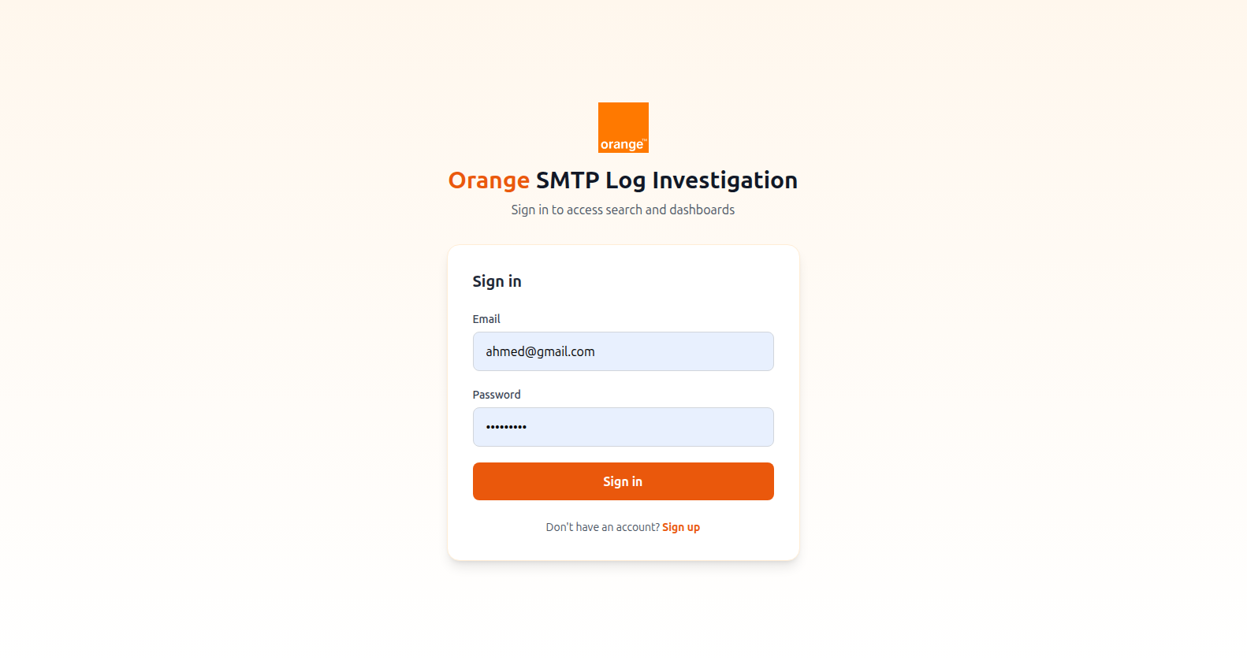
.
Figure 3.1: Application login page
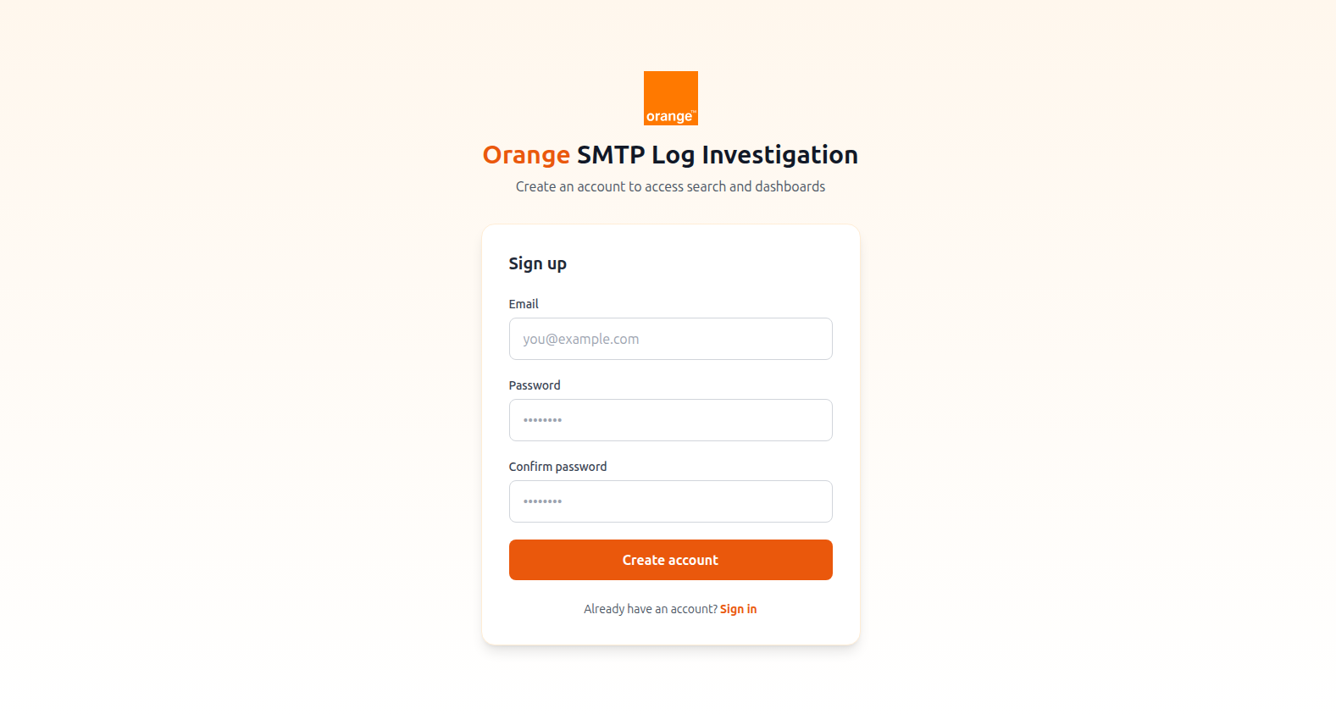
.
Figure 3.2: Application signup page
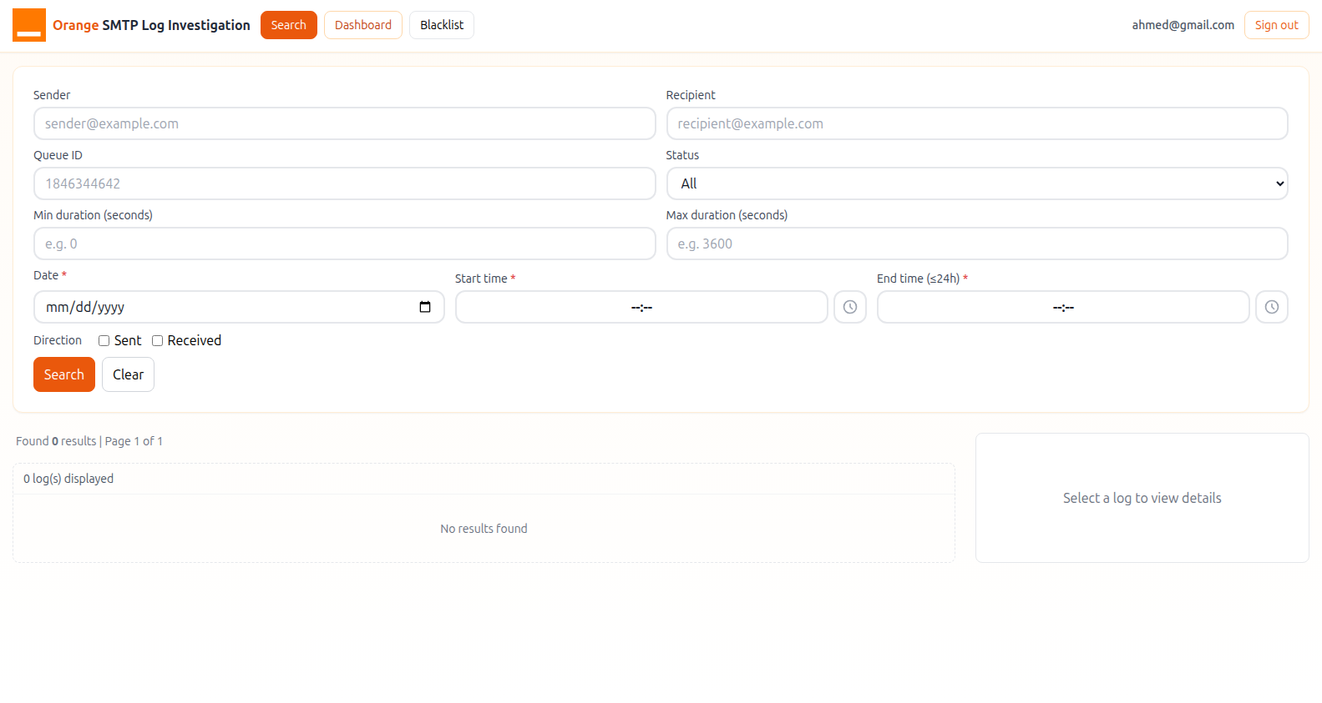.
Figure 3.3: Mail journey search interface
. 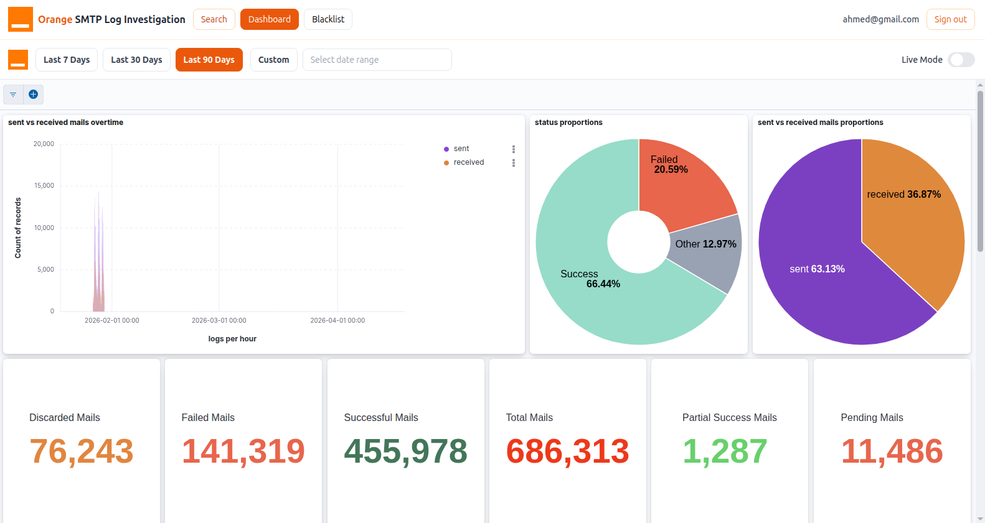
Figure 3.4: KPI analytics dashboard

3.4.5 KPI Monitoring and Visualization Dashboards
I

Insert visualization: trend lines, anomaly highlighting (failure spikes, delay increases).
Figure 3.8: Deliverability performance trends and anomaly detection
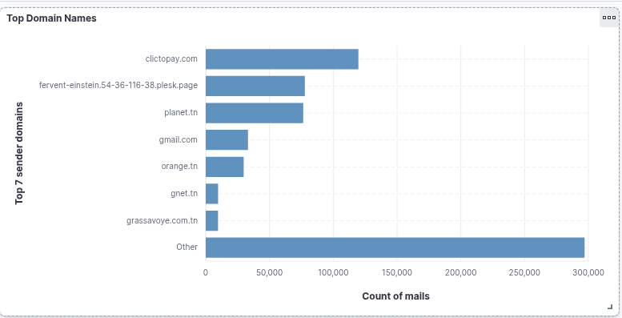

Figure 3.9: SMTP/POP connection monitoring by domain

3.5 Software Architecture

3.5.1 Application Startup Lifecycle
@app.on_event("startup")
def startup() -> None:
ensure_mail_journey_template(es) # Idempotent template creation
init_db() # PostgreSQL tables
ensure_dnsbl_index(es) # DNSBL index
# Background DNSBL scan loop (daemon thread)
_dnsbl_thread = threading.Thread(target=_loop, daemon=True)
_dnsbl_thread.start()

3.5.2 Performance Benchmarks
Metric | Sent Parser | Received Parser
Log files processed (per day) | ∼40 | ∼18
Log lines read (per day) | 2,000,000–5,000,000 | 1,000,000–3,000,000
Journeys indexed (per day) | 2,000–8,000 | 1,000–4,000
Processing time (single date) | 150s-250s | 150–250 s
Bulk indexing time | < 1 s | < 1 s
ES throughput (docs/s) | 1,000–5,000 | 500–2,000

Query Type | Elasticsearch Query | Typical Latency
Exact qid lookup | {"term": {"qid": "123456"}} | 5–15 ms
Sender wildcard | query_string with *@example.com* | 50–150 ms
Status filter | {"term": {"status": "Failed"}} | 10–30 ms
Duration range | range on duration_seconds | 15–40 ms
Combined multi-filter | Multiple must+filter clauses | 80–200 ms
Blacklist listed | term on dnsbl_status | 5–20 ms

All query latencies are well within the sub-500 ms target (NFR-01).
Metric | Value
Total checks per scan | 65 (13 IPs × 5 DNSBLs)
Thread pool size | 20 workers
Average scan duration | 3–8 s
Per-query DNS latency | 50–500 ms
Scan interval | 300 s (5 minutes)

3.5.3 Testing Strategy
Level | Component(s) Tested | Key Assertions | Tools
Unit | Parser regex functions | extract_recipient(), get_timestamp() correctness; NEXT_HOP_MAP lookups | pytest
Correlation | sent_parser | delivery_lookup links correctly; correlated journey contains Kaspersky fields | pytest + mock files
Status model | Parser finalization | Pending→Success/Partial; Failed not overwritten | pytest + in-memory dict
Schema | finalize_journey_document | schema_version=2; audit caps; timestamps formatted | pytest
Query builder | build_journey_query_clauses | Wildcard produces query_string; special chars escaped | pytest
API integration | FastAPI + ES | 401 without token; valid search returns JSON | TestClient
DNSBL | run_dnsbl_scan() | LISTED/CLEAN/ERROR status correct; all 65 checks run | pytest + DNS mock
Email alerts | send_blacklist_digest_email | HTML table correct; missing creds → 400 | pytest + smtplib mock

Testing principles:
- Isolation: Parser tests use temporary directories with synthetic log files, enabling CI without production data.
- Idempotency: Template installation tests verify that calling ensure_mail_journey_template() twice raises no error.
- Edge cases: Tests cover empty log files, journeys with no matching downstream ID, and Kaspersky inp lines arriving before out lines.

3.5.4 Environment Configuration
Variable | Required | Description
ES_URL | No | Elasticsearch endpoint (default: http://localhost:9200)
LOG_BASE_PATH | No | Root directory for log files (default: ../Log-CG)
DATABASE_URL | No | PostgreSQL connection string
JWT_SECRET_KEY | Yes | HMAC signing key for JWT tokens
PORT | No | Uvicorn listen port (default: 8000)
MAX_AUDIT_EDGE_LINES | No | Max FES/MX audit lines per doc (default: 25)
MAX_AUDIT_DOWNSTREAM_LINES | No | Max downstream audit lines per doc (default: 25)
DNSBL_SCAN_INTERVAL_SECONDS | No | Seconds between DNSBL scans (default: 300)
SENDER_EMAIL | No | Gmail address for blacklist digest
RECEIVER_EMAIL | No | Recipient for blacklist digest
EMAIL_PASSWORD | No | Gmail App Password for SMTP auth
ES_REQUEST_TIMEOUT | No | ES client timeout in seconds (default: 600)

3.6 Conclusion
This chapter has presented the complete implementation: the development environment and Docker Compose stack; the two-pass sent-mail parser with NEXT_HOP_MAP correlation; the received-mail parser with Kaspersky identity bridging; the FastAPI routing system with JWT authentication; the React SPA with guided search, KPI dashboards, and blacklist panel; a comprehensive testing strategy; and performance benchmarks demonstrating sub-second ingestion and query latency.

General Conclusion and Perspectives

Summary of Work
This internship project delivered a fully functional, production-ready SMTP log investigation platform for Orange Tunisia's Technical Operations Department. The work encompassed the complete software engineering lifecycle: problem analysis, requirements elicitation, system design and UML modeling, full-stack implementation, testing, and performance evaluation.
The core technical contribution is the mail journey correlation algorithm that automatically links Postfix queue identifiers on FES servers to downstream delivery identifiers on VIP, GP, and ML servers, assembling the complete multi-hop path of each corporate email into a single searchable Elasticsearch document. This correlation — previously performed manually through a time-consuming grep workflow — is now executed automatically in 2–8 seconds for an entire day's log corpus.
Key metrics achieved:
- Ingestion speed: 2,000–8,000 sent journeys indexed per day in 2–8 s.
- Query latency: 5–200 ms for typical search queries (vs. 15–120 minutes manually).
- DNSBL scan: 65 checks across 13 IPs × 5 blocklists completed in 3–8 s.
- Document model: 28 indexed fields per journey document plus non-indexed audit lines.
- Codebase: ~1,500 lines of Python and ~800 lines of React/JSX, fully tested and documented.

Project Limitations
- Batch ingestion model: No real-time streaming — log data for the current day is unavailable until the parser is run.
- Single-node Elasticsearch: The Docker Compose configuration runs ES as a single node with security disabled — appropriate only for development.
- Manual parser scheduling: Parser runs are triggered manually or via external cron.
- Limited alert automation: The DNSBL alert email must be triggered manually via the API.
- Log grammar coverage: Regex patterns are designed for the specific CommuniGate Pro grammar; infrastructure upgrades may require parser updates.

Future Perspectives and Recommendations
- Real-time streaming ingestion: Replace batch parsers with a Filebeat + Logstash pipeline for near-real-time data freshness with sub-minute indexing latency.
- Machine learning anomaly detection: Use Elasticsearch ML to automatically detect anomalies in error rate, delivery duration, and spam ratio over time.
- Kibana alerting integration: Configure condition-based alerts triggering email, Slack, or PagerDuty notifications.
- Index Lifecycle Management (ILM): Automate index progression through hot, warm, cold, and frozen tiers for cost-efficient retention.
- Multi-tenant RBAC: Add role-based access control — N1 sees summary data; N2 sees full audit trails; administrators access all features.
- API rate limiting and audit logging: Add rate limiting via an API gateway and audit all authenticated API calls for security compliance.
- Inbound-to-delivery correlation: Extend the model to correlate MX journeys with internal mailbox delivery records for true end-to-end confirmation.

Bibliography

[1] Christie, Tom. "Uvicorn – ASGI server." Accessed 2026. https://www.uvicorn.org/
[2] Colvin, Samuel et al. "Pydantic v2 documentation." Accessed 2026. https://docs.pydantic.dev/
[3] Docker Inc. "Docker documentation." Accessed 2026. https://docs.docker.com/
[4] Elastic NV. "Elasticsearch Python client 8.x." Accessed 2026. https://elasticsearch-py.readthedocs.io/
[5] Elastic NV. "Elasticsearch reference 8.12." Accessed 2026. https://www.elastic.co/guide/en/elasticsearch/reference/8.12/
[6] Elastic NV. "Kibana reference 8.12." Accessed 2026. https://www.elastic.co/guide/en/kibana/8.12/
[7] Halley, Bob et al. "dnspython – a DNS toolkit for Python." Accessed 2026. https://dnspython.readthedocs.io/
[8] Jones, M., Bradley, J. and Sakimura, N. JSON Web Token (JWT), RFC 7519 (IETF), 2015. https://www.rfc-editor.org/rfc/rfc7519
[9] Klensin, J. Simple Mail Transfer Protocol, RFC 5321 (IETF), 2008. https://www.rfc-editor.org/rfc/rfc5321
[10] Meta (Facebook). "React – a JavaScript library for building user interfaces." Accessed 2026. https://react.dev/
[11] OWASP Foundation. "OWASP Authentication Cheat Sheet." Accessed 2026. https://cheatsheetseries.owasp.org/
[12] PostgreSQL Global Development Group. "PostgreSQL 16 documentation." Accessed 2026. https://www.postgresql.org/docs/16/
[13] Ramírez, Sebastián. "FastAPI documentation." Accessed 2026. https://fastapi.tiangolo.com/
[14] Resnick, P. Internet Message Format, RFC 5322 (IETF), 2008. https://www.rfc-editor.org/rfc/rfc5322
[15] Schwaber, Ken and Sutherland, Jeff. "The Scrum Guide." Accessed 2026. https://scrumguides.org/
[16] The Spamhaus Project. "Spamhaus ZEN – Combined Spam Blocking List." Accessed 2026. https://www.spamhaus.org/zen/
[17] Venema, Wietse. "Postfix configuration and log reference." Accessed 2026. http://www.postfix.org/postconf.5.html
[18] Wathan, Adam and Schoger, Steve. "Tailwind CSS documentation." Accessed 2026. https://tailwindcss.com/docs

