**Exploring Information and Communication Technologies (TIC)**

"A Comprehensive Report on TIC and Related Technologies"

01/03/2024

Section B

Usthb

**Table of Contents:**

1. Introduction

2. Overview of TIC

3. Google Services

4. Microsoft Tools

5. Git and GitHub

6. Integration of TIC Technologies

7. Challenges and Future Trends

8. Conclusion

9. References

\*\***Introduction**:**

1. **Significance of TIC:**

   - Information and Communication Technologies (TIC) stand as the cornerstone of our interconnected global society, reshaping the dynamics of communication, information access, and business operations.

2. **Purpose of the Report:**

   - This report aims to intricately examine TIC and its associated technologies, providing a thorough understanding of their pivotal role in shaping the contemporary digital landscape.

3. **Scope and Relevance:**

   - Within these pages, we will explore essential TIC components, including Google services, Microsoft tools, Git, and GitHub. Unveiling these technologies is crucial for navigating the complexities of our tech-centric world.

4. **Connection to Everyday Life:**

   - TIC has seamlessly woven into the fabric of our daily existence, influencing our work methodologies, social interactions, and access to information. From communication platforms to collaborative tools, TIC has become an integral part of our modern lifestyle.

5. **Evolution of TIC:**

   - Tracing the evolutionary path of TIC unveils a captivating narrative marked by technological advancements and societal shifts. From the early days of the internet to the current era of cloud computing and artificial intelligence, TIC has consistently evolved.

\*\***Overview of TIC**:**

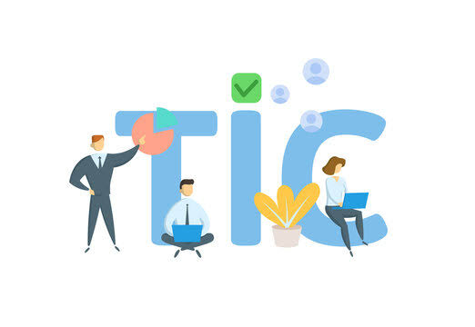

1. **Definition of TIC:**

   - Information and Communication Technologies (TIC) encompass a wide range of tools and systems designed to facilitate the exchange, processing, and management of information in various contexts.

2. **Evolution of TIC:**

   - Tracing the historical trajectory of TIC reveals its dynamic evolution, marked by significant milestones and technological advancements that have continually reshaped the landscape.

3. **Importance of TIC:**

   - TIC holds paramount importance in contemporary society, serving as a linchpin for revolutionizing communication, streamlining business operations, transforming education, and influencing numerous other sectors.

4. **Components of TIC:**

   - At its core, TIC comprises essential components including hardware, software, networks, and robust data management systems, collectively driving the seamless flow of information.

5. **Role in Digital Transformation:**

   - TIC is a catalyst for digital transformation, playing a pivotal role in reshaping industries, fostering innovation, and enhancing operational efficiency through the integration of cutting-edge technologies.

6. **Current Trends in TIC:**

   - The present landscape of TIC is characterized by dynamic trends, including the proliferation of artificial intelligence, the advent of the Internet of Things (IoT), and an increased emphasis on cybersecurity to safeguard digital ecosystems.

7. **Challenges in TIC Implementation:**

   - Acknowledging the implementation challenges is vital, with considerations extending to issues related to privacy, security, and the digital divide that may impact the equitable access to TIC resources.

8. **Future Outlook for TIC:**

   - Looking forward, the future of TIC holds promise, with ongoing developments in emerging technologies shaping new frontiers. Anticipated advancements offer glimpses into potential societal impacts and transformative possibilities.

\*\***Google Services**:**

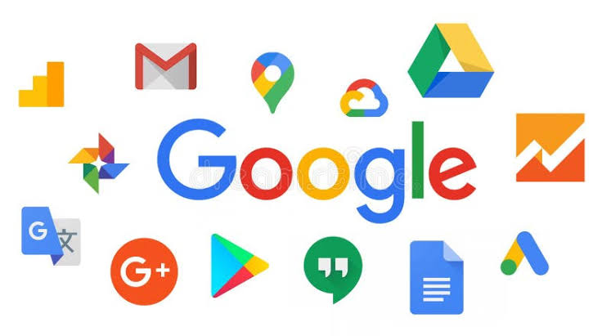

1. **Introduction to Google Services:**

   - Google Services constitute a diverse array of tools and platforms developed by Google, playing a pivotal role in the digital ecosystem.

2. **Gmail:**

   - *Overview:* Gmail stands as a widely used email service, known for its intuitive interface and efficient organization.

   - *Key Features:* Explore features such as advanced search capabilities, effective spam filtering, and seamless integration with other Google services.

3. **Google Drive:**

   - *Cloud Storage and Collaboration:* Google Drive serves as a robust cloud storage solution, fostering collaboration through features like document sharing, version control, and real-time editing.

4. **Google Docs, Sheets, and Slides:**

   - *Collaborative Productivity Tools:* These tools facilitate real-time collaboration on documents, spreadsheets, and presentations, enhancing teamwork and productivity.

5. **Google Calendar:**

   - *Time Management and Scheduling:* Google Calendar offers an intuitive platform for scheduling events, setting reminders, and synchronizing with other Google services for seamless planning.

6. **Google Maps:**

   - *Navigation and Location-based Services:* Google Maps plays a pivotal role in navigation, providing real-time updates, location sharing, and detailed mapping services.

7. **Google Search:**

   - *Access to Information:* Google Search remains a fundamental service for accessing information online, continually evolving with features like voice search and personalized results.

8. **Google Analytics:**

   - *Website and Data Analytics:* Google Analytics is a powerful tool for website owners, offering insights into website performance, user behavior, and audience demographics.

9. **Integration of Google Services:**

   - *Synergy between Services:* Explore how these Google services synergize, creating a cohesive ecosystem for users and businesses.

Certainly, let's continue with the content:

**6. **Microsoft Tools**:**

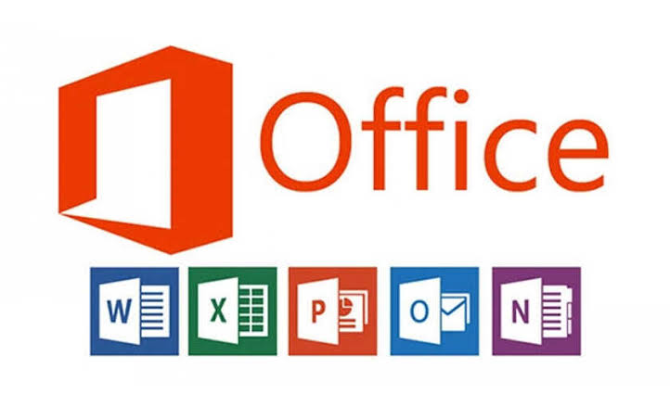

- **Introduction to Microsoft Tools:**

  - Microsoft Tools constitute a suite of indispensable software applications crucial for enhancing digital productivity and collaboration.

- **Microsoft Office Suite:**

  - *Productivity Applications:* The Microsoft Office Suite, featuring applications like Word, Excel, and PowerPoint, serves as the backbone for document creation, data analysis, and dynamic presentations.

- **Microsoft Teams:**

  - *Collaboration Hub:* Microsoft Teams seamlessly integrates chat, video conferencing, and file sharing, creating a centralized platform for enhanced team communication and project management.

- **Azure:**

  - *Cloud Computing Services:* Azure, Microsoft's comprehensive cloud computing service, empowers businesses with scalable solutions for application development, deployment, and management.

- **Integration of Microsoft Tools:**

  - *Interconnected Ecosystem:* The interconnectedness of Microsoft tools creates a cohesive ecosystem, fostering streamlined workflows and efficient digital operations.

**7. **Git and GitHub:**\*\*



- **Introduction to Version Control:**

  - Git, a version control system, revolutionizes code management by tracking changes, facilitating collaboration, and ensuring code integrity.

- **GitHub Collaboration:**

  - GitHub, as a collaborative platform, enhances distributed development by hosting Git repositories, enabling seamless code collaboration, and providing powerful version control capabilities.

- **Benefits of Git and GitHub:**

  - The benefits of utilizing Git and GitHub are vast, including improved collaboration, code traceability, and effective project management, contributing to overall software development efficiency.

**8. **Integration of TIC Technologies:**\*\*

- **Interconnected Synergy:**

  - The integration of Google services, Microsoft tools, Git, and GitHub creates a powerful synergy, fostering seamless collaboration, data flow, and comprehensive project management.

- **Case Studies:**

  - Explore real-world case studies illustrating successful integration scenarios, showcasing the practical benefits of combining these technologies.

**9. **Challenges and Future Trends**:**

- **Challenges in TIC Implementation:**

  - Implementation challenges encompass security concerns, interoperability issues, and the need for user adoption, emphasizing the importance of addressing these hurdles for successful TIC integration.

- **Future Trends in TIC:**

  - Anticipate future trends in TIC, including advancements in artificial intelligence, evolving cybersecurity measures, and the continued evolution of cloud computing, highlighting the dynamic trajectory of the field.

**10. **Conclusion**:**

- **Summary of Key Points:**

  - Summarizing the report's key findings underscores the pivotal role of TIC in reshaping communication, collaboration, and technological innovation.

- **Closing Thoughts:**

  - Concluding reflections emphasize the dynamic nature of TIC, urging continuous adaptation and exploration in the ever-evolving digital landscape.