To create a directory in MS-DOS or the Windows command line, use the [md or mkdir MS-DOS command](https://www.computerhope.com/mdhlp.htm). For example, below we are creating a new directory called "hope" in the [current directory](https://www.computerhope.com/jargon/c/currentd.htm).

mkdir hope

You can also create multiple new directories in the current directory with the **md** command. In the next example, we are creating three new directories, called "user1," "user2," and "user3," in the current directory.

md user1 user2 user3

If you want to create a directory with spaces, you need to surround the directory name with [quotes](https://www.computerhope.com/jargon/q/quote.htm). In the example below, we are creating a directory called "my example directory" in the current directory.

md "my example directory"

To create a directory in the [parent directory](https://www.computerhope.com/jargon/p/parechil.htm), without first moving into that directory, you can use the command below. This example moves back one directory to create the "example" directory.

md ..\example

To create a [subdirectory](https://www.computerhope.com/jargon/s/subdirec.htm) in a different directory without moving it, use a command similar to the example below. This command creates a "test" directory in the hope directory.

mkdir hope\test

**Tip**

Once a directory is created, you can use the [cd command](https://www.computerhope.com/cdhlp.htm) to change the directory and move into that directory.

To make a directory in another [drive](https://www.computerhope.com/jargon/d/drive.htm) without moving into that drive, use a command similar to the example below. This command creates an "example" directory on the F: drive. The drive letter "f:" can be substituted from any [drive letter](https://www.computerhope.com/jargon/d/drivelet.htm).

md f:\example

**More:**

[**https://ss64.com/nt/more.html**](https://ss64.com/nt/more.html)

MORE displays the output one screen at a time, then pauses and displays the message MORE at the bottom of your screen.

To display the file SALE2.TXT, one screen full of data at a time, enter  
  
**more < sale2.txt**  
  
To display the output of the TYPE command one screen at a time, you can enter the command using the following format:  
  
**TYPE (filename)|MORE**  
  
For example, to display the file LET3.DOC in the LETTERS directory on drive B, enter  
  
**type b:\letters\let3.doc|more**

MOVE

Move a file from one folder to another.

Syntax

MOVE [*options*] [*Source*] [*Target*]

Key

*source* : The path and filename of the file(s) to move.

*target* : The path and filename to move file(s) to.

*options*:

/Y Suppress confirmation prompt, when overwriting files.

/-Y Enable confirmation prompt, when overwriting files.

**Examples:**  
  
In the current folder:  
MOVE oldfile.wp newfile.doc  
  
Move a file, specifying the full path:  
MOVE g:\department\oldfile.wp "c:\Files to Convert\newfile.doc"  
  
Specify the drive and filename, assumes the [current](https://ss64.com/nt/cd.html) folder on both drives is correct:  
MOVE a:oldfile.wp c:newfile.doc

# RD

Remove (or Delete) a Directory.

Syntax

RD [*pathname*](https://ss64.com/nt/path.html#pathname)

RD /S [*pathname*](https://ss64.com/nt/path.html#pathname)

RD /S /Q [*pathname*](https://ss64.com/nt/path.html#pathname)

Key

/S : Delete all files and subfolders

in addition to the folder itself.

Use this to remove an entire folder tree.

/Q : Quiet - do not display Y/N confirmation

**Examples**

Remove 'C:\demo documents\work' and all files and sub folders:

RD /S "C:\demo documents\work"

Remove 'C:\source_files' but only if it is already empty:

RD "C:\source_files"

# REN

Rename a file or files.

REN [*drive*:][*path*]*SourceMask TargetMask*

## **SourceMask**

The sourceMask works as a filter to determine which files are renamed. The wildcards work here the same as with any other command that filters file names.

## **TargetMask**

The *TargetMask* specifies the new name. It is always applied to the full long name; The *TargetMask* is never applied to the short 8.3 name, even if the *SourceMask* matched the short 8.3 name

**Examples**

Rename Monday.txt as Tuesday.txt  
C:\> REN Monday.txt Tuesday.txt

# *sort*

## Overview:

Sorts input.

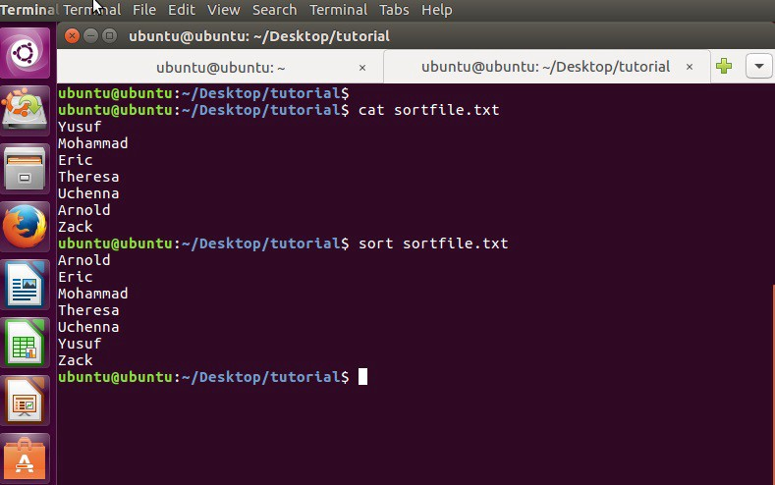

XCOPY:

<https://ss64.com/nt/xcopy.html>

TREE:

<https://geniushub.io/tree-command-list-folders-directories-files-windows-cmd-dos/>

IPCONFIG:

<https://ss64.com/nt/ipconfig.html>

NETSTAT:

<https://ss64.com/nt/netstat.html>

PING:

<https://ss64.com/nt/ping.html>

nsloopup:

<https://ict.senecacollege.ca/wiki/ifs/index.php/DrawingBroad>