Software Requirements and Design Document
for
Parking Management System
Prepared by Ahmed Bin Asim, Jawad Ahmad Khan, Fahd Ahmed
National University of Computing and Emerging Sciences
November 24, 2024
Table of Contents
Table of Contents
1. Introduction 1
1.1 Purpose 1
1.2 Product Scope 1
1.3 Title 1
1.4 Objectives 1
1.5 Problem Statement 2
2. Overall Description 3
2.1 Product Perspective 3
2.2 Product Functions 3
2.3 List of Use Cases 4
2.4 Extended Use Cases 4
2.5 Use Case Diagram 16
3. Other Nonfunctional Requirements 17
3.1 Performance Requirements 17
3.2 Safety Requirements 17
3.3 Security Requirements 17
3.4 Software Quality Attributes 18
3.5 Business Rules 18
3.6 Operating Environment 18
4. Domain Model 20
5. System Sequence Diagram 21
6. Sequence Diagram 32
7. Class Diagram 43
8. Packages Diagram 44
9. Components Diagram 45
9. Deployment Diagram Error: Reference source not found

Introduction

Purpose
The purpose of this document is to define the software requirements for SpaceSync: Intelligent Dual-Floor Basement Parking Management System for FAST NUCES Islamabad. The system aims to provide an efficient, user-friendly, and inclusive parking management solution by leveraging real-time space tracking, intelligent allocation algorithms, and advanced accessibility features to optimize parking operations and enhance user satisfaction.

Product Scope
The SpaceSync: Intelligent Dual-Floor Basement Parking Management System is designed to optimize parking operations at FAST NUCES Islamabad’s new basement facility. By utilizing advanced technologies like real-time monitoring as well as catering for the user’s needs, the system enhances parking efficiency, reduces congestion, and provides a seamless user experience, including accessibility for disabled users. The system aims to maximize space utilization, improve traffic flow, and provide valuable data for future campus planning. Aligning with the institution's goals of innovation and sustainability, SpaceSync supports a smarter, more efficient campus infrastructure, improving both operational performance and user satisfaction.

Title
SpaceSync: Intelligent Dual-Floor Basement Parking Management System for FAST NUCES Islamabad
This project aims to develop a smart parking management system for the dual-floor basement parking facility at FAST NUCES Islamabad. The system will provide an efficient, user-friendly solution to optimize parking space utilization, reduce congestion, and enhance the overall parking experience for students, faculty, and staff.

Objectives
- Develop a comprehensive parking management system that efficiently handles reservations, token issuance, and access control.
- Implement intelligent space allocation algorithms to maximize parking capacity utilization.
- Integrate accessibility features to accommodate disabled users and ensure inclusive design.
- Create a real-time monitoring system to prevent entrance congestion and manage traffic flow.
- Implement a user-friendly interface for both administrators and parking users.
- Incorporate data analytics for continuous improvement of parking efficiency and user experience.

Problem Statement
The rapid increase in vehicle ownership among students, faculty, and staff at FAST NUCES Islamabad has led to significant parking challenges, including difficulty finding available spaces, traffic congestion at entrances, and underutilization of parking capacity. The newly constructed dual-floor basement parking facility offers a solution to these issues, but without an advanced parking management system, its potential will not be fully realized. Existing systems lack the ability to optimize space allocation, track real-time occupancy, and manage traffic flow effectively. Additionally, the need for accessible parking solutions for disabled users has not been sufficiently addressed.
The SpaceSync Parking Management System is designed to address these challenges by incorporating intelligent space allocation algorithms, real-time occupancy tracking, and a user-friendly interface while ensuring inclusivity for all users. The system will optimize parking efficiency, reduce congestion, and improve the overall user experience. The feasibility of this solution is high, supported by advancements in IoT, cloud computing, and mobile technologies, making it possible to implement a cost-effective and scalable system. This system will not only meet the immediate parking needs but also provide valuable insights for future campus planning and growth, ensuring that the new parking facility operates at its full potential.

Overall Description

Product Perspective
The SpaceSync Parking Management System is a new, self-contained product developed specifically for the dual-floor basement parking facility at FAST NUCES Islamabad. It is designed to replace outdated and inefficient parking systems that rely on manual processes or basic token-based methods. The system integrates advanced technologies such as IoT sensors, real-time occupancy tracking, and predictive analytics to optimize parking space utilization, traffic flow, and user experience. Although SpaceSync operates as an independent solution, it will interface with existing campus systems, such as user authentication and access control systems, to manage reservations, vehicle identification, and access to parking spots. The system will provide real-time data to improve decision-making and continuously enhance parking efficiency, ensuring seamless integration with the university's broader infrastructure.

Product Functions
- User Registration and Authentication: Allows users to create accounts, log in, and securely access the parking system.
- Parking Space Management:
  - Space Reservation: Users can reserve parking spots in advance.
  - Real-Time Occupancy Tracking: Monitors space availability in real-time.
  - Intelligent Space Allocation: Optimizes parking space utilization with advanced algorithms.
- User Interaction:
  - User Interface: Intuitive interface for users and administrators to interact with the system.
  - Notifications/Updates: Sends real-time notifications about parking availability and reservation status.
  - Requesting Services: Allows users to request additional services, such as car washes.
- Payments and Violations:
  - Fining for Violations: Issues fines for parking violations (e.g., unauthorized parking, overstaying).
  - Collecting Fines/Payments: Facilitates fine payments and parking charges.
  - Handling Lost Receipts: Assists users in retrieving or verifying lost parking receipts.
- Feedback:
  - Collecting User Feedback: Gathers feedback on user experience to improve system performance.

List of Use Cases
- Registering for PMS
- Entering Parking (Managing Parking)
- Exiting Parking (Managing Parking)
- Getting Parking Notifications/Updates
- Collecting User Feedback
- Handling Lost Receipt
- Fining for Violations
- Collecting Fines/Payments
- Reserving Parking Space
- Cancelling Parking Space
- Extending Parking Space
- Viewing Parking History
- Requesting Car Wash Service

Extended Use Cases

Use Case: Registering for Parking Management System (1) | Writer: Jawad Ahmed
Scope: Parking Management System
Level: User-Goal
Primary Actors: Teacher, Student, Admin
Stakeholders and Interests:
Teachers and Students: Wishes to register for the Parking Management System
Admin: Approves the teachers/students
Pre-conditions: Teacher and Admin must be full time employees and have been issued their cards
Post-Conditions: Teacher and Admin’s data has been saved in the Database and have been assigned a parking spot
Main Success Scenario  A) Teacher & Students requests to sign up for the parking management system.  D) Teacher chooses from the possible parking spots, while students are assigned an overall block | B) System requests for information of the user and verifies it with the interlinked university system to verify the teacher.  C) System gives various options to the Teacher to choose a parking spot based on the seniority of the teacher  E) System saves the user’s data and keeps track of the available parking spots, sending a confirmation email to the user.
Extensions  D) 1.2) Teacher chooses whether they wish to still register for parking management system, otherwise exit | B) 1.1) If teacher isn’t available in the database, an email is sent to the admin  C) 1).1 If a teacher has a high seniority position, he is given a parking spot in top tier, closer to elevator  D) 1.1) If no parking spot is available, the teacher is given alternative options

Use Case: Entering Parking (2) | Writer: Jawad Ahmed
Scope: Parking Management System
Level: User-Goal
Primary Actors: Student, Teacher, Guest, Visitor
Stakeholders and Interests:
User: Wishes to park the car
Admin: Wishes to keep track of the parking
Pre-conditions: User is in a car and not on foot. There is only 1 person in the car. The parking system is operational
Post-Conditions: User enters the parking spot. A picture of the user’s number plate is taken
Main Success Scenario  A) The user drives towards the parking entry gate.  C) The user holds their receipt or parking card up to the scanner.  G) The user chooses a parking spot | B) As the user approaches, the parking system requests the user to present their receipt or parking card.  D) The parking system scans and verifies the receipt/card  E) The system captures a picture of the user’s number plate, and saves it in his record  F) The system offers the user to choose from a parking spot  H) The parking spot is reserved, and the gate opens  I) The system sends an email to the user, and opens the gate
Extensions  E) 1.2) The user is requested to move to the general parking. | E) 1.1) The system detects that the receipt or card is invalid (e.g., expired, not recognized).  E) 2.1) The system fails to properly scan the user’s receipt, and calls the admin personnel from his office, who manually checks the receipt.  F) 1.1) The parking area is full and the system gives an error message to the user, to proceed to the general parking

Use Case: Exiting Parking (3) | Writer: Jawad Ahmed
Scope: Parking Management System
Level: User-Goal
Primary Actors: Student, Teacher, Guest, Visitor
Stakeholders and Interests:
User: Wishes to leave the parking space
Admin: Wishes to keep track of the parking
Pre-conditions: User has a valid receipt/card. User entry has been recorded
Post-Conditions: User is allowed to exit the parking area. System logs the exit time and updates the user’s parking record
Main Success Scenario  A) The user drives towards the parking exit gate.  C) The user holds their receipt or parking card up to the scanner.  F) User leaves the parking space | B) As the user approaches, the parking system requests the user to present their receipt or parking card.  D) The parking system scans and verifies the receipt/card, cross checking with the time of entry.  E) System informs user of any fines incurred during their stay at the parking  G) The system updates the freed up parking space
Extensions | D) 1.1) System fails to verify the receipt/card and informs the admin  D) 2.1) If a user has overstayed, a fine is added to the user’s bill.

Use Case: Getting Parking Notifications/Updates (4) | Writer: Jawad Ahmed
Scope: Parking Management System
Level: User-Goal
Primary Actors: Admin, Student, Teacher
Stakeholders and Interests:
Admin: Sends notifications related to parking and updates
Users: Is kept updated if a specific parking spot is closed
Pre-conditions: User is registered with the system and not a visitor / guest
Post-Conditions: Email notifications are sent to all registered users about the updates
Main Success Scenario  A) User drives to the parking space  C) User leaves the parking space | B) System sends an automatic email to the user  D) System sends an automatic email to the user  E) System sends all updates and important news to all registered users
Extensions  B) 1.1) User does not receive emails and can contact admin directly to resolve any issues | E) 1.1) For non-registered users, notifications would be available outside the parking space

Use Case: Collecting User Feedback (05) | Writer: Ahmed Bin Asim
Scope: Parking Management System
Level: User-Goal
Primary Actors: Visitor, Student, Teacher
Stakeholders and Interests:
Admin: Interested in receiving feedback on improving the system.
User: Wants to provide feedback easily after using the parking system.
Pre-conditions: User must have used the parking system.
Post-Conditions: Feedback is stored for analysis.
Main Success Scenario  B) Submits feedback through a simple form. | A) System asks users for mandatory feedback form to improve services  C) Stores feedback for later review by the admin.
Extensions | C) 1.1) If feedback submission fails, the user is notified and prompted to try again later.  C) 1.2) Logs any feedback submission issues and notifies admins if persistent.

Use Case: Handling Lost Receipt (06) | Writer: Ahmed Bin Asim
Scope: Parking Management System
Level: User-Goal
Primary Actors: Visitor, Admin
Stakeholders and Interests:
User: Wants a resolution to the lost receipt issue quickly.
Parking Staff: Interested in resolving issues while ensuring payment.
Pre-conditions: User must have lost their parking receipt.
Post-Conditions: User pays the fine and exits the parking area.
Main Success Scenario  A) Reports lost receipt to the system/staff and follows instructions to pay a fine. | B) System asks for confirmation email  C) Verifies the user's parking session. Opens the gate after payment
Extensions | A) 1.1) Unable to pay the fine immediately. The system logs the issue and allows deferred payment options.  A) 2.1) Notifies the admin if multiple lost receipt incidents are reported.

Use Case: Fining for Violations (07) | Writer: Ahmed Bin Asim
Scope: Parking Management System
Level: User-Goal
Primary Actors: Visitor, Student, Admin, Teacher
Stakeholders and Interests:
Admin: Interested in applying rules fairly and enforcing fines for violations.
User: Wants clear information on any fines impose
Pre-conditions: User violates parking rules (e.g., overstaying).
Post-Conditions: Fine is imposed and collected.
Main Success Scenario | A) Detects violation (e.g., overstaying) and notifies the user of the fine.  B) The fine is added to the user’s account and can be paid later or before leaving the parking area.
Extensions  A) 1.1) If a user disputes the fine, the system records the dispute for admin review. | B) 1,1) Allows payment of fines through various methods (online, at the terminal).

Use Case: Collecting Fines/Payments (08) | Writer: Ahmed Bin Asim
Scope: Parking Management System
Level: User-Goal
Primary Actors: Visitor, Student, Teacher, Admin
Stakeholders and Interests:
Admin: Interested in receiving payments for fines or services.
User: Wants a seamless and transparent payment process.
Pre-conditions: User is required to pay a fine or parking fee.
Post-Conditions: Payment is processed and recorded.
Main Success Scenario  A) Initiates payment via the system. | B) Processes the payment and updates the user account with payment confirmation.
Extensions | B) 1.1) Payment fails; the system offers alternative payment methods or retries.  B) 1.2) Send confirmation of successful or failed payment via email or SMS.

Use Case: Reserving Parking Space (09) | Writer: Fahd Ahmad
Scope: Parking Management System
Level: User-Goal
Primary Actors: Teacher, Admin, Student
Stakeholders and Interests:
User: Wants to reserve a parking spot in advance.
Admin: Interested in managing reserved spots efficiently.

Pre-conditions: Users must have access to reservation functionality.
Post-Conditions: Parking space is reserved for the user.
Main Success Scenario  A) Requests reservation for a specific date/time. | B) Confirms availability and reserves the space for the user and generates a slip  C) Updates the system.
B) 1.1) Unable to reserve; the system provides alternate available slots.

C) 1.1) Sends reservation confirmation via email or SMS.

Use Case: Canceling Parking Space (10) | Writer: Fahd Ahmad
Scope: Parking Management System
Level: User-Goal
Primary Actors: Teacher, Admin, Student
Stakeholders and Interests:
User: Wants to cancel a parking reservation.
Admin: Wants to free up the spot for others in case of cancellation.
Pre-conditions: User has an active reservation
Post-Conditions: Reservation is canceled, and the spot is made available for others.
Main Success Scenario  A) Requests an extension of parking time. | B) Cancels the reservation and frees the parking spot.
Extensions | C) 1.1) Admin gets an urgent order to free up parking space.  C) 1.2) Parking space freed up and reservation canceled  B) 1.1) Late cancellation incurs a fee; the system notifies the user.  B) 1.2) Logs the cancellation and refunds the fee (if applicable).

Use Case: Extending Parking Space (11) | Writer: Fahd Ahmad
Scope: Parking Management System
Level: User-Goal
Primary Actors: Student, Teacher, Admin
Stakeholders and Interests:
User: Wants to extend the parking time without moving the vehicle.
Admin: Interested in ensuring correct billing for extended parking times.
Pre-conditions: User has an active parking session.
Post-Conditions: Parking session is extended, and the user is notified accordingly.
Main Success Scenario  A) Requests an extension of parking time.  C) User chooses the available extension slots | B) User is given a choice of various extensions of time slot  D) Time slot is extended and the user is notified
Extensions  B) 1.2) User has a choice to book another parking spot separately and in case they are not available, they can ask the PMS to move the car on their own | B) 1.1) Parking slot is further booked ahead, and cannot be booked further

Use Case: Viewing Parking History (12) | Writer: Fahd Ahmad
Scope: Parking Management System
Level: User-Goal
Primary Actors: Student, Teacher
Stakeholders and Interests:
User: Wants to review past parking sessions for tracking purposes.
Admin: Interested in providing detailed parking history.
Pre-conditions: User has parked in the past and the system has recorded the data.
Post-Conditions: History is displayed to the user.
Main Success Scenario  A) Requests parking history through the system | .  B) Retrieves and displays past parking sessions with date, time, and fees.
Extensions  A) 1.1) Requests detailed history in a downloadable format. | A) 1.2) Send parking history as a PDF or CSV.

Use Case: Requesting Car Wash Service (13) | Writer: Fahd Ahmad
Scope: Parking Management System
Level: User-Goal
Primary Actors: Guest, Teacher, Car Washer
Stakeholders and Interests:
User: Wants to request a car wash service while parked.
Car Washer: Interested in offering the services to users.
Pre-conditions: User is parked and the car wash service is available. User applying for car wash is either a guest visitor or a teacher
Post-Conditions: Car wash is scheduled and completed.
Main Success Scenario  A) Requests car wash service for their parked vehicle | .  B) Schedules the service and confirms the request.  C) Email generated and sent to the user.  D) The system updates the bill for the car wash to the user’s account
Extensions | B) 1.1) If the car washer is not available, request isn’t confirmed and the user is notified

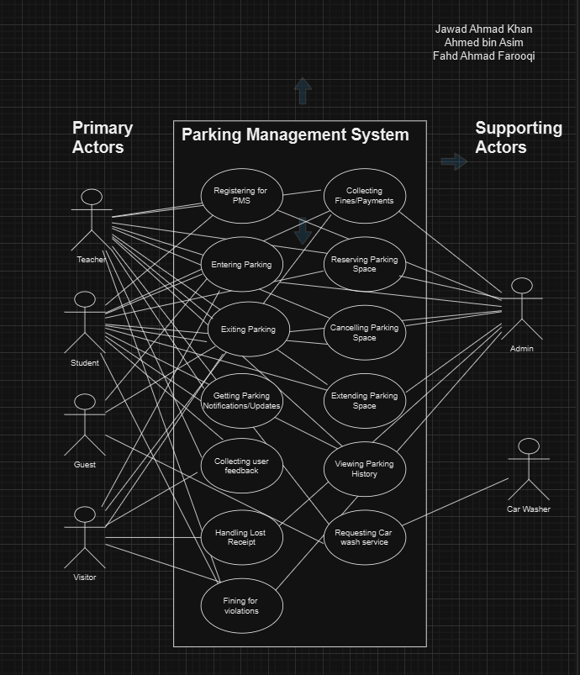
Use Case Diagram

Other Nonfunctional Requirements

Performance Requirements
The SpaceSync Parking Management System must meet several performance requirements to ensure optimal functionality under various conditions. Real-time occupancy tracking must update the status of parking spaces within 2-3 seconds to provide users with accurate and up-to-date information. The system should be able to handle up to 1,000 concurrent users, ensuring that reservations, traffic flow management, and payment processing functions do not experience delays during peak hours. Notifications for parking updates or reservation confirmations must be delivered to users within 5 seconds of an action being completed. Additionally, the system must process parking fines and payment transactions within 10 seconds, ensuring quick resolution for users. Traffic flow management should maintain smooth vehicle entry and exit, with minimal congestion, by optimizing real-time space allocation. These performance standards are essential to providing a seamless and efficient parking experience, minimizing user wait times, and ensuring the system can handle the expected volume of users during busy periods.

Safety Requirements
The SpaceSync Parking Management System must prioritize safety to prevent data loss, system failures, or user harm. User data, especially payment and personal information, must be protected with strong encryption, complying with GDPR or local data privacy laws. The system must ensure safe vehicle movement within the facility, with clear traffic paths and real-time occupancy updates to avoid directing users to occupied or unsafe spaces. Disabled parking spaces must be prioritized and protected from misuse.
To prevent software failures, regular system backups and alerts should be implemented, and in case of failure, administrators should be notified for quick resolution. Hardware components must be certified for safety (e.g., CE, UL), ensuring they meet public safety standards. Additionally, the system should provide clear user guidance and warnings to minimize accidents or damage to vehicles.

Security Requirements
The SpaceSync Parking Management System must protect user data with strong encryption (e.g., TLS) for secure transmission and storage, ensuring compliance with GDPR or local data privacy laws. User authentication must include multi-factor authentication (MFA) for secure account access, and RFID or mobile-based methods for secure entry and exit to the parking facility.
The system must prevent unauthorized access through regular security audits and meet relevant certifications like ISO 27001 for information security and PCI DSS for payment handling. Secure backups and transaction logs must be maintained to prevent data loss or corruption.

Software Quality Attributes
The SpaceSync Parking Management System must prioritize usability, ensuring an intuitive interface for both users and administrators, with a focus on ease of use over ease of learning. The system should be highly reliable, with 99.9% uptime to ensure continuous operation, especially during peak usage times. It must also be robust, able to handle a high volume of concurrent users (up to 1,000) without performance degradation. Interoperability is crucial, as the system must integrate seamlessly with existing campus infrastructure, including payment gateways and access control hardware. The software must be maintainable and adaptable, with modular components that can be updated or expanded without significant downtime. Additionally, portability is important, allowing the system to be accessed on multiple devices (PCs, smartphones, tablets) with consistent performance across all platforms. Testability should be built in from the beginning, ensuring that features are easily testable for quality assurance and future upgrades.

Business Rules
The SpaceSync Parking Management System operates with specific roles and permissions to ensure efficient functioning. Users (students, faculty, staff) can create accounts, reserve spaces, access real-time updates, and request services. Administrators manage the system, oversee parking allocations, handle user issues, and enforce fines for violations. Parking Enforcement Officers issue fines for rule breaches, while Maintenance Personnel ensure the system’s functionality through regular checks and security audits. Disabled users are given priority for accessible parking spaces. Only verified users can make payments, ensuring secure transactions and proper management of the parking facility.

Operating Environment
The SpaceSync Parking Management System will operate on a cloud-based platform, utilizing IoT sensors for real-time occupancy tracking and automated access control hardware (RFID or mobile-based). It will be compatible with modern web browsers and mobile operating systems, including iOS and Android. The system will integrate with the campus’s existing network infrastructure and payment gateways, ensuring seamless communication with external applications for payment processing and user authentication. The software will be built on a secure, scalable cloud environment, supporting the latest versions of Linux or Windows Server as the backend operating system. The system will also work with any external reporting tools or campus management systems as needed.

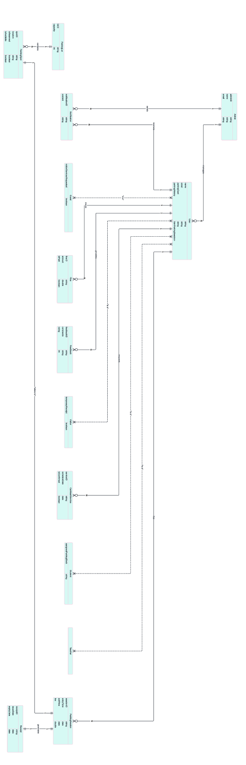
Domain Model

System Sequence Diagram
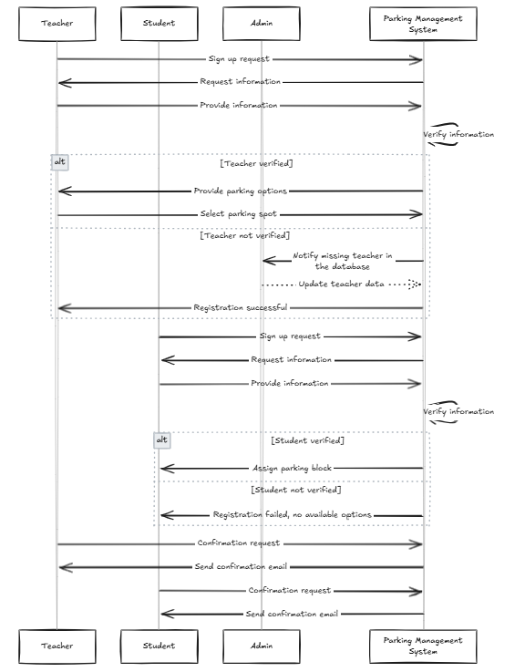
  - Registering for Parking Management System

  - Managing Parking
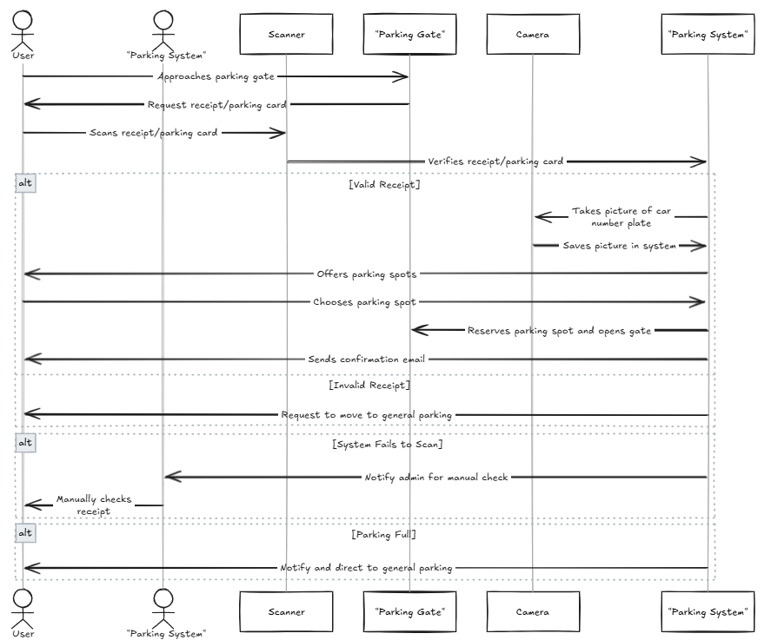

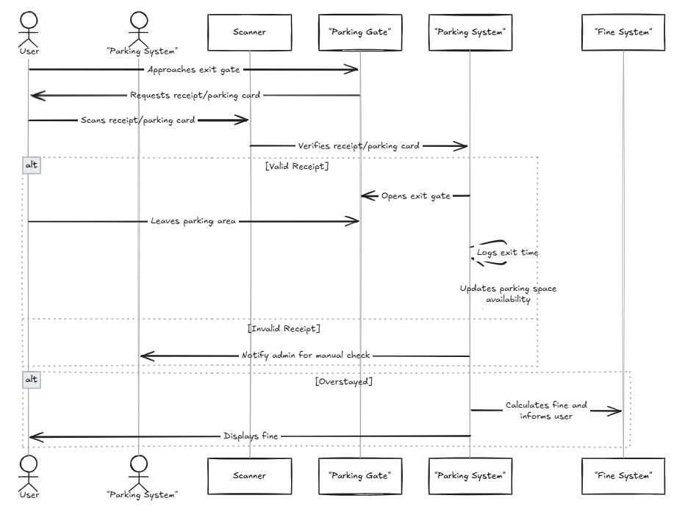
  - Getting Parking Notifications
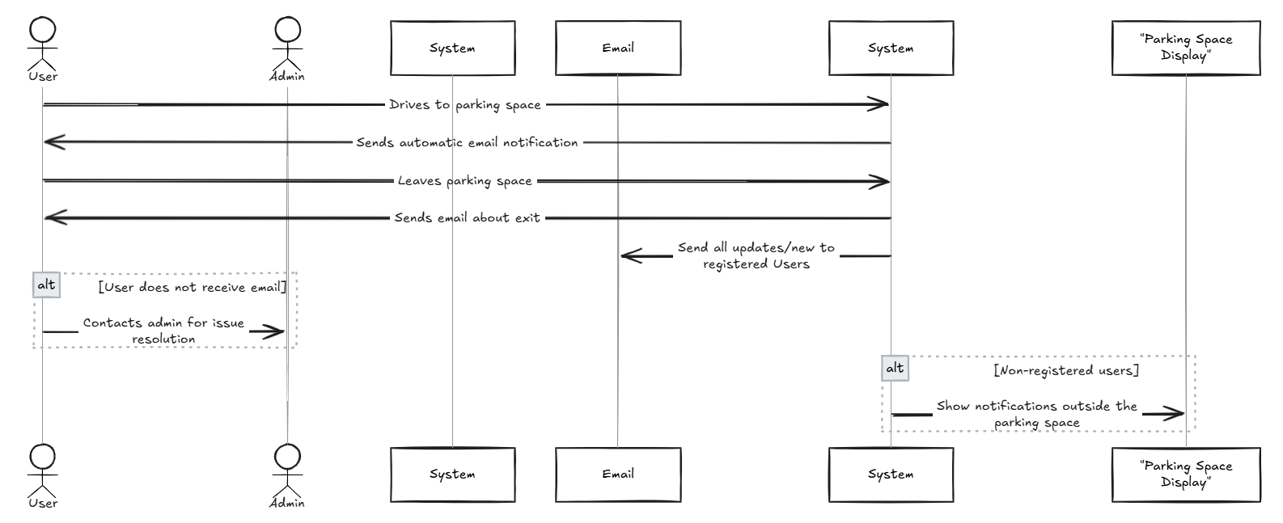

  - Collecting User Feedback
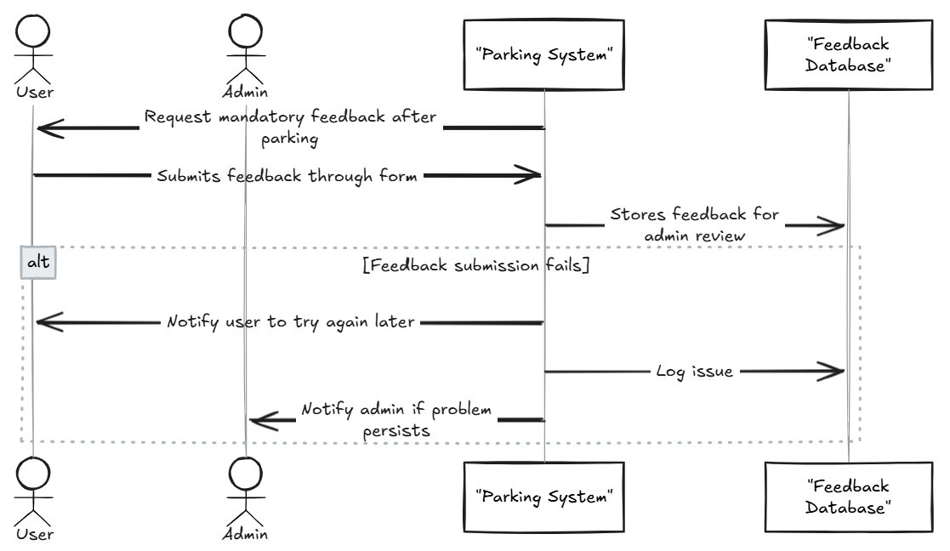
  - Handling Lost Receipt
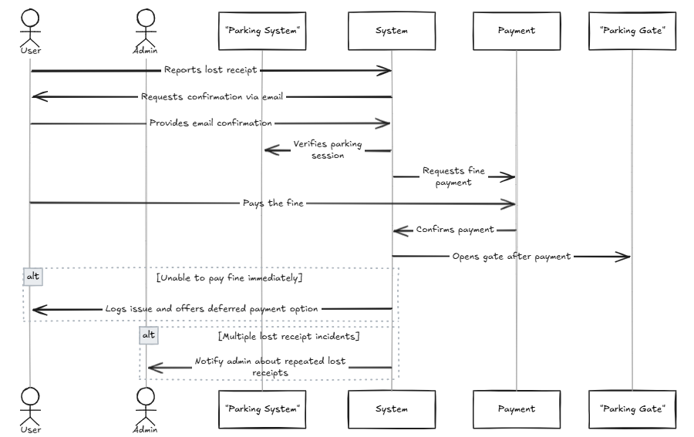

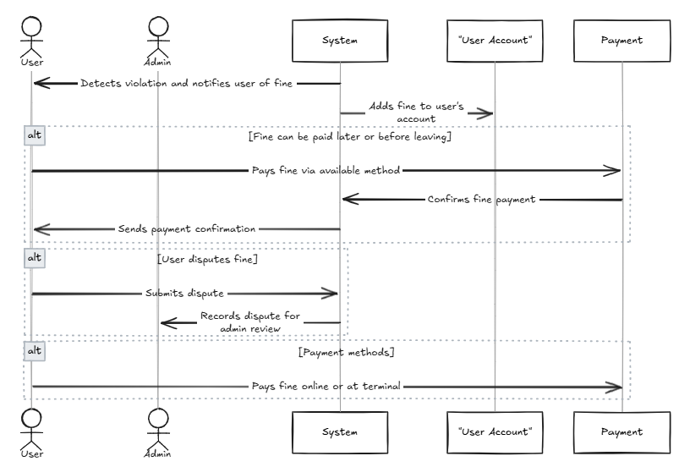
  - Fining for violation

  - Collecting Fines/payments
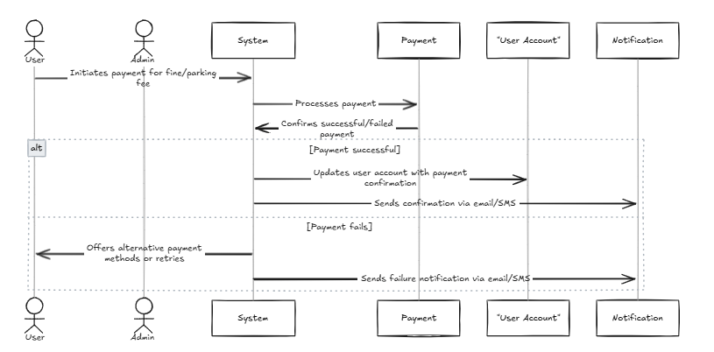
  - Reserving Parking Space

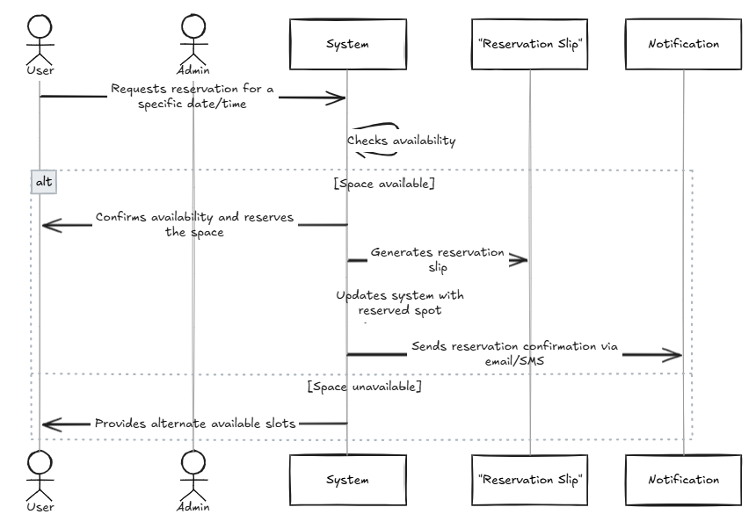
  - Cancelling Parking Space
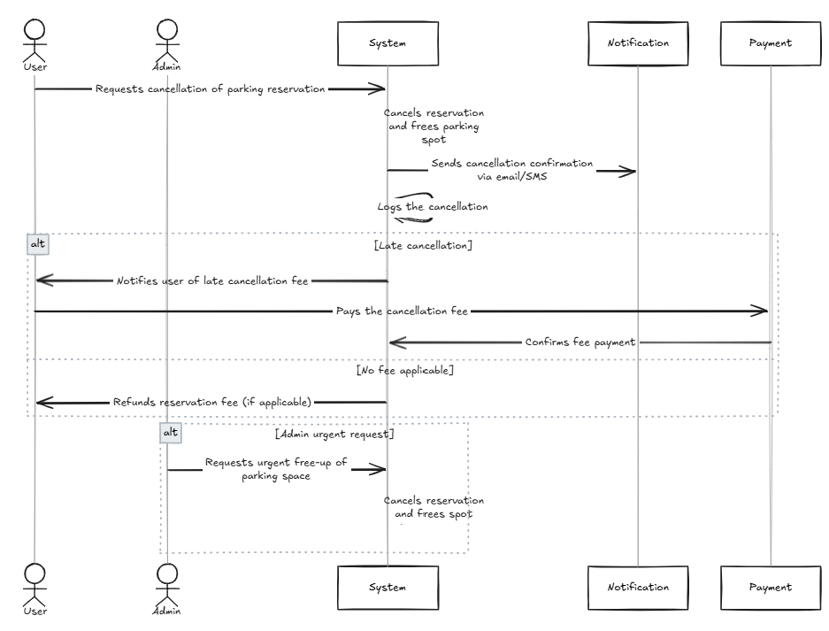

  - Extending Parking Space

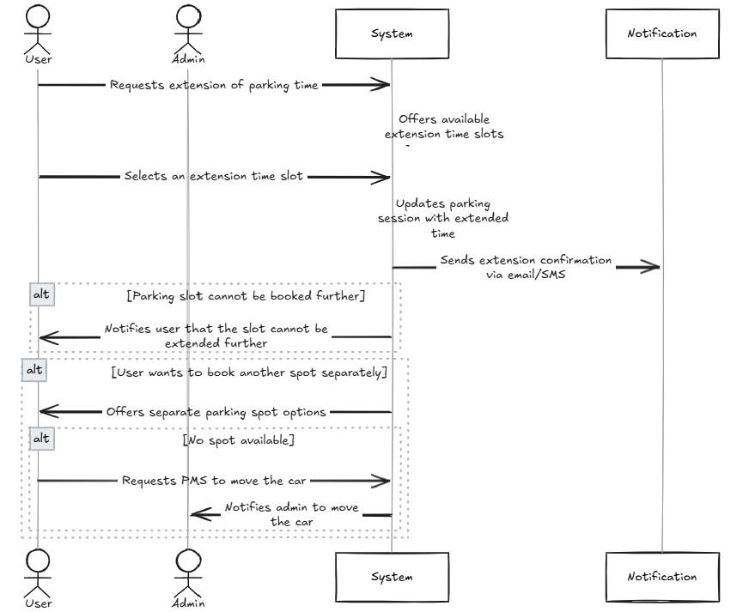

  - Viewing Parking History

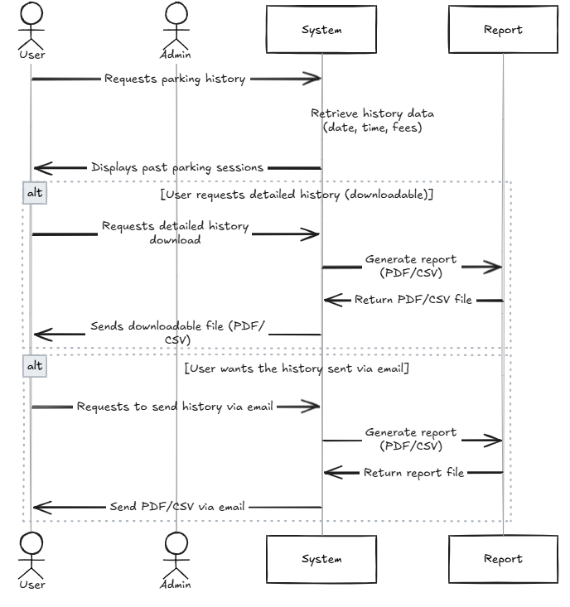
  - Requesting Car Wash Service

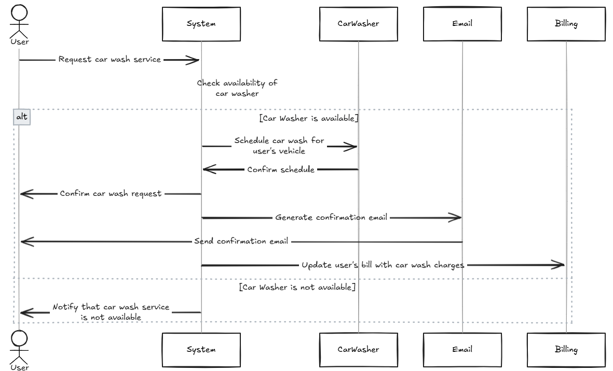

Sequence Diagram

  - Register for Parking Management System
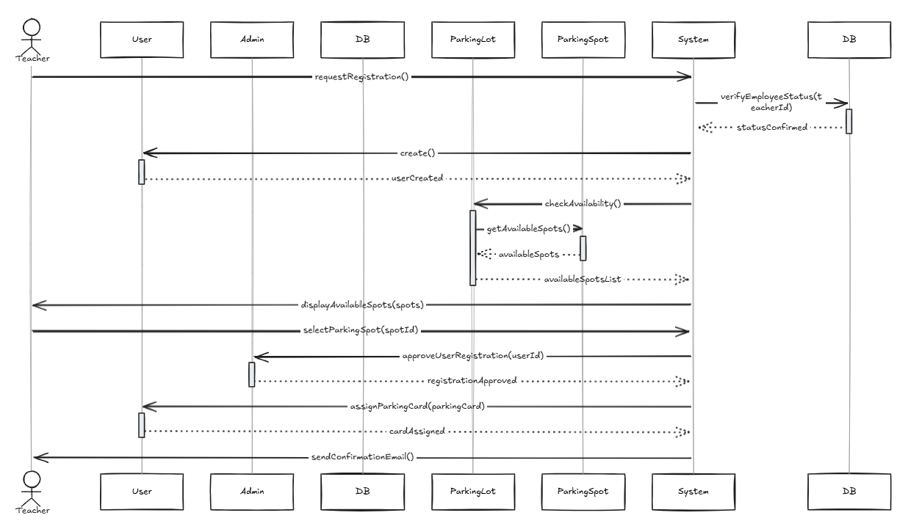

  - Entering Parking Space

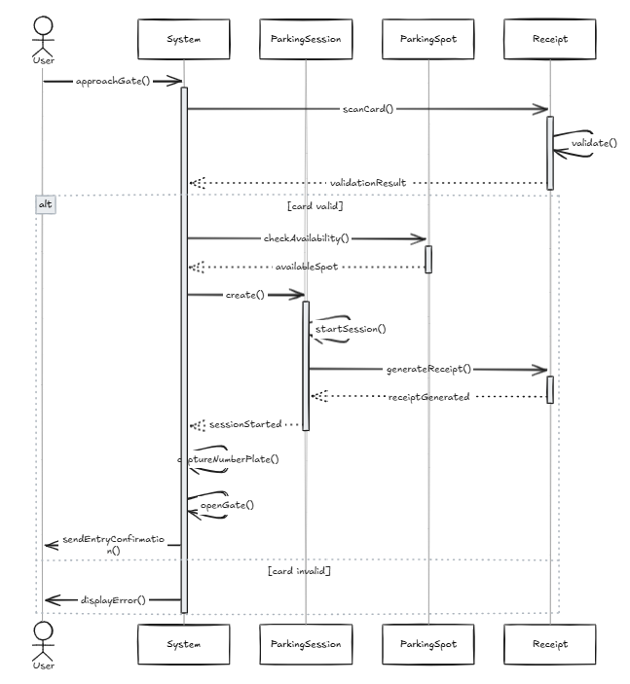
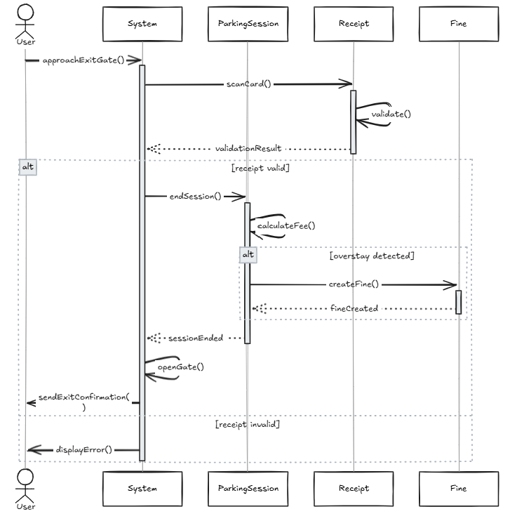
  - Exiting Parking Space
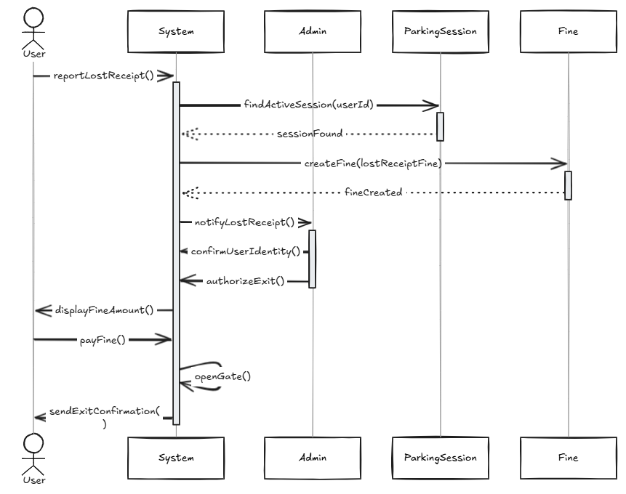

  - Handle lost receipt process

  - Reserve parking Space process
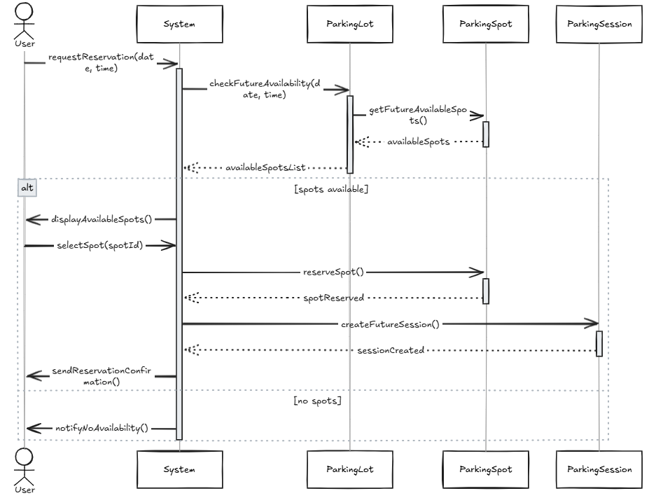
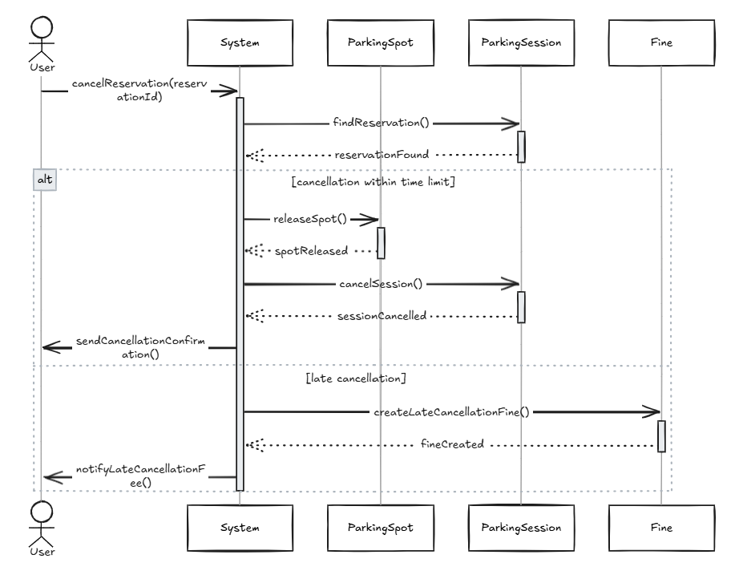
  - Cancel Parking Reservation Process
  - Extend Parking Duration

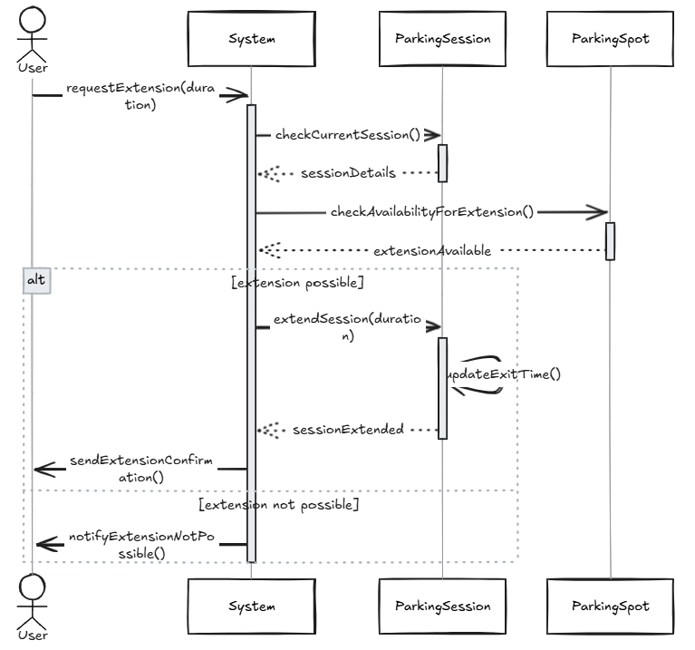
  - View parking history

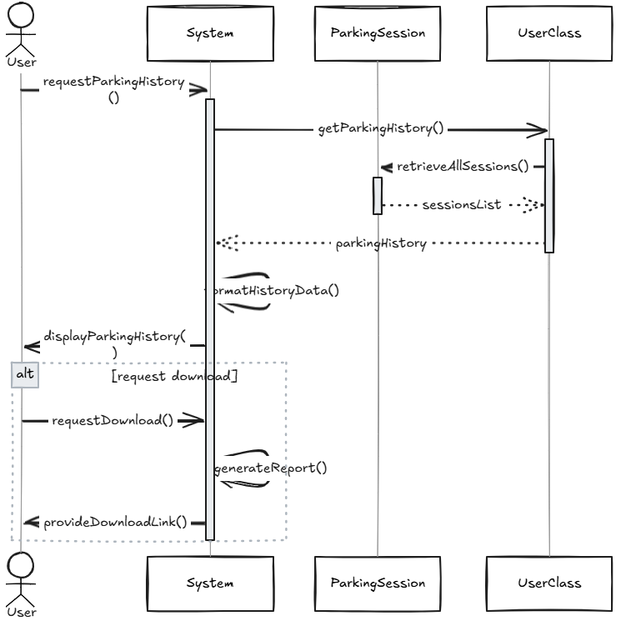
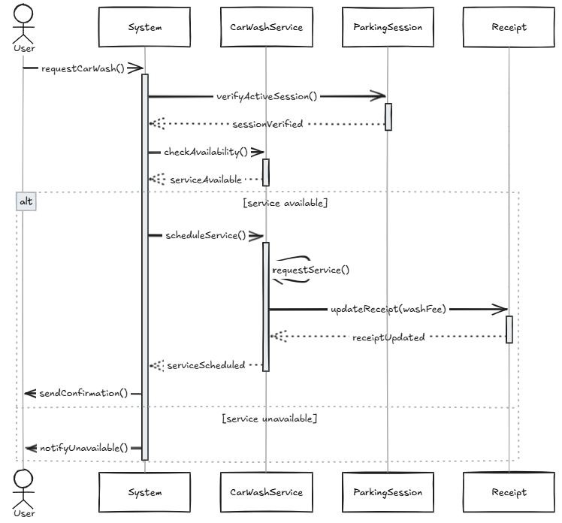
  - Request Car Wash

  - Collecting user feedback

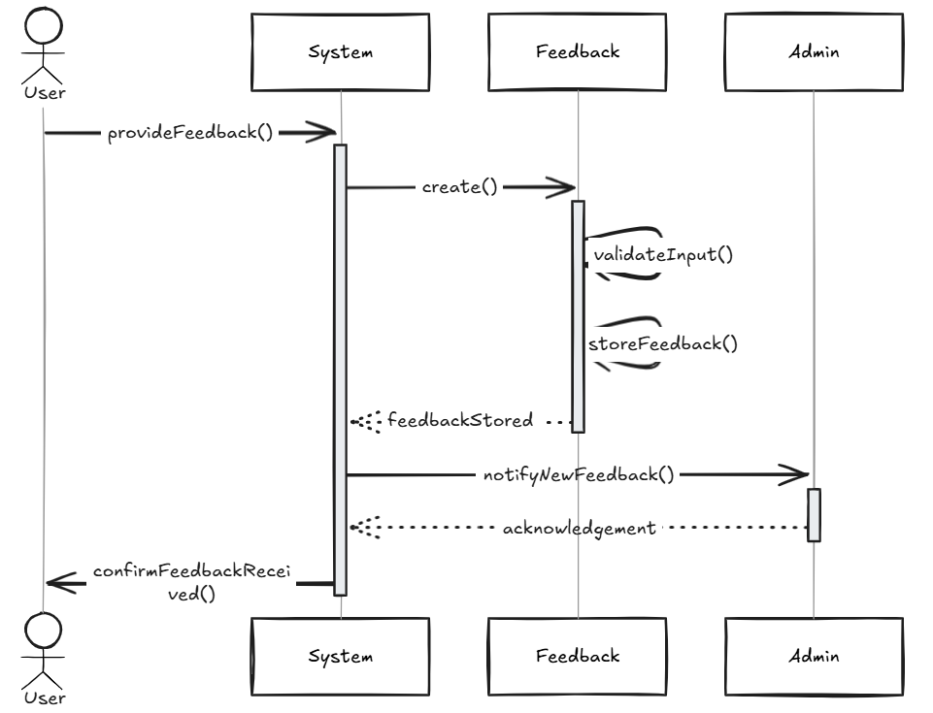

  - Handling Parking violations

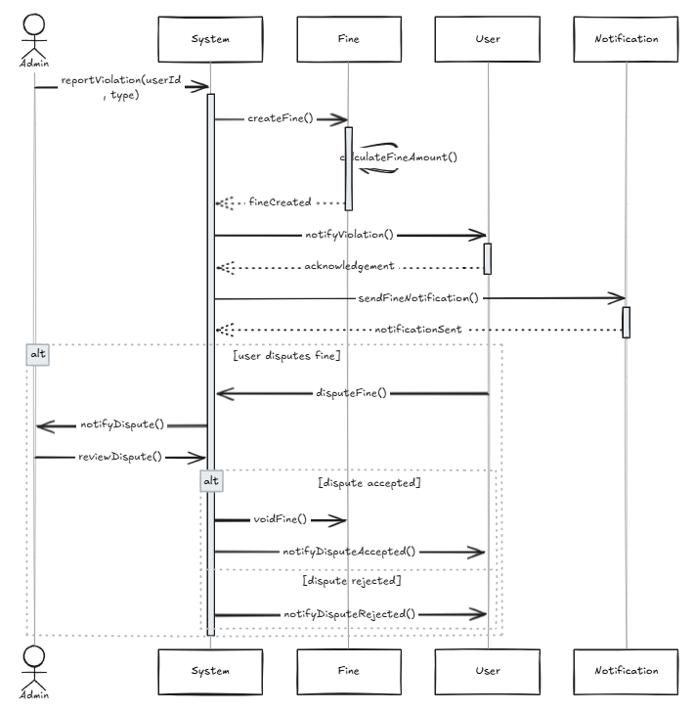

Class Diagram
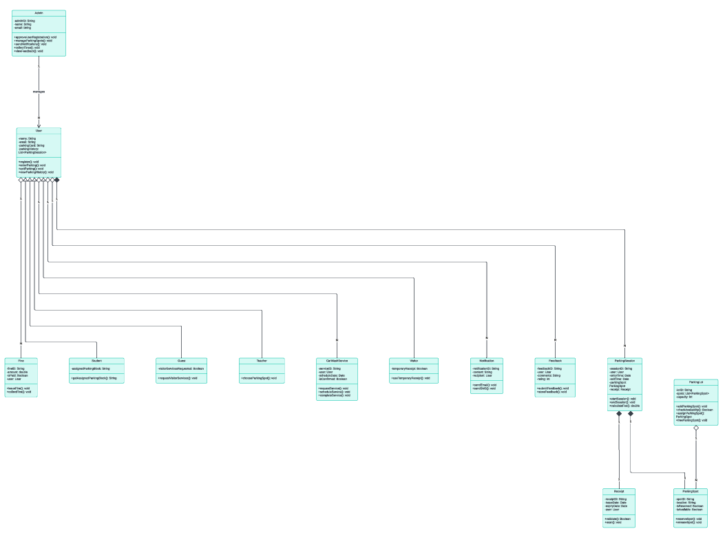

Packages Diagram
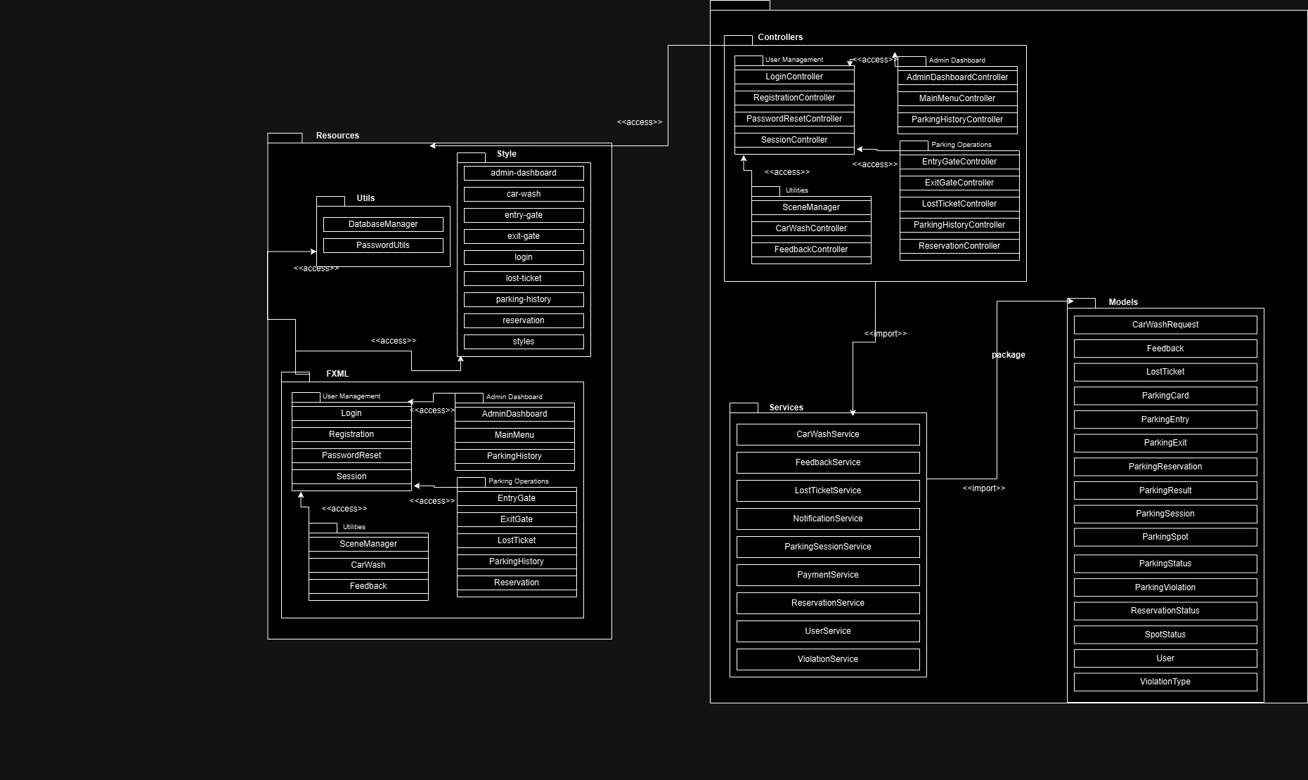

Component Diagram
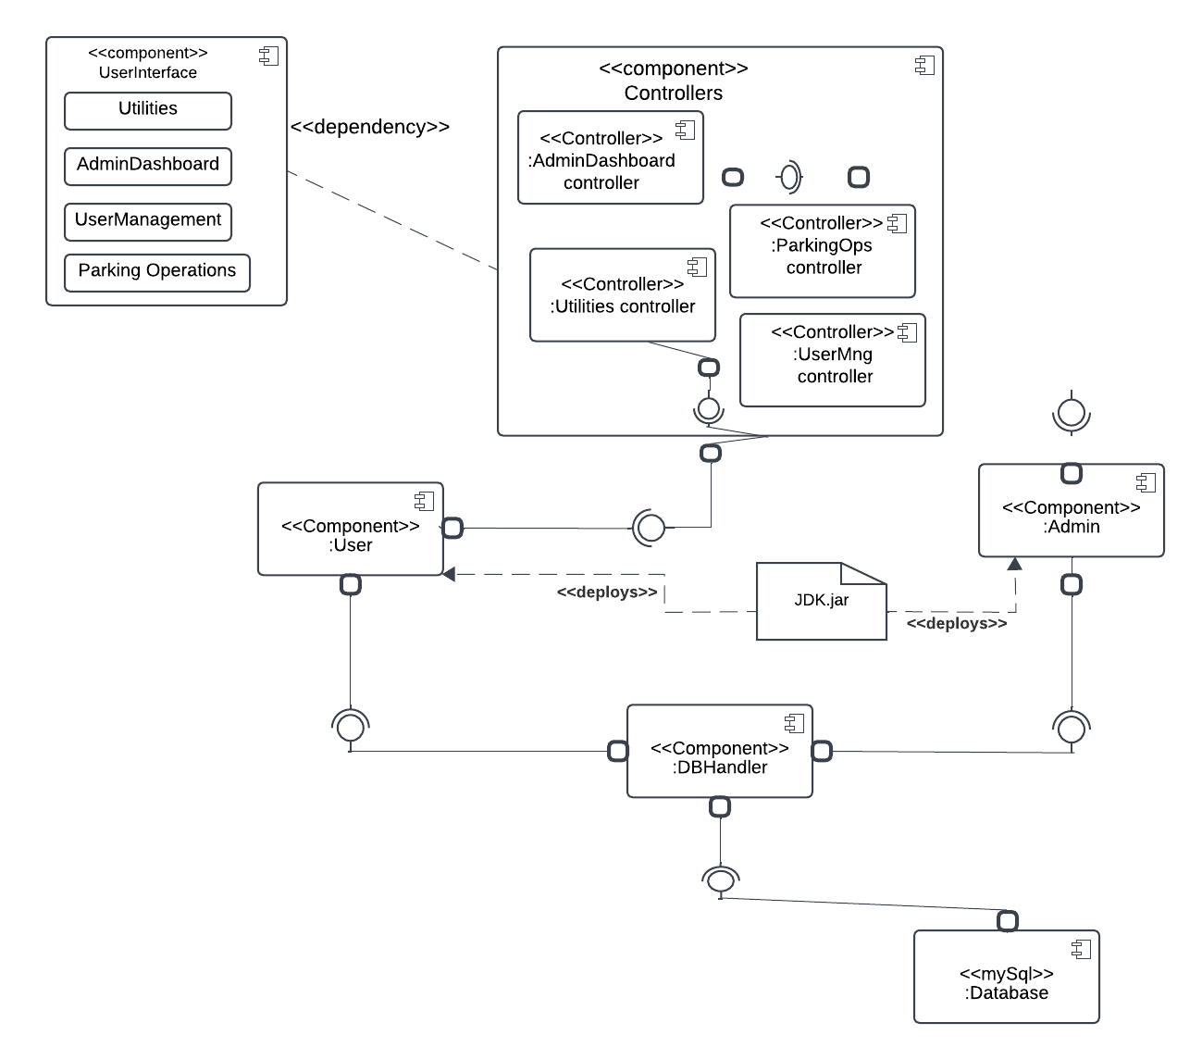

Deployment Diagram

