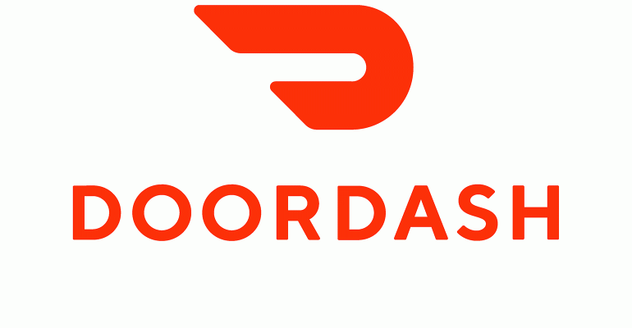

a DoorDash customer, hesitates to order his favorite Cake and coffee due to its huge service costs and tips that he has to pay extra. To address his valid concern, DoorDash has introduced automated dashers in the field and the rein of those dashers in the hands of operations team as an App. We, as a team, are excited to introduce the ‘Automated Dasher App’ to help many more customers in the San Francisco area.

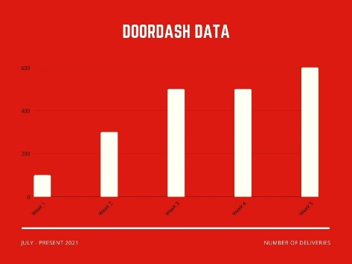The operations team within DoorDash will be equipped with this powerful tool soon. They could help the customers to track their food real time, track the exact location of robot, get the time of delivery, directions of the robots, etc. This is not just to read or track their status. They could also control those robots in the field to re-route them, to add a new job or to control its peripherals like unlocking the trunk. Operations team, being the face of our customers, must be equipped with the right tools at the right time to serve them better. ‘Automated Dasher App’ is exactly designed for this purpose which would be an all-in-one product for the operations team.

Results are great. the reviews are impressive and encouraging. Additionally, we ran multiple field tests with robots to deliver the food and collected user feedback.

And in the figure data about number of deliveries increases week by week.

We are going to add many more features based on our customer feedback and we are looking forward to launch it in all US markets soon!

This launch would not be possible without our fantastic team.

Ahmed Abdelnasser,

Product Manager of Automated Dasher

on behalf of and list all your team member