User Guide

## Background:

Over the years, there has been an increase in the usage of service robots for many domestic and industrial needs. They are deployed in a wide variety of applications ranging from simple household to a complicated medical environment. Service robots powered with artificial intelligence, using computer vision and deep learning, have also entered into logistics and delivery services, where they can make nearly human-level intelligent decisions. This creates a greater opportunity for companies to automate their operations to a great extent.

Small deliveries have always been a pain area for DoorDash due to its higher operating costs and low returns. This is also a problem for human dashers who would not get a fair tip for their service and also for the customers who hesitates to make small orders from restaurants. These problems exist for the competitors as well, but we would be in the upfront if we start focusing on this segment now. We could convert this problem into an opportunity by automating the delivery process using service robots instead of human dashers. We assume that there could be lots of potential interests from customers to make small orders if they don’t get the feel of being judged and to exchange this feeling and prove that we care about you even you need a small order. A service robot meant mainly for small deliveries would give them the comfort that they need and this would reduce the delivery and service charges from their total amount. Small deliveries here mean, an order with just one or two inexpensive items, like for example, an order with just a dessert or a snack. From the company’s perspective, the operating costs of service robots would be insignificant compared to human dashers. This allows Human dashers also to focus on bigger and long-distance delivery orders which has a potential for a better tip for their service.

Finally, the idea is to fully automate the food delivery using robots, initially we might have to intervene and offer our manual service to support the customers and also to track and control the robot in case of issues.

## Details:

**Key Features** this app offers the operators are:

1. An operator can just enter the customer’s registered email ID or phone number or order number to retrieve the status of the active order of a customer and he can also track the food or the robot that is delivering the food real time.
2. The operator can get the current address where the robot is moving and also gets to see the actual position in a map view.
3. The operator can know the estimated time that the robot takes to deliver the food to the customer.
4. The operator can manually control the robot remotely like changing the route.
5. The operator can know the status of the robot and can assign a new order or schedule order.

**Features Screens:**

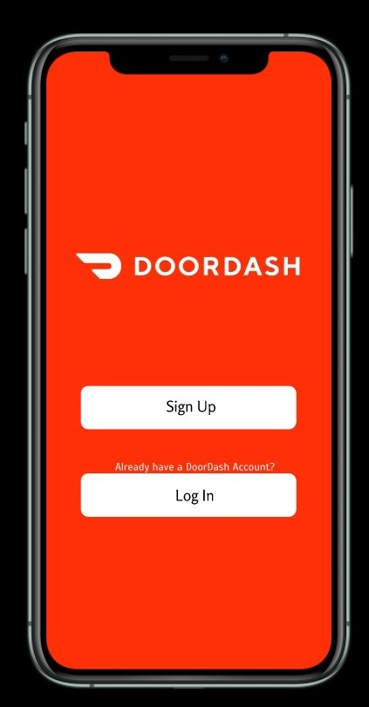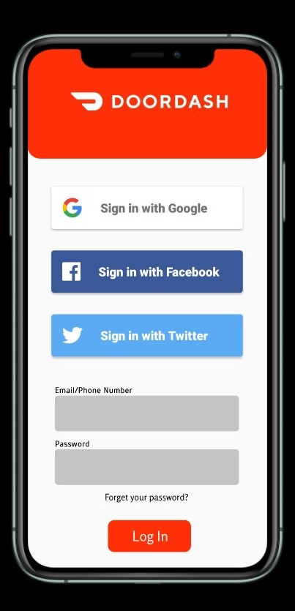

**Sign in:** Open the app and you will see the sign-in screen of the app, Also the operator can sign in with Google, Facebook and Twitter.

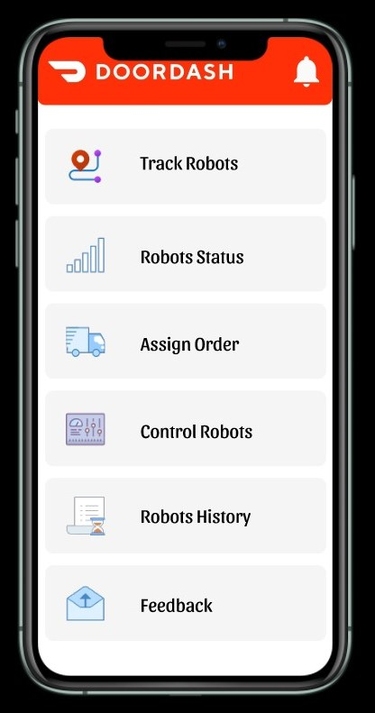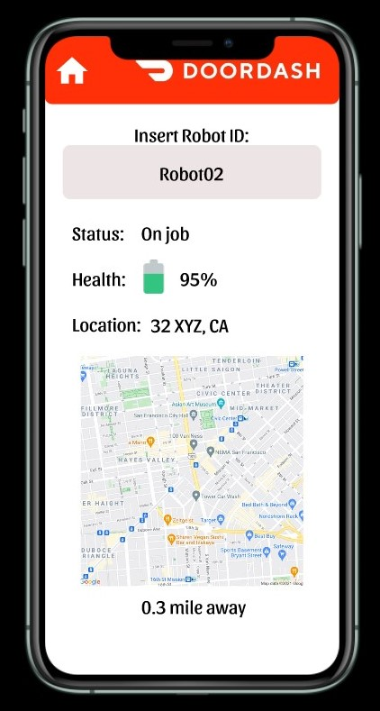

**Track Robot:** Once you login, the main screen shows all options available for operators you can choose Track Robots to see the status, Health and Location by only insert robot ID or Order ID.

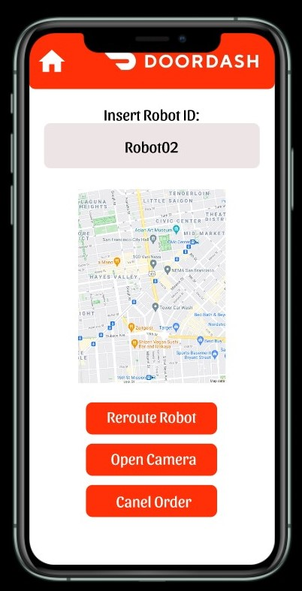

**Control Robot:** Once you login, the main screen shows all options available for operators you can choose Control Robot and you can see the robot location and can reroute the robot, open camera and cancel order.