***Comparison between hierarchical clustering***

***And k-medoids in graph***

We notice from both graphs as we go max of top or max of bottom that data become more spread.

Also, as data become less spread so most of data concentrate at that point as 180,190 and so on

In hierarchical clustering graph:

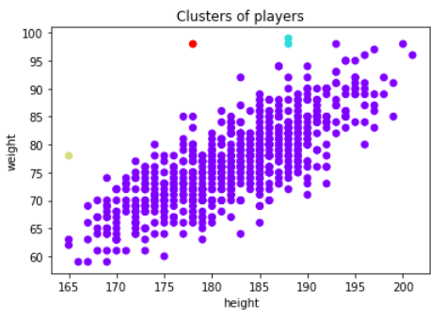

We noticed that the data in:

Red cluster=1

Yellow cluster=1

Light blue cluster=2

Purple= 363

In k-medoids graph:

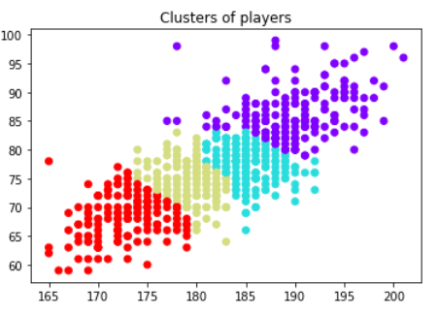

We noticed that data in:

Red cluster=100

Yellow cluster=75

Light blue cluster=82

Purple cluster=110