

Etat finale A= p ep-fermutre(p)=(p,q,r)

Transition (p,q,r),a = p A

Transition (p,q,r),b= q B

Transition (p,q,r),c = r C etat finale

Eta finale B= q ep-fermutre(q)=(q,r)

Transition (q,r),a = -

Transition (q,r),b= q B

Transition (q,r),c = r C

C= r ep-fermutre(r)=(r )

Transition (r),a = -

Transition (r),b= -

Transition (r),c = c C

R.T.T

|  |  |  |  |
| --- | --- | --- | --- |
|  | a | b | c |
| A | A | B | C |
| B | - | B | C |
| C | - | - | C |

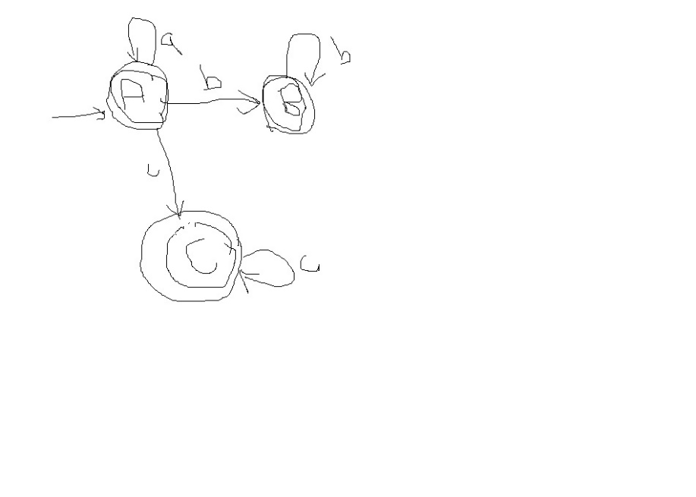



A = { 0 }, ep fermeture {0 } = {0,1,2 }

Transition { (0,1,2) ,a } = {4 } =B

Transition { (0,1,2) ,b } = { 3} = C

B = {4 }, ep fermeture { 2,4} = {2,4 }

Transition { ( 2,4) , a} = {4 } = B

Transition { ( 2,4) ,b } = { 3,5} = D (état final)

C = { 3}, ep fermeture { 1,3} = {1,3 }

Transition { ( 1,3) , a } = {5,4 }= E (état final)

Transition { ( 1,3) ,b } = {3 }= C

D = {3,5 }, ep fermeture {3,5 } = { 3,5 ,1}

Transition { 3,5 ,1)a } = 4,5 E

Transition { ( 3,5 ,1) , b} = {3 } = C

E= { 5,4}, ep fermeture { 5,4} = {5,4,2 }

Transition { ( 5,4,2) , a } = { 4} = B

Transition { ( 5,4,2) , b} = { 3,5} = D

R.T.T

|  |  |  |
| --- | --- | --- |
|  | a | b |
| A | B | C |
| B | B | D |
| C | E | C |
| D (état final) | E | C |
| E(état final) | B | D |



