Cairo University Dated:{issue_date}

Faculty of Computer and Artificial Intelligence

Graduates Affair

2009/2010

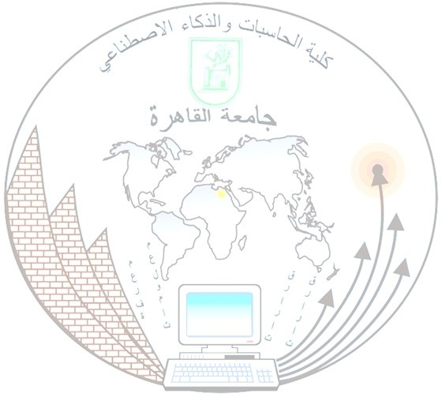**Verification Letter**

To Whom It May Concern:

The Faculty of Computers and Artificial Intelligence – Cairo University certifies that:

Student/ {Name} Student ID/ {GraduateId}

Nationality: {Nationality} Born in: {Nationality}

Year: {year} Graduated in: {EndDate} Date Birth:{BirthDate}

And obtained a bachelor’s degree in computers and information

Major: {Department} Minor: {minor}

This certificate has been issued upon his/her request, noting that the Faculty Council approved the result on {issue_date}, and the result is currently being approved by the University Council.

Competent employee Reviewer Director Graduates Affairs

Dean of the Faculty

( )

* The name of the College of Computers and Information has been changed to the College of Computers and Artificial Intelligence by Prime Ministerial Resolution No. (1442) of 2019 amending some provisions of the Executive Regulations of the Universities Regulation Law.