ﺗﺤﺮﻳﺮﺍ ﻓﻲ / ---- / -------

# ﺇﻓـــــــــــﺎﺩﺓ

ﺟﺎﻣﻌﺔ ﺍﻟﻘﺎﻫﺮﺓ ﻛﻠﻴﺔ ﺍﻟﺤﺎﺳﺒﺎﺕ ﻭﺍﻟﺬﻛﺎﺀ ﺍﻻﺻﻄﻨﺎﻋﻲ

ﺍﺩﺍﺭﺓ ﺷﺌﻮﻥ ﺍﻟﺨﺮﻳﺠﻴﻦ

# 2010 / 2009

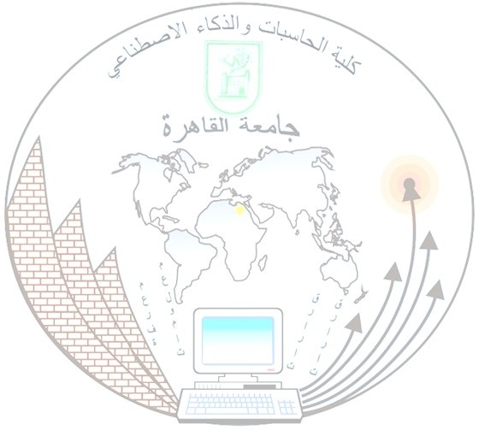

ﺇﻟﻰ ﻣﻦ ﻳﻬﻤﻪ ﺍﻷﻣﺮ :

ﺗﻔﻴﺪ ﻛﻠﻴﺔ ﺍﻟﺤﺎﺳﺒﺎﺕ ﻭﺍﻟﺬﻛﺎﺀ ﺍﻻﺻﻄﻨﺎﻋﻲ* – ﺟﺎﻣﻌﺔ ﺍﻟﻘﺎﻫﺮﺓ ﺑﺄﻥ :

ﺭﻗﻢ ﺍﻟﻄﺎﻟﺐ /

ﻣﺤﻞ ﺍﻟﻤﻴﻼﺩ :

ﺍﻟﻄﺎﻟﺐ /

ﺍﻟﺠﻨﺴﻴﺔ :

ﺗﺎﺭﻳﺦ ﺍﻟﻤﻴﻼﺩ

ﺧﺮﻳﺞ ﺩﻭﺭ :

: ﻋﺎﻡ

ﺗﺨﺼﺺ ﻓﺮﻋﻰ :

ﻭﺣﺼﻞ ﻋﻠﻰ ﺩﺭﺟﺔ ﺍﻟﺒﻜﺎﻟﻮﺭﻳﻮﺱ ﻓﻰ ﺍﻟﺤﺎﺳﺒﺎﺕ ﻭﺍﻟﻤﻌﻠﻮﻣﺎﺕ

ﺗﺨﺼﺺ ﺭﺋﻴﺴﻰ :

ﻭﻗﺪ ﺗﺤﺮﺭﺕ ﻫﺬﺍ ﺍﻻﻓﺎﺩﺓ ﺑﻨﺎﺀ ﻋﻠﻰ ﻃﻠﺒﻬﺎ ﻋﻠﻤﺎ ﺑﺄﻥ ﻣﺠﻠﺲ ﺍﻟﻜﻠﻴﺔ ﻗﺪ ﺃﻋﺘﻤﺪ ﺍﻟﻨﺘﻴﺠﺔ ﺑﺘﺎﺭﻳﺦ 31/7/2010 ﻭﺟﺎﺭﻱ

# ﺃﻋﺘﻤﺎﺩ ﺍﻟﻨﺘﻴﺠﺔ ﻣﻦ ﻣﺠﻠﺲ ﺍﻟﺠﺎﻣﻌﺔ.

ﻣﺪﻳﺮ ﺷﺌﻮﻥ ﺍﻟﺘﺨﺮﺝ

ﻋﻤﻴـــــﺪ ﺍﻟﻜﻠﻴــــــﺔ ) (

ﺍﻟﻤﺮﺍﺟﻊ

ﺍﻟﻤﻮﻇﻒ ﺍﻟﻤﺨﺘﺺ

* ﺗﻢ ﺗﻌﺪﻳﻞ ﻣﺴﻤﻰ ﻛﻠﻴﺔ ﺍﻟﺤﺎﺳﺒﺎﺕ ﻭﺍﻟﻤﻌﻠﻮﻣﺎﺕ ﺇﻟﻰ ﻛﻠﻴﺔ ﺍﻟﺤﺎﺳﺒﺎﺕ ﻭﺍﻟﺬﻛﺎﺀ ﺍﻻﺻﻄﻨﺎﻋﻲ ﺑﻘﺮﺍﺭ ﺭﺋﻴﺲ ﻣﺠﻠﺲ ﺍﻟﻮﺯﺍﺭﺀ ﺭﻗﻢ (1442) ﻟﺴﻨﺔ 2019 ﺑﺘﻌﺪﻳﻞ ﺑﻌﺾ

ﺍﺣﻜﺎﻡ ﺍﻟﻼﺋﺤﺔ ﺍﻟﺘﻨﻔﻴﺬﻳﺔ ﻟﻘﺎﻧﻮﻥ ﺗﻨﻈﻴﻢ ﺍﻟﺠﺎﻣﻌﺎﺕ