Ball Component – Documentation

Role in the Game
The ball is the central dynamic object in the Ping Pong game. It continuously moves across the screen, bouncing off the top and bottom borders and interacting with the paddles. When it passes beyond a paddle, it results in a score for the opposing player. The ball’s behavior is critical for maintaining game flow and determining the winner.

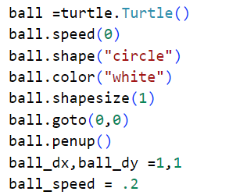
The Code

Explanation of the Code
Code Line | Description
ball = turtle.Turtle() | Creates a turtle object to represent the ball.
ball.speed(0) | Sets the drawing speed to the fastest (no animation delay).
ball.shape("circle") | Sets the shape of the ball to a circle.
ball.color("white") | Sets the ball’s color to white for clear visibility.
ball.shapesize(stretch_len=1, stretch_wid=1) | Keeps the ball at the default size (20x20 pixels).
ball.goto(x=0, y=0) | Places the ball at the center of the screen to start.
ball.penup() | Prevents the ball from drawing lines as it moves.
ball_dx, ball_dy = 1, 1 | Sets the initial direction for horizontal and vertical movement.
ball_speed = 0.2 | Controls the overall speed of the ball.

Ball Movement Logic
Inside the main game loop, the ball updates its position on each frame using the following code:
ball.setx(ball.xcor() + (ball_dx * ball_speed))
ball.sety(ball.ycor() + (ball_dy * ball_speed))
This allows the ball to move smoothly in both the horizontal and vertical directions, determined by its speed and directional variables.

Summary
The ball is a vital component of the Ping Pong game. It maintains interactivity and challenge by:
• Constantly moving across the screen.
• Bouncing off the top and bottom borders.
• Reacting to collisions with paddles.
• Triggering scores when a player misses the ball.
This implementation ensures that the gameplay remains fluid, competitive, and visually dynamic.

