Player 1 & Player 2 Setup
This part explains the setup and configuration of Player 1 and Player 2 in the project using the turtle graphics module. Each player is represented as a rectangular paddle, suitable for the game.

Player 1 Configuration
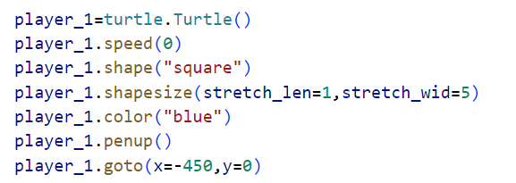
Code:

Explanation:
- Initializes a turtle object named “player_1” .
- Sets the speed to the fastest for instant rendering.
- Defines the shape as a square
- stretches it to create a rectangular paddle.
- Assigns a blue color to distinguish Player 1.
- Disables drawing while moving the turtle.
- Positions the paddle on the left side of the screen at coordinates (-450, 0).

Player 2 Configuration
2nd Player configuration is the same as the 1st player but with changing the attributes from “Player 1” to “Player 2” , different color “red” and different position on the screen (450, 0).

Players Visualization

Summary
Attribute | Player 1 | Player 2
Shape | Square (stretched) | Square (stretched)
Color | Blue | Red
Position | Left (-450, 0) | Right (450, 0)
Size | 1x5 (vertical paddle) | 1x5 (vertical paddle)
Speed | Fast (0) | Fast (0)

