**Task 04 (Different Plots/Graphs)**

1. **Histogram**

A histogram is a graphical representation of the distribution of numerical data. It uses bars to display the frequency of data points falling within specific ranges or "bins". Essentially, it provides a visual summary of the data's distribution, showing how often different values occur.

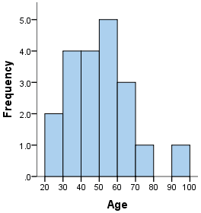 [src](https://statistics.laerd.com/statistical-guides/understanding-histograms.php)

1. **Stem & Leaf**

A stem-and-leaf plot is a way to organize and visualize numerical data, similar to a histogram. It splits each data point into two parts: a "stem" (usually the leading digit(s)) and a "leaf" (typically the last digit). This display allows for easy identification of data distribution, central tendency, and variability.

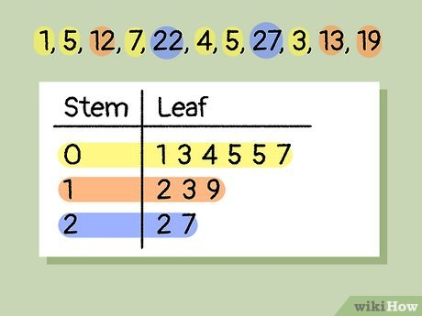 [src](https://www.wikihow.com/Read-a-Stem-and-Leaf-Plot)

**3 – Box Plot**

A box plot, also known as a box-and-whisker plot, is a standardized way of displaying the distribution of data based on a five-number summary: minimum, first quartile, median, third quartile, and maximum. It visually represents the spread and skew of data, and can be used to identify outliers

[src](https://www.simplypsychology.org/boxplots.html)

**4 – Dot Plot**

A dot plot is a simple form of data visualization that consists of data points plotted as dots on a graph with an x- and y-axis. These types of charts are used to graphically depict certain data trends or groupings.

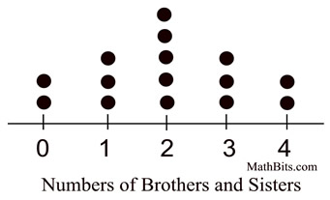 [src](https://mathbitsnotebook.com/Algebra1/StatisticsData/STdotplot.html)

**5 – Pie Chart**

A pie chart is a graphical representation technique that displays data in a circular-shaped graph. It is a composite static chart that works best with few variables. Pie charts are often used to represent sample data—with data points belonging to a combination of different categories.

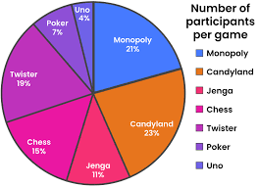 [src](https://www.houseofmath.com/encyclopedia/statistics-and-probability/statistics/charts/what-does-pie-chart-mean)

**6 – Bar Chart**

A bar chart is used when you want to show a distribution of data points or perform a comparison of metric values across different subgroups of your data. From a bar chart, we can see which groups are highest or most common, and how other groups compare against the others.

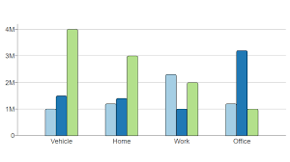 [src](https://www.google.com/imgres?q=Bar%20Chart&imgurl=https%3A%2F%2Fwww.cdc.gov%2Fcove%2Fmedia%2Fimages%2F2024%2F09%2FBar-Chart-01.png&imgrefurl=https%3A%2F%2Fwww.cdc.gov%2Fcove%2Fdata-visualization-types%2Fbar-chart.html&docid=tgUiZ_2SsnfahM&tbnid=1jK8MNzFEVymmM&vet=12ahUKEwjp1Lvb8uOOAxWsXUEAHXvDGH0QM3oECBEQAA..i&w=2048&h=1152&hcb=2&ved=2ahUKEwjp1Lvb8uOOAxWsXUEAHXvDGH0QM3oECBEQAA)

**7 – Symmetry & Skewness**

Symmetry and skewness are statistical concepts that describe the shape of a data distribution. A symmetric distribution is balanced, meaning it looks the same on both sides of the center. A skewed distribution, in contrast, is asymmetrical, with a tail extending longer on one side than the other.

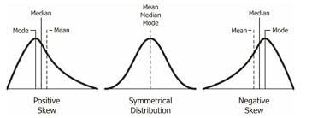 [src](https://itfeature.com/statistics/skew-kurt/measures-of-skewness/)

**8 – Heatmap**

A heatmap depicts values for a main variable of interest across two axis variables as a grid of colored squares. The axis variables are divided into ranges like a bar chart or histogram, and each cell's color indicates the value of the main variable in the corresponding cell range.

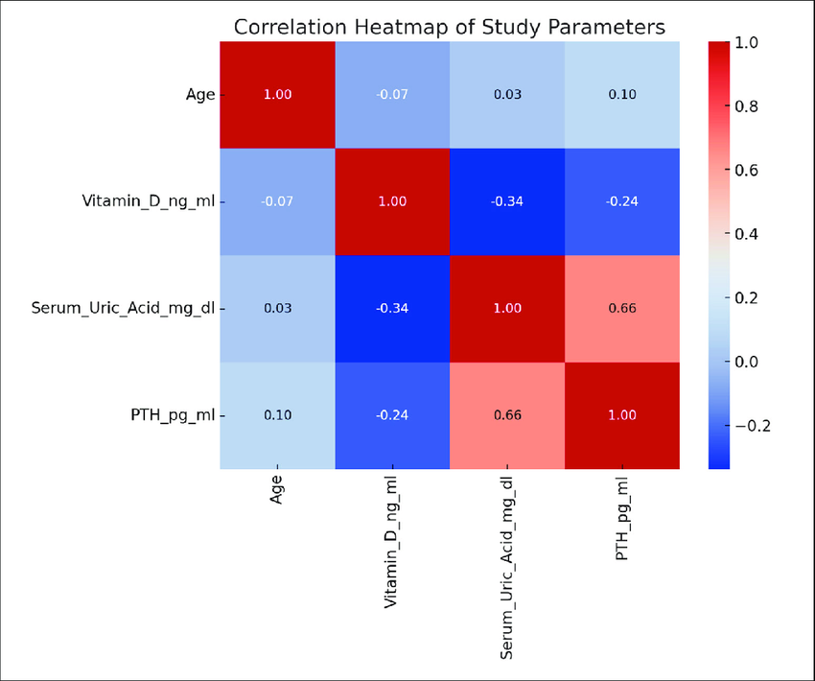 [src](https://www.researchgate.net/figure/Correlation-heat-map-The-heatmap-provides-a-visual-representation-of-the-Pearson_fig2_380663652)

**9 – Violin Plot**

A violin plot is a statistical chart used to visualize the distribution of numerical data, combining features of a box plot and a kernel density plot. It displays the data's median, quartiles, and the density of the data at different values, providing a more comprehensive view of the distribution than a simple box plot.

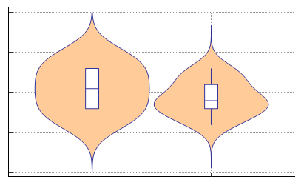 [src](https://www.medcalc.org/manual/violinplot.php)

By: Ahmed Diab