**Name** /Ahmed Ehab Hamed Tolba

**B.N** /40

**Date** /5/6/2021

**Topic** /Covid19

***Application brief*** /Ichose Covid 19 because it is a global epidemic that occupies the whole world, and it is one of the important issues that concern everyone who is interested in it, whether they are specialists in the field of medicine, engineering or any other field.

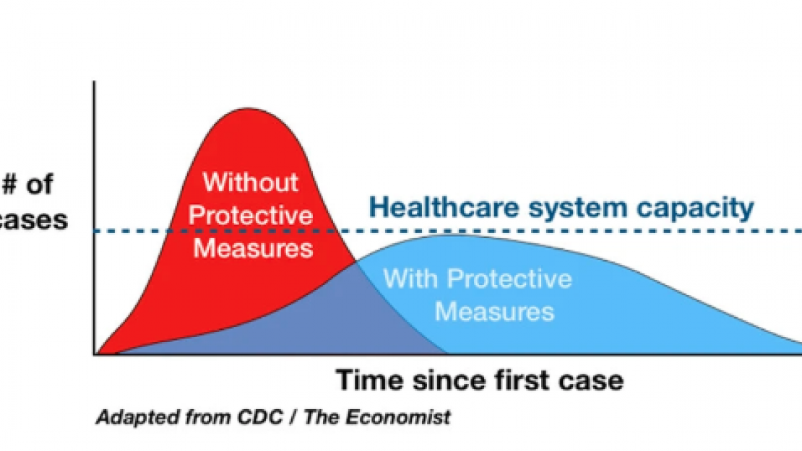

**The Main Topic**

1. **What are some ways engineers are playing a role in responding to the pandemic?**
2. **What are some specific innovations that engineers are bringing to the response effort?**
3. **In light of what we’ve learned so far, are there ways engineering can help us prepare for the next pandemic?**
4. **How is the NAE contributing to the pandemic response?**

**<html>**

**<img src="https://theforum.erf.org.eg/app/uploads/2020/03/1584990581_946_118839_corona4930541_1920.jpg"width="70%/>**

**<head>**

**<title>Engineering a Response to the COVID-19 Pandemic</title>**

**</head>**

**<body>**

**<body bgcolor="#DCDCDC">**

**<h1>Engineering a Response to the COVID-19 Pandemic</h1><hr></hr>**

**<h2>The Main Topics</h2>**

**<pre>**

**<ol type="1">**

**<li><a href="E:\Ahmed\computer\html\Topic1.html"target="blank">What are some ways engineers are playing a role in responding to the pandemic?</a></li>**

**<li><a href="E:\Ahmed\computer\html\Topic2.html"target="blank">What are some specific innovations that engineers are bringing to the response effort?</a></li>**

**<li><a href=E:\Ahmed\computer\html/"target="blank">In light of what we’ve learned so far, are there ways engineering can help us prepare for the next pandemic?</a></li>**

**<li><a href="E:\Ahmed\computer\html\Topic4.html"target="blank"> How is the NAE contributing to the pandemic response?</a></li>**

**<li><a href="http://nas.edu/legal/privacy/index.html/"target="blank">To More Information</a> </li>**

**</body>**

**</html>**