📌 Project Documentation
Wi-Fi Fingerprinting Indoor Localization using RSSI + KNN
1. Project Overview
This project implements an Indoor Localization System based on Wi-Fi Fingerprinting using the RSSI signal strength collected from nearby Wi-Fi Access Points.
The system estimates the user’s current position by comparing the live Wi-Fi signal readings with a previously built database called Radio Map.
2. Main Goal
The main goal of the project is:
✅ To predict the user’s indoor location (x, y coordinates) using Wi-Fi RSSI readings.
3. Main Concept (Wi-Fi Fingerprinting)
Wi-Fi Fingerprinting is divided into two main phases:

🔹 3.1 Offline Phase (Training Phase)
In this phase, we collect Wi-Fi RSSI readings at known reference points.
Steps:
- Stand at a known point (x, y).
- Scan Wi-Fi networks multiple times.
- Save RSSI values for selected Access Points (BSSID).
- Compute the average RSSI per point.
- Build the Radio Map database.

🔹 3.2 Online Phase (Localization Phase)
In this phase, we estimate the location of the user in real-time.
Steps:
- Collect multiple Wi-Fi scans at the unknown location.
- Compute average RSSI values.
- Compare the current fingerprint with the Radio Map.
- Apply KNN to find the nearest reference point.
- Output the estimated position.

🧠 4. Algorithms Used

4.1 RSSI Conversion
The Wi-Fi scanning tool provides SIGNAL in percentage (%). We approximate RSSI in dBm using:
RSSI=(SIGNAL/2)−100RSSI = (SIGNAL / 2) - 100RSSI=(SIGNAL/2)−100
This is a common approximation used in Wi-Fi fingerprinting projects.

4.2 Euclidean Distance
To compare the current fingerprint with stored fingerprints, we use Euclidean Distance:
dist=∑(curr(bssid)−ref(bssid))2dist = \sqrt{\sum (curr(bssid) - ref(bssid))^2}dist=∑(curr(bssid)−ref(bssid))2
A smaller distance means the fingerprints are more similar.

4.3 K-Nearest Neighbors (KNN)
KNN is used to classify the current location.
Steps:
- Compute distance between current RSSI and each point in Radio Map.
- Sort distances.
- Select the K nearest points (K = 3).
- Choose the closest point as the estimated location.

Building Plan
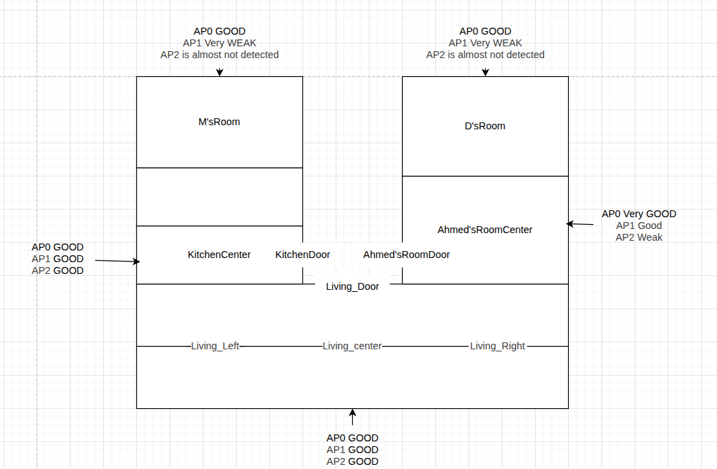
Example For output
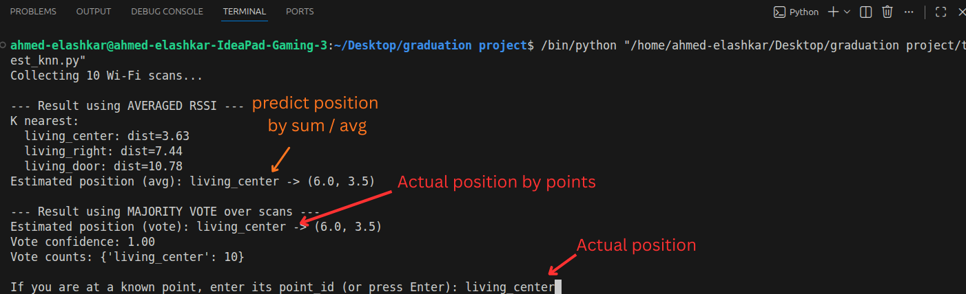
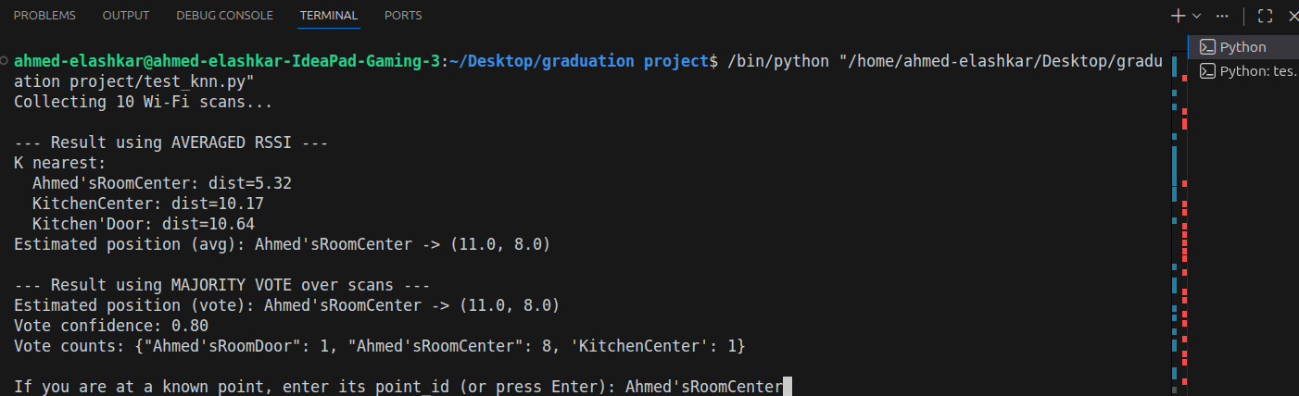
✅ Results Table (22 Runs)
Run | Actual Position | Predicted (AVG) | AVG Correct? | Predicted (VOTE) | Vote Conf. | VOTE Correct? | Right Room
1 | living_center | living_center | ✅ | living_center | 1.00 | ✅ | ✅
2 | living_center | living_center | ✅ | living_center | 0.60 | ✅ | ✅
3 | living_center_bottom | living_left | ❌ | living_left | 1.00 | ❌ | ✅
4 | living_center_bottom | living_left | ❌ | living_left | 1.00 | ❌ | ✅
5 | living_right | living_right | ✅ | living_left | 0.50 | ❌ | ✅
6 | living_right | M'sRoom | ❌ | M'sRoom | 0.60 | ❌ | ❌
7 | living_extreme_right | living_right | ❌ | living_right | 0.70 | ❌ | ✅
8 | living_right_extreme | living_left | ❌ | living_left | 0.70 | ❌ | ✅
9 | living_left | living_left | ✅ | living_left | 1.00 | ✅ | ✅
10 | living_left | living_left | ✅ | living_left | 1.00 | ✅ | ✅
11 | living_left_extreme | living_left | ❌ | living_left | 1.00 | ❌ | ✅
12 | living_left_extreme | living_left | ❌ | living_left | 1.00 | ❌ | ✅
13 | Ahmed'sRoomDoor | Ahmed'sRoomDoor | ✅ | Ahmed'sRoomCenter | 0.40 | ❌ | ✅
14 | Ahmed'sRoomCenter | Ahmed'sRoomCenter | ✅ | Ahmed'sRoomCenter | 0.80 | ✅ | ✅
15 | KitchenCenter | KitchenCenter | ✅ | KitchenCenter | 0.30 | ✅ | ✅
16 | KitchenCenter | Kitchen'Door | ❌ | Kitchen'Door | 1.00 | ❌ | ✅
17 | KitchenCenter | KitchenCenter | ✅ | Kitchen'Door | 0.30 | ❌ | ✅
18 | D'sRoom | D'sRoom | ✅ | D'sRoom | 1.00 | ✅ | ✅
19 | D'sRoom | D'sRoom | ✅ | M'sRoom | 0.40 | ❌ | ✅
20 | M'sRoom | KitchenCenter | ❌ | D'sRoom | 0.80 | ❌ | ❌
21 | M'sRoom | KitchenCenter | ❌ | M'sRoom | 0.50 | ✅ | ❌

🎯 Accuracy (22 Runs)
✅ Right Room = 18 / 21
Note: In the last four readings, the signal was unstable and weak. Some of the networks we are working with could not be detected. One network had a good signal, another was very poor, and the third one could not be found.

So, if we exclude the last four readings, the accuracy will be 16/17 = 94%
✅ AVG Accuracy Correct = 10 / 22 ✅ AVG Accuracy = 45.45%
✅ VOTE Accuracy
Correct = 8 / 22 ✅ VOTE Accuracy = 36.36%
⭐ Final Summary
Method | Correct | Total | Accuracy
Right Room | 18 | 21 | 85.71%
AVG RSSI | 10 | 22 | 45.45%
Majority Vote | 8 | 22 | 36.36%

