Transport Analysis System - Database Design

ER Diagram
The following ER Diagram represents the system structure:
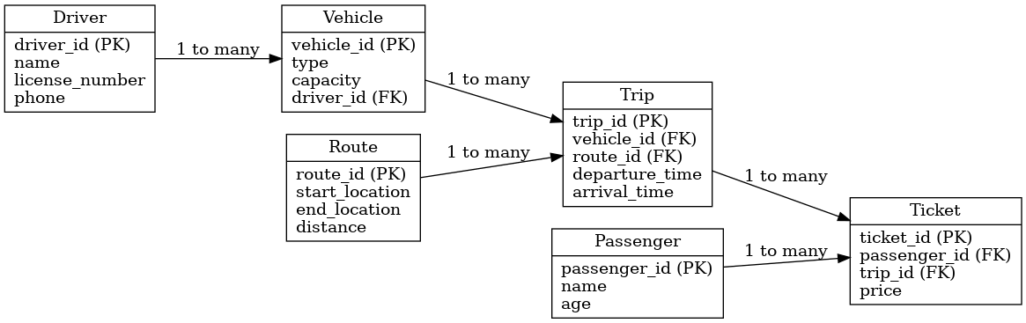

ER Diagram Explanation
The ER Diagram represents the structure of the Transport Analysis system.
It shows the main entities such as vehicles, drivers, routes, trips, passengers, and tickets.
- A Driver can operate multiple vehicles.
- A Vehicle can perform multiple trips.
- Each Trip is assigned to one route.
- A Passenger can book multiple trips through tickets.
- The Ticket acts as a link between passengers and trips.
This design ensures efficient data organization and avoids redundancy.

Logical Schema
Driver(driver_id PK, name, license_number, phone)
Vehicle(vehicle_id PK, type, capacity, driver_id FK)
Route(route_id PK, start_location, end_location, distance)
Trip(trip_id PK, vehicle_id FK, route_id FK, departure_time, arrival_time)
Passenger(passenger_id PK, name, age)
Ticket(ticket_id PK, passenger_id FK, trip_id FK, price)

Physical Schema (SQL)
CREATE TABLE Driver (
driver_id INT PRIMARY KEY,
name VARCHAR(100),
license_number VARCHAR(50),
phone VARCHAR(20)
);
CREATE TABLE Vehicle (
vehicle_id INT PRIMARY KEY,
type VARCHAR(50),
capacity INT,
driver_id INT,
FOREIGN KEY (driver_id) REFERENCES Driver(driver_id)
);
CREATE TABLE Route (
route_id INT PRIMARY KEY,
start_location VARCHAR(100),
end_location VARCHAR(100),
distance FLOAT
);
CREATE TABLE Trip (
trip_id INT PRIMARY KEY,
vehicle_id INT,
route_id INT,
departure_time DATETIME,
arrival_time DATETIME,
FOREIGN KEY (vehicle_id) REFERENCES Vehicle(vehicle_id),
FOREIGN KEY (route_id) REFERENCES Route(route_id)
);
CREATE TABLE Passenger (
passenger_id INT PRIMARY KEY,
name VARCHAR(100),
age INT
);
CREATE TABLE Ticket (
ticket_id INT PRIMARY KEY,
passenger_id INT,
trip_id INT,
price FLOAT,
FOREIGN KEY (passenger_id) REFERENCES Passenger(passenger_id),
FOREIGN KEY (trip_id) REFERENCES Trip(trip_id)
);

Use Case Mapping
Driver: Manage Drivers (Add, Update, Track licenses)
Vehicle: Manage Vehicles (Register, Assign driver)
Route: Manage Routes (Define start/end, distance)
Trip: Manage Trips (Assign vehicle, route, schedule)
Passenger: Manage Passengers (Register users)
Ticket: Booking System (Book trips, pricing)

