Transport Analysis - Requirements Gathering

1) Stakeholder Analysis
- Operations Manager: Needs fleet visibility, route efficiency, and on-time performance tracking.
- Dispatcher: Needs trip assignment, schedule control, and quick reassignment workflow.
- Driver: Needs clear trip instructions and simple status updates.
- Business Analyst: Needs KPI trends, period comparisons, and exportable reports.
- Executive/Owner: Needs utilization, cost, and service quality summaries.

2) User Stories & Use Cases
- As a dispatcher, I want to assign a vehicle and driver to each trip so that operations stay on schedule.
- As a driver, I want to update trip status in real time so that dispatch can monitor progress.
- As an operations manager, I want delay alerts so that I can intervene before SLA breaches.
- As an analyst, I want route and period comparisons so that I can identify optimization opportunities.
Core Use Cases:
- Plan and assign trips.
- Execute and monitor trip lifecycle.
- Manage disruptions and delays.
- Analyze KPI and route performance.

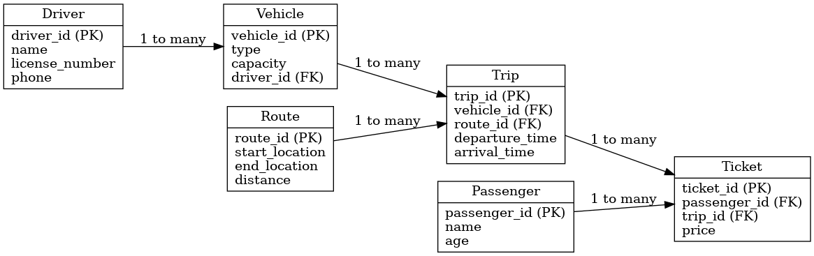

3) Functional Requirements
FR-01: User authentication and role-based access control (RBAC).
FR-02: Fleet management for vehicles, drivers, and capacities.
FR-03: Trip scheduling and assignment.
FR-04: Trip lifecycle tracking (planned, active, completed, delayed).
FR-05: Route and distance analytics.
FR-06: KPI dashboard (on-time %, utilization, cost/trip).
FR-07: Delay and incident alerts/notifications.
FR-08: Report generation and CSV export.
FR-09: Audit logs for critical operational changes.

4) Non-functional Requirements
NFR-01 Performance: Dashboard load time <= 3 seconds for normal datasets.
NFR-02 Availability: 99.5% monthly uptime target for core features.
NFR-03 Security: Hashed passwords, protected APIs, RBAC checks, and activity logs.
NFR-04 Usability: Key workflows should be completed with minimal user training.
NFR-05 Reliability: Consistent transactions and no data loss in normal failure scenarios.
NFR-06 Scalability: Support growth in users, vehicles, and trip records.
NFR-07 Maintainability: Modular architecture and documented interfaces.

5) Scope and Assumptions
In Scope (v1): Fleet/trip operations, tracking, KPI dashboards, alerts, and reports.
Out of Scope (v1): Deep IoT GPS integration, billing integration, native mobile app.
Assumptions: Data is entered by operations users, internet is available in office sites, and rollout is phased.

