* **Project-Diagram.**

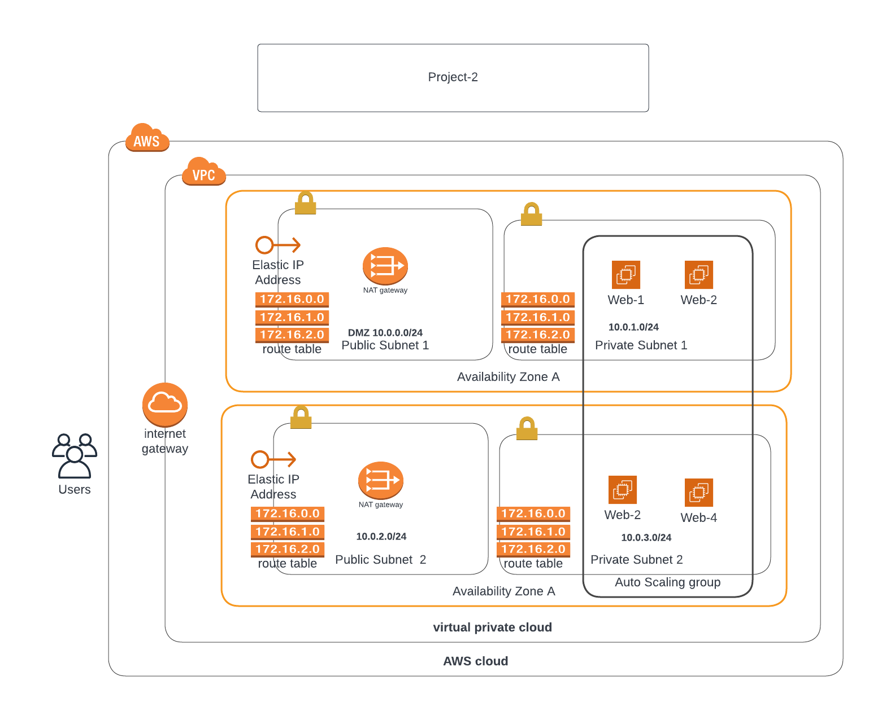

* **To create Network stack.**

aws cloudformation create-stack --stack-name network2 --template-body file://network.yml

* **To create servers stack.**

aws cloudformation create-stack --stack-name servers --template-body file://servers.yml --capabilities CAPABILITY_NAMED_IAM

* **Screenshots**

