Google Price Stock

Ahmed Zakaria Ali

2024-08-23

# Check Data set Structure

##generate line chart for price & date

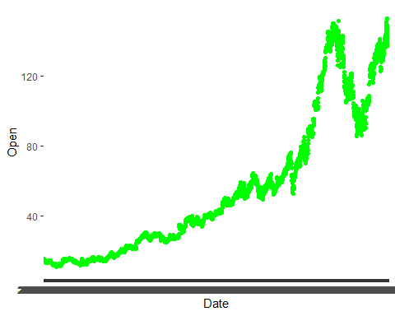

## Min. 1st Qu. Median Mean 3rd Qu. Max.   
## 10.97 22.02 41.55 55.11 75.50 152.80

## 10% 20% 25% 30% 40% 50% 60% 70%   
## 14.58959 17.49735 22.02202 26.96350 33.27100 41.55000 54.46010 63.05460   
## 75% 80% 90%   
## 75.49825 95.37600 124.60000

## [1] 53.48

## [1] 10.96872 152.80000

## [1] 141.8313

## [1] 1600.605