**Lab 3**

1. Using vi write your CV in the file mycv. Your CV should include your name, age, school, college, experience,...

1. Open mycv file using vi command then: Without using arrows state how to:
   1. Move the cursor down one line at time. **j key**
   2. Move the cursor up one line at time. **K key**
   3. Search for word age **/age**
   4. Step to line 5 (assuming that you are in line 1 and file is more than 5 lines**). :5**

* 1. Delete the line you are on and line 5. **5dd**
  2. How to step to the end of line and change to writing mode in one-step.

**:A**

1. List the available shells in your system.

1. List the environment variables in your current shell.

**Printenv & env**

1. List all of the environment variables for the bash shell. **Man bash**
2. What are the commands that list the value of a specific variable?

1. Display your current shell name.

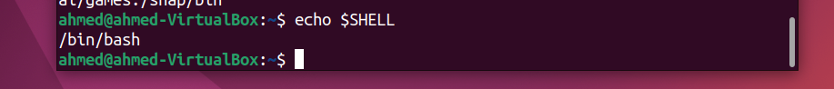

1. Edit in your profile to display date at login and change your prompt permanently.

* + 1. Execute the following command :

echo \ then press enter What is the purpose of \ ?

Notice the prompt ”>” what is that? and how can you change it from “>” to “:”

**it tells the shell to treat the following character as literal character**

**rather than interpreting it as a special character so the command**

**continues on the next line**

* + 1. Create a Bash shell alias named ls for the “ls –l” command

