Lab 5

1. A screenshot of a computer

   Description automatically generatedCompress a file by compress, gzip, zip commands and decompress it again. State the differences between compress and gzip commands.

Compress ➔ compressed the file from 18k to 5.8k

gzip ➔ compressed the file from 18k to 1.3k

1. A screen shot of a computer

   Description automatically generatedWhat is the command used to view the content of a compressed file.
2. Backup /etc directory using tar utility.
3. A computer screen shot of a computer program

   Description automatically generatedStarting from your home directory, find all files that were modified in the last two day.
4. Starting from /etc, find files owned by root user.

1. Find all directories in your home directory.

1. A computer screen shot of a computer

   Description automatically generatedWrite a command to search for all files on the system that, its name is “.profile”.
2. A screen shot of a computer program

   Description automatically generatedIdentify the file types of the following: /etc/passwd, /dev/pts/0, /etc, /dev/sda
3. 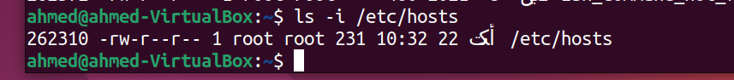A screenshot of a computer

   Description automatically generatedA screenshot of a computer

   Description automatically generatedList the inode numbers of /, /etc, /etc/hosts.
4. A screenshot of a computer screen

   Description automatically generatedCopy /etc/passwd to your home directory, use the commands diff and cmp, and Edit in the file you copied, and then use these commands again, and check the output.
5. A computer screen with white text

   Description automatically generatedCreate a symbolic link of /etc/passwd in /boot.
6. Create a hard link of /etc/passwd in /boot. Could you? Why?

**No , because /etc and /boot are not in the partition**