Name : Ahmed El-Metwally Mohamed

Lab 1

1. Install
2. What is the difference between cat and more command?

Cat:

* Display the entire contents of a file
* When you use cat to view a file, the entire file is displayed in one go, and you can scroll through the output with your terminal's scrollbar.

More:

* Show one screen in one time.
* Displays a screenful of text and waits for you to press the spacebar to view the next screen

1. What is the difference between rm and rmdir using man?

Rmdir:

* used for removing empty directories. It will not remove directories with files or subdirectories inside them.
* The man rmdir page will provide information on how to use rmdir to remove empty directories.

Rm: used for deleting files and directories.

1. Create the following hierarchy under your home directory:

1. Remove dir11 in one-step. What did you notice? And how did you overcome that?

I have to go the file first to can remove dir11 and use rm -r

1. Then remove dir12 using rmdir –p command. State what happened to the hierarchy (Note: you are in your home directory).

1. The output of the command pwd was /home/user. Write the absolute and relative path for the file mycv

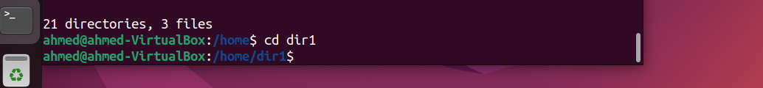

1. Copy the /etc/passwd file to your home directory making its name is mypasswd.



1. Rename this new file to be oldpasswd.

1. You are in /usr/bin, list four ways to go to your home directory

* First way:

* A screen shot of a computer program

  Description automatically generatedSecond way:
* Third Way:

* Fouth Way:

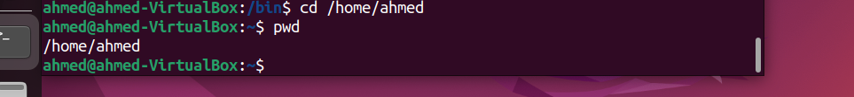

1. List Linux commands in /usr/bin that start with letter w

1. Display the first 4 lines of /etc/passwd
2. Display the last 7 lines of /etc/passwd

1. Display the man pages of passwd the command and the file sequentially in one command.

Man -a passwd

1. Display the man page of the passwd file.

Man 5 passwd

1. Display a list of all the commands that contain the keyword passwd in their man page.

Man -k keyword