How to import excel to sql?

***The quickest way to get your Excel file into SQL is by using the import wizard:***

1. **Open SSMS** (Sql Server Management Studio) and connect to the database where you want to import your file into.
2. **Import Data**: in SSMS in Object Explorer under 'Databases' right-click the destination database, select **Tasks, Import Data**. An import wizard will pop up (you can usually just click 'Next' on the first screen).

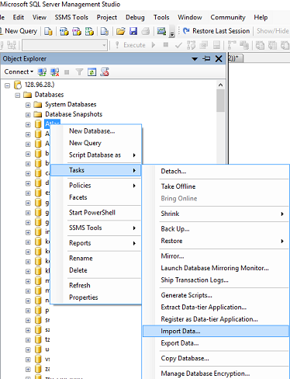

1. The next window is '**Choose a Data Source**', select **Excel**:

* In the 'Data Source' dropdown list select Microsoft Excel (this option should appear automatically if you have excel installed).
* Click the 'Browse' button to select the path to the Excel file you want to import.
* Select the version of the excel file (97-2003 is usually fine for files with a .XLS extension, or use 2007 for newer files with a .XLSX extension)
* Tick the 'First Row has headers' checkbox if your excel file contains headers.
* Click next.

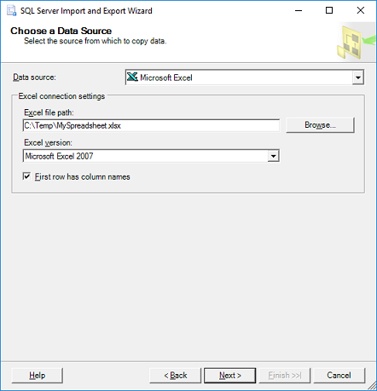

4. On the '**Choose a Destination**' screen, **select destination database**:

* Select the 'Server name', Authentication (typically your sql username & password) and select a Database as destination. Click Next.

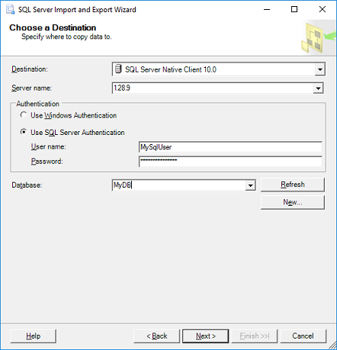

1. On the '**Specify Table Copy or Query**' window:
   * For simplicity just select 'Copy data from one or more tables or views', click Next.
2. '**Select Source Tables:**' choose the worksheet(s) from your Excel file and specify a destination table for each worksheet. If you don't have a table yet the wizard will very kindly create a new table that matches all the columns from your spreadsheet. Click Next.

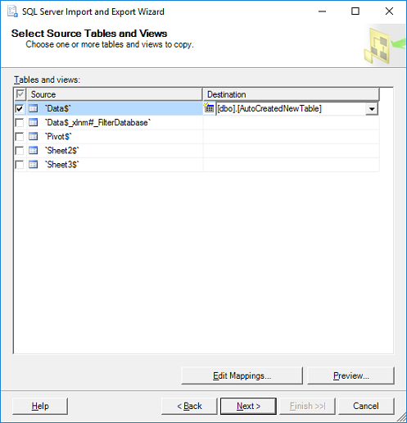

7.Click Finish

**How to Export SQL Server data to an Excel file**

In SQL Server Management Studio (SSMS), there is a feature that provides for exporting data from one data source to another data source; in this case, data from SQL Server will be copied to an Excel file trough Export Wizard.

To start to use this feature, go to **Object Explorer**, right click on any database (e.g. AdventureworksDW2016CTP3), under the **Tasks**, choose **Export Data** command:

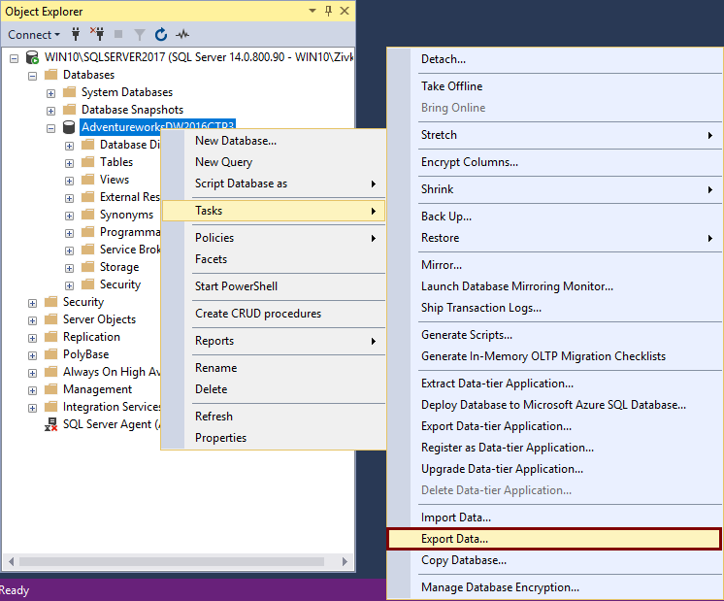

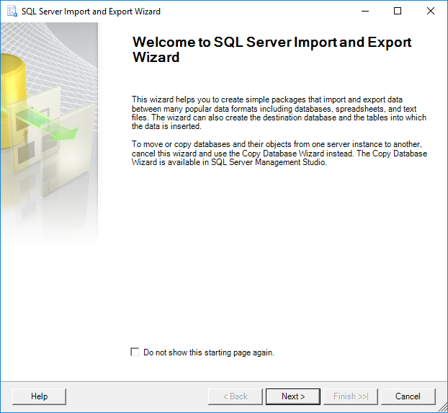

To proceed with exporting SQL Server data to an Excel file, click the **Next** button. This will open the **Choose a Data Source** window. On this window, a source from which you want to copy data can be chosen:

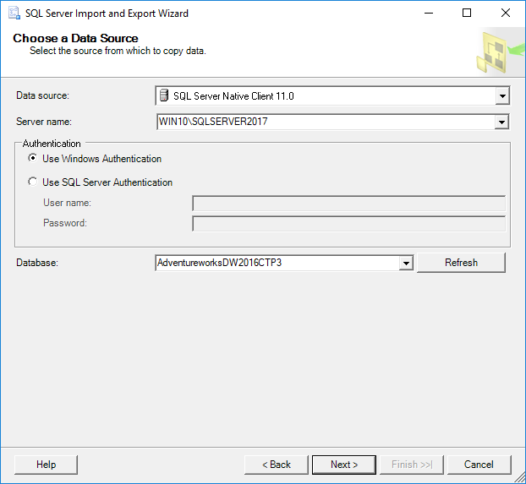

This will open the **Choose a Destination** window in which can be specified where to copy data from the data source:

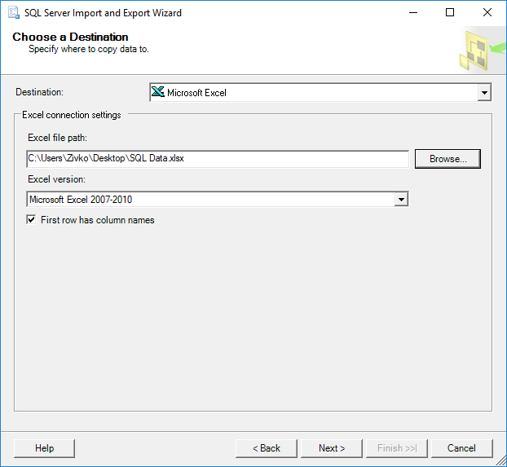

In the **Destination** drop down box, choose the **Microsoft Excel** item. Under the **Excel file path**, choose the destination for copied data from SQL Server data source (SQL Data.xlsx). In the **Excel version** drop down box, choose the version of the Microsoft Excel worksheet. After these are all set, press the **Next** button to continue.

After launching this SQL Server Import and Export Wizard, it will be prompted with the same window that is used via SSMS. After setting all previous options, click the Next button. The **Specify Table Copy or Query** window will appear:

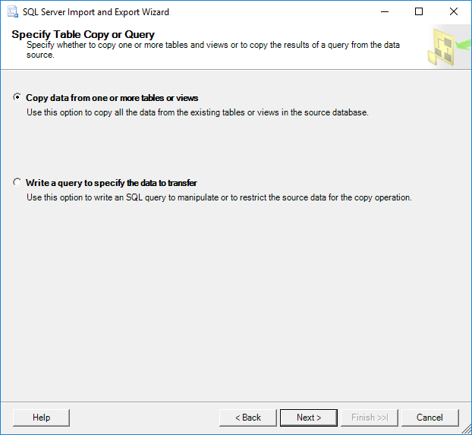

Select the **Copy data from one or more tables or views** radio button and click the **Next** button. The **Select Source Table and Views** window allows choosing one or more tables and views from which you want to export SQL Server data to an Excel file by clicking the check box next to the name of the table/view:

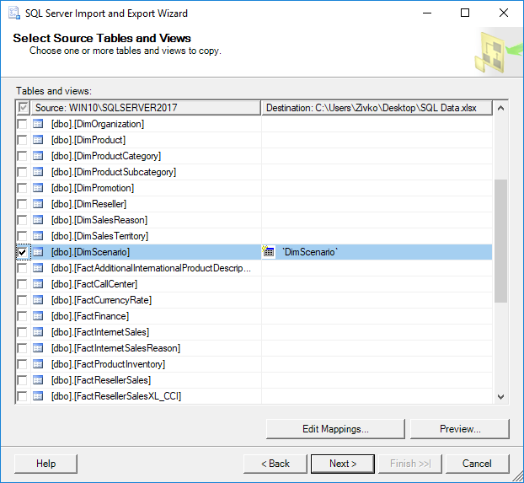

After choosing which tables/views data will be copied to an Excel file, click the **Next** button:

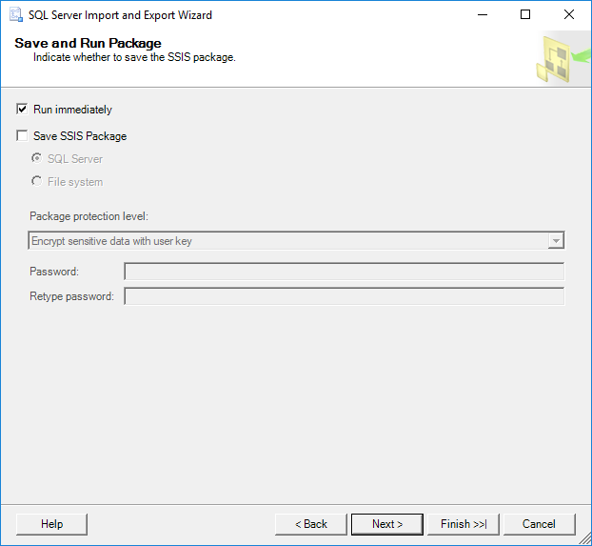

On the **Save as Run Package** window, check the **Run immediately** check box and click the **Next** button:

