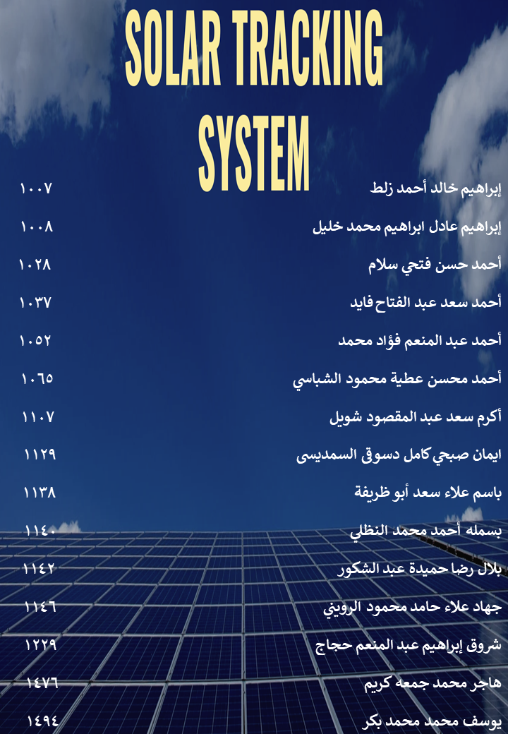

* **Introduction**

A dual axis solar tracking system is a sophisticated mechanism designed to optimize the orientation of solar panels throughout the day to maximize energy capture. Unlike fixed or single-axis systems, dual-axis trackers can adjust both the azimuth (horizontal angle) and the elevation (vertical angle) of the solar panels. This system is particularly effective in maximizing solar energy absorption by following the sun's path across the sky.

* **Advantages of Dual Axis Solar Tracking Systems**

1. **Increased Energy Production:**

* **Higher Efficiency:** Dual axis trackers can increase solar panel efficiency by 25% to 40% compared to fixed systems. This is because they maintain the optimal angle relative to the sun throughout the day and across seasons.

1. **Better Performance in Low Light Conditions:**

* **Improved Light Capture:** By adjusting to the best possible angle, these systems can capture more sunlight during early mornings and late afternoons, as well as on cloudy days.

1. **Maximized ROI:**

* **Higher Yield:** The increased efficiency translates to more significant energy yields, ensuring a faster return on investment (ROI) despite the higher initial cost of installation.

1. **Space Optimization:**

* **Efficient Land Use:** Since dual axis trackers optimize panel orientation, they can be spaced more effectively, maximizing the energy output per unit area of land.
* **Usefulness of Dual Axis Solar Tracking Systems**

1. **Commercial and Utility-Scale Projects:**

* Ideal for large-scale solar farms where maximizing output is crucial to meet energy demands and financial goals.

1. **Rural and Off-Grid Applications:**

* Beneficial for rural electrification projects and off-grid systems where reliability and maximized energy production are essential.

1. **Research and Development:**

* Useful in experimental setups and educational institutions for studying the effects of various tracking mechanisms on solar energy capture.
* **Idea of Making a Dual Axis Solar Tracking System**
* **Components Required:**

1. **Solar Panels**: Photovoltaic panels to convert solar energy into electrical energy.
2. **Microcontroller**: To control the motors and ensure accurate tracking (e.g., Arduino).
3. **Sensors**: Light sensors (e.g., LDRs) to detect the sun's position.
4. **Motors**: Servo motors or stepper motors for precise movement.
5. **Mounting Structure**: A robust structure to hold the panels and motors.
6. **Power Supply**: Batteries, Arduino wire or other power sources to run the system.
7. **Software**: Programming logic to control the tracking algorithm.

* **Construction Steps:**

1. **Design the Mounting Structure**: Build a frame that can securely hold the solar panels and allow movement in both axes.
2. **Install Motors**: Attach the motors to the frame for controlling the tilt and rotation.
3. **Sensor Placement**: Place light sensors strategically around the panels to detect the sun’s position.
4. **Microcontroller Setup**: Program the microcontroller to process sensor data and control the motors accordingly.
5. **Integration and Testing**: Assemble all components, integrate the system, and test it under various conditions to ensure proper functionality.

* **Benefits and Utilization**

1. **Energy Optimization:**

* **Enhanced Yield:** Dual axis tracking systems ensure that solar panels are always positioned at the optimal angle, significantly increasing daily and seasonal energy yields.

1. **Cost Efficiency in the Long Term:**

* **Reduced Energy Costs:** Higher energy production reduces the cost per kilowatt-hour over the system’s lifespan, making it economically viable in the long term.

1. **Environmental Impact:**

* **Reduced Carbon Footprint:** Higher efficiency means more renewable energy production, contributing to reduced reliance on fossil fuels and lower greenhouse gas emissions.

1. **Scalability:**

* **Modular Deployment:** Suitable for both small-scale and large-scale applications, making it versatile for different energy needs and project sizes.
* **Conclusion**

Dual axis solar tracking systems represent a significant advancement in solar energy technology. Their ability to maximize solar energy capture makes them an attractive option for various applications, from residential to large-scale solar farms. Despite the higher initial costs, the long-term benefits in terms of efficiency, energy yield, and environmental impact make them a worthwhile investment. Embracing dual axis tracking technology can play a crucial role in advancing sustainable energy solutions and optimizing the use of solar power.