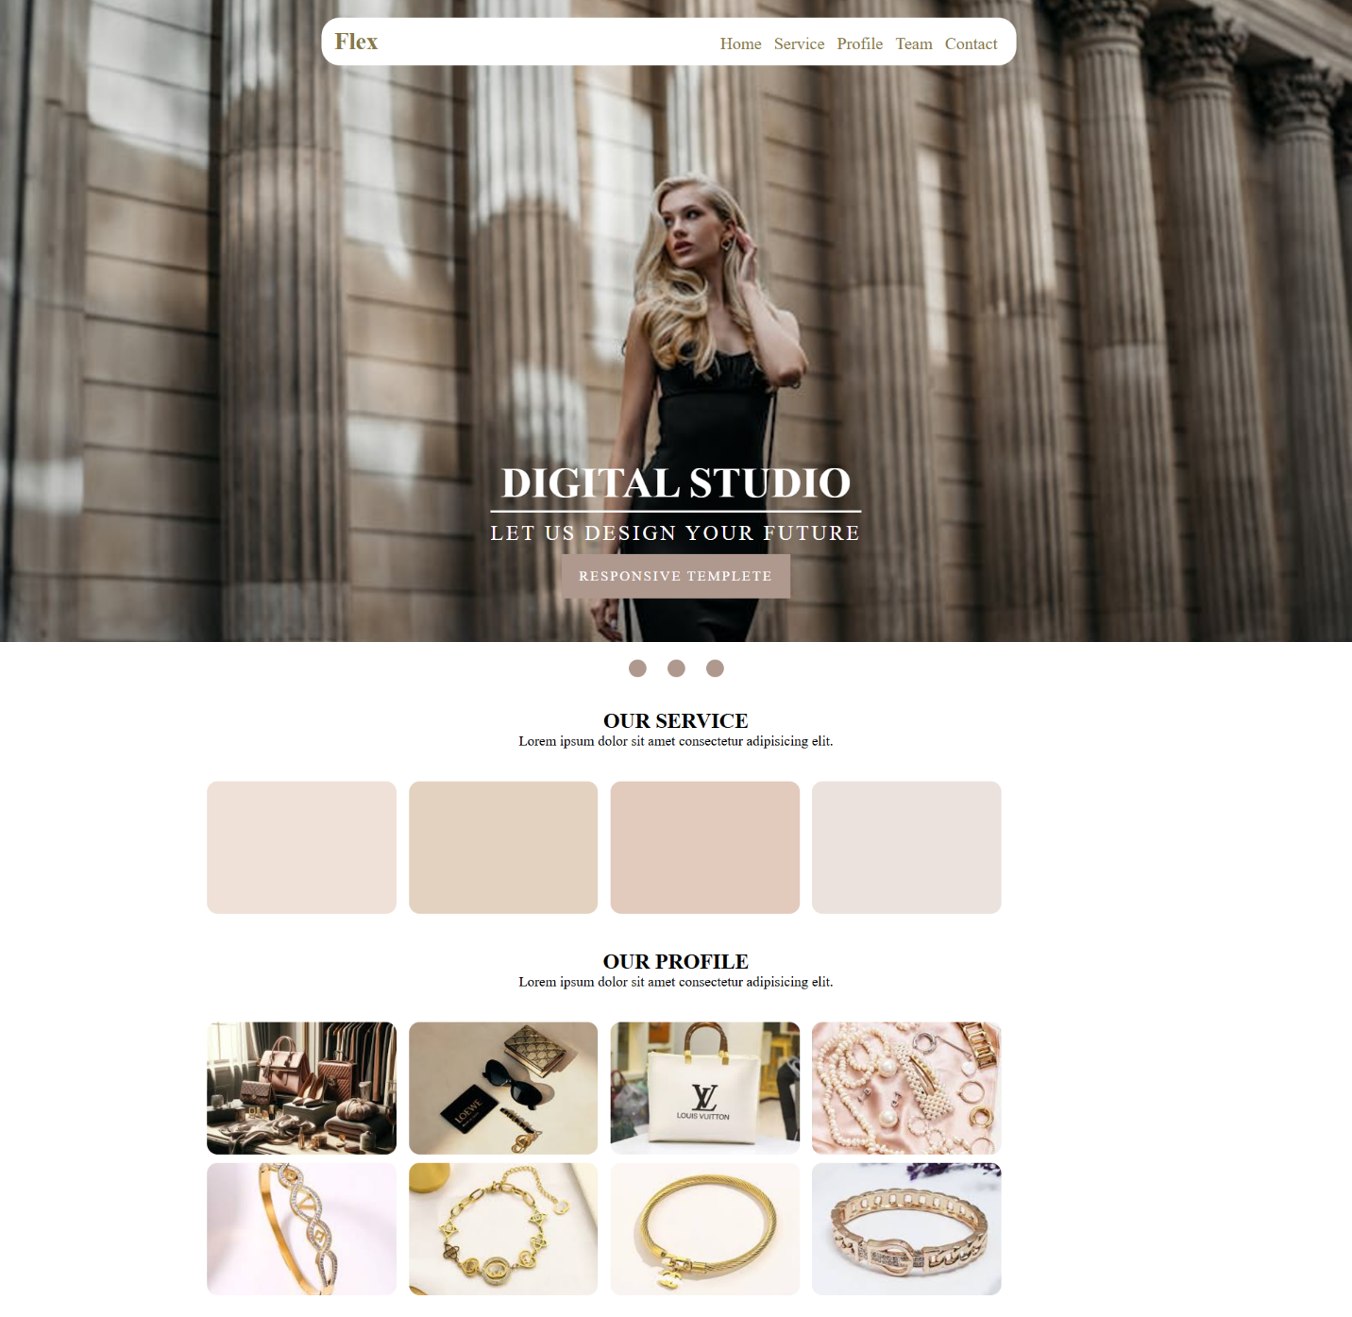

* Html

<html *lang*="en">

<head>

    <meta *charset*="UTF-8">

    <meta *name*="viewport" *content*="width=device-width, initial-scale=1.0">

    <link *rel*="stylesheet" *href*="style.css">

    <title>task 2</title>

</head>

<body>

   <nav>

    <div *class*="icon">

        Flex

    </div>

    <div *class*="links">

        <a *href*="" *class*="link">Home</a>

        <a *href*="" *class*="link">Service</a>

        <a *href*="" *class*="link">profile</a>

        <a *href*="" *class*="link">team</a>

        <a *href*="" *class*="link">contact</a>

    </div>

   </nav>

   <section *class*="land">

    <div *class*="title">

        <h1>

            digital studio

        </h1>

        <p>let us design your future</p>

        <a *href*="#">responsive Templete</a>

    </div>

   </section>

   <div *class*="circles">

    <div *class*="circle"></div>

    <div *class*="circle"></div>

    <div *class*="circle"></div>

   </div>

   <section *class*="container">

    <div *class*="title">

        <h2>our service</h2>

        <p>Lorem ipsum dolor sit amet consectetur adipisicing elit. </p>

    </div>

    <div *class*="colors">

        <div *class*="color brown"> </div>

        <div *class*="color brown2"> </div>

        <div *class*="color brown3"> </div>

        <div *class*="color brown4"> </div>

    </div>

   </section>

   <section *class*="container">

    <div *class*="title">

        <h2>our profile</h2>

        <p>Lorem ipsum dolor sit amet consectetur adipisicing elit. </p>

    </div>

    <div *class*="colors">

        <div *class*="color img "> <img *src*="img/img1.jpeg"></div>

        <div *class*="color img2"> <img *src*="img/img2.jpeg"></div>

        <div *class*="color img3"> <img *src*="img/img3.jpeg"></div>

        <div *class*="color img4"> <img *src*="img/img4.jpeg"></div>

        <div *class*="color img5"> <img *src*="img/img5.jpeg"></div>

        <div *class*="color img6"> <img *src*="img/img6.jpeg"></div>

        <div *class*="color img7"> <img *src*="img/img7.jpeg"></div>

        <div *class*="color img8"> <img *src*="img/img8.jpeg"></div>

    </div>

   </section>

</body>

</html>

* Css

\* {

  margin: 0;

  padding: 0;

}

nav {

  background-color: #fff;

  padding: 12px 15px;

  width: 50%;

  margin: auto;

  position: absolute;

  top: 20px;

  left: 50%;

  transform: translateX(-50%);

  z-index: 9999;

  border-radius: 21px;

}

nav *.icon* {

  color: #874;

  display: inline-block;

  text-transform: capitalize;

  width: calc(100% - 330px);

  font-weight: bold;

  font-size: 1.7rem;

}

nav *.links* {

  display: inline-block;

}

nav *.link* {

  display: inline-block;

  text-transform: capitalize;

  margin: 0 5px;

  text-decoration: none;

  color: #874;

  align: right;

  font-size: 1.2rem;

}

*/\* nav .link:last-child::after {*

*content: "";*

*display: block;*

*clear: both;*

*} \*/*

*.land* {

  background-image: url("https://images.pexels.com/photos/20264907/pexels-photo-20264907/free-photo-of-young-woman-in-a-black-dress-posing-in-front-of-a-colonnade.jpeg?auto=compress&cs=tinysrgb&w=900");

  background-position: center;

  background-size: cover;

  background-origin: content-box;

  background-repeat: no-repeat;

  aspic-ratio: 1;

  width: 100%;

  height: 100vh;

  position: relative;

}

*.land* *.title* {

*/\* width: 400px; \*/*

  position: absolute;

  bottom: 50px;

  left: 50%;

  transform: translateX(-50%);

  color: #fff;

  text-align: center;

  text-transform: uppercase;

}

*.land* *.title* h1 {

  font-size: 3rem;

  border-bottom: 3px solid #fff;

  padding-bottom: 3px;

}

*.land* *.title* p {

  font-size: 1.5rem;

  margin-top: 10px;

  letter-spacing: 3px;

}

*.land* *.title* a {

  display: inline-block;

  text-transform: uppercase;

  background-color: #af998f;

  text-decoration: none;

*/\* border: 1px solid #fff; \*/*

  border: none;

  padding: 16px 20px;

  color: #fff;

  font-size: 1rem;

  margin-top: 10px;

  letter-spacing: 2px;

}

*.circles* {

  margin: 20px auto;

  width: fit-content;

}

*.circles* *.circle* {

  display: inline-block;

  width: 20px;

  height: 20px;

  margin: 0 10px;

  background-color: #af998f;

  border-radius: 50%;

}

*.container* {

  position: relative;

  margin: 20px auto;

  width: 70%;

}

*.container* *.title* {

  text-align: center;

  margin: auto;

  padding: 12px 0;

}

*.container* *.title* h2 {

  text-align: center;

  text-transform: uppercase;

}

*.container* *.title* p {

  text-align: center;

  margin: auto;

}

*.container* *.colors* {

  margin: 20px 0;

}

*.container* *.color* {

  width: 20%;

  height: 150px;

  display: inline-block;

  margin: 5px 5px;

  border-radius: 12px;

}

*.brown* {

  background-color: #efe0d8;

}

*.brown2* {

  background-color: #e4d2c0;

}

*.brown3* {

  background-color: #e2cabd;

}

*.brown4* {

  background-color: #ebe2de;

}

*.container* *.color*  img {

  width: 100%;

  height: 100%;

  object-fit: cover;

  border-radius: 12px;

}