IRIS RECOGNITION &CONTROLLING A ROBOTIC EYE USING OPENCV
Farhan Sadick Zawad, Sohel Aman Khan, Ahmad Rahman Farabi
School of Computer Science and Engineering
BRAC UNIVERSITY
66 Mohakhali, Dhaka
farhansz07@gmail.com, sohelamankhan@gmail.com, farabi2051@gmail.com

Abstract— Main purpose of this project is to control a robotic eye using OPENCV, in other word extensive use of image processing. We have designed a hardware which consists of two pair of mechanical eyes, which would be controlled by an Arduino. Our objective is to detect faces and their eyes from the faces, and move our mechanical eye with respect to that particular human eye. In this paper, we presented our systems software and hardware part. Each result is described briefly and appropriate pointers are provided to permit and in-depth study of any particular result.
Keywords— Arduino Mega 2560, Robotic eye, Serial Communication, OPENCV, Image processing, Eye tracking.

Introduction
Notwithstanding the extensive research effort that has gone into image processing, we have yet to see a system that can be deployed effectively in an unconstrained setting, with all of the attendant variability in imaging parameters such as sensor noise, viewing distance, and illumination. Even though image processing not reaching at its peak many objectives and goals are achieved through image processing. Lots of projects are done on this too. We also have implemented such a system, which is one of the examples of image processing. Using image processing techniques, we have focused on eye tracking in this project. Many researches focus on eye tracking as one of the methods to achieve human machine interface. Eye tracking systems are cheaper system compared to brain computer interface systems. By improving the methods and algorithm, the robustness of eye tracking systems can be improved. From these motivations, eye tracking systems have been conducted. Some researchers conducted offline eye detection which used the images from database [1, 2, 3]. For the human machine interface system, the eye tracking has to work in real time situation in order to control the movement of any devices. Kawato’s work is pretty good and reliable [4]. They use two cameras and head movement cancellation for real time eye detection. Eye detection during head movement was possible. Many researchers also achieved eye detection using active IR illumination sensor and special embedded systems together with object recognition techniques [5, 6]. On the other hand we have developed a system that can detect eye using webcam as hardware and OPENCV codes as software. In an auspicious environment, we can easily detect faces and their eyeball. By parsing that data we have monitored and considered the movement of our mechanical eyeballs.

Background
In this project, we mainly focus on iris recognition using the video or multiple image processing. With the processed image, the hardware will take immediate action. The main goal is to build a system which can detect a human eye movement with a camera and copy the movement but the bigger aspect of this project is to help the robotic eye implementation in human body.
- Image Processing:
The main challenge of this project is the image processing part. It is an advanced and bigger part of computer science technology. The images, taken by a camera, are processed with different software. We had to detect the human iris and its movement[7,8].
- Robotic eye:
In this part, a simple hardware is made to integrate with the software and the processed image. From the images, the eye will take decision to move left, right, up and down.

Design of the system

Overview
The project needs hardware - software integration. From the software, the images will be processed and then it will send commands through serial port to the hardware to interact. In the image processing part, the camera will take a video or multiple images at a very short time and by comparing different images it detects the movement.
In fig:3.1, the links are shown.

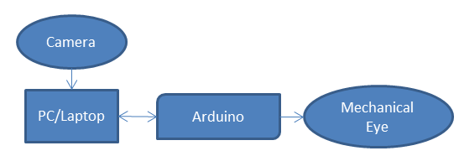

Fig:3.1

Software
The main tasks of this project are done by the software.
We used OpenCV library,Microsoft Visual Studio 2013 and CeempleOpenCV VS4. We used Haar Cascade Classifier to detect human face [8].
The language we used is C / C++ language. OpenCV (Open Source Computer Vision) is a library of programming functions which mainly aimed at real-time computer vision. It is originally developed by Intel research center. The library is cross-platform and free for use under the open source BSD license. It is written in C++ language. but it still retains a less comprehensive though extensive older C interface. We used Microsoft VS ‘13 to write code for our system.
When the code runs, it opens command prompt and 3 camera interfaces. In the command prompt, the code prints the eye movement. One camera interface gets busy taking multiple images and other one detects the human eye and marks the eye and iris. The last one is to detect the iris movement[7,8].
Then, after taking and processing images, the code will take decisions whether the eyes are in left, right, up or down position. When it finds the position of the eye, it will send a command through serial to the hardware part of our project.

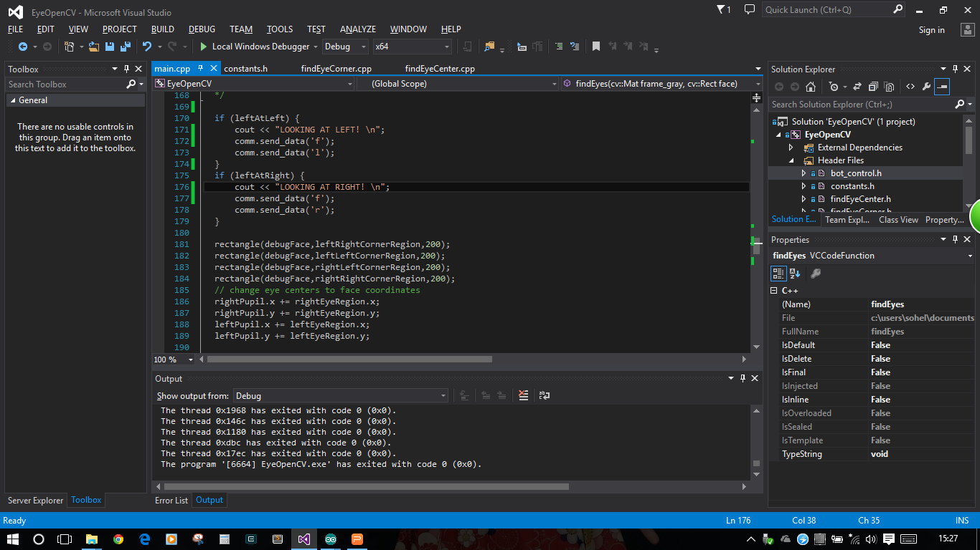

Fig: 3.2
Fig 3.2 shows the coding part in Microsoft visual studio.

C. Hardware
In hardware part, we built a simple robotic eye using some equipment. The hardware part consists of:
- Arduino Mega 2560
- Two SG90 mini servos
- Plastic plate for base
- Two Table Tennis Balls
- Breadboard
- Steel strings
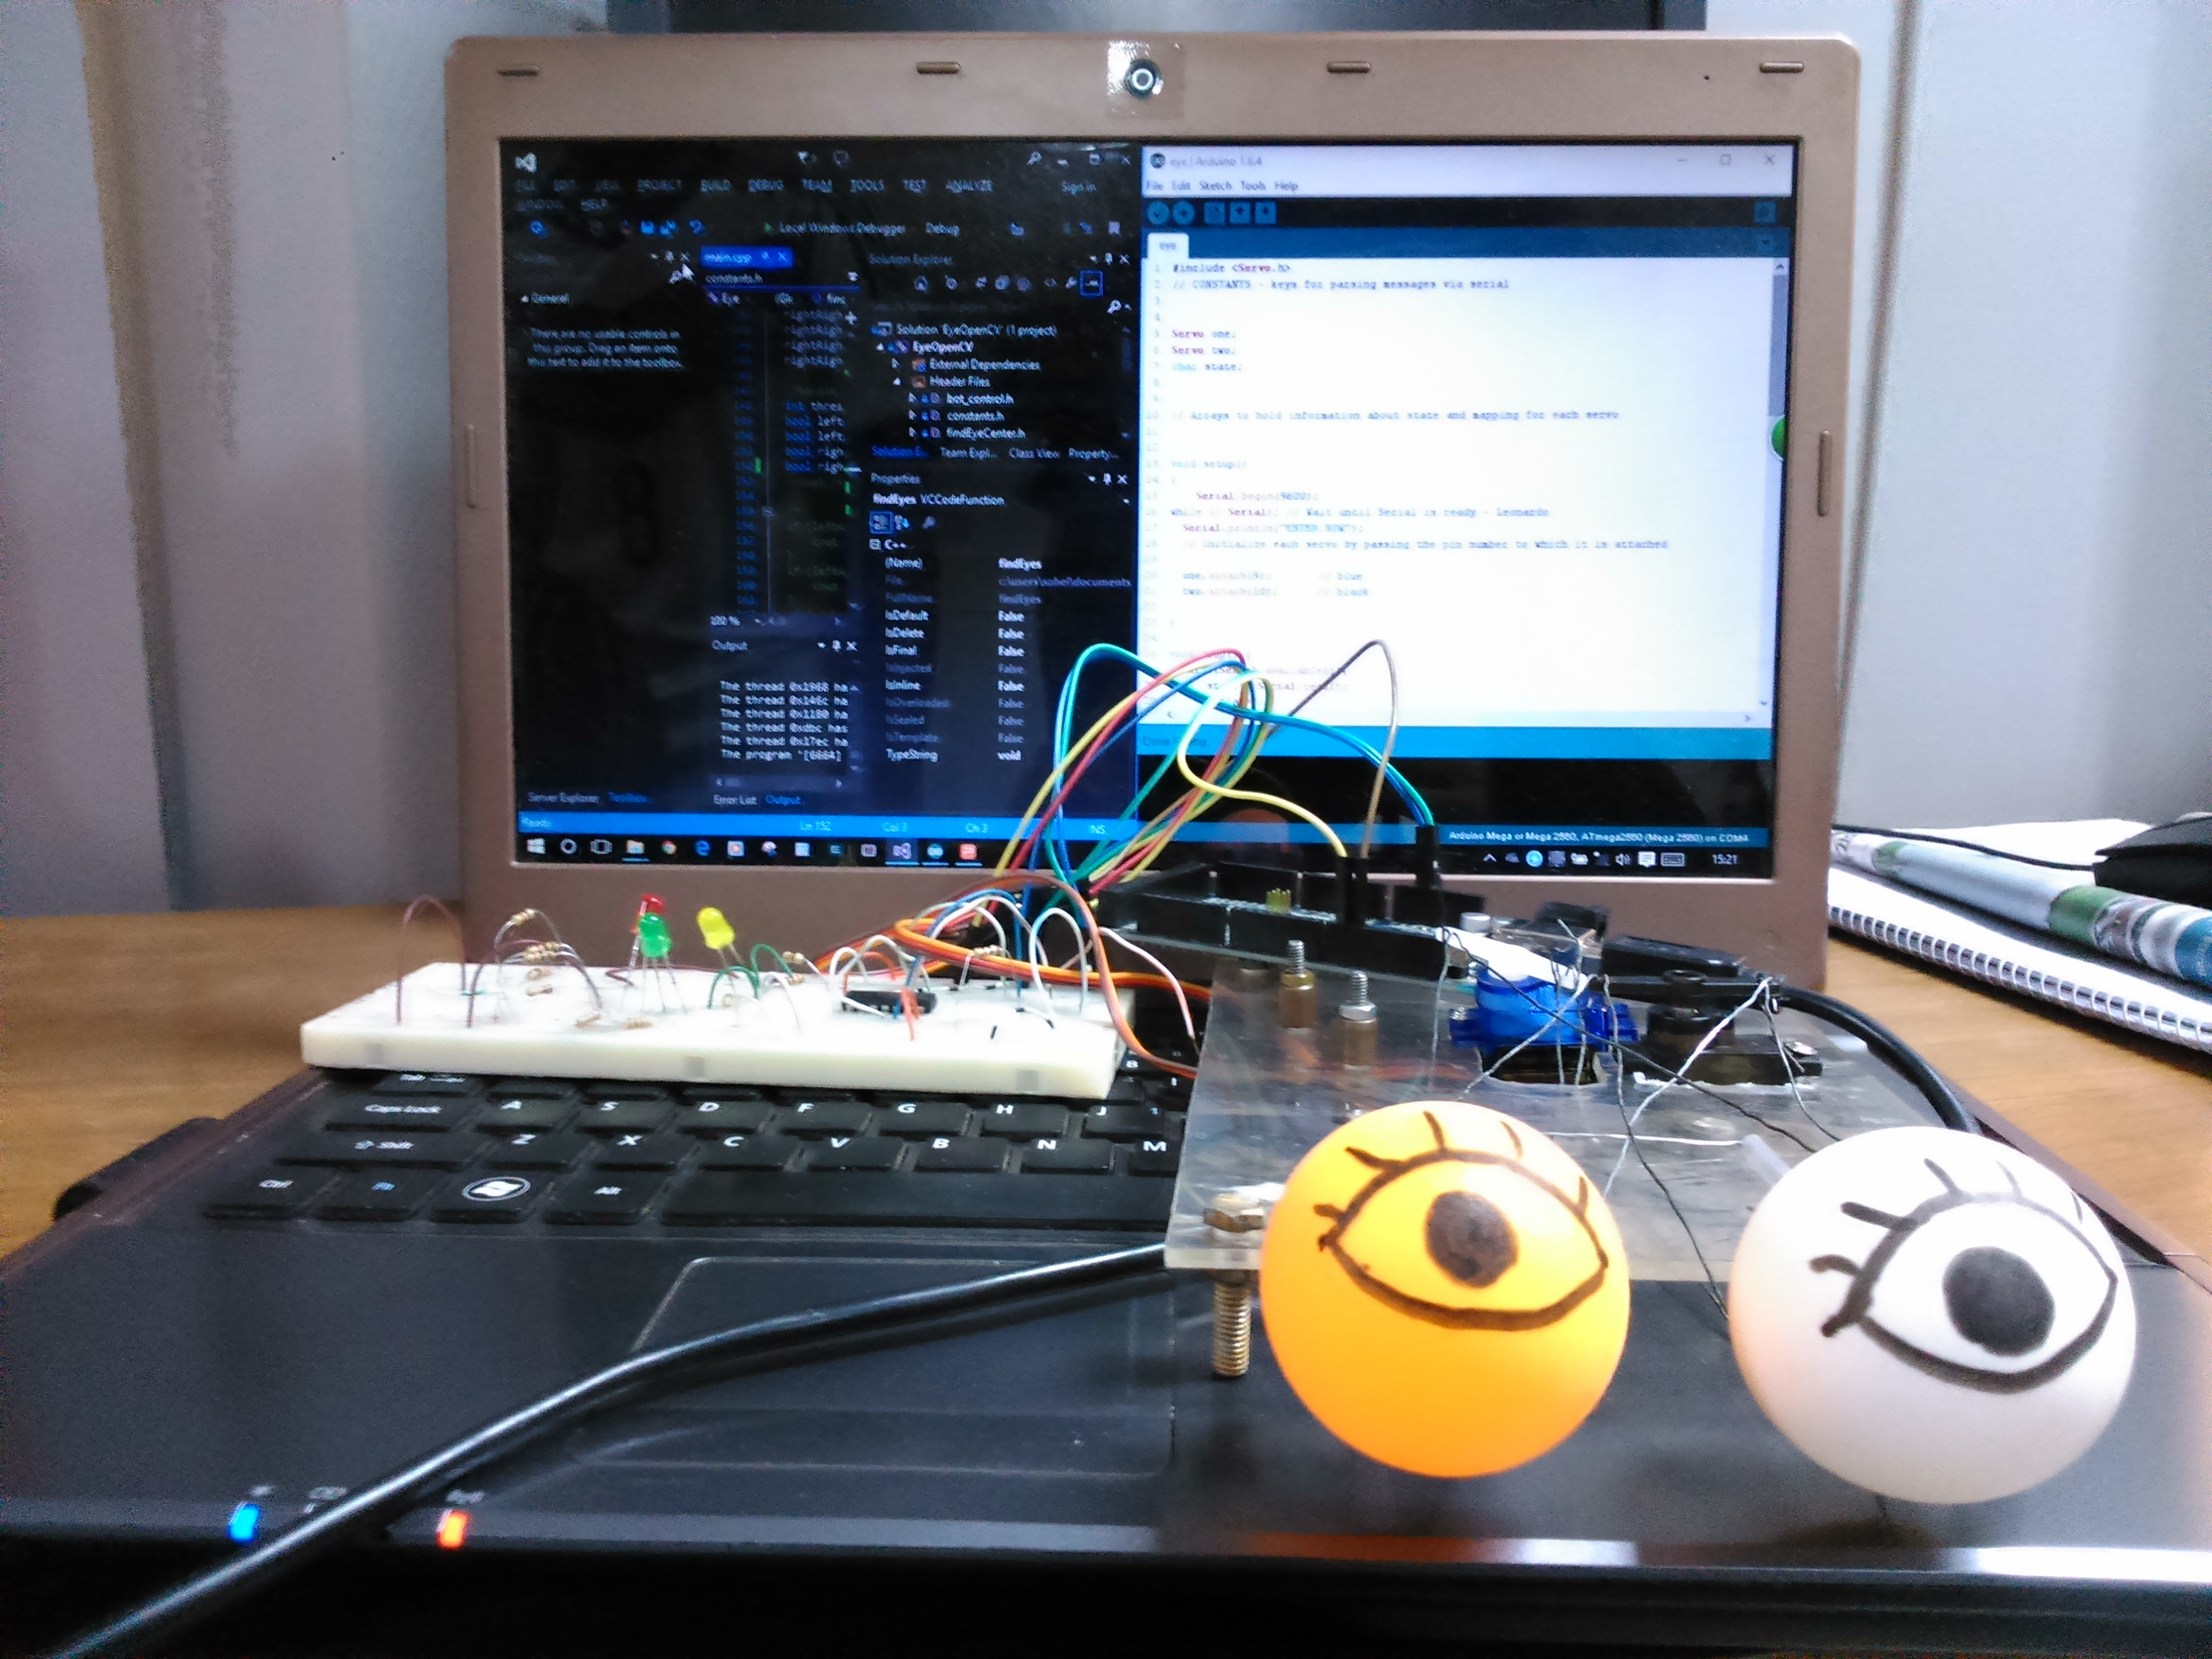
Fig: 3.3
Fig 3.3 shows the hardware of the robotic eyes.
The Arduino actually receives the command the software sent from the serial port and then it sends signal to the servos through PWM to rotate in the certain position. So, if the human eye looks left, the robotic eye will look left and same goes for right, up and down [9].

Circuit Design
The circuit is pretty simple to explain. The 2 servos are connected to the Arduino. Through the PWM pins , it sends pulse signals to the servos to rotate in a certain angle. VCC and GND of servos are connected to the Arduino’s vcc and gnd.

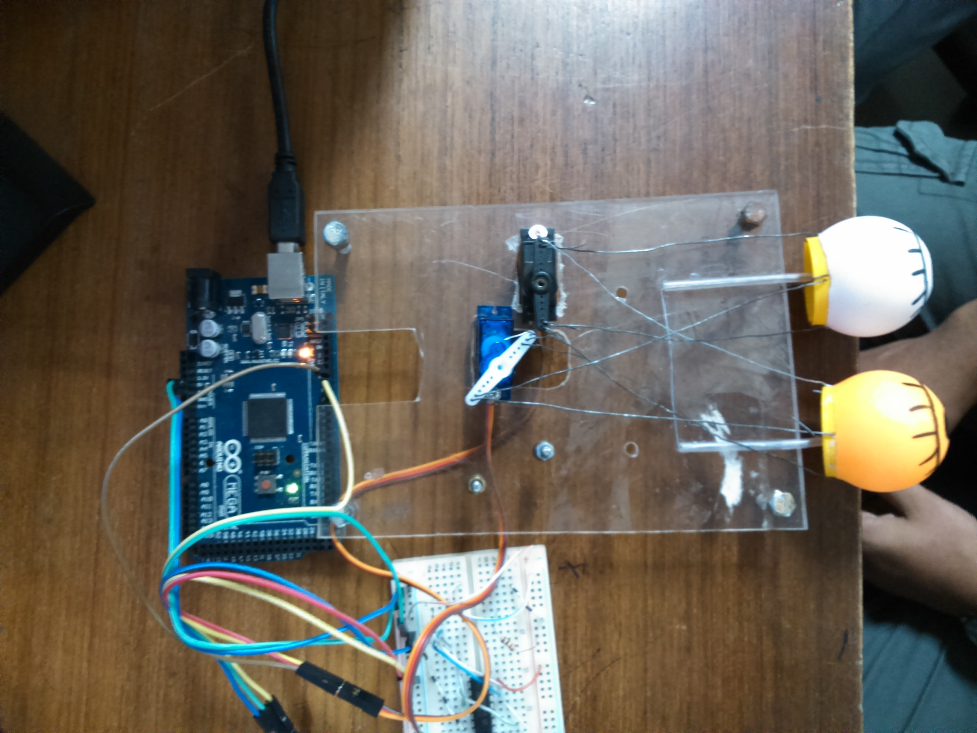
Fig: 3.4

Developing the software
The main challenge of this project was to develop the sofatware. It was much tough to interact with the software. As we studied JAVA language, it was hard to interact with C language. Still we managed to cope up with this. The main image processing code is written in Linux OS first which was perfectly worked there using OpenCV library. But sending data through serial port in linux was difficult . So we switched to windows and used Microsoft VS’13 to code with OpenCV [7,8].

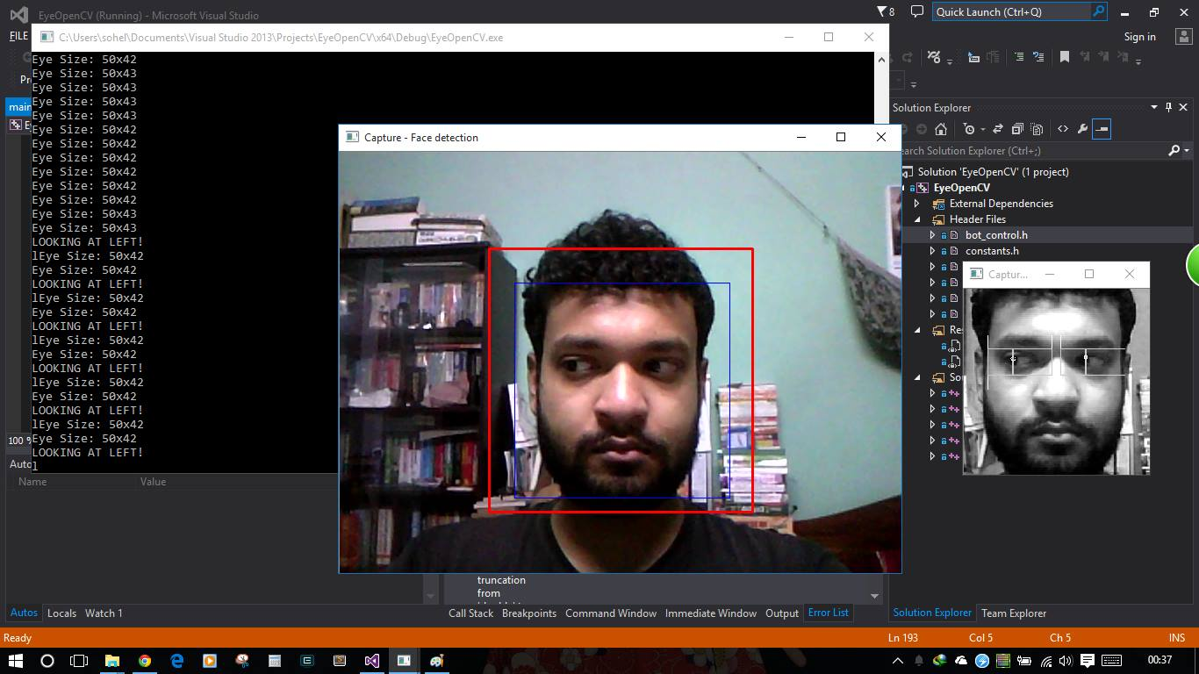

Fig: 5.1

In Fig 5.1, there is demonstration of the running code. As the human is looking left, it detects the movement and printing left.

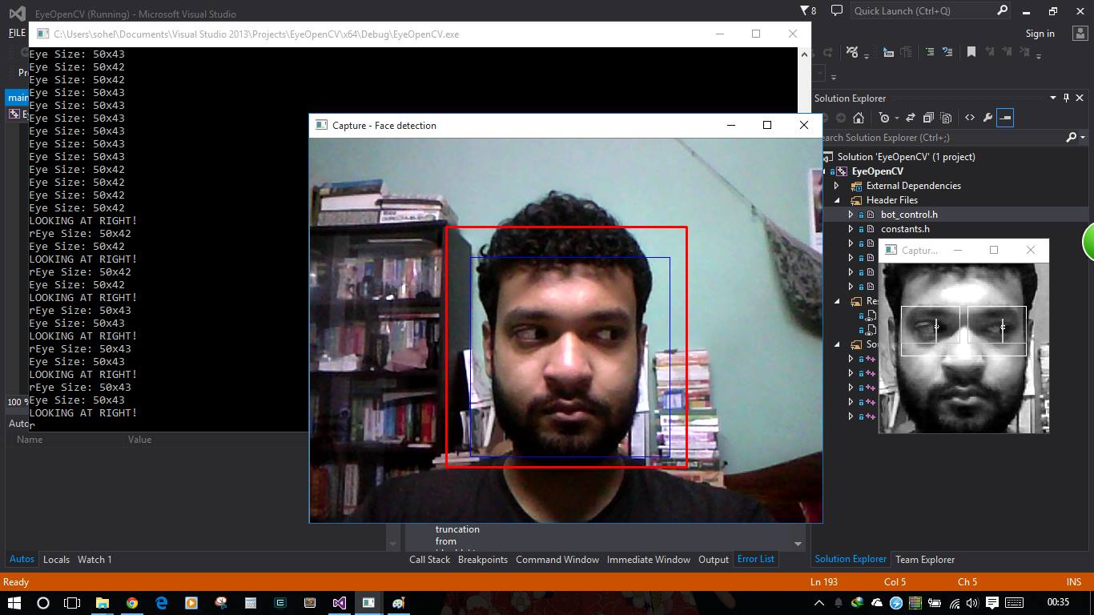

Fig: 5.2
In Fig 5.2, there is demonstration of the running code. As the human is looking right, it detects the movement and printing left.

It was quite a challenge but we managed to do it. We used a integrator CeempleOpenCV VS4 to integrate OpenCV with the visual studio. There is atleast 1000 lines of code in 5 classes and also 6 header files. The whole code is written in C++ language.

Communication
The main communication from software to hardware is done through the serial port. We select a serial port to send commands to the hardware and make sure that in the same port the Arduino is running. Arduino is coded to receive the commands and generate and send signals to the servos to rotate.

Power

The power in the hardware is actually given by the Arduino pins. The vcc and ground of the servos are connected to the 5v and gnd pins of arduino. The mini servos needs 5V to work so we do not have to use external power supply for those. For connecting 2 servos to the power, we use a small breadboard.

Cost

Items | Price (TK)
Arduino Mega 2560 | 900
Mini servo SG90/SG91 | 250x2
Breadboard | 120
Other | 100
Total | 1620

As we can see from the table, the project is very much affordable as it costs very less than other costly projects.

BLOCK DIAGRAM

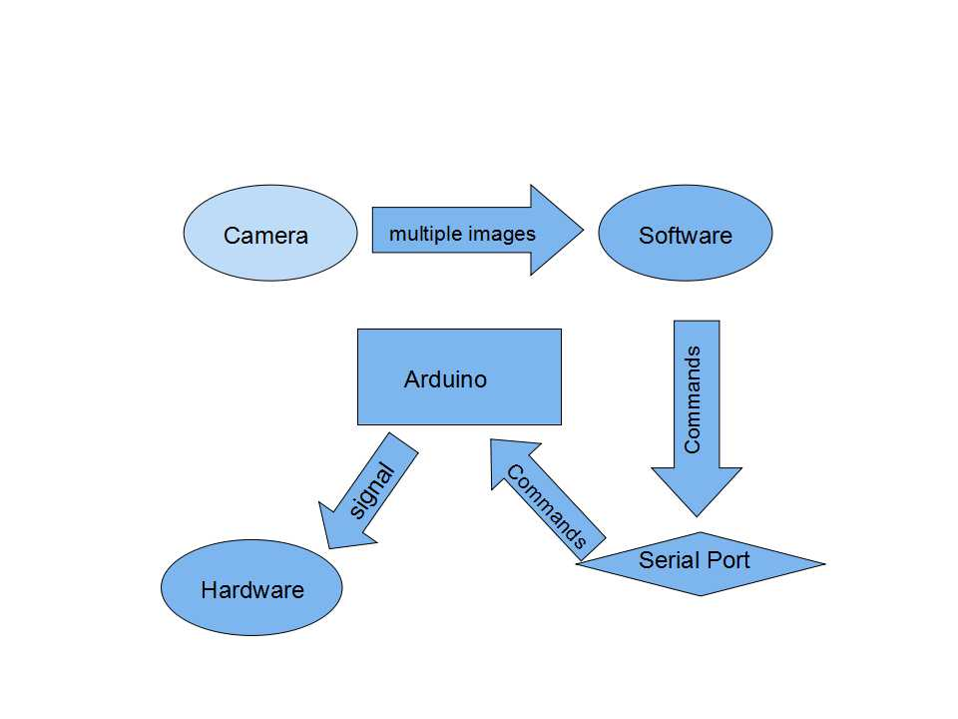

Fig: 4.1
This (Fig- 4.1) is the whole system in block diagram. Here we have shown what is going on with our system. A computer device is connected with a camera and arduino mega 2560 device. The camera is working as an input device and passing data as input to the software. Then the software processes the data and sends command to the arduino mega 2560 via serial port. The arduino mega 2560 then move the mechanical eyes accordingly.

Control system

The main control of the system is in the possession of the software. Software processes the images and then control the hardware eyes through the serial port.

Capability

The Software code can process the video images by detecting human eyes and then detects the iris. If it properly detects the iris, then it will be able to detect the iris movement and send command of any direction through the serial.
The hardware of robotic eyes is capable of moving in any direction. Generally, it can go up, down, left, right and into the 4 corners like left-up corner or bottom right corner etc.

Difficulties

We have faced many difficulties with the software part. As we have no earlier experience with the image processing, we found it difficult to process the images. Also, we have less experience of using software like OpenCV, Microsoft VS or C language. The lighting condition of testing the image processing has been a rough work. The ideal light condition is to be made to run the coding. So it takes a lot of effort to make such project.

FUTURE SCOPE

In this advanced world of technology, the image processing is becoming more popular nowadays. In near future, it can be possible to replace human eyes with robotic eyes which can be able to act and work exactly like human eyes. This types of research has already been going on in many countries. We are planning to go ahead with the image process to the next level in which the camera will be implemented inside the eyes and can detect any object and take decisions automatically.

Conclusion

A good eye tracking systems should be robust, provide comfort to user in terms of using, low cost and real time responses. Based on the results, the developed real time independent user eye tracking systems provide good results in accordance with these criteria. The robustness of the system was also verified under different situations such as multiple users (with glasses and without glasses), multiple ages, multiple lighting conditions (illumination change), multiple pose and variation of distances. By implementing flexible region of interest for image extraction, the size of data for determination has been reduced, hence it provides faster computation time and enable real time application.

Acknowledgment
We are indebted to Rubel Biswas Sir for his tremendous help during his individual interview session with the researchers of this project where he provided his valuable words for this project.

We are also grateful to Dr. Khalilur Rhaman for his motivational guidelines which kept us on the right track.

References

[1] Zheng Z, Yang J, Yang L (2005). A robust method for eye features
extraction on color image. Patt. Recog. Lett., 26: 2252-2261.
[2] Feng GC, Yuen PC (2001). Multi-cues eye detection on gray intensity image. Patt. Recog. Lett., 34: 1033-1046.

[3] Wang P, Ji Q (2007). Multi-view face and eye detection using discriminant features. Computer Vision and Image Understanding,
105: 99-111.

[4] Kawato S, Tetsutani N (2004). Detection and tracking of eyes for gazecamera
control. Image and Vision Computing, 22: 1031-1038.

[5] Zhu Z, Ji Q (2005). Robust real-time eye detection and tracking under variable lighting conditions and various face orientations. Computer Vision and Image Understanding, 98: 124-154.

[6] Amir A, Zimet L, Vincentelli AS, Kao S (2005). An embedded system for
an eye-detection sensor. Computer Vision and Image Understanding,
98: 104-123.

[7]Tristan Hume (2001). EyeLike Master,
https://github.com/trishume/eyeLike.git

[8] Face Detection using Haar Cascades,
http://docs.opencv.org/master/d7/d8b/tutorial_py_face_detection.html#gsc.tab=0

[9] LGProspects. Animatronic Eyes,
http://www.instructables.com/id/Eyes/

