Spatiotemporal Assessment and Forecasting of Desertification Risk in Sindh: A Framework using Satellite Imagery and Deep Learning

Abstract—In Pakistan's Sindh region desertification is increasing as a result of unpredictable monsoon patterns, overuse of agricultural resources, and land degradation. This paper outlines a framework which involves training two deep learning models on satellite data spanning from January 2016 to February 2026. Model A (SindhUNet) computes a Desertification Sensitivity Index (DSI) using 33 satellite channels, attaining an MAE of 0.0231, a Pearson r of 0.9581 and a Mean SSIM of 0.9608. Model B (SindhConvGRUUNet) generates autoregressive DSI forecasts until 2030 and has an MAE of 0.0564 together with a Skill Score against Persistence of 0.0048. When the analysis is carried out at the district level for the districts of Tharparkar, Thatta, Badin, Nawabshah, Khairpur and Dadu, risk maps that have geographical meaning are obtained. However, because of autoregressive error accumulation the forecasted DSI becomes zero in four of the six districts by 2030, a limitation that has been noted and discussed.

Keywords— Desertification Sensitivity Index (DSI), Spatiotemporal Forecasting, ConvGRU-UNet, MEDALUS Framework, Remote Sensing, Multi-Sensor Data Fusion, Geospatial Artificial Intelligence (GeoAI).

Introduction:
Pakistan is experiencing a serious environmental crisis, with 62 million of its 79.6 million hectares already being prone to desertification. The situation is most severe in Sindh, the lower riparian province, since water scarcity, land degradation and ecological collapse are all progressing simultaneously. This area suffers from a persistent annual water deficit of 40 to 45 per cent. In extremely arid areas like Tharparkar, satellite records indicate a 60 per cent loss of natural tree cover between 2000 and 2020.
Desertification is the term used for the deterioration of land in arid, semi-arid and dry sub-humid regions as a result of both climate change and human activity. Sindh has an area of about 140,914 km² and extends from the Thar Desert in the east to the Indus Delta and the coast of the Arabian Sea, with irrigated farming being concentrated in the Indus corridor. Studies of the vegetation in Tharparkar show a continuous decline in NDVI that is associated with an increasing vapor-pressure deficit and with land-surface temperatures exceeding 47°C [1]. A spatio-temporal analysis of the rainfall shows that the frequency of drought has increased considerably in the eastern districts [2]. Due to chronic over-irrigation, secondary salinisation has affected around 40% of the irrigated soils in the lower Indus basin. Since the 1980s, the land cover in the Indus Delta has gradually been replaced by salt flats and bare soil instead of productive fields and mangrove buffers [3]. Coastal surveys indicate that the mangrove area has decreased by approximately 50% over four decades [4]. The same kind of change in land cover is seen in southern Punjab [5], and neural-network methods have been applied to forecasting urban sprawl in Islamabad [6].
The MEDALUS Framework calculates a composite Desertification Sensitivity Index (DSI) as the geometric mean of four different sub-indices: the Climate Quality Index (CQI), the Vegetation Quality Index (VQI), the Soil Quality Index (SQI) and the Land/Management Quality Index (LQI). For each of the sub-indices satellite-observable variables are used. In previous applications in northeastern Algeria [7] and in the Thatta–Badin districts of Sindh [8] there was strong agreement between the DSI derived from satellite data and that measured in the field. A systematic review of desertification detection which makes use of multispectral Landsat imagery and deep learning models has also stressed the importance of combining spectral indicators with modern architectures in order to improve detection accuracy [9].
Efforts to combat desertification in Sindh are still fragmented. Most of the existing studies make use of optical imagery only and do not include SAR, soil data or climate reanalysis. The limited number of machine-learning applications are confined to binary classification or the production of static risk maps. The encoder–decoder model developed for Thatta and Badin [8] represents the most recent prior work, but it makes use of coarser data and does not carry out multi-year autoregressive prediction. Recent work that optimises a Swin Transformer encoder together with Capsule Networks (SwinCapT) for spatiotemporal desertification classification in the same arid Thatta–Badin setting further shows the benefit of hierarchical attention is capable of capturing both local and global patterns [10]. To date, no published system has combined real-time satellite data with multi-year forecasting at the district level. This study addresses that gap by employing a Geospatial Artificial Intelligence (GeoAI) framework which provides a 10-year multi-sensor dataset covering four ecological strata, SindhUNet for estimating DSI on a single-month basis from 33 satellite channels, SindhConvGRUUNet for forecasting over five years on a quarterly basis, and district-level risk maps that incorporate quantified uncertainty.

METHODOLOGY 2:
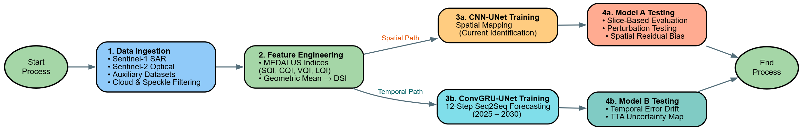
A. Study Area and Data
The study is concerned with Sindh Province (23°N–28°N, 66°E–71°E). The area of Tharparkar (Arid/Desert) lies in the eastern part of the desert fringe and has an annual rainfall that seldom goes above 150 mm. Thatta and Badin (Coastal/Mangrove) include the Indus Delta; the land cover analysis shows a dramatic reduction in mangrove area over four decades [3], [4]. Khairpur (Agriculture) is situated along the Indus north of Sukkur and is a major region for the production of sugar cane and cotton. Multi-sensor approaches that combine Sentinel-1 and Sentinel-2 have previously been shown effective for soil-salinity monitoring in comparable dryland settings [11]. Dadu (Shrub/Grass) is in the transitional area between the irrigated plain and the Kirthar range and is dominated by dry shrubland.
The sampling followed a stratified design based on ESA WorldCover v100 (2020). The native classes were rewritten to correspond to four specially defined strata: Agriculture (ESA class 40), Arid/Desert (class 60), Shrub/Grass (classes 20 and 30), and Coastal/Mangrove (classes 90 and 95). A total of 1,000 sample points were selected using GEE stratifiedSample at a resolution of 10 metres: 300 for Agriculture, 300 for Arid/Desert, 200 for Shrub/Grass, and 200 for Coastal/Mangrove. Each point was then transformed into a bounding box of 640 m × 640 m. The 1,000 patches were divided in the ratio of 80/20 into 400 training patches and 100 validation patches. An additional 500 non-overlapping patches was set aside as a holdout test set, the data for which spans from January 2024 to February 2026.
TABLE I
Dataset composition and temporal coverage
TABLE I
Dataset composition and temporal coverage
Split | Patches | Time Period | Months | Samples (UNet) | Samples (ConvGRU-UNet) | Strata
Train | 400 | Jan 2016–Dec 2023 | 96 | 38,400 | 10,800 | 1–4
Validation | 100 | Jan 2016–Dec 2023 | 96 | 9,600 | 2,700 | 1–4
Test (Holdout) | 500 | Jan 2024–Feb 2026 | 26 | 13,000 | 2,500 | 1–4

B. The preprocessing of images and the engineering of features
The processing of all the satellite data was carried out on the Google Earth Engine platform. The Sentinel-2 SR images were filtered to include only those scenes with less than 60 per cent cloud cover and were cloud-masked using the Scene Classification Layer. Monthly median composites were then produced. For the Sentinel-1 GRD data, only images acquired in IW mode and having VV and VH polarisations were selected; monthly median composites were calculated in linear sigma-nought space. Sentinel-1 SAR has also been used successfully for soil-moisture mapping with cloud-based regression on Google Earth Engine [12]. The MODIS products (LST, ET, LAI), the TerraClimate variables, the CHIRPS precipitation data, the VIIRS night-light data, the GPWv4 population density data, and the Google Dynamic World land cover data were all processed using the published scale factors. The static datasets (SRTM elevation/slope/aspect, OpenLandMap SOC, SoilGrids bulk density) were sampled once and the resulting tiles were applied to all the monthly time steps.

Through multi-sensor data fusion, each monthly time step the data consists of a spatial image with 38 channels and an effective resolution of 10 metres. The first 33 channels act as satellite inputs, while channels 33 to 36 contain the four MEDALUS sub-indices and channel 37 contains the target DSI.
TABLE II
Channel composition of the 38-band monthly tensor

TABLE II
Channel composition of the 38-band monthly tensor
Channels | Source | Variables | Count
0–2 | Sentinel-1 | VV, VH backscatter, VH–VV ratio | 3
3–9 | Sentinel-2 | Blue, Red, NIR, SWIR; NDVI, NDWI, MSI | 7
10–12 | Sentinel-2 | NDDI, SAVI, EVI | 3
13–15 | MODIS | LST (°C), Evapotranspiration, LAI | 3
16 | CHIRPS | Monthly total rainfall (mm) | 1
17–22 | TerraClimate | Pr, PET, Tmax, Tmin, VPD, PDSI | 6
23–25 | OpenLandMap / SoilGrids | SOC, Texture class, Bulk density | 3
26–29 | SRTM | Elevation, Slope, Aspect, Hillshade | 4
30–32 | VIIRS / GPWv4 / Dynamic World | Night lights, Pop. density, Land cover | 3
33–36 | Computed (MEDALUS) | CQI, VQI, SQI, LQI | 4
37 | Computed (MEDALUS) | DSI (training target) | 1

C. Index Formulation
The four sub-indices and composite DSI are calculated as follows:
CQI = (f_rain × f_pdsi × f_temp × f_vpd)^(1/4)
VQI = (f_ndvi × f_savi × f_evi × f_nddi)^(1/4)
SQI = (f_soc × f_bulk × f_ndwi × f_slope)^(1/4)
LQI = (f_lc_sens × f_pop × f_lights)^(1/3)
DSI = (CQI × VQI × SQI × LQI)^(1/4)

The DSI ranges from 0 to 1, with values nearing 1.0 showing a high degree of sensitivity to desertification.
D. Deep Learning Architectures
SindhUNet assigns a single monthly observation (33 channels × 64 × 64) to a DSI map of size 1 × 64 × 64. It uses a standard encoder-decoder architecture with four stages of downsampling. The encoder has depths of 64, 128, 256 and 512 channels, with a 512-channel bottleneck at 4×4. The decoder follows the same structure but uses transposed convolution for upsampling and concatenates the results from the skip connections. The architecture contains 13,257,409 trainable parameters. U-Net-based architectures have also been extended with spatio-temporal Sentinel-1 features for land-cover mapping [13].
The training was carried out using AdamW with a learning rate of 3×10⁻⁴ and a weight decay of 1×10⁻⁵. The objective function was a weighted mix of MSE and MAE [14].
The SindhConvGRUUNet employs a shared CNN encoder which compresses each DSI map from (B, 1, 64, 64) to (B, 128, 8, 8). A ConvGRU encoder creates a final hidden state that captures the temporal history [15], [16]. A ConvGRU decoder then generates the future DSI maps in an autoregressive manner by using a residual approach that predicts the delta DSI rather than the absolute values [14], [17]. The loss function was Huber loss (with δ = 0.1) based on the predicted deltas compared to the target deltas [18]. This architecture have total of about 2.3 million trainable parameters. Prior work has shown that ConvGRU outperforms standard LSTMs when predicting two-dimensional spatial fields over time [19].

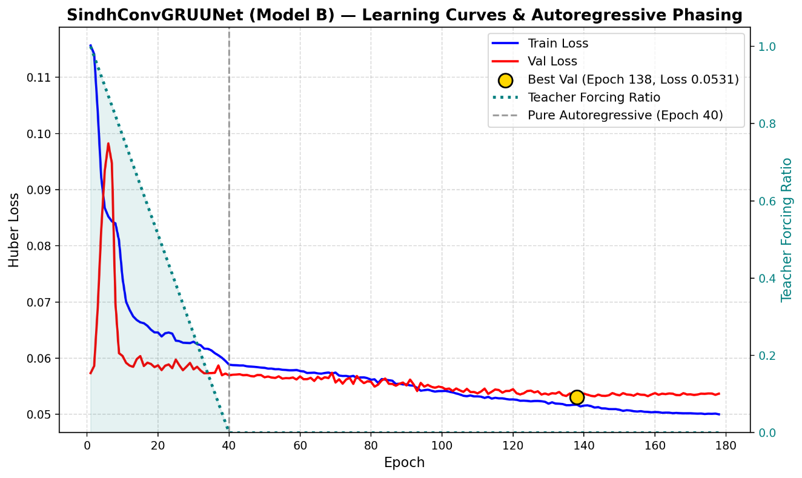

RESULTS 2
A. The spatial baseline and the factors that influence features
The baseline maps for the DSI were created for six inference districts. For Badin, an analysis of the importance of various features showed that the climate and soil moisture factors were the main drivers of the predicted DSI. The anomaly maps compared with the 2025 baseline and the stacked bar charts showing the contributions of the sub-indices for both Badin and Nawabshah indicate that the higher SQI and CQI values are responsible for the greatest amount of risk in the irrigated and coastal areas. The agriculture and arid regions display the most consistent spatial patterns of risk, whereas the coastal mangrove areas show greater local variability.
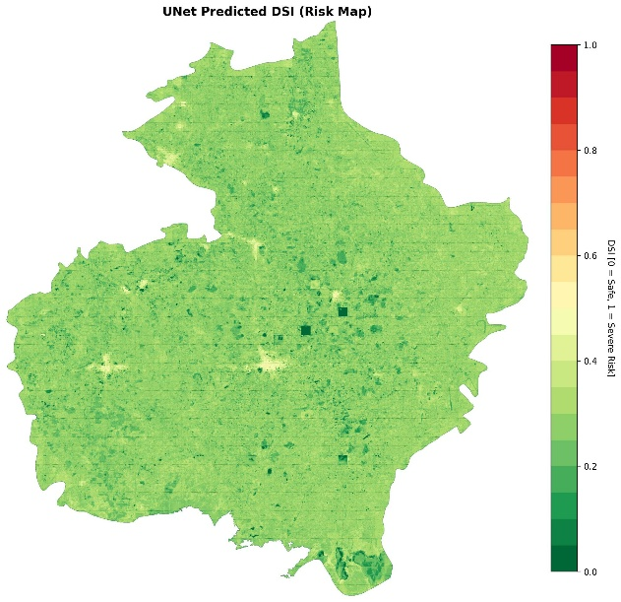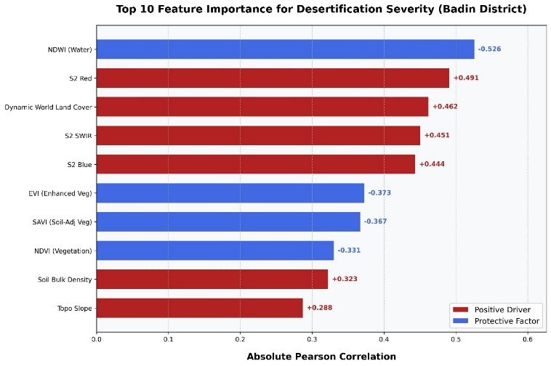
B. Spatiotemporal Forecasting (2025–2030)
Table III presents the expected development of the districts by 2030. In the case of Badin (Coastal/Deltaic) and Nawabshah (Agriculture), there is active growth in desertification sensitivity, the net increase over five years being 0.077 and 0.052 respectively. On the other hand, Tharparkar, Thatta, Khairpur, and Dadu show recursive attenuation: the autoregressive decoder causes the forecasted mean DSI to reach 0.0 by the end of the forecast period. This is a well-known limitation of long-horizon autoregressive rollout due to error accumulation. The model must therefore be regarded as showing directional trends rather than providing accurate annual values for these four districts.
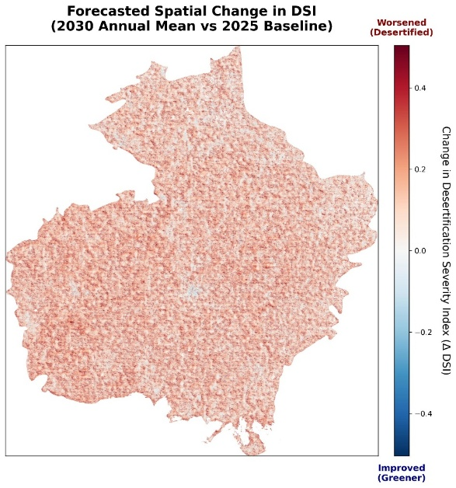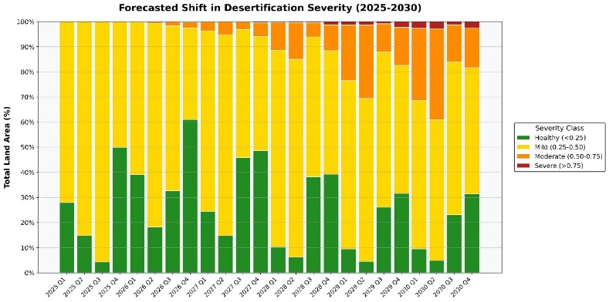
Badin District

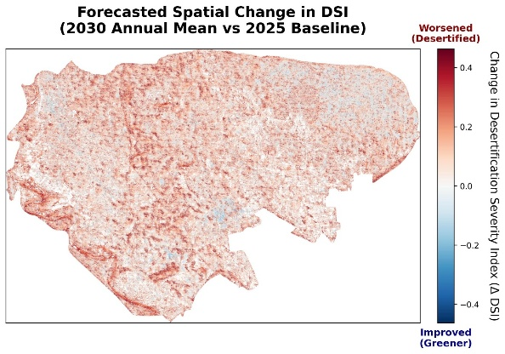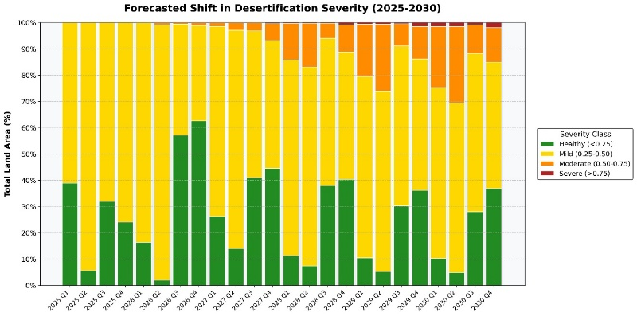

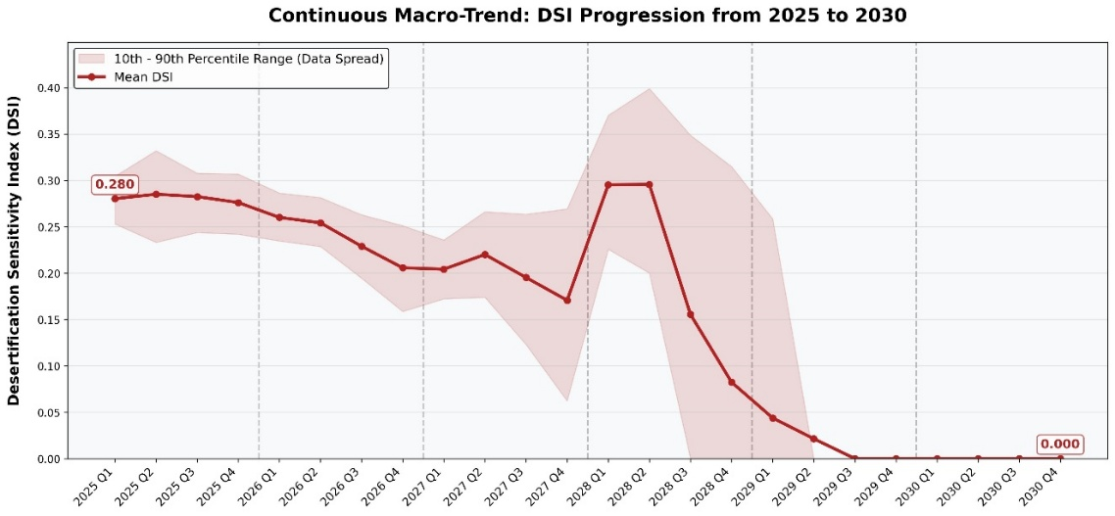
TABLE III
2030 district trajectory summary
# | Stratum | District | 2025 DSI | 2030 DSI | Δ | Status
1 | Coastal/Deltaic | Badin | 0.267 | 0.344 | +0.077 | Active Expansion
2 | Agriculture | Nawabshah | 0.267 | 0.319 | +0.052 | Active Expansion
3 | Hyper-Arid | Tharparkar | 0.280 | 0.000 | −0.280 | Recursive Attenuation
4 | Deltaic Margin | Thatta | 0.255 | 0.000 | −0.255 | Recursive Attenuation
5 | Desert Fringe | Khairpur | 0.244 | 0.000 | −0.244 | Recursive Attenuation
6 | Shrub/Grass | Dadu | 0.260 | 0.000 | −0.260 | Recursive Attenuation

Validation Results:
Category | Metric | Model A (CNN-UNet) | Model B (ConvG UNet)
Shared Metrics | Mean Absolute Error (MAE) | 0.0231 | 0.0564
Shared Metrics | Root Mean Square Error (RMSE) | 0.0323 | 0.0781
Shared Metrics | Pearson Correlation (r) | 0.9581 | 0.4599
Shared Metrics | Spearman Rho (rho) | 0.9140 | 0.2717
Shared Metrics | Mean SSIM | 0.9608 | 0.5137
Model A Specific (High-DSI Detection) | R-squared (R^2) | 0.8543 | —
Model A Specific (High-DSI Detection) | Precision (DSI ≥ 0.4) | 0.3112 | —
Model A Specific (High-DSI Detection) | Recall (DSI ≥ 0.4) | 0.9191 | —
Model A Specific (High-DSI Detection) | F1 Score | 0.4649 | —
Model B Specific (Baseline Comparison) | Skill Score vs. Persistence | — | 0.0048
Model B Specific (Baseline Comparison) | Persistence MAE | — | 0.0518
Model B Specific (Baseline Comparison) | Improvement Over Persistence | — | -0.0046

C. The robustness of the model and its epistemic uncertainty
The test set consisting of 13,000 samples (in the case of Model A) and 2,500 samples (for Model B) includes data from spatial locations and time periods which were not encountered during training. When evaluated on a slice basis, Model A showed the best accuracy in the Agricultural strata (with a MAE of 0.020 and an RMSE of 0.028), while the error levels were similar in the Coastal/Mangrove and Shrub/Grass areas. The highest errors are seen in the Coastal/Mangrove patches.
When perturbation testing was carried out, 20% standard deviation Gaussian noise was applied to 53.2 million pixels and this produced a global mean deviation of 0.0066. The spatial residual mapping showed a small global over-prediction bias of +0.0194, with the highest value occurring in the Shrub/Grass areas (+0.0228). With respect to Model B, the temporal error drift analysis found that the MAE increased linearly from 0.0432 at T+1 to 0.0696 at T+4. Test Time Augmentation, which was applied to more than 10.2 million of the forecasted pixels, resulted in a very stable global mean uncertainty.

CONCLUSION:
This paper presents a detailed framework for spatiotemporal evaluation and prediction of desertification risk in Sindh. SindhUNet accurately maps the present DSI at 30 m effective resolution. SindhConvGRUUNet makes quarterly DSI forecasts through 2030, correctly identifying active expansion in Badin and Nawabshah. In Tharparkar, Thatta, Khairpur, and Dadu, autoregressive error accumulation forces forecasted DSI to 0.0, a limitation that is noted and limits interpretation of long-horizon trajectories in hyper-arid and transitional zones to directional trends only.
The current assessment maps can be made use of by the district environmental agencies to help decide which areas to focus on for water harvesting in the residual high-SOC patches of Tharparkar, for mangrove restoration in the active distributary channels in Thatta and Badin, and in the canal command areas of Khairpur, in cases where a high SQI shows that there is secondary salinization. The results show a "recursive attenuation" phenomenon in which the predicted DSI mathematically reduces to 0.0 in several districts; future versions of the model must incorporate physics-informed loss functions or fixed aridity anchors in order to stop the hidden state from decaying as the time horizon extends in very dry areas. The framework has to include conditioning based on CMIP6 climate scenarios so as to produce different desertification trajectories according to particular global warming scenarios.

References
[1] S. S. Hassan et al., “Monitoring the effects of climate change and topography on vegetation health in Tharparkar, Pakistan,” J. Water Climate Change, vol. 15, no. 8, pp. 3472–3486, Jul. 2024, doi: 10.2166/wcc.2024.398.
[2] M. Usman and J. E. Nichol, “A spatio-temporal analysis of rainfall and drought monitoring in the Tharparkar region of Pakistan,” Remote Sens., vol. 12, no. 3, Art. no. 580, 2020, doi: 10.3390/rs12030580.
[3] M. Masood, C. He, S. A. Shah, and S. A. U. Rehman, “Land use change impacts over the Indus Delta: A case study of Sindh Province, Pakistan,” Land, vol. 13, no. 7, Art. no. 1080, 2024, doi: 10.3390/land13071080.
[4] M. Irfan et al., “Spatiotemporal modelling of coastal vulnerability and ecosystem degradation in Indus Delta: A Landsat and DSAS approach,” Mehran Univ. Res. J. Eng. Technol., vol. 44, no. 4, pp. 209–221, Oct. 2025, doi: 10.22581/muet1982.0502.
[5] Y. Hu et al., “Land use/land cover change detection and NDVI estimation in Pakistan’s southern Punjab province,” Sustainability, vol. 15, no. 4, Art. no. 3572, 2023, doi: 10.3390/su15043572.
[6] S. Sarwar et al., “Forecasting urban sprawl dynamics in Islamabad: A neural network approach,” Remote Sens., vol. 17, no. 3, Art. no. 492, 2025, doi: 10.3390/rs17030492.

[7] Z. Khaldi et al., “PyGEE-ST-MEDALUS: AI spatiotemporal framework integrating MODIS and Sentinel-1/-2 data for desertification risk assessment in northeastern Algeria,” Remote Sens., vol. 17, no. 19, Art. no. 3350, Oct. 2025, doi: 10.3390/rs17193350.
[8] K. Panhwar, B. N. Soomro, S. Bhatti, and F. H. Jaskani, “Novel encoder–decoder architecture with attention mechanisms for satellite-based environmental forecasting in smart city applications,” Future Internet, vol. 17, no. 9, Art. no. 380, 2025, doi: 10.3390/fi17090380.
[9] K. Panhwar, B. Naz, and S. Bhatti, “A Systematic Review of Desertification Identification with Multispectral LANDSAT Image and Deep Learning Models,” International Journal of Innovations in Science & Technology, vol. 6, no. 1, pp. 143–169, Feb. 2024.
[10] K. Panhwar, B. Naz, S. Bhatti, A. Shaikh, and A. Alqazzaz, “Optimizing swin transformer encoder for spatiotemporal desertification classification in an arid environment,” PeerJ Computer Science, vol. 12, Art. no. e3788, 2026, doi: 10.7717/peerj-cs.3788.
[11] J. W. Sirpa-Poma et al., “Complementarity of Sentinel-1 and Sentinel-2 data for soil salinity monitoring to support sustainable agriculture practices in the Central Bolivian Altiplano,” Sustainability, vol. 16, no. 14, Art. no. 6200, 2024, doi: 10.3390/su16146200.
[12] T. T. Kondraju et al., “Soil moisture mapping using Sentinel-1 SAR data and cloud-based regression modeling on Google Earth Engine,” Environ. Earth Sci. Proc., vol. 36, no. 1, Art. no. 9, 2025, doi: 10.3390/eesp2025036009.
[13] L. Russo, A. Sorriso, S. L. Ullo, and P. Gamba, “A deep learning architecture for land cover mapping using spatio-temporal Sentinel-1 features,” arXiv:2503.07230, 2025.
[14] R. Yang et al., “Enhancing severe weather predictions with the I-ConvGRU model: An iterative approach for radar echo time series through ConvGRU and RainNet integration,” J. Hydroinformatics, vol. 26, no. 9, pp. 2197–2215, Aug. 2024, doi: 10.2166/hydro.2024.068.
[15] T. Ma, L. Zhang, X. Diao, and O. Ma, “ConvGRU in fine-grained pitching action recognition for action outcome prediction,” arXiv:2008.07819, 2020.
[16] Y. Xu, Q. Xie, Z. Ni, and P. Ren, “CGSCNet: ConvGRU based skip-connection framework for hyperspectral image super-resolution,” in Proc. 7th Int. Conf. Sensors, Signal Image Process. (SSIP), 2024, pp. 97–102, doi: 10.1145/3725949.3725957.
[17] R. Xiao et al., “OKG-ConvGRU: A domain knowledge-guided remote sensing prediction framework for ocean elements,” Remote Sens., vol. 17, no. 15, Art. no. 2679, 2025, doi: 10.3390/rs17152679.
[18] A. Atabati, I. Jazireeyan, M. Alizadeh, and R. B. Langley, “Prediction of ionospheric scintillation with ConvGRU networks using GNSS ground-based data across South America,” Remote Sens., vol. 16, no. 15, Art. no. 2757, 2024, doi: 10.3390/rs16152757.
[19] J. Tang, Z. Zhong, M. Ding, D. Yang, and H. Liu, “Forecast of ionospheric TEC maps using ConvGRU deep learning over China,” IEEE J. Sel. Topics Appl. Earth Observ. Remote Sens., 2024.

