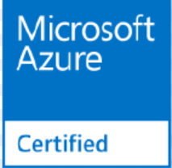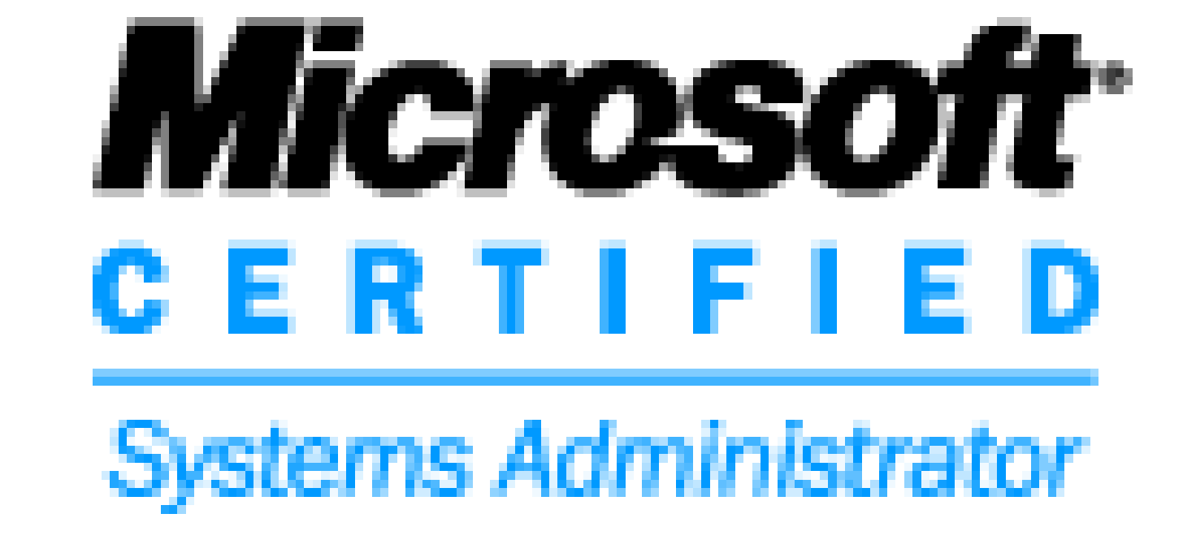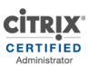

**Ahmed Farook Gaziyani**

**Sahyog Shoppping Centre & Residential Arcade,**

**B3/34 above Olympia Gym Shailesh Nagar Mumbra.**

**Dist: Thane.**

**Mob- 9221285433**

**Email- ahmedgaziyani@yahoo.com.**

A result-driven IT professional with experience in the engineering, administration and support of information systems. Knowledge in basic troubleshooting of LAN network system. Experience on Servers, Mailing System and Desktops, in addition, have a well-rounded background in Microsoft Server 2003, 2008, 2012 environments Fast and reliable; quick learner; team player.

**Objective:** Multi Product Expert and a PowerShell Scripter.

**Area of interest:** Azure Cloud Consultant / Windows Servers / Active Directory / VMware / Citrix / Nutanix / PowerShell Scripting / Provide Training.

**Experience:** **About 13 Yrs**.

**Skills Set:** Azure Cloud administrator**,** Google Cloud**,** Windows 2008, Windows 2012 R2, Active Directory, DNS, SCOM, VMware, PowerShell, Nutanix. Training people on above technologies

**Achievement**

* Received the Appreciation AWARD for Implementing Active Directory & DNS Infrastructure for TCS.
* Team CAP AWARD for Technical Performance from WIPRO INFOTECH
* Received Cash award of Euro 500 for MAAS Infra Project
* From the last 5 years got 1 rating (Excel Performer) in Capgemini Performance Rating
* Every 2 years got promoted in CapGemini.
* Currently working as Escalation Engineer for complete Wintel Infrastructure.
* Internal L&D Trainer, trained more than 300 working professionals on PowerShell

**Academic Qualification:**

1. Completed BSC-IT with First Class from SMU University in 2011.
2. Passed Diploma in Computer Technology from YCMO University in 2007.
3. Passed SSC with from Mumbai Board in 2003.

**Additional Qualification:**

1. Microsoft Certified System Administrator
2. Microsoft 2012 Hyper-V certified
3. Citrix Certified
4. Nutanix Certified
5. Azure Certified

==================================================================================================

**Work Experience:**

**LTI : June 2018 till Date**

**Project : Carrier Global Services**

**Designation : Azure Cloud Consultant**

**Microsoft Azure (Cloud) Operations:**

* Managing Azure IAAS Platform
* Responsible for managing multiple subscription (Prod/Pre-Prod/Dev/INFRA)
* Knowledge on Different type of subscription and on EA part
* Managing and deploying resource group as per the requirement
* Strong understanding of Azure Vnet / Subnet as per the CIDR notation.
* Strong knowledge on NSG and Associated the NSG on Multi Subnets and Created the Rule for RDP / IIS / and blocking traffic between subnets (vlan like scenario) of same Vnet.
* Strong Knowledge on Azure Network Gateway part knowledge on.
  + **Site to Site Connectivity**
  + **Point to Site**
  + **Multi-Site**
  + **Express Route**
* Peered Virtual Network in Hub and Spoke topology between same regions
* Knowledge on Load balancer inter and external
* Superb knowledge on PowerShell
* Worked on Storage (Blob Storage and File Share) and Managed Disk and Unmanaged Disk.
* Worked on Azure VM and Availability sets and Reserved VM instances and VM templates
* AD sync between On-Premise & Azure AD, manage users and groups and monitor AD Connect, Adding Custom Domain and synching user with UPN attribute and detail knowledge of working with Source Anchor attributes
* AD Sync with Password Hash Sync / ADFS / And Passthrough Authentication.
* Worked on troubleshooting issues related to delta and initial Sync.
* Worked on Azure backup and recovery and snapshots.
* Overall Complete knowledge on IAAS Module (VM / Network / Storage) and on Azure AD.

**Azure Projects Successfully Completed:**

* Migrated on-Premise Machines to Azure
* Create the plan for Network separation for demerger of carrier.
* Migrated all Express Route Authorization to vNet Peering
* Migrated VM’s between Cross Tenant Azure to Azure
* Planned BCDR for a Clustered Application
* Implemented Light House as we were having multiple subscriptions in different business owned tenant.
* Implemented Cost Saving strategies like removing unwanted gateways / disk / resize VM’s / Reserved VM Instance
* Planned the network strategies across the environment
* Created a PAAS based DR using Webapp / SQL DB / and Traffic Manager for almost 2 applications instances across regions.
* Migrated all the basic LB to Standard LB’s Due to limitation of Global Peering Not supporting Basic Lb’s

**Capgemini India PVT LTD:** Oct 2012 till date (Almost 5.5 Years Completed)

**Project Assigned:** TOTAL

**Designation:** Senior Consultant

**Role:**

* Remote supporting more than 5000 servers for TOTAL.
* Responsible for Installation & configuration of VMware Infra including (ESXi Hosts, SRM, Update Manager etc..)
* Scripting many things through PowerShell.
* Managing more than 300+ ESXI Hosts & Domain Controllers.
* Helping team resolving issues and currently handling escalations.
* Installation / Demotion of ESXI Hosts & Domain Controller upon request.
* Managing File Servers / DHCP Servers and Clusters.
* Knowledge on Active Directory /FSMO /LDAP / Group Policies /DNS.
* Implementation & Management of SCOM 2012 r2 Infrastructure.
* Interaction with client for escalated issues.
* In-depth Knowledge of VMware / AD / PowerShell / Nutanix.
* Troubleshooting Domain Controller issue.
* Helping team member for solving issues.
* Worked on multiple technologies.
* Trained people on multiple technologies (VMware / Windows Server / Active Directory / Nutanix / PowerShell).

**VMware sphere 5.5 & 6.0**

* Having In-depth knowledge of VMware vSphere.
* Managing & maintaining around 200 ESXi host with High availability solution of Vmware.
* Design, install, configure VMware ESXi, within vSphere 5 & 6 environments with Virtual Center management, Consolidated Backup, DRS, HA, DPM, vMotion, Having good knowledge on command line tool like PowerShell.
* Build, configure and deploy VMs and templates. Completed Physical-to-Virtual (P2V), migration of Windows 2008, and 2012.
* Ensuring best practice should be followed on infrastructure.
* Analyze and troubleshooting the major issue on infra & providing root cause analysis to client. Also working with L2 team on escalated issues.
* Providing solution for performance related issue of compute & storage resources on infra. Like VM, Storage & network performance related issue.
* Hands on experience in iSCSI, NFS, and Fiber Channel protocols, Fiber Channel cabling.
* Doing capacity planning of vSphere infra including Compute & Storage resources. Also Responsible to maintain 99% uptime of infra. Creating Virtual Machines.
* Ensure uptime of ESX vSphere Cluster.
* Ensure HA, DRS configured and working with routine checks.
* Taking Snapshot Backups / Cloning & creating OVF template of Virtual Machines.
* Creating new data store & managing Data Store Space.
* Creating scheduled task for automation of work.
* Patch update with the help of Update Manager

===============================================================================

**TCS –eServe LTD (TATA CONSULTANCY SERVICES): From Feb 2009 to March 2010 on the Payroll of Byzan Systems and From Apr 2010 on the Payroll of TCS.**

**Client: TCS –eServe LTD (TATA CONSULTANCY SERVICES)**

**Designation:** Server Engineer (Wintel System Administrator and Active Directory Support)

**Role**

* Remotely Support of all in-house Domain Controllers.
* Supporting for Windows 2003 Server & Windows 2008 Server.
* Installing the Domain Controller & Additional Domain Controller upon request.
* Configuring and Troubleshooting issues related to sites and services.
* Configuring & troubleshooting issues related to DNS.
* Knowledge on Active Directory /FSMO /LDAP / Group Policies /DNS
* Troubleshooting issues related to Active Directory Replication.
* Monitoring Active Directory through SCOM (System Center Operations Manager).
* Monitor the issues related to hardware failure on branded servers i.e. Hp, Dell etc. & inform the same to Client.
* Interact with client for critical issues which need immediate attention of the onsite technician.
* Implemented several projects and handed over to team
* Managing SQL servers (Taking Backup and Shrinking Databases)
* Patches Installation on all Domain Controllers
* Managing more than 25 Domain Controllers for TCS
* Analyzing unexpected server reboot

**Project Implemented at TCS:**

* Implemented the new Active Directory Forest for TCS eServe and for TCS Client.
* Implementation of RDP Setup, configuring Sites & Group Policies for TCS.
* Implemented SCOM for TCS.
* Implemented SCCM for TCS
* Implemented Profile Based Removable Device Control through Group Policy
* Implemented DHCP
* Implemented LYNC 2010 for Live Meeting purpose

==================================================================================================

**Wipro InfoTech: Apr 2008 till Jan 2009 (Total tenure)**

**Empower HR Pvt. Ltd., a Wipro InfoTech Ltd. Channel Partner from Apr 2008 to Nov 2008 and from Nov 2008 on the payroll of Wipro (Retainer)**

**Client: Future Group**

**Designation:** Desktop Level2 Engineer**.**

**Role:**

* System Administration:
* All Server administration in a team environment.
* Handle first level Diagnosis of all Server
* Maintain and Troubleshoot all server, Network in a Domain Environment.
* Applying MS-patches and O.S Service packs on critical servers after getting approval of IT Team.
* Creating, Deleting and Modifying Domain ID’s for windows login. Defining and Managing GPO for the department OU’s & performing Server 2003 environment Configuration
* Monitor Server through Monitoring tools.
* Handle technical escalations of client. Providing technical support to all team members for queries and helping them to solve the problem with efficient solutions in all types of calls.
* Attending Calls of VIP Users

**Technical Contribution:**

Guiding and Training Engineers to work in a team and defining task for all engineers. Finding solution to technical problems and creating knowledge base document that can be used for reference in future. Invent ways to accomplish a specific task with minimum time and efforts.

**Indian Institute of Hardware Technology: From Sep 2007 till Apr 2008**

**Designation: - Lab In charge and Trainer.**

**Role:**

* Responsible for maintaining, upgrading, and assembling desktop computers.
* Installed operating systems, applications, service packs etc.
* Troubleshoot hardware problems with network cards, video cards, sound cards, motherboards, modems etc.
* Provides the training of MCSE on 2003.

**Personal Details:**

**Languages Known :** Hindi & English

**Date of birth :** 22-08-1987

**Marital Status :** Married

**Mob :** 9221285433

**Email :** [ahmedgaziyani@gmail.com](mailto:ahmedgaziyani@gmail.com).

**Yours sincerely**

**Ahmed Gaziyani**