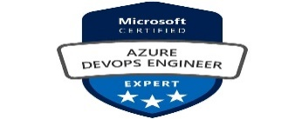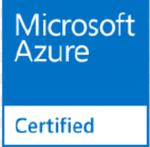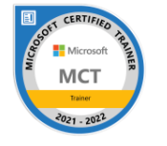

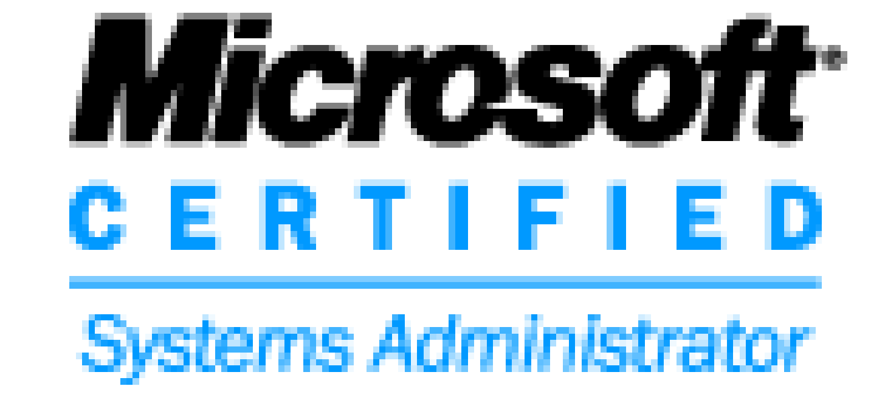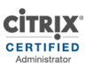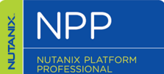

|  |  |  |  |  |  |  |  |  |  |  |  |
| --- | --- | --- | --- | --- | --- | --- | --- | --- | --- | --- | --- |
| Ahmed Gaziyani | |  |  | | --- | --- | | A/410, Universal Arcade, Amrut Nagar, Mumbra 400612 |  | | 9221285433 / 8369263501 |  | | ahmedgaziyani@gmail.com |  | | http://bit.do/ahmedgaziyani |  | | https://twitter.com/@ahmedgaziyani |  | |

A result-driven IT professional with experience in the Administration / Implementation / Planning / Training / Troubleshooting in IT Infrastructure Products Azure Cloud / Active Directory / Scripting / Virtualization / Windows etc.

# Skills

|  |  |
| --- | --- |
| * Azure Cloud Consultant * PowerShell Scripter * Windows Servers * Active Directory | * Passionate trainer * SCOM * VMware * JavaScript Coder |

# Experience

### June 2018 – Till Date

## Azure Cloud Consultant / LntInfotech / MUMBAI

**Azure Operations:**

* Managing Azure IAAS Platform
* Responsible for managing multiple subscription (Prod/Pre-Prod/Dev/INFRA)
* Knowledge on Different type of subscription and on EA part
* Strong Working Experience in Azure Networks Services
  + VNET
  + NSG
  + Peering (Hub & Spoke Architechture)
  + UDR
  + Virtual Network Gateways (S2S , P2S , ER)
  + Load Balancers (Basic & Standard)
  + Traffic Manager
  + Application Gateway
* Strong Working Experience in Azure Storage Services
  + Blob
  + Fileshares
* Strong Working Experience in Compute / Backups
  + VM Size
  + Reservations
  + Cost Savings
  + Backup & Snapshot
  + Monitoring
  + Troubleshooting
* Overall Complete Working experience on IAAS Module (VM / Network / Storage) and on Azure AD.

**Azure Project Planned & Completed:**

* Migrated On-Premises Machines to Azure
* Created & Implemented the plan for Network separation for demerger of carrier.
* Migrated all Express Route Authorization to vNet Peering
* Migrated VM’s between Cross Tenant Azure to Azure
* Planned BCDR for a Clustered Application
* Implemented Light House as we were having multiple subscriptions in different business owned tenant.
* Implemented Cost Saving strategies like removing unwanted gateways / disk / resize VM’s / Reserved VM Instance
* Planned the network strategies across the environment
* Created a PAAS based DR using Webapp / SQL DB / and Traffic Manager for almost 2 applications instances across regions.
* Migrated all the basic LB to Standard LB’s Due to limitation of Global Peering Not supporting Basic Lb’s
* Conversion of RD hosts to LBs (Inbound NAT) which saved almost 120 license and compute cost.

**Azure Automations:**

* Automating Backup report
* Automating VM inventory report
* Writing PowerShell scripts for any need
* Pulling out report through Azure Kusto query

### Oct 2012 – June 2018

## Senior Consultant / Capgemini / MUMBAI

**Active Directory / Windows L3 Operations Support:**

* Remote supporting more than 5000 servers for TOTAL.
* Responsible for Installation & configuration of VMware Infra including (ESXi Hosts, SRM, Update Manager etc.)
* Scripting many things through PowerShell.
* Managing more than 300+ ESXI Hosts & Domain Controllers.
* Helping team resolving issues and currently handling escalations.
* Installation / Demotion of ESXI Hosts & Domain Controller upon request.
* Managing File Servers / DHCP Servers and Clusters.
* Knowledge on Active Directory /FSMO /LDAP / Group Policies /DNS.
* Implementation & Management of SCOM 2012 r2 Infrastructure.
* Interaction with client for escalated issues.
* In-depth Knowledge of VMware / AD / PowerShell / Nutanix.
* Trained people on multiple technologies (VMware / Windows Server / Active Directory / Nutanix / PowerShell).

### Feb 2009 – OCT 2012

## Server Engineer / TCS / Mumbai (Worked on contract and then on Payroll

**Active Directory Support:**

* Planned / Implemented Entire Active Directory Infrastructure for TCS-eServe (Financial Arm of TCS)
* Remotely Support of all in-house Domain Controllers.
* Implemented SCOM from Scratch
* Managed Entire AD infra for TCS for almost 4 years.

### Apr 2008 – Nov 2008

## Desktop Support L2 / Wipro / Mumbai (Contract Employee)

### Apr 2007 – Apr 2008

## Trainer / IIHT (Contract Employee)

# Education

1. Completed BSC-IT with First Class from SMU University in 2011.
2. Passed Diploma in Computer Technology from YCMO University in 2007.
3. Passed SSC with from Mumbai Board in 2003.

# Certifications:

1. Microsoft Certified System Administrator
2. Microsoft 2012 Hyper-V certified
3. Citrix Certified
4. Nutanix Certified
5. Azure Administration
6. Azure DevOps
7. Microsoft Certified Trainer

**Area Of interest:**

* Automation Expert
* Technical Problem Solver
* DevOps
* Trainer
* Blockchain

**Achievement:**

* Received Extra mile award from LntInfotech
* From the last 2 years getting 4 rating in LTI which is Excel Performer in LTI
* Received the Appreciation AWARD for Implementing Active Directory & DNS Infrastructure for TCS.
* Team CAP AWARD for Technical Performance from WIPRO INFOTECH
* Received Cash award of Euro 500 for MAAS Infra Project
* Throughout my tenure in Capgemini (5 years) got 1 rating (Excel Performer) in Capgemini Performance Rating
* Every 2 years got promoted in CapGemini.
* Currently working as an Escalation Engineer for complete Azure Cloud and Wintel Infrastructure.
* Internal L&D Trainer, trained more than 300 working professionals on PowerShell

**Yours sincerely**

**Ahmed Gaziyani**