# **Quartus Results**

## Elevator Controller (Top Level File):

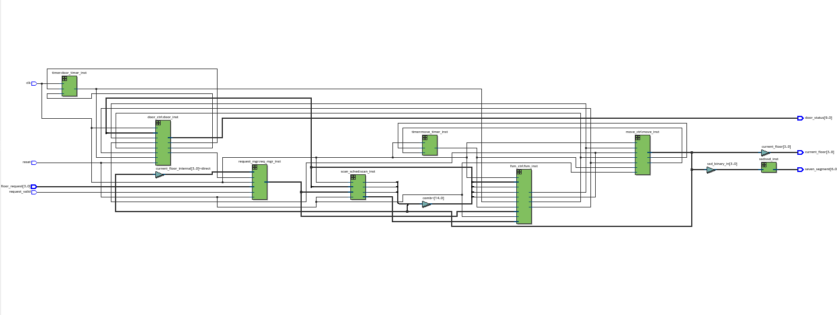

## Move Controller:

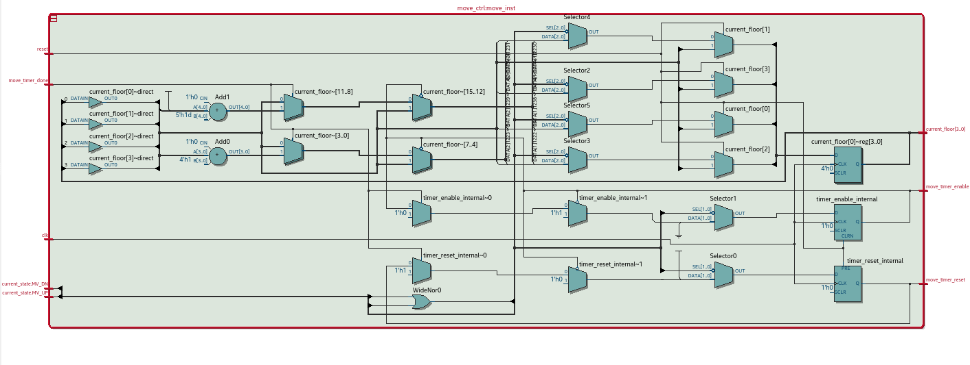

FSM Diagram: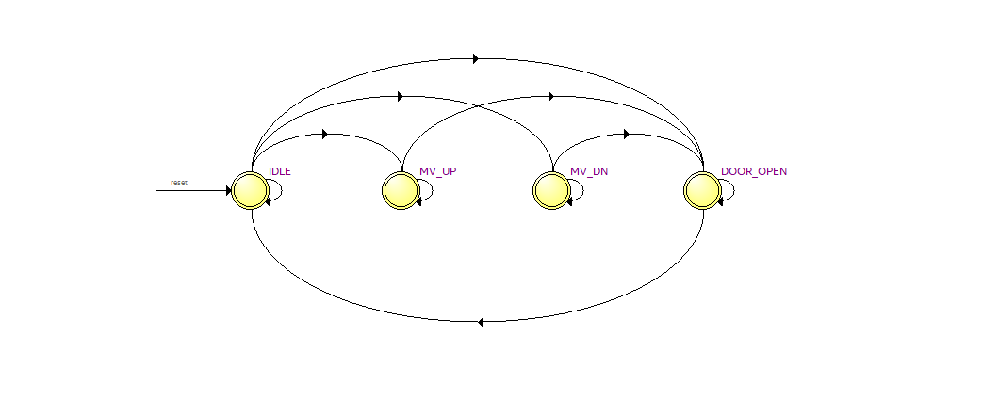

Detailed FSM:

