|  |  |  |
| --- | --- | --- |
| **شعار جامعة بنها الجديد**f |  | **logo.jpg** |
| **Benha University** |  | **Faculty of Computers & Informatics** |

***E-Peak***

A senior project submitted in partial fulfillment of the requirements for the degree of Bachelor of Computers and Informatics.

**Computer Science Departement,**

***Project Team***

1. Abanoub Fayez Kamal Mikhail .
2. Ahmed Fathy Abd-Elfattah Hassan.
3. Manar Elsayed Mohamed Ezzat.
4. Hala Mahmoud Gouda Elsayed.
5. Yara Abd -Elrahmaan Mahmoud Ali.
6. Yousef Reda Saed El-Hadad.

***Under Supervision of***

**Dr. Ahmed Taha**

Benha, July 2019

*Declaration*

We hereby certify that this material, which we now submit for assessment on the program of  
study leading to the award of Bachelor of Computers and Informatics in computer scienceis  
entirely our own work, that we have exercised reasonable care to ensure that the work is  
original, and does not to the best of our knowledge breach any law of copyright, and has not  
been taken from the work of others save and to the extent that such work has been cited and  
acknowledged within the text of our work.

**Signed:** _____________________________  
 _____________________________  
 _____________________________  
 _____________________________

____________________________

______________________________

**Date:** Thrusday , 4 July 2019.

Abstract

*Abstract*

As an abstract for this document, this document has been prepared by the College of computer and informatics , Benha University. In this document ,we will describe all phases that lead us to complete this project.

**About the project:-**

E-peak is a web application which is useful for students who are going to choose any course in higher education, for them this application is helpful to make the correct the decision with the accurate information. In addition, E-peak is useful also for Instructors to manage their courses easily.

Table of content

Contents

1. INTRODUCTION 7

PROBLEM STATEMENT 7

CURRENT SOLUTIONS 8

SOFTWARE DEVELOPMENT CYCLE 8

Requirement Analysis 8

Design 8

Implementation 8

Qualityassurance 8

Testing & integration 9

Maintenance 9

2. PLANNING AND SYSTEM REQUIREMENT 9

PALNNING of the system. 9

TIME ESTIMATION 9

User Requirements 11

1. Functional Requirements 11

2. Non-Functional Requirements 26

system stackholders 27

context digram 27

DATA FLOW DIAGRAM 28

entity relationship diagram (ERD) 29

3.SOFTWARE AND HARDWARE PLATFORMS 32

1. METHODOLOGY: - 32

Epics: 32

Stories tables: 32

2. Tools 33

IntelliJ IDEA: 34

MySQL Workbench 34

TortoiseSVN : 34

Node JS 35

The Java Development Kit (JDK) 35

Version control: 36

3 – Technologies 37

Components 38

Structural Directives 38

Routing 38

TypeScript (TS) 39

Spring Boot 39

Spring JDBC 39

Restful Web Services (API) 40

HTML5 41

CSS3 41

4 – Project ARCHITeCTURE 42

FRONT-END layer 43

BACK-END Layer 43

DataTier Layer 45

Summary of Architecture: 45

6 - IMPLEMENTAION DETAILS 46

COURSE RES 46

Quiz RES 54

Attandance RES 57

Grade RES 58

User RES 58

Lecture RES 59

Attachment RES 60

7-Deploy project using maven 62

REFERENCES 63

List of figures:-

*LIST OF FIGURES*

Figure 1 Learning Systems 7

Figure 2 Software Development Cycle 8

Figure 3 Gantt chart 10

Figure 4 Milestone 10

Figure 5 Use Case 11

Figure 6 Context diagram figure 27

Figure 7 user management 28

Figure 8 ERD Diagram 30

Figure 9 Intellij 33

Figure 10 my sql workbench 33

Figure 11 Tortoize Svn 33

Figure 12 nodejs 34

Figure 13CLI 34

Figure 14 JDK 35

Figure 15 history 35

Figure 16 angular 36

Figure 17 type script 38

Figure 18 spring boot 38

Figure 19 Rest API 39

Figure 20 Html&CSS 40

Figure 21 project architecture 41

Figure 22 authentication 43

Figure 23 authorization 44

*Chapter One*

# INTRODUCTION

Technology is changing the way teacher and learner interactions. Earlier learning has only one option that is to go to school and learn, but today we have various options of learning whatever we want. Some of the modern options of learning include e-Learning, online learning, distance learning, blended learning, digital learning and virtual learning along with class room learning.

Today's learners want relevant, mobile, self-paced, and personnel content. This need is fulfilled with the online learning here, students can learn at their own comfort and with their own requirement.

The online method of learning is the best suited for everyone. This digital revolution has led to remarkable changes in how the content is accessed, consumed, discussed, and shared. Online educational courses can be taken up by office goers and housewives too at the time that suits them. Depending on their availability and comfort, many people choose to learn at weekends or evenings.

Figure 1 Learning Systems

Course management system CMS is a collection of software tools providing an online environment for course interactions. A CMS typically includes a variety of online tools and environments. It is used very widely in universities and schools.

## PROBLEM STATEMENT

With the advent in technology and with the perpetual increase in the strength of the students and the number of departments in the educational institutions, it is laborious to exchange the study materials between students and faculties members.

In most schools and universities, different teachers and professors overwhelm students with many education sites where they upload the resources of their subjects. Student finds it hard to look for materials, or announcements.

The main objective is to help the students get over the traditional methods of learning and use the internet where the notes for their respective subjects are easily available. It provides an automation procedure of studying online. The implementation of this project helps both the students and the teachers. The teachers can upload their materials on to the website by using their unique ID and the students can gain access to these materials.

## CURRENT SOLUTIONS

Social media sites are used excessively for this purpose for communications between students and their teachers, also different storage services are used for uploading materials (ex: Google Drive).

## SOFTWARE DEVELOPMENT CYCLE

### Requirement Analysis

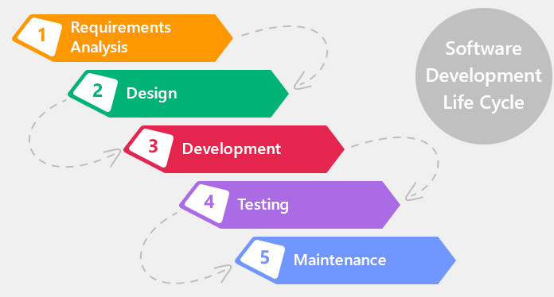In this stage we have searched in the Learning management systems field trying to find a way to help in improving education process, we get some information from professors we met, the team also make a survey for what difficulties students face while studying and what is needed to facilitate the educational process. This information is then used to plan the basic project approach and creating several scenarios, planning for the quality assurance, learning about new up to date technologies in web development.

Figure 2 Software Development Cycle

### Design

In this stage the team produce more than one designs of the software based on the scenarios we have in the previous stage, then chooses the perfect design.

### Implementation

In this stage of SDLC the actual development starts and the product is built. The programmers build prototype using Java as a programming language and Spring framework as the backend, and Angular as the front-end.

The prototype is iterated over for enhancement until satisfaction. Programming team has divided the system into modules working on them in parallel to complete the implementation stage in time.

### Qualityassurance

By following the studied steps, splitting tasks on the team, estimating time and resources required to complete each task, ensuring that software is delivered on time, on schedule and in accordance with the requirements of system.

The project plan is settled and resources are available and work broke down.

### Testing & integration

In this stage we firstly checked that is all modules error free and perform what’s they designed for and then test the application as a whole to make sure that all is doing well.

The application may first be released in a limited segment and tested in the by some users to get their feedbacks, based on them the product may be released as it is or not.

### Maintenance

Improve performance or other attributes based on the feedbacks and fixing any bugs appeared in the testing stage for the next updates

*C h a p t e r Two*

# 2. PLANNING AND SYSTEM REQUIREMENT

The purpose of this section provides details about the system functionality. It also introduces stockholders and their interaction with the system. It mentions the system assumptions about the solution. It provides scope of the system, future work and time planning. Further, it also provides the requirements specifications in detailed terms and a description of the different system interfaces.

Different specification techniques are used in order to specify the requirements more precisely for different audiences.

## planNING of the system.

As part of the implementation, we need to implement system that helps students, Instructors and make educational activities online. Each one of them has specific services to use.

**IN SCOPE**

User Management.

Course Management.

Administrations.

* **FUTURE WORK**

1. Localization
2. Notification
3. Chat

## TIME ESTIMATION

Accurate time estimation is a skill essential for good project management. It is important to get time estimates right for two main reasons:

1. Time estimates drive the setting of deadlines for delivery and planning of projects, and hence will impact on other peoples assessment of your reliability and competence as a project manager.
2. Time estimates often determine the pricing of contracts and hence the profitability of the contract/project in commercial terms.

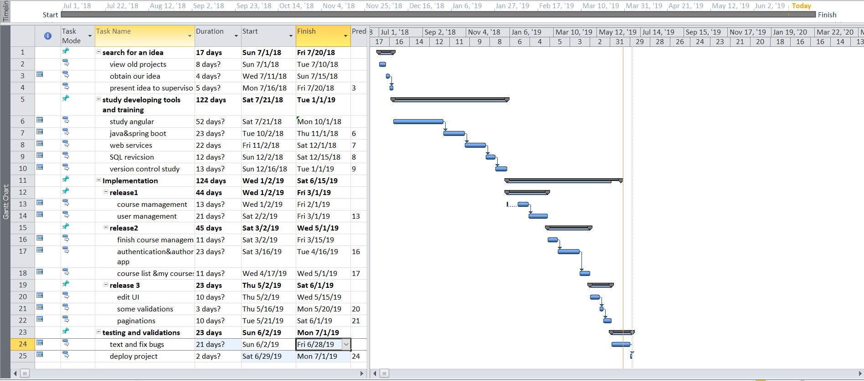

Figure 3 Gantt chart

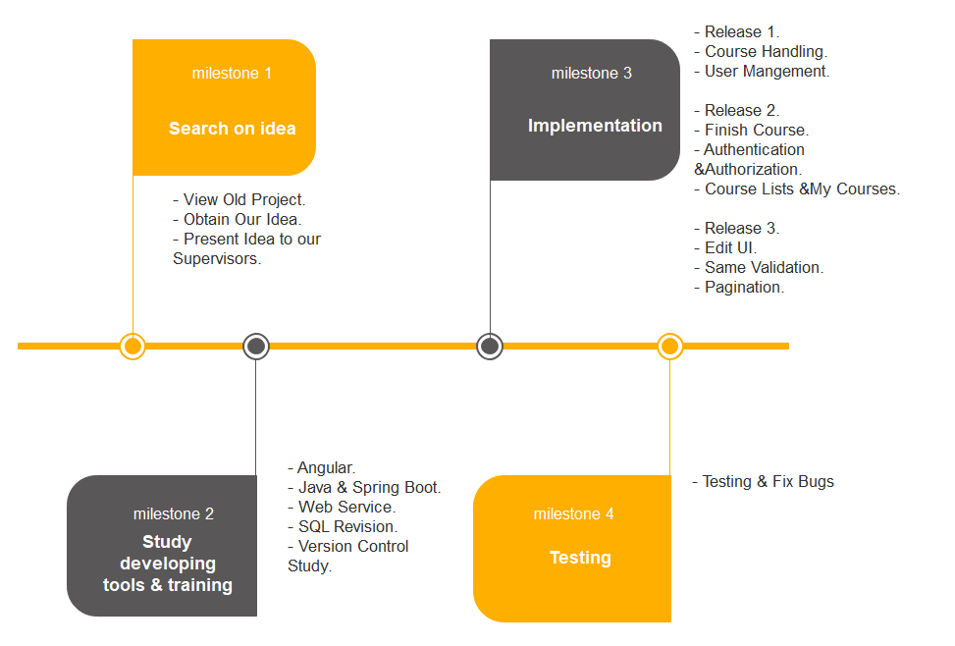

Figure 4 Milestone

## User Requirements

This section includes requirements that directly affect the customer. It describes the functional and non–functional requirements of the system. The section also describes other specifi­cations related to the user requirements.

### 1. Functional Requirements

The use cases diagrams below illustrate the system’s functional requirements

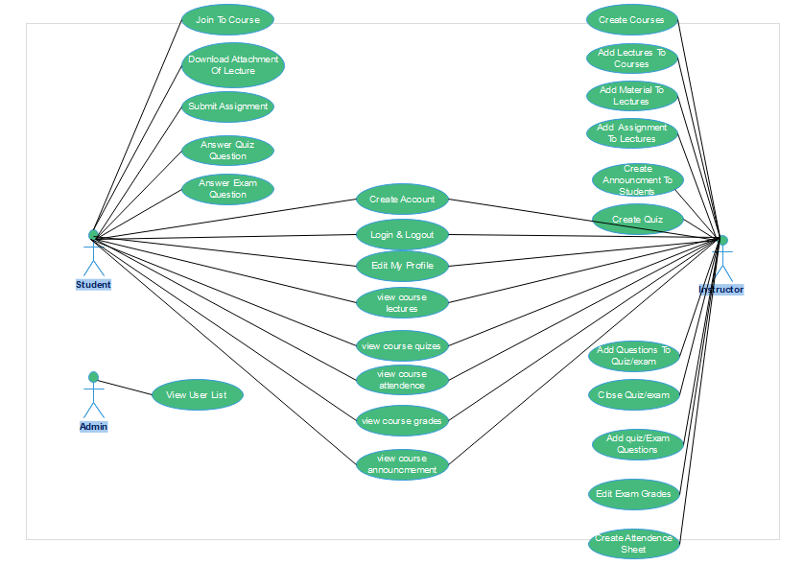

Figure 5 Use Case

#### **WELCOME USE CASE**

|  |  |
| --- | --- |
| **Use Case Name** | Welcome Page |
| Use case number | 1 |
| Users | Any User (Visitor or System User) |
| Description | This use case is used to navigate general user to the features of system and navigate him to Login and Signup |
| Assumptions | None |
| Pre-Conditions | None |
| Basic Flow | 1. User open web application and see welcome page and features of system also information about system. 2. Then, he will decide if he will Sign up, login or quit. |
| Post-Conditions | The system navigates the user to the login page. |
| Blocking Flow | None. |

#### USER SIGNUP USE CASE

|  |  |
| --- | --- |
| **Use Case Name** | student signup use case |
| Use case number | 2 |
| Users | Any User (Visitor or System User) |
| Description | This use case is used to help user to create account as a student or Instructor. |
| Assumptions | None. |
| Pre-Conditions | Actor is a system user. |
| Basic Flow | 1. User fill sign up form that include username, password-mail …etc. 2. Then, press register. |
| Post-Conditions | The system navigates the student to login to the new account  User’s LOGIN USE CASE |
| Blocking Flow | None. |

#### User’s LOGIN USE CASE

|  |  |
| --- | --- |
| **Use Case Name** | user’s login use case |
| Use case number | 3 |
| Users | Admin, System User |
| Description | This use case is used to login user into the application. |
| Assumptions | None |
| Pre-Conditions | Actor is a System user. |
| Basic Flow | 1. User enters username & password. 2. User presses the login button. |
| Post-Conditions | The user has been authenticated and authorized to use the account then ,The system navigates the user to the course list page. |
| Blocking Flow | The user enters invalid username and/or password 🡪 *the system shows an error message.* |

#### USER’s LOGOUT USE CASE

|  |  |
| --- | --- |
| **Use Case Name** | user’s logout use case |
| Use case number | 4 |
| Users | Admin ,system User |
| Description | This use case is used to logout user from the application. |
| Assumptions | Actor is already signed in. |
| Pre-Conditions | None. |
| Basic Flow | * + 1. The user clicks the logout link/button. |
| Post-Conditions | The user is logged out from the application.  The system navigates the user to the login page. |

#### VIEW USER PROFILES USE CASE

|  |  |
| --- | --- |
| **Use Case Name** | Load user profiles use case |
| Use case number | 5 |
| Users | Admin |
| Description | This use case is used to load users’ profiles page. |
| Assumptions | Actor is already signed in. |
| Pre-Conditions | Actor is authorized to view users’ privileges. |
| Basic Flow | 1. The user selects to open/view the Profiles page*.* 2. The system loads the Profiles entries from the database. |
| Post-Conditions | The system navigates the user to the profiles page.  The system loads the users’ profiles. |
| Blocking Flow | None. |
| Alternative Flow | None. |

#### EDIT USERS Profiles USE CASE

|  |  |
| --- | --- |
| **Use Case Name** | edit users profile use case |
| Use case number | 6 |
| Users | system user |
| Description | This use case is used to edit and save users’ profiles. |
| Assumptions | Actor is already signed in. |
| Pre-Conditions | Actor is authorized to view users’ privileges. |
| Basic Flow | 1. User navigates to the users’ profiles page using use case 2. User applies his changes. 3. User clicks the save button. |
| Post-Conditions | The changes have been updated in database. Then , system shows that the user changes have been done successfully. |

#### ALL COURSES USE CASE

|  |  |
| --- | --- |
| **Use Case Name** | all courses use case |
| Use case number | 7 |
| Primary Actor | Student, Instructor |
| Description | This use case is used to load all courses in the system. |
| Assumptions | Actor is already signed in. |
| Pre-Conditions | None |
| Basic Flow | 1. User click courses button. |
| Post-Conditions | The system loads other all courses. |
| Blocking Flow | None |

#### USER COURSES USE CASe

|  |  |
| --- | --- |
| **Use Case Name** | user courses use case |
| Use case number | 8 |
| Primary Actor | Student ,Instructor |
| Description | This use case is used to load all courses that student is in or created by instructor. |
| Assumptions | Actor is already signed in. |
| Pre-Conditions | None |
| Basic Flow | **The following is the basic flow of this use case:**   1. User click my courses button. |
| Post-Conditions | The system loads other all courses that student is in or created by instructor. |
| Blocking Flow | None |

#### CREATE NEW COURSE

|  |  |
| --- | --- |
| **Use Case Name** | create new course use case |
| Use case number | 9 |
| Primary Actor | Instructor. |
| Description | This use case is used to create new course. |
| Assumptions | Actor is already signed in. |
| Basic Flow | 1. User clicks on create course button. 2. Then, user fill in the form and press create button. |
| Post-Conditions | The system navigates to course dashboard. |

#### JOIN NEW COURSE

|  |  |
| --- | --- |
| **Use Case Name** | join new course use case |
| Use case number | 10 |
| Primary Actor | Student |
| Description | This use case is used to join new course. |
| Assumptions | Actor is already signed in. |
| Pre-Conditions | None |
| Basic Flow | 1. User clicks on course name. 2. Then, system will load course information with enroll button. 3. Student clicks on enroll if he isn’t enrolled before. |
| Post-Conditions | The system navigate to course lectures pages. |

#### VIEW ANNOUNCEMENT

|  |  |
| --- | --- |
| **Use Case Name** | view announcement usecase |
| Use case number | 11 |
| Primary Actor | Student, Instructor |
| Description | This use case is used to view announcement of the course |
| Assumptions | Actor is already signed in.  Actor is the instructor of the course or student in the course. |
| Pre-Conditions | None |
| Basic Flow | 1. User clicks on announcement. |
| Post-Conditions | system will load list of course announcement |

#### CREATE ANNOUNCEMENT

|  |  |
| --- | --- |
| **Use Case Name** | create announcement usecase |
| Use case number | 12 |
| Primary Actor | Instructor |
| Description | This use case is used to add new announcement to students of the course. |
| Assumptions | Actor is already signed in.  Actor is the instructor of the course. |
| Pre-Conditions | None |
| Basic Flow | 1. User click on create announcement button. 2. User write announcement and click share |
| Post-Conditions | system will add the new announcement and navigate to view announcements page |

#### VIEW COURSE LECTURES

|  |  |
| --- | --- |
| **Use Case Name** | view lectures usecase |
| Use case number | 13 |
| Primary Actor | Instructor, student |
| Description | This use case is used to view lectures of the course. |
| Assumptions | Actor is already signed in.  Actor is the instructor of the course or student in the course. |
| Pre-Conditions | None |
| Basic Flow | 1. User click on lectures button. |
| Post-Conditions | system will course lectures page. |

#### CRETAE LECTURE

|  |  |
| --- | --- |
| **use case name** | view lectures usecase |
| Use case number | 14 |
| Primary Actor | Instructor |
| Description | This use case is used to add new lecture to the course. |
| Assumptions | Actor is already signed in.  Actor is the instructor of the course or student in the course. |
| Pre-Conditions | None |
| Basic Flow | 1. User click on create lecture button. 2. Fill the form of create lecture. 3. Press create button |
| Post-Conditions | system will add the new lecture and navigate user to course lectures page. |

#### ADD ATTACHMENT TO LECTURE

|  |  |
| --- | --- |
| **Use Case Name** | materials use case |
| Use case number | 15 |
| Primary Actor | Instructor |
| Description | This use case is used to enable instructor to upload materials of the course. |
| Assumptions | Actor is already signed in. |
| Pre-Conditions | Actor is creator of the course. |
| Basic Flow | 1. User click add material button. 2. Then, select files to upload. |
| Post-Conditions | System upload files and navigate user to lecture details page |
| Blocking Flow | None |

#### DOWNLOAD ATTACHMENT

|  |  |
| --- | --- |
| **Use Case Name** | download attachment use case. |
| Use case number | 16 |
| Primary Actor | student |
| Description | This use case is used to view and download materials of the course. |
| Assumptions | Actor is already signed in. |
| Pre-Conditions | Actor is enrolled in the course. |
| Basic Flow | 1. User click material button. 2. System will load lecture attachment. 3. Student click on file name. |
| Post-Conditions | the file will be downloaded on user PC. |
| Blocking Flow | None |

#### SUBMIT ASSIGNMENTS

|  |  |
| --- | --- |
| **Use Case Name** | assignments usecase |
| Use case number | 17 |
| Primary Actor | Student |
| Description | This use case is used to submit assignments of the course before deadline. |
| Assumptions | Actor is already signed in. |
| Pre-Conditions | Actor is enrolled in any course. |
| Basic Flow | 1. User click upload button. 2. Select folder from computer. 3. Click submit |
| Post-Conditions | The system send file to the admin of the course (instructor). |
| Blocking Flow | If the student submit assignment after deadline show error message. |

#### VIEW COURSE QUIZES/EXAMS USE CASE

|  |  |
| --- | --- |
| **Use Case Name** | view exams usecase |
| Use case number | 18 |
| Primary Actor | Instructor, student |
| Description | This use case is used to view lectures of the course. |
| Assumptions | Actor is already signed in. |
| Pre-Conditions | Actor is the instructor of the course or student in the course |
| Basic Flow | 1. User click on quizzes/exams button. |
| Post-Conditions | system will load course quizzes/exams page. |

#### CREATE QUIZ

|  |  |
| --- | --- |
| **Use Case Name** | create quiz usecase |
| Use case number | 19 |
| Primary Actor | Instructor |
| Description | This use case is used to add quiz to the course. |
| Assumptions | Actor is already signed in. |
| Pre-Conditions | Actor is the instructor of the course. |
| Basic Flow | 1. User click on create quiz button. 2. User fill the form and press next button. |
| Post-Conditions | system will add the new quiz and navigate to add quiz/ page exam questions page |

#### ADD QUIZ/EXAM QUESTIONS

|  |  |
| --- | --- |
| **Use Case Name** | create quiz usecase |
| Use case number | 20 |
| Primary Actor | Instructor |
| Description | This use case is used to add questions to the quiz/exam. |
| Assumptions | Actor is already signed in. |
| Pre-Conditions | Actor is the instructor of the course. |
| Basic Flow | 1. User select question type. 2. Then add questions to quiz 3. Click submit button. |
| Post-Conditions | System will add the questions and navigate user to course quizzes/exams. |

#### ANSWER QUIZ AND EXAM QUESTIONS

|  |  |
| --- | --- |
| **Use Case Name** | answer questions use case. |
| Use case number | 21 |
| Primary Actor | Student |
| Description | This use case is used to answer questions of quizzes and exams. |
| Assumptions | Actor is already signed in. |
| Pre-Conditions | Actor is enrolled in any course. |
| Basic Flow | 1. User click on quiz/exam name. 2. If he doesn’t answer before the system will load quiz questions page. |
| Post-Conditions | The system navigates to course quizzes/ course exams page |
| Blocking Flow | Actor is not enrolled in any course. |

#### VIEW QUIZ/EXAM MAIN DETAILS USE CASE

|  |  |
| --- | --- |
| **Use Case Name** | view quiz/exam main details use case. |
| Use case number | 22 |
| Primary Actor | Instructor |
| Description | This use case is used to view quiz/exam main details. |
| Assumptions | Actor is already signed in. |
| Pre-Conditions | Actor is creator of the course. |
| Basic Flow | 1. User click on quiz/exam name. |
| Post-Conditions | If he is the instructor of the course, the system will load main details of the quiz/exam. |
| Blocking Flow | Actor is not creator of the course. |

#### view quiz/exam result use case

|  |  |
| --- | --- |
| **Use Case Name** | view quiz/exam result use case. |
| Use case number | 23 |
| Primary Actor | Student. |
| Description | This use case is used to view quiz/exam result. |
| Assumptions | Actor is already signed in. |
| Pre-Conditions | Actor is student in the course. |
| Basic Flow | 1. User click on quiz/exam name. |
| Post-Conditions | If he is the instructor of the course, the system will load main details of the quiz/exam. |
| Blocking Flow | Actor is not student in the course. |

#### VIEW GRADES USE CASE

|  |  |
| --- | --- |
| **Use Case Name** | view grades of the exams use case. |
| Use case number | 24 |
| Primary Actor | Student, instructor |
| Description | This use case is used to view grades of the exams. |
| Assumptions | Actor is already signed in. |
| Pre-Conditions | Actor is student in the course or instructor of the course. |
| Basic Flow | 1. User click on grades button. |
| Post-Conditions | If he is the instructor of the course, the system will load the grades of all students.  If he is student in the course, the system will load his grades only |
| Blocking Flow | Actor is not student in the course or not creator of the course. |

#### EDIT GRADES USE CASE

|  |  |
| --- | --- |
| **Use Case Name** | edit grades of the exams use case. |
| Use case number | 25 |
| Primary Actor | instructor |
| Description | This use case is used to edit grades of the exams. |
| Assumptions | Actor is already signed in. |
| Pre-Conditions | Actor is the instructor of the course. |
| Basic Flow | 1. User click on edit grades button. |
| Post-Conditions | The system loads the grades of all students enabled for editing. |
| Blocking Flow | Actor is not creator of the course. |

#### VIEW ATTENDENCE USE CASE

|  |  |
| --- | --- |
| **Use Case Name** | view attendance of the course. |
| Use case number | 26 |
| Primary Actor | instructor, student |
| Description | This use case is used view attendance of the course. |
| Assumptions | Actor is already signed in. |
| Pre-Conditions | Actor is the instructor of the course or student of the course. |
| Basic Flow | 1. User click on attendance button. |
| Post-Conditions | If he is the instructor of the course, the system will load attendance of all students.  If he is student in the course the system will load his attendance only. |
| Blocking Flow | Actor is not creator of the course or student in the course. |

#### CREATE ATTENDECE SHEET USE CASE

|  |  |
| --- | --- |
| **Use Case Name** | create attendance of the course. |
| Use case number | 27 |
| Primary Actor | instructor |
| Description | This use case is used create attendance of the course. |
| Assumptions | Actor is already signed in. |
| Pre-Conditions | Actor is the instructor of the course. |
| Basic Flow | 1. User click on create attendance button. |
| Post-Conditions | The system loads/creates attendance sheet page. |
| Blocking Flow | Actor is not creator of the course or student in the course. |

#### VIEW USER LIST USE CASE

|  |  |
| --- | --- |
| **Use Case Name** | view attendance use case |
| Use case number | 28 |
| Primary Actor | System admin. |
| Description | This use case is used to view list of all users in the system. |
| Assumptions | Actor is already signed in. |
| Pre-Conditions | Actor is having a role of system admin. |
| Basic Flow | 1. User click users’ button. |
| Post-Conditions | The system loads updated attendance file after every lecture. |

## 2.Non-Functional Requirements

Here we specify some nonfunctional constraints that the program satisfies in order to be more concrete and stable.

* **Operational.**Our system is designed for Personal Computers, Mobile & Tablets, it only needs a valid connection to the Internet and web browser.
* **Performance requirement.**

1. The system operates in real-time with high speed and responsive time under any circumstances.
2. If unable to process HTTP request, should show error message.
3. Web pages are loaded in a few seconds.
4. HTTP request should be performed very quickly.
5. Design should be attractive.

* **Security requirements**

1. Users should be authenticated.
2. User should have privilege to access specific pages and takes specific actions.
3. The details need to be maintained properly.

* **Maintainability: -**

Developers of the applications always reads the users’ feedback on the system and respond fast to any bugs or problems.

## system stackholders

|  |  |
| --- | --- |
| **Role** | **Description** |
| Instructors | They used the system to manage their own courses |
| Students | They used the system to reach to contests of their courses. |

## context digram

The [Context Diagram](https://www.modernanalyst.com/Resources/Articles/tabid/115/ID/1355/Introduction-to-Context-Diagrams.aspx) shows the system under consideration as a single high-level process and then shows the relationship that the system has with other external entities (systems, organizational groups, external data stores, etc.).

* All external entities are shown on the context diagram as well as major data flow to and from them.
* The diagram does not contain any data storage.
* The single process in the context-level diagram, representing the entire system, can be exploded to include the major processes of the system.
* It also called level 0 data flow diagram.

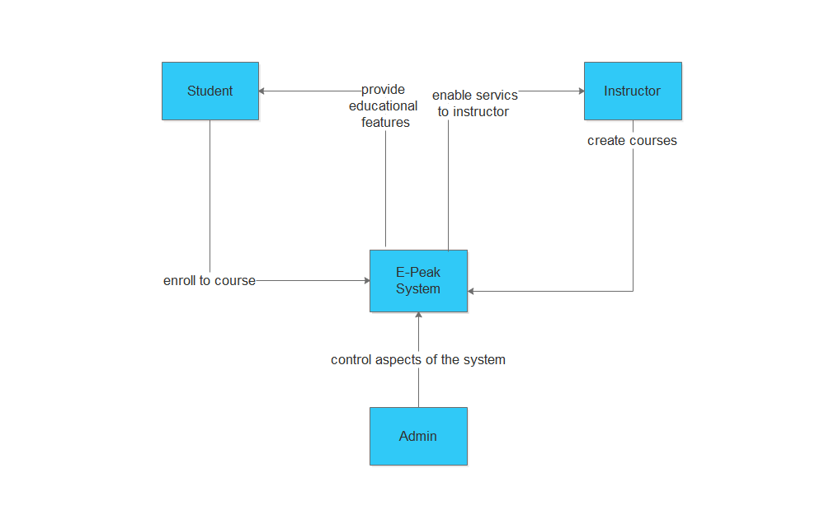

Figure 6 Context diagram figure

## DATA FLOW DIAGRAM

“A data flow diagram, or a DFD, is a visual representation of any process or system’s flow of information. By mapping out your process or system’s flow of data, DFDs help you better understand your process or system, uncover its kinks, improve it, and can even help you implement a new process or system. DFDs can range from simple overviews to complex, granular displays of a process or system.” hubspot.coma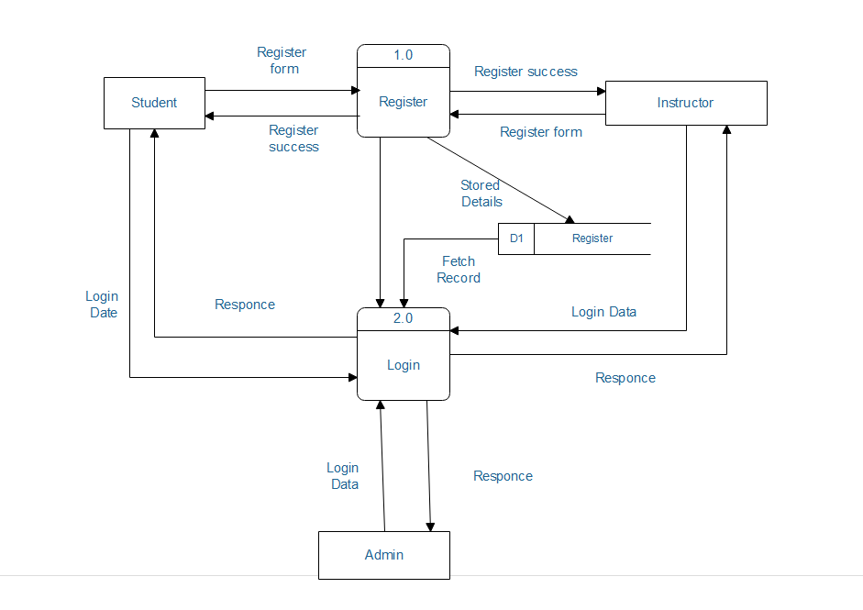

Figure 7 user management

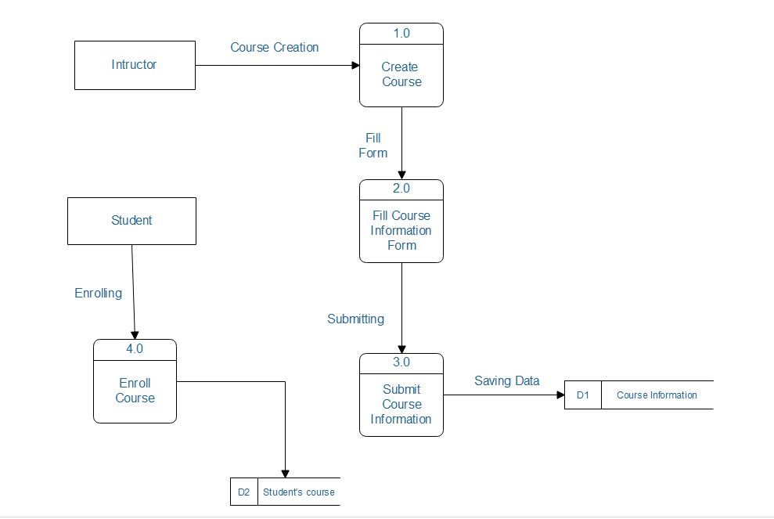

Figure 8 create course DFD

## entity relationship diagram (ERD)

Entity relationship diagram displays the relationships of entity set stored in a database. In other words, we can say that ER diagrams help you to explain the logical structure of databases. At first look, an ER diagram looks very similar to the flowchart. However, ER Diagram includes many specialized symbols, and its meanings make this model unique.

* ERD Benefits.

1. ER model allows you to draw Database Design.
2. It is an easy to use graphical tool for modeling data
3. Widely used in Database Design
4. It is a GUI representation of the logical structure of a Database
5. It helps you to identify the entities which exist in a system and the relationships between those entities.

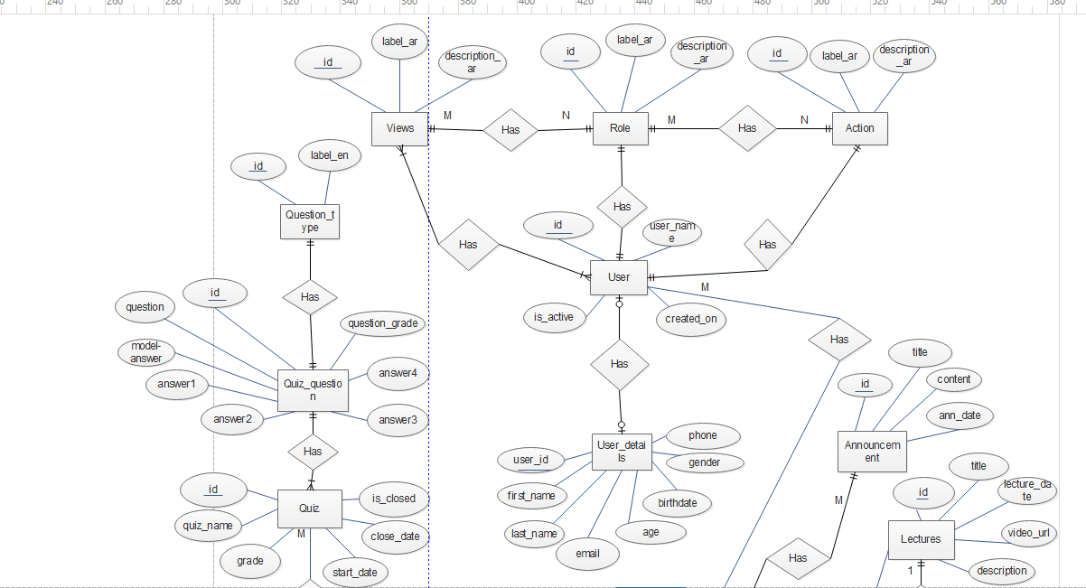

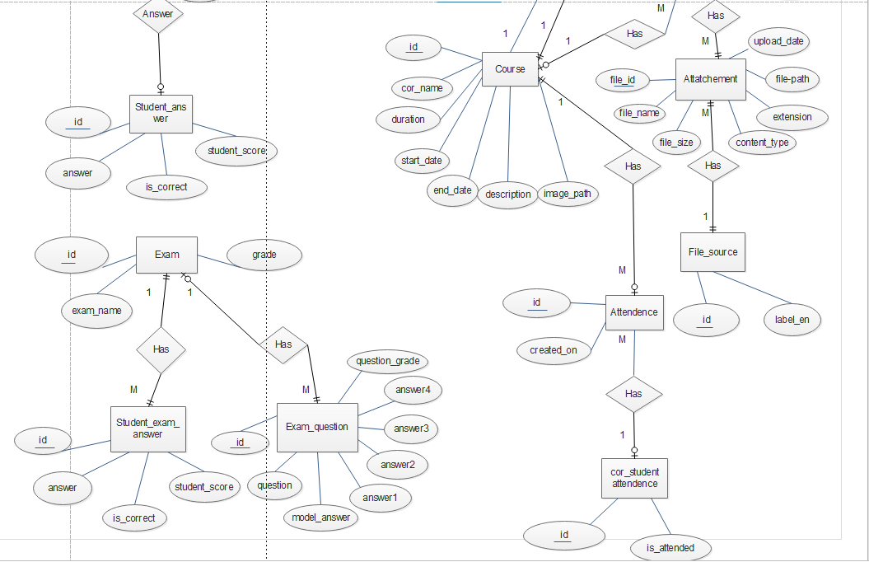

Figure 8 ERD Diagram

*C h a p t e r Three*

# SOFTWARE AND HARDWARE PLATFORMS

## METHODOLOGY: -

We used Agile Methodology which is a process by which a team can manage a project by breaking it up into several stages (Epics & Stories) and involving constant collaboration with stakeholders and continuous improvement and iteration (Sprints) at every stage.

Agile methodology begins with clients describing how the end product will be used and what problem it will solve. This clarifies the customer's expectations to the project team.

Then the project passes through a process of planning, executing, and evaluating which might just change the final deliverable to fit the customer's needs. Continuous collaboration is a key among both team members and project stakeholders, to make fully-informed decisions.

First Project breaking down is into Epics

### Epics:

1. Course List
2. Course Details
3. Security
4. Administration

### Stories tables:

|  |  |  |
| --- | --- | --- |
| Story Name | Epic | Assignee |
| [EP-1] Register | **security** | Ahmed Fathy |
| [EP-2] Login | **security** | Ahmed Fathy |
| [EP-3] User Profile | **security** | Manar El Sayed |
| [EP-4] Edit USER | **security** | Manar El Sayed |
| [EP-4] User List | **adminstration** | Manar El Sayed |
| [EP-5] My Courses | **Course List** | Hala Mahmoud |
| [EP-6] All Courses | **Course List** | Hala Mahmoud |
| [EP-7] View exam grades for Instructor | **Grade** | Hala Mahmoud |
| [EP-8] View exam grades for Student | **Grade** | Hala Mahmoud |
| [EP-9] View quiz grades for Instructor | **Grade** | Hala Mahmoud |
| [EP-10] View quiz grades for Student | **Grade** | Hala Mahmoud |
| [EP-11] Edit Grades | **Grade** | Hala Mahmoud |
| [EP-12] Create Attendance | **Attendance** | Yara Abd El Rahman |
| [EP-13] View Instructor Attendance | **Attendance** | Yara Abd El Rahman |
| [EP-14] View Student Attendance | **Attendance** | Yara Abd El Rahman |
| [EP-15] Create Announcement | **Announcement** | Yara Abd El Rahman |
| [EP-16] View Announcement | **Announcement** | Yara Abd El Rahman |
| [EP-17] Welcome page | **Welcome page** | Yousef Reda |
| [EP-18] Create Course | **Courses** | Yousef Reda |
| [EP-19] Course Information | **Courses** | Yousef Reda |
| [EP-20] Create Lecture | **Lecture** | Yousef Reda |
| [EP-21] Course Lecture | **Lecture** | Yousef Reda |
| [EP-22] Lecture Details | **Lecture** | Abanoub Fayez |
| [EP-23] Create Quiz | **Quiz** | Ahmed Fathy |
| [EP-24] Add Quiz Questions | **Quiz/exam** | Ahmed Fathy |
| [EP-25] Course Quizzes | **Quiz/exam** | Ahmed Fathy |
| [EP-26] Quiz Main Details | **Quiz/exam** | Ahmed Fathy |
| [EP-27] answer Questions | **Quiz/exam** | Ahmed Fathy |
| [EP-28] Quiz Result | **Quiz/exam** | Yara Abd El Rahman |
| [EP-29] Course Exams | **Exam** | Ahmed Fathy |
| [EP-30] Upload attachment | **Attachment** | Abanoub Fayez |

## Tools

### IntelliJ IDEA:

Figure 9 Intellij

It’s an IDE (Integrated Development Environment) which we use to write our code and develop our system.

Features:

1. Supports many file types (Java, HTML, TS)
2. Easy to refactor, support.
3. Has plugin for Source Control
4. Has plugin for executes SQL queries on Database.

### MySQL Workbench

Figure 10 my SQL workbench

MySQL Workbench is a c**lient software for database designing and modeling**for MySQL Server relational database. It facilitates creation of new physical data models and modification of existing MySQL databases with reverse/forward engineering and change management functions.

### TortoiseSVN :

“TortoiseSVN is a client software used for the source control on Windows. It is based on Apache™ Subversion (SVN) ®”

Figure 11 Tortoize Svn

Features:

1. Provides a nice and easy user interface for Subversion.
2. Developed under the GPL. Which means it is completely free for anyone to use, including in a commercial environment, without any restriction.
3. The source code is also freely available, so you can even develop your own version if you wish to. Since it's not integration for a specific”.

### Node JS

Figure 12 nodejs

It’s a cross platform JavaScript runtime built on Chrome's V8 JavaScript engine, it executes JavaScript code outside of a browser.

Node.js let developers use JavaScript to write command line tools and run server side scripts to produce dynamic web page content before the page is rendered by the web browser.

Consequently, Node.js represents a “JavaScript everywhere” node.js includes npm which is considered a large repository with many libraries for Node based projects.

NPM includes two distinct components:

1. Website: used for searching for packages
2. Command Line Interface (CLI): used for run & build the project, It’s commands executes in terminal:
   * npm install <library-name> 🡪 to install libraries.
   * npm start 🡪 to run the angular code application

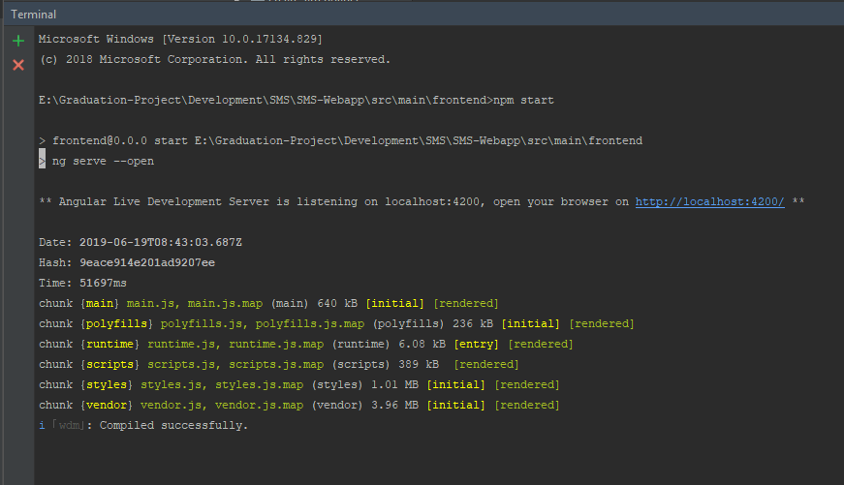

Figure 13CLI

### The Java Development Kit (JDK)

JDK is an acronym for Java Development Kit. The Java Development Kit (JDK) is a software development environment which is used to develop Java applications. It contains JRE + development tools. JDK is used for implementing any one of the below Java Platforms released by Oracle Corporation :

* Standard Edition Java Platform
* Enterprise Edition Java Platform
* Micro Edition Java Platform

The JDK contains a Java Virtual Machine (JVM) and a few other resources such as an interpreter/loader (java), a compiler (javac), an archiver (jar), a documentation generator (Javadoc), etc. used in Java Application development.

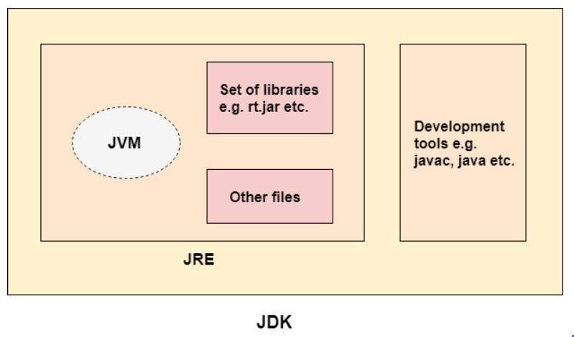

Figure 14 JDK

### Version control:

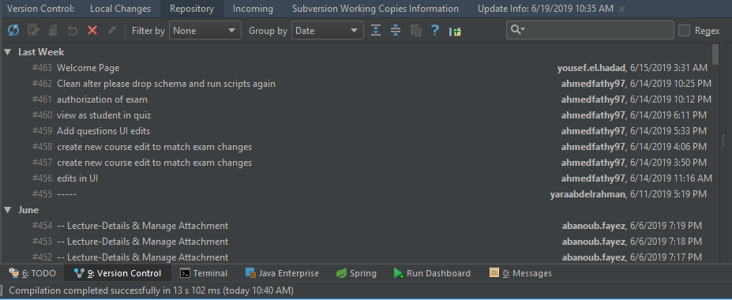

Figure 15 history

It is used to manage and control the changes that occur in the code and documents, which is also known as reversion control or source control, these changes are finally merged into several versions.

## 3 – Technologies

* 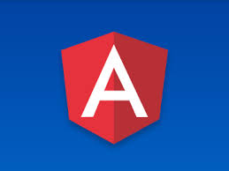**Angular 6** (components , Structural Directives , Service , Routing , Guards , Interceptor )

Figure 16 angular

There are five major releases of Angular. The first version that was released is Angular 1, which is also called AngularJS. Angular 1 was followed by Angular 2, which came in with a lot of changes when compared to Angular 1.

The structure of Angular is based on the components/services architecture.

* **Common features in version 5 and 6** 
  1. **HTTPClient API.**

HTTPClient API was introduced to deprecate the HTTP library. It is much faster, secure and efficient than HTTP library.

* 1. **Multiple export aliases.**
  2. **Internationalized Pipes for Number, Date, and Currency**.
  3. **Build Optimizer**

Build Optimizer introduced. It optimizes the build size and improves the application speed. Angular CLI uses Build Optimizer automatically.

* 1. **Improved Compiler**

Compiler from Angular 5 leading for faster compilation. Compiler uses Typescript transforms.

* **The new features added to Angular**

**6- Updated Angular CLI, Command Line interface**

New commands added, like ng-update to migrate from previous version to current version. ng-add to quickly add application features to make application a progressive web apps.

**7- Updated CDK, Component Development Kit.**

Supports creating custom UI elements without need of angular material library. Supports responsive web design layouts. Supports overlay packages to create pop-ups.

1. **Updated Angular Material**

New Tree component added, mat-tree, a styled version and cdk-tree, a unstyled version, to represent a hierarchical structure like tree.

1. **Angular Element**

Allows Angular Components to be published as Web Components which can then be used in any HTML page. Using Angular Element package, native custom elements can be created easily.

### Components

Major part of the development with Angular 6 is done in the components. Components are basically classes that interact with the .html file of the component, which gets displayed on the browser. The file structure has the app component and it consists of the following files.

**app.component.css**

**app.component.html**

**app.component.ts**

### Structural Directives

Structural directives are responsible for HTML layout. They shape or reshape the DOM’s structure , by adding ,removing ,or manipulating elements. Structural directives have a * sign before the directive. For example, **\*ngIf** and **\*ng For**.

**DOM**: Document Object Model (as body , div , …. ) is the way Javascript sees its containing pages data. It is an object that includes how the HTML/XHTML/XML is formatted, as well as the browser state.

### Routing

Routes tell the router which view to display when a user clicks a link or pastes a URL into the browser address bar.

A typical Angular [Route](https://angular.io/api/router/Route) has two properties:

* + - path: a string that matches the URL in the browser address bar.
    - component: the component that the router should create when navigating to this route.

### TypeScript (TS)

TypeScript is JavaScript plus some additional features.

TypeScript is a primary language for Angular application development. It is a superset of JavaScript with design-time support for type safety and tooling.

Browsers can't execute Typescript directly. Typescript must be convert into JavaScript using the –**tsc**– compiler, which requires some configuration**.**

Figure 17 type script

### Spring Boot

Figure 18 spring boot

Spring Boot provides a good platform for Java developers to develop a stand-alone and production-grade spring application that we can “**just run”** with minimum configurations without the need for an entire Spring configuration setup. Embed Tomcat, Jetty or Undertow directly (no need to deploy WAR files). Spring boot help us:

* To avoid complex XML configuration in Spring.
* To develop a production ready Spring applications in an easier way.
* To reduce the development time and run the application independently.
* Offer an easier way of getting started with the application.
* To provides a powerful batch processing and manages REST endpoints.

### Spring JDBC

Itis a powerful mechanism to connect to the database and execute SQL queries. It internally uses JDBC API .It provides us with methods to write the queries directly so it help us to save a lot of time.

Spring framework provides following approaches for JDBC database access:

* JdbcTemplate
* NamedParameterJdbcTemplate
* SimpleJdbcTemplate
* SimpleJdbcInsert and SimpleJdbcCall

**Basic Queries**

* + This is the central framework class that manages all the database communication and exception handling.
  + is the main API through which we’ll access most of the functionality that we’re interested in:

1. creation and closing of connections.
2. executing statements and stored procedure calls.
3. iterating over the ResultSetand returning results.

### Restful Web Services (API)

Figure 19 Rest API

* A web service is a collection of open protocols and standards used for exchanging data between applications or systems. Software applications written in various programming languages and running on various platforms can use web services to exchange data over computer networks like the Internet in a manner similar to inter-process communication on a single computer. This interoperability (e.g., between Java and Python, or Windows and Linux applications) is due to the use of open standards.
* Web services based on REST Architecture are known as RESTful web services. These webservices uses HTTP methods to implement the concept of REST architecture. A RESTful web service usually defines a URI, Uniform Resource Identifier a service, provides resource representation such as JSON and set of HTTP Methods.

1. **HTTP methods.**

There are four HTTP methods are commonly used in REST based architecture :

* 1. **GET** : Provides a read only access to a resource.
  2. **POST** : Used to create a new resource.
  3. **DELETE** : Used to remove a resource.
  4. **PUT** : Used to update a existing resource or create a new resource.

**b) Jersey -RESTful Web Services in Java**

in order to simplify development of RESTful Web services and their clients in Java, a standard and portable [JAX-RS API](http://jax-rs-spec.java.net/) has been designed.

* + **Jersey RESTful Web Services framework** is open source, production quality, framework for developing RESTful Web Services in Java that provides support for JAX-RS APIs and serves as a JAX-RS (JSR 311 & JSR 339) Reference Implementation. Jersey framework is more than the JAX-RS Reference Implementation and provides it’s own [API](https://jersey.github.io/apidocs/latest/jersey/index.html) that extend the JAX-RS toolkit with additional features and utilities to further simplify RESTful service and client development.
* **Goals of Jersey summarized in the following points:**
  1. Track the JAX-RS API and provide regular releases of production quality Reference Implementations that ships with GlassFish;
  2. Provide APIs to extend Jersey & Build a community of users and developers; and finally
  3. Make it easy to build RESTful Web services utilising Java and the Java Virtual Machine.

### HTML5

Figure 20 Html&CSS

**HTML5** stands for Hyper Text Markup Languagethat describes the structure of a Web pageand consists of a series of elementsThose tell the browser how to display the content and are represented by tags. This tags considered as label pieces of content such as "heading" <h> , "paragraph" <p> , "table" <table> , and so on.

### CSS3

Css stands for **C**ascading **S**tyle **S**heetsthat describes **how HTML elements are to be displayed on screen, paper, or in other media.** It can control the layout of multiple web pages all at onceCSS can be added to HTML elements in 3 ways(**Inline – Internal** **– External**).

## 4 – Project ARCHITeCTURE

Project Architecture means what are the layers in our project with flow diagram .each tier can be referred as a ‘layer’**. E-Peak** project contains three tiers which is consider three layers like angular layer , spring layer and data layer , then we draw the all layers flow.

**E-Peak System consist of three tiers Angular, Spring and Database:**

* Front-End Layer ( Angular )
* Back-End Layer ( API )
* Database Layer ( MySQL )

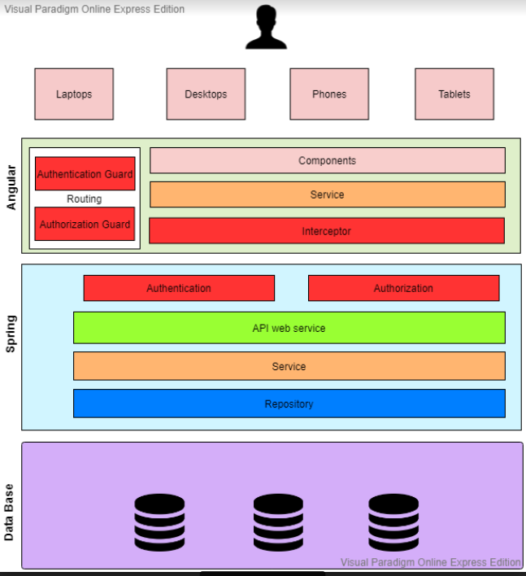

Figure 21 project architecture

### FRONT-END layer

It is also known as Client Layer. Top most layer of an application. The main functionality of this layer is to communicate with Application Layer.

**The Flow of this tier:**

* User using UI Application to make actions with buttons or fill a form with data.
* The HTML form store data as an object which is carry it to service.
* At Service Class Using REST API web service data send to Spring Layer.

**For Example:**

Create Course Component when an end user could see form and buttons to enter course data and to click on submit.

#### Authentication & authorizations in Front-end layer:

* **Interceptor :**

Interceptors provide a mechanism to intercept and/or mutate outgoing requests or incoming responses. They are very similar to the concept of middleware with a framework like Express, except for the frontend. Interceptors can be really useful for features like caching and logging.

* **Guards :**

we used guardrouting (as CanActivate) in authentication and authorization to control privilege of user such the following cinditions ;

* + Maybe the user must login (authenticate) first.
  + Perhaps the user has logged in but is not authorized to navigate to the target component.
  + We might ask the user if it’s OK to discard pending changes rather than save them.

There are four different types of Guards:

* 1. **CanActivate :** Checks to see if a user can visit a route.
  2. **CanActivateChild:** Checks to see if a user can visit a routes children.

### BACK-END Layer

As create course component example, once user click on submit spring layer interact with data base layer and sends course data. It controls an application’s functionality by performing detailed processing. This layer acts as mediator between the Presentation or UI and the Database layer.

**The Flow of this tier:**

1. Now data are located in service at Controller or Resource class which able to send it to another Service class using object of Model class carried same front-end data.
2. The Service class make a logic operations on data before sending it to Repository.
3. Then at Repository Class there are service take which his parameter your data and its body is SQL Query which do the excellent action user had chosen.

#### Authentication & authorization in BACK-END layer:

Figure 22 authentication

* **Authentication filter :** In token-based authentication, the client exchanges *hard* credentials (such as username and password) for a piece of data called *token*. For each request, instead of sending the hard credentials, the client will send the token to the server to perform authentication and then authorization.

In a few words, an authentication scheme based on tokens follow these steps:

1. The client sends their credentials (username and password) to the server.
2. The server authenticates the credentials and, if they are valid, generate a token for the user.
3. The server stores the previously generated token in some storage along with the user identifier and an expiration date.
4. The server sends the generated token to the client.
5. The client sends the token to the server in each request.
6. The server, in each request, extracts the token from the incoming request. With the token, the server looks up the user details to perform authentication.
   * If the token is valid, the server accepts the request.
   * If the token is invalid, the server refuses the request.
7. Once the authentication has been performed, the server performs authorization.
8. The server can provide an endpoint to refresh tokens.

* 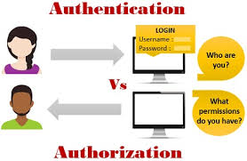**Authorization filter:**

Figure 23 authorization

This filter is used to determine if the current user has the privilege to access the requested view or make the requested action. If the user has privilege to access

This request ,the server response with ok. Else ,the server response with error 401 unauthorized.

### DataTier Layer

The Data is stored in this layer. Spring layer communicates with Database layer to retrieve or store data.

It contains a methods that connects the database and performs required action.

E.g.: INSERT , UPDATE , DELETE and SELECT.

### Summary of Architecture:

E-Peak Architecture diagram show system flow from action which is human user take to the result and changes in database. And in our system we have three roles e.g.: Instructor , Student and System Admin. So we should ensure that which role of users is signed in to limit his actions.

The Front End layer which is Web Application build in Angular interaction with Authentication and Authorization Services to define the user.

Then, Any action user takes with UI translated to second phase Back-End layer by using web service like API. In controller the business logic operations are performed and send to Repository which interaction with Database tier.

In Database tier, there are some queries are carried from Repository or Back-End Layer. These queries are executed and change in current data.

## 6 - IMPLEMENTAION DETAILS

### COURSE RES

|  |  |  |  |  |  |  |  |  |  |
| --- | --- | --- | --- | --- | --- | --- | --- | --- | --- |
| **Story** | **[EP-1] Create Course** | | | | **Controller** | CourseRes | | **Function** | createNewCourse() |
| **Method** | **POST** | | | | **URL** | **/api/courses/** | | | |
| **Description** | Instructor fill the information of the Course in the System and submit the form to add new Course. | | | | | | | | |
| **Flow** | 1. Validate the Input of the form 2. Check the instructor ID 3. Insert the Data of the Course | | | | | | | | |
| **Authorization** | | | | | | | | | |
| **Role** | | | **Privilege Type** | | | | **Privilege value** | | |
| **Instructor** | | | **Action** | | | | **ADD-COR** | | |
| **Instructor** | | | **View** | | | | **ADD-COR** | | |
| **REST Parameter** | | | | | | | | | |
| **Attribute** | | **Parameter Type** | | **Data Type** | | **Description** | | | |
| CousreDTO | | PathParameter | | details | | It contains a course information from HTML form. | | | |

|  |  |  |  |  |  |  |  |  |  |
| --- | --- | --- | --- | --- | --- | --- | --- | --- | --- |
| **Story** | **[EP-19] Course Information** | | | **Controller** | | CourseRes | | **Function** | viewCourse() |
| **Method** | **GET** | | | **URL** | | **/api/courses/{corID}** | | | |
| **Description** | When user click on course info the system send course id and get course data from Data Base. | | | | | | | | |
| **Flow** | 1. Send course ID 2. Select the course data 3. Return data to HTML and present it . | | | | | | | | |
| **Authorization** | | | | | | | | | |
| **Role** | | | **Privilege Type** | | | | **Privilege value** | | |
| **Any User** | | | **Action** | | | | **-** | | |
| **Any User** | | | **View** | | | | **-** | | |
| **REST Parameter** | | | | | | | | | |
| **Attribute** | | **Parameter Type** | | | **Data Type** | **Description** | | | |
| CorID | | PathParmter | | | Int | It contains a course id which used to select course data. | | | |

|  |  |  |  |  |  |  |  |  |  |
| --- | --- | --- | --- | --- | --- | --- | --- | --- | --- |
| **Story** | **[EP-20] Create Lecture** | | | | **Controller** | | CourseRes | **Function** | createNewLecture() |
| **Method** | **POST** | | | | **URL** | | **/api/courses/{courseID}/lecture** | | |
| **Description** | Instructor fill the information of the lecture in the System and submit the form to add new lecture | | | | | | | | |
| **Flow** | 1. Validate the Input of the form 2. Check the instructor ID 3. Insert the Data of the Lecture | | | | | | | | |
| **Authorization** | | | | | | | | | |
| **Role** | | | **Privilege Type** | | | **Privilege value** | | | |
| **Instructor** | | | **Action** | | | **ADD-LEC** | | | |
| **Instructor** | | | **View** | | | **ADD-LEC** | | | |
| **REST Parameter** | | | | | | | | | |
| **Attribute** | | **Parameter Type** | | **Data Type** | | | **Description** | | |
| LectureDTO | | PathParmter | | LectureDTO | | | Contain a Lecture information from HTML form. | | |

|  |  |  |  |  |  |  |  |  |  |
| --- | --- | --- | --- | --- | --- | --- | --- | --- | --- |
| **Story** | **[EP-6] All Courses** | | | | **Controller** | | CourseRes | **Function** | findAllCourses() |
| **Method** | **Get** | | | | **URL** | | **/api/course/all** | | |
| **Description** | This function gets all courses from database and display it for student to enable it to make join in any course | | | | | | | | |
| **Flow** | 1-call service(**findAllCourse**) in (**Course Res**) in **findAllCourses** function that's method is **GET** which it's dataType is (**CourseResultSet**) use this model to return a list of course information(CourseVto) and used in pagination  2-usig services to call my repositry  This services (**in CourseSer**)is **findAllCourse** which it's dataType is (**CourseResultSet**) use this model to return a list of course information(CourseVto) and used in pagination  3-(**in CourseRep**)I used a select query to get all courses with specific information such as (id,duration,course-name,start date,end date, description, instructor name) from database | | | | | | | | |
| **Authorization** | | | | | | | | | |
| **Role** | | | **Privilege Type** | | | **Privilege value** | | | |
| **instructor** | | | **view** | | | **COURSE_LIST** | | | |
| **student** | | | **view** | | | **COURSE_LIST** | | | |
| **REST Parameter** | | | | | | | | | |
| **Attribute** | | **Parameter Type** | | **Data Type** | | | **Description** | | |
| pageNum | | Query parameter | | int | | | It contains the num of page that these courses display in it. | | |

|  |  |  |  |  |  |  |  |  |  |
| --- | --- | --- | --- | --- | --- | --- | --- | --- | --- |
| **Story** | **[EP-5] My Courses** | | | **Controller** | | CourseRes | | **Function** | myCourse |
| **Method** | **GET** | | | **URL** | | **/api/course/** | | | |
| **Description** | This function check first who is login if it was instructor display courses that's who create  If it was student display courses that he enrolls in it and each student can see its courses | | | | | | | | |
| **Flow** | 1-call service(**myCourse**) in (**Course Res**) in **myCourses** function that's method is **GET** which it's dataType is (**CourseResultSet**) use this model to return a list of course information(CourseVto) and used in pagination  2-usig services to call my repositry  -This services (**in CourseSer**)is **myCourse** which it's dataType is (**CourseResultSet**) use this model to return a list of course information(**CourseVto**) and used in pagination  -there is in it check to know who is log in instructor or student to determine which repositry will call it .  3-(**in CourseRep** ) I used a select query to get all instructor courses (**findAllInstructorCourse**)and  select query to get all student courses(**findAllStudentCourse**)  with specific information such as (id,duration,course-name,start date,end date, description, instructor name) from database. | | | | | | | | |
| **Authorization** | | | | | | | | | |
| **Role** | | | **Privilege Type** | | | | **Privilege value** | | |
| **instructor** | | | **view** | | | | **MY_COURSE** | | |
| **student** | | | **view** | | | | **MY_COURSE** | | |
| **REST Parameter** | | | | | | | | | |
| **Attribute** | | **Parameter Type** | | | **Data Type** | **Description** | | | |
| pageNum | | Query parameter | | | int | It contains the num of page that these courses display in it. | | | |
| currentUser | | Path parameter | | | int | It contains value we know from it who is login (student or instrctor) | | | |

|  |  |  |  |  |  |  |  |  |  |
| --- | --- | --- | --- | --- | --- | --- | --- | --- | --- |
| **Story** | **[EP-7] view instructor grade** | | | | **Controller** | | CourseRes | **Function** | getCourseGrade |
| **Method** | **GET** | | | | **URL** | | **/api/course/{courseID}/grade** | | |
| **Description** | This function display the grade of all student to the instructor | | | | | | | | |
| **Flow** | * Query return list of students with grades (first name , last name , mid 1 , final ) * Then display them to instructor | | | | | | | | |
| **Authorization** | | | | | | | | | |
| **Role** | | | **Privilege Type** | | | **Privilege value** | | | |
| **Instructor** | | | **View** | | | **ADD_GRADE** | | | |
| **Student** | | | **View** | | | **ADD_GRADE** | | | |
| **REST Parameter** | | | | | | | | | |
| **Attribute** | | **Parameter Type** | | **Data Type** | | | **Description** | | |
| corID | | Path parameter | | int | | | It contain a number to tell us which is couse . | | |
| pageNum | | Queryparameter | | int | | | It contains the num of page that these courses display in it. | | |

|  |  |  |  |  |  |  |  |  |  |
| --- | --- | --- | --- | --- | --- | --- | --- | --- | --- |
| **Story** | **[EP-8] View Student grade** | | | | **Controller** | | CourseRes | **Function** | getCourseGrade |
| **Method** | **GET** | | | | **URL** | | **/api/course/{courseID}/grade** | | |
| **Description** | This function display grade for student by its id . | | | | | | | | |
| **Flow** | * Query return specific student with grades (first name , last name , mid 1 , final ) * Then display them to specif | | | | | | | | |
| **Authorization** | | | | | | | | | |
| **Role** | | | **Privilege Type** | | | **Privilege value** | | | |
| **Instructor** | | | **View** | | | **ADD_GRADE** | | | |
| **Student** | | | **View** | | | **ADD_GRADE** | | | |
| **REST Parameter** | | | | | | | | | |
| **Attribute** | | **Parameter Type** | | **Data Type** | | | **Description** | | |
| corID | | Path parameter | | int | | | It contain a number to tell us which course is choosen . | | |
| pageNum | | Queryparameter | | int | | | It contains the num of page that these grade display in it. | | |

|  |  |  |  |  |  |  |  |  |  |  |
| --- | --- | --- | --- | --- | --- | --- | --- | --- | --- | --- |
| **Story** | **[EP-7] view instructor quiz grade** | | | | **Controller** | | | CourseRes | **Function** | getQuizGrade |
| **Method** | **Get** | | | | **URL** | **/api/course/{courseID}/grade/quizes** | | | | |
| **Description** | This function display the grade quizes of all student to the instructor | | | | | | | | | |
| **Flow** | 1. Query return list of students with Quiz grades (first name , last name , StdScore , totalScore) 2. Then display them to instructor | | | | | | | | | |
| **Authorization** | | | | | | | | | | |
| **Role** | | | **Privilege Type** | | | | **Privilege value** | | | |
| **instructor** | | | **View** | | | | **ADD_GRADE** | | | |
| **Student** | | | **View** | | | | **ADD_GRADE** | | | |
| **REST Parameter** | | | | | | | | | | |
| **Attribute** | | **Parameter Type** | | **Data Type** | | **Description** | | | | |
| corID | | Path parameter | | int | | It contain a number to tell us which course is choosen . | | | | |
| pageNum | | Query parameter | | int | | It contains the num of page that these grade display in it. | | | | |

|  |  |  |  |  |  |  |  |  |  |
| --- | --- | --- | --- | --- | --- | --- | --- | --- | --- |
| **Story** | **[EP-7] view student quiz grade** | | | | **Controller** | | CourseRes | **Function** | getQuizGrade |
| **Method** | **Get** | | | | **URL** | | **/api/course/{courseID}/grade/quizes** | | |
| **Description** | This function display the grade quizes of to each student | | | | | | | | |
| **Flow** | 1. Query return specific students with Quiz grades (first name , last name , StdScore , totalScore ) 2. Then display it to student | | | | | | | | |
| **Authorization** | | | | | | | | | |
| **Role** | | | **Privilege Type** | | | **Privilege value** | | | |
| **instructor** | | | **View** | | | **ADD_GRADE** | | | |
| **student** | | | **View** | | | **ADD_GRADE** | | | |
| **REST Parameter** | | | | | | | | | |
| **Attribute** | | **Parameter Type** | | **Data Type** | | | **Description** | | |
| corID | | Path parameter | | int | | | It contain a number to tell us which course is choosen | | |
| pageNum | | Query parameter | | int | | | It contains the num of page that these grade display in it. | | |

|  |  |  |  |  |  |  |  |  |  |  |  |
| --- | --- | --- | --- | --- | --- | --- | --- | --- | --- | --- | --- |
| **Story** | **[EP-11] View instructor attendance** | | | | **Controller** | | | CourseRes | **Function** | | getCourseAttendance() |
| **Method** | **GET** | | | | **URL** | | | **/api/course/courseID/attendance** | | | |
| **Description** | Display attendance sheet of students for instructor | | | | | | | | | | |
| **Flow** | * We have 2 Queries  1. Query return list of student (**findAllCourseStudents(id)**) . 2. Query return list of student attendance (first name , last name , date , is_attend ) 3. Transfer this lists into pivot table | | | | | | | | | | |
| **Authorization** | | | | | | | | | | | |
| **Role** | | | **Privilege Type** | | | | **Privilege value** | | | | |
| **Instructor** | | | **View** | | | | **ADD_ATTENDANCE** | | | | |
| **REST Parameter** | | | | | | | | | | | |
| **Attribute** | | **Parameter Type** | | **Data Type** | | **Description** | | | | | |
| courseID | | Payload | | INT | | It contains id of course | | | |  | |

|  |  |  |  |  |  |  |  |  |  |  |  |
| --- | --- | --- | --- | --- | --- | --- | --- | --- | --- | --- | --- |
| **Story** | **[EP-11] View student attendance** | | | | | **Controller** | | | CourseRes | **Function** | getCourseAttendance() |
| **Method** | **GET** | | | | **URL** | | **/api/course/courseID/attendance** | | | | |
| **Description** | Display attendance of specific student | | | | | | | | | | |
| **Flow** | * We have 2 Queries  1. Query return one student depend on its id . 2. Query return list of student attendance (first name , last name , date , is_attend ) 3. Transfer this list into pivot table | | | | | | | | | | |
| **Authorization** | | | | | | | | | | | |
| **Role** | | | **Privilege Type** | | | | | **Privilege value** | | | |
| **Instructor** | | | **View** | | | | | **ADD_ATTENDANCE** | | | |
| **REST Parameter** | | | | | | | | | | | |
| **Attribute** | | **Parameter Type** | | **Data Type** | | | **Description** | | | | |
| courseID | | Payload | | INT | | | It contains id of course | | | | |

|  |  |  |  |  |  |  |  |  |  |  |
| --- | --- | --- | --- | --- | --- | --- | --- | --- | --- | --- |
| **Story** | **[EP-13] Create Announcement** | | | | **Controller** | | CourseRes | | **Function** | createAnnouncement() |
| **Method** | **POST** | | | | **URL** | | **/api/course/courseID/newAnnouncment** | | | |
| **Description** | Instructor fill the information of Announcement he want to tell students about it | | | | | | | | | |
| **Flow** | 1. It is checked if instructor has been logged in the course is the same instructor who created it (**by ID**) 2. Insert the Data of the Announcement in database (insert query in repository that add title and description about announcement in database ) | | | | | | | | | |
| **Authorization** | | | | | | | | | | |
| **Role** | | | **Privilege Type** | | | **Privilege value** | | | | |
| **Instructor** | | | **Action** | | | **COR_ADD_ANNOUNCEMENT** | | | | |
| **Instructor** | | | **View** | | | **COR_ADD_ANNOUNCEMENT** | | | | |
| **Student** | | | **View** | | | **COR_ADD_ANNOUNCEMENT** | | | | |
| **REST Parameter** | | | | | | | | | | |
| **Attribute** | | **Parameter Type** | | **Data Type** | | | | **Description** | | |
| request | | Payload | | ContainerRequestContext | | | | It contains the current user | | |
| courseID | | PathParameter | | INT | | | | It contains a course information from HTML form. | | |
| announcement | | Payload | | Announcement | | | | It contains title and description of announcement | | |

|  |  |  |  |  |  |  |  |  |  |  |
| --- | --- | --- | --- | --- | --- | --- | --- | --- | --- | --- |
| **Story** | **[EP-14] View Announcement** | | | | **Controller** | | | CourseRes | **Function** | getCourseAnnouncments() |
| **Method** | **GET** | | | | **URL** | | | **/api/course/courseID/announcmentList** | | |
| **Description** | Display Announcements to students | | | | | | | | | |
| **Flow** | Query return announcement that instructor want student to see it with date | | | | | | | | | |
| **Authorization** | | | | | | | | | | |
| **Role** | | | **Privilege Type** | | | **Privilege value** | | | | |
| **Instructor** | | | **View** | | | **COR_ADD_ANNOUNCEMENT** | | | | |
| **Student** | | | **View** | | | **COR_ADD_ANNOUNCEMENT** | | | | |
| **REST Parameter** | | | | | | | | | | |
| **Attribute** | | **Parameter Type** | | **Data Type** | | | **Description** | | | |
| cousreID | | PathParameter | | INT | | | It contains a id of course . | | | |
| pageNum | | QueryParameter | | INT | | | It contains page number . | | | |

|  |  |  |  |  |  |  |  |  |  |
| --- | --- | --- | --- | --- | --- | --- | --- | --- | --- |
| **Story** | **[EP-18] create quiz** | | | | **Controller** | | **CourseRes** | **Function** | createQuiz(int courseID) |
| **Method** | **post** | | | | **URL** | | Api/Course/{courseID}/newQuiz | | |
| **Description** | This API is used by instructor to add quiz to his course. | | | | | | | | |
| **Flow** | 1. API receive quiz data from user. 2. Apply some validations in service. 3. Insert quiz data into database. | | | | | | | | |
| **Authorization** | | | | | | | | | |
| **Role** | | | **Privilege Type** | | | **Privilege value** | | | |
| **Instructor** | | | **View** | | | **ADD-QUIZ** | | | |
| **REST Parameter** | | | | | | | | | |
| **Attribute** | | **Parameter Type** | | **Data Type** | | | **Description** | | |
| quizData | | --- | | QuizDTO | | | It is object from QuizDto model to collect quiz data . | | |
| courseID | | Path parameter | | Int | | | It carry the value of course number . | | |

|  |  |  |  |  |  |  |  |  |  |
| --- | --- | --- | --- | --- | --- | --- | --- | --- | --- |
| **Story** | **[EP-20] Course Quizes** | | | | **Controller** | | **CourseRes** | **Function** | getCourseQuizes() |
| **Method** | **Get** | | | | **URL** | | API/Course/{courseID}/Quizes | | |
| **Description** | This API is used by student and Instructor to view list of course quizes . | | | | | | | | |
| **Flow** | 1. Receive courseID from client application. 2. Apply some validations on service. 3. Retrieve list of quizes from database. | | | | | | | | |
| **Authorization** | | | | | | | | | |
| **Role** | | | **Privilege Type** | | | **Privilege value** | | | |
| **student** | | | **view** | | | **Course_Quizes** | | | |
| **instructor** | | | **view** | | | **Course_Quizes** | | | |
| **REST Parameter** | | | | | | | | | |
| **Attribute** | | **Parameter Type** | | **Data Type** | | | **Description** | | |
| corID | | Path parameter | | int | | | It carry the value of course number. | | |

|  |  |  |  |  |  |  |  |  |  |
| --- | --- | --- | --- | --- | --- | --- | --- | --- | --- |
| **Story** | **[EP-22] Course exams** | | | **Controller** | | **CourseRes** | | **Function** | getCourseExams() |
| **Method** | **Get** | | | **URL** | | API/Course/{courseID}/Exams | | | |
| **Description** | This API is used by student and Instructor to view list of course quizes . | | | | | | | | |
| **Flow** | 1. Receive courseID from client application. 2. Apply some validations on service. 3. Retrieve list of exams from database. | | | | | | | | |
| **Authorization** | | | | | | | | | |
| **Role** | | | **Privilege Type** | | | | **Privilege value** | | |
| **student** | | | **view** | | | | **Course_EXAMS** | | |
| **instructor** | | | **view** | | | | **Course_ EXAMS** | | |
| **REST Parameter** | | | | | | | | | |
| **Attribute** | | **Parameter Type** | | | **Data Type** | **Description** | | | |
| corID | | Path parameter | | | int | It carry the value of course number. | | | |

### Quiz RES

|  |  |  |  |  |  |  |  |  |
| --- | --- | --- | --- | --- | --- | --- | --- | --- |
| **Story** | **[EP-19] add questions** | | | | **Controller** | **QuizRes** | **Function** | createQuizQuestions() |
| **Method** | **post** | | | | **URL** | Api/Quiz/{quizID}/questions | | |
| **Description** | This API is used by instructor to add questions to quiz. | | | | | | | |
| **Flow** | 1 .receive list of questions from angular applications.  2. apply some validations om service .  3.insert quiz questions into database . | | | | | | | |
| **Authorization** | | | | | | | | |
| **Role** | | | **Privilege Type** | | | **Privilege value** | | |
| **Instructor** | | | **View** | | | **ADD-QUESTIONS** | | |
| **REST Parameter** | | | | | | | | |
| **Attribute** | | **Parameter Type** | | **Data Type** | | **Description** | | |
| quizID | | Path parameter | | Int | | It carry the value of quiz number. | | |
| questions | | --- | | LIST<QuestionsDto> | | It is object from QuestionDto model to collect questions . | | |

|  |  |  |  |  |  |  |  |
| --- | --- | --- | --- | --- | --- | --- | --- |
| **Story** | **Quiz state** | | **Controller** | | **QuizRes** | **Function** | getQuizState() |
| **Method** | **Get** | | **URL** | | API/quiz/{quizID}/state | | |
| **Description** | This API is used to get the state of the quiz to determine which page will appear to user that is logged in now. | | | | | | |
| **Flow** | 1. Receive current user that is active now. 2. According to user and its role the method return number if state | | | | | | |
| **REST Parameter** | | | | | | | |
| **Attribute** | | **Parameter Type** | | **Data Type** | **Description** | | |
| currentUser | | Context | | UserVto | It carry information about the current user that is active now | | |
| quizID | | Path parameter | | Int | It carry the value of quiz number. | | |

|  |  |  |  |  |  |  |  |  |
| --- | --- | --- | --- | --- | --- | --- | --- | --- |
| **Story** | **Quiz Informations** | | | **Controller** | **QuizRes** | | **Function** | getQuizInfo() |
| **Method** | **Get** | | | **URL** | API/quiz/{quizID}/quizDetails | | | |
| **Description** | This API is used by instructor to view details about the quiz such that the number of students that answered the quiz | | | | | | | |
| **Flow** | 1. Receive quizID from web application. 2. Apply some validations on service. 3. Retrieve information of the quiz from database | | | | | | | |
| **Authorization** | | | | | | | | |
| **Role** | | | **Privilege Type** | | | **Privilege value** | | |
| **Instructor** | | | **View** | | | **QUIZ_INFO** | | |
| **REST Parameter** | | | | | | | | |
| **Attribute** | | **Parameter Type** | | **Data Type** | **Description** | | | |
| quizInfo | | --- | | QuizInfoVTO | It carry object of quiz information. | | | |
| quizID | | Path parameter | | Int | It carry the value of quiz number. | | | |

|  |  |  |  |  |  |  |  |  |  |
| --- | --- | --- | --- | --- | --- | --- | --- | --- | --- |
| **Story** | **Quiz questions** | | | | **Controller** | | **QuizRes** | **Function** | getQuizQuestiosn() |
| **Method** | **Get** | | | | **URL** | | API/quiz/{quizID}/questionsView | | |
| **Description** | This API is used by student to view quiz questions available for answering. | | | | | | | | |
| **Flow** | 1. Receive quizID from client application. 2. Apply some validations on service. 3. Retrieve information of the quiz from database. | | | | | | | | |
| **Authorization** | | | | | | | | | |
| **Role** | | | **Privilege Type** | | | **Privilege value** | | | |
| **Student** | | | **View** | | | **QUIZ_INFORMATION** | | | |
| **instructor** | | | **View** | | | **QUIZ_INFORMATION** | | | |
| **REST Parameter** | | | | | | | | | |
| **Attribute** | | **Parameter Type** | | **Data Type** | | | **Description** | | |
| quizID | | Path parameter | | Int | | | It carry the value of quiz number. | | |
| quizQuestions | | ---- | | List<QuestionsVto> | | | Carry List of questions for specific quiz | | |

|  |  |  |  |  |  |  |  |  |  |
| --- | --- | --- | --- | --- | --- | --- | --- | --- | --- |
| **Story** | **submitQuizAnswers** | | | | **Controller** | | **quizRes** | **Function** | submitAnswer() |
| **Method** | **Post** | | | | **URL** | | API/quiz/{quizID}/Answer | | |
| **Description** | This API is used by student to submit quiz questions after answer. | | | | | | | | |
| **Flow** | 1. Receive quizID from client application. 2. Receive current user also 3. Apply some validations on service. 4. Insert list of answers to database | | | | | | | | |
| **Authorization** | | | | | | | | | |
| **Role** | | | **Privilege Type** | | | **Privilege value** | | | |
| **Student** | | | **View** | | | **Submit_Answer** | | | |
| **REST Parameter** | | | | | | | | | |
| **Attribute** | | **Parameter Type** | | **Data Type** | | | **Description** | | |
| quizID | | Path parameter | | Int | | | It carry the value of quiz number. | | |
| studentAnswere | | ----- | | List<StudentAnswer> | | | Carry List of student answere for specific quiz | | |

|  |  |  |  |  |  |  |  |  |  |
| --- | --- | --- | --- | --- | --- | --- | --- | --- | --- |
| **Story** | **Close quiz** | | | | **Controller** | **QuizRes** | | **Function** | closeQuiz() |
| **Method** | **Update** | | | | **URL** | API/quiz/{quizID}/close | | | |
| **Description** | This API is used by instructor to close quiz after deadline. | | | | | | | | |
| **Flow** | 1. Receive quizID from client application 2. Apply some validations on service. 3. Update is_closed column to true . | | | | | | | | |
| **Authorization** | | | | | | | | | |
| **Role** | | | **Privilege Type** | | | | **Privilege value** | | |
| **Instructor** | | | **action** | | | | **CLOSE_QUIZ** | | |
| **REST Parameter** | | | | | | | | | |
| **Attribute** | | **Parameter Type** | | **Data Type** | | **Description** | | | |
| quizID | | Path parameter | | Int | | It carry the value of quiz number. | | | |

|  |  |  |  |  |  |  |  |  |  |
| --- | --- | --- | --- | --- | --- | --- | --- | --- | --- |
| **Story** | **Quiz Result** | | | | **Controller** | **QuizRes** | | **Function** | getQuizResult() |
| **Method** | **Get** | | | | **URL** | API/quiz/{quizID}/result | | | |
| **Description** | This API is used by student to view details about his answer of quiz. | | | | | | | | |
| **Flow** | 1. Receive quizID from client application 2. Apply some validations on service. 3. Retrieve result form database. | | | | | | | | |
| **Authorization** | | | | | | | | | |
| **Role** | | | **Privilege Type** | | | | **Privilege value** | | |
| **student** | | | **View** | | | | **QUIZRESULT** | | |
| **REST Parameter** | | | | | | | | | |
| **Attribute** | | **Parameter Type** | | **Data Type** | | **Description** | | | |
| quizID | | Path parameter | | Int | | It carry the value of quiz number. | | | |

### Attandance RES

|  |  |  |  |  |  |  |  |  |
| --- | --- | --- | --- | --- | --- | --- | --- | --- |
| **Story** | **[EP-11] Create Attendance** | | | **Controller** | AttendanceRes | | **Function** | createAttendanceSheet () |
| **Method** | **POST** | | | **URL** | **/api/attendance/courseID/new** | | | |
| **Description** | Instructor fill the information of the Lecture on specific course (attendance date , attendance) to add new attendance sheet on course | | | | | | | |
| **Implementation** | 1. It is checked if instructor has been logged in the course is the same instructor who created it (**by ID**) 2. It is checked if the date has been recorded in the absence sheet before or not  * If has been recorded , return list of students who attended in this date to allow the instructor to modify student's attendance * If not , return list of students enrolled in this course  1. Determines the status of the student (attend – absent ) | | | | | | | |
| **Authorization** | | | | | | | | |
| **Role** | | | **Privilege Type** | | | **Privilege value** | | |
| **Instructor** | | | **Action** | | | **ADD_ATTENDANCE** | | |
| **Instructor** | | | **View** | | | **ADD-ATTENDANCE** | | |
| **REST Parameter** | | | | | | | | |
| **Attribute** | | **Parameter Type** | | **Data Type** | | | **Description** | |
| Request | | Payload | | ContainerRequestContext | | | It contains the current user | |
| courseID | | PathParameter | | INT | | | It contains course id | |
| attendanceDate | | Payload | | AttendanceDTO | | | It contains date of lecture | |

### Grade RES

|  |  |  |  |  |  |  |  |  |  |
| --- | --- | --- | --- | --- | --- | --- | --- | --- | --- |
| **Story** | **[EP-9] Edit grade** | | | | **Controller** | GradeRes | | **Function** | EditGradeSheet |
| **Method** | **Post** | | | | **URL** | **/api/grade/{courseID}/new** | | | |
| **Description** | This function enable instructor to make edit on the grade of the exams | | | | | | | | |
| **Flow** | 1-after an instructor make edit on the grade  2-the query make a post to this value in database. | | | | | | | | |
| **Authorization** | | | | | | | | | |
| **Role** | | | **Privilege Type** | | | | **Privilege value** | | |
| **Instructor** | | | **action** | | | | **COR_ADD_GRADE** | | |
| **Instructor** | | | **View** | | | | **ADD_GRADE** | | |
| **REST Parameter** | | | | | | | | | |
| **Attribute** | | **Parameter Type** | | **Data Type** | | **Description** | | | |
| corID | | Path parameter | | int | | It contain a number to tell us which is course to get the grade of it to make edit on it . | | | |
| GradeType | | Query parameter | | string | | Specify which type of grade is select to make edit on it . | | | |

### User RES

|  |  |  |  |  |  |  |  |  |  |
| --- | --- | --- | --- | --- | --- | --- | --- | --- | --- |
| **Story** | **[EP-3]User Profile** | | | | **Controller** | UserRes | | **Function** | findUserByID() |
| **Method** | **GET** | | | | **URL** | **api/User/{userID}/profile** | | | |
| **Description** | View profile data of the current logged in user. | | | | | | | | |
| **Flow** | 1. This serves receive user id 2. If user id not found, return error user not found . 3. If user is found, select it's data from database. 4. Return user data in userVTO object. | | | | | | | | |
| **Authorization** | | | | | | | | | |
| **Role** | | | **Privilege Type** | | | | **Privilege value** | | |
| **Any Role** | | | **Views** | | | | **USER_PROFILE** | | |
| **REST Parameter** | | | | | | | | | |
| **Attribute** | | **Parameter Type** | | **Data Type** | | **Description** | | | |
| userID | | PathParam | | Int | |  | | | |

|  |  |  |  |  |  |  |  |  |  |
| --- | --- | --- | --- | --- | --- | --- | --- | --- | --- |
| **Story** | **[EP-4]Edit user** | | | **Controller** | | UserRes | | **Function** | updateUserVto() |
| **Method** | **POST** | | | **URL** | | **api/User/{userID}/edit** | | | |
| **Description** | User fill the information about himself in the edit form and click save to save this information in database | | | | | | | | |
| **Flow** | 1. Validate the Inputs of the form. 2. If inputs are okay , save data in database. 3. Return user data in userVTO object. | | | | | | | | |
| **Authorization** | | | | | | | | | |
| **Role** | | | **Privilege Type** | | | | **Privilege value** | | |
| **Any Role** | | | **Views** | | | | **USER_EDIT** | | |
| **REST Parameter** | | | | | | | | | |
| **Attribute** | | **Parameter Type** | | | **Data Type** | **Description** | | | |
| userID | | PathParam | | | Int |  | | | |

|  |  |  |  |  |  |  |  |  |  |
| --- | --- | --- | --- | --- | --- | --- | --- | --- | --- |
| **Story** | **[EP-]User List** | | | **Controller** | | UserRes | | **Function** | findAllUsers() |
| **Method** | **GET** | | | **URL** | | **api/User/find** | | | |
| **Description** | View all users in the system . | | | | | | | | |
| **Flow** | 1. When admin click on any link in full name . 2. admin will go to the user's profile and will know all informations about this user. 3. Return user data in userVTOList object. | | | | | | | | |
| **Authorization** | | | | | | | | | |
| **Role** | | | **Privilege Type** | | | | **Privilege value** | | |
| **Any Role** | | | **Views** | | | | **USER_LIST** | | |
| **REST Parameter** | | | | | | | | | |
| **Attribute** | | **Parameter Type** | | | **Data Type** | **Description** | | | |
| -- | | -- | | | -- |  | | | |

### Lecture RES

|  |  |  |  |  |  |  |  |  |  |
| --- | --- | --- | --- | --- | --- | --- | --- | --- | --- |
| **Story** | **[EP-25] Lecture Details** | | | | **Controller** | LectureRes | | **Function** | listLectures() |
| **Method** | **GET** | | | | **URL** | **/api/lecture/{lecID}** | | | |
| **Description** | Instructor or student can view lecture details | | | | | | | | |
| **Flow** | 1. Click on lecture label name 2. Retrieve lecture data 3. Redirects lecture details page | | | | | | | | |
| **Authorization** | | | | | | | | | |
| **Role** | | | **Privilege Type** | | | | **Privilege value** | | |
| **Instructor** | | | **View** | | | | **Lecture-details** | | |
| **Student** | | | **View** | | | | **Lecture-details** | | |
| **REST Parameter** | | | | | | | | | |
| **Attribute** | | **Parameter Type** | | **Data Type** | | **Description** | | | |
|  | | PathParam | | LectureDTO | | 1. Receive LectureID 2. Retrieve list of lectures from database 3. Return the list | | | |

### Attachment RES

|  |  |  |  |  |  |  |  |  |  |
| --- | --- | --- | --- | --- | --- | --- | --- | --- | --- |
| **Story** | **[EP-26] Upload Files** | | | | **Controller** | AttachmentRes | | **Function** | uploadFile() |
| **Method** | **POST** | | | | **URL** | **/api/attachment/file** | | | |
| **Description** | Instructor browse files on his computer and clicks on upload to save it on server | | | | | | | | |
| **Flow** | 1. Browse files 2. upload 3. receive response | | | | | | | | |
| **Authorization** | | | | | | | | | |
| **Role** | | | **Privilege Type** | | | | **Privilege value** | | |
| **Instructor** | | | **Action** | | | | **Add-materials** | | |
| **Instructor** | | | **View** | | | | **Add-materials** | | |
| **REST Parameter** | | | | | | | | | |
| **Attribute** | | **Parameter Type** | | **Data Type** | | **Description** | | | |
| File | | QueryParam | | Response | | 1. Receive file information and content 2. Save it in storage 3. Insert information the database 4. Return response with the state of file | | | |

|  |  |  |  |  |  |  |  |  |  |
| --- | --- | --- | --- | --- | --- | --- | --- | --- | --- |
| **Story** | **[EP-27] Retrieve List of Files** | | | | **Controller** | AttachmentRes | | **Function** | listFiles() |
| **Method** | **GET** | | | | **URL** | **/api/attachment/files** | | | |
| **Description** | Shows the list of files in the course or a specific lecture | | | | | | | | |
| **Flow** | 1. Obtain Lecture ID 2. Get list of files of a specific lecture or course 3. Retrieve files for download | | | | | | | | |
| **Authorization** | | | | | | | | | |
| **Role** | | | **Privilege Type** | | | | **Privilege value** | | |
| **Instructor** | | | **View** | | | | **Lecture-details** | | |
| **Student** | | | **View** | | | | **Lecture-details** | | |
| **REST Parameter** | | | | | | | | | |
| **Attribute** | | **Parameter Type** | | **Data Type** | | **Description** | | | |

|  |  |  |  |  |  |  |  |  |  |
| --- | --- | --- | --- | --- | --- | --- | --- | --- | --- |
| **Story** | **[EP-28] Download File** | | | | **Controller** | AttachmentRes | | **Function** | downloadFileById() |
| **Method** | **GET** | | | | **URL** | **/api/attachment/downloadFile/{fileID}** | | | |
| **Description** | Instructor or student can download files | | | | | | | | |
| **Flow** | 1. click on file name label 2. browse to save content | | | | | | | | |
| **Authorization** | | | | | | | | | |
| **Role** | | | **Privilege Type** | | | | **Privilege value** | | |
| **Instructor** | | | **Action** | | | | **Download-materials** | | |
| **Student** | | | **Action** | | | | **Download-materials** | | |
| **REST Parameter** | | | | | | | | | |
| **Attribute** | | **Parameter Type** | | **Data Type** | | **Description** | | | |
| Resource  ByteArrayResource | | PathParam | | Response | | 1. receive file id 2. retrieve file path of the file 3. return file as a resourceByteArray | | | |

|  |  |  |  |  |  |  |  |  |  |
| --- | --- | --- | --- | --- | --- | --- | --- | --- | --- |
| **Story** | **[EP-29] remove File** | | | | **Controller** | AttachmentRes | | **Function** | removeFile() |
| **Method** | **DELETE** | | | | **URL** | **/api/attachment/{fileID}** | | | |
| **Description** | Instructor can remove files from server | | | | | | | | |
| **Flow** | 1. list of files in the course or lecture 2. click on remove button | | | | | | | | |
| **Authorization** | | | | | | | | | |
| **Role** | | | **Privilege Type** | | | | **Privilege value** | | |
| **Instructor** | | | **Action** | | | | **Add-materials** | | |
| **Instructor** | | | **View** | | | | **Add-materials** | | |
| **REST Parameter** | | | | | | | | | |
| **Attribute** | | **Parameter Type** | | **Data Type** | | **Description** | | | |
| --- | | PathParam | | Void | | 1. obtain file ID 2. delete file from storage 3. delete from database | | | |

## 7-deploy project using maven

* **What is Maven?**

Maven is a large repository which have many libraries available for anyone use, Instead of downloading these libraries in the project, It provides us the ability to add these libraries as some dependencies in configuration file for the project (pom.xml), and It will download the libraries and import them in the project automatically. Maven also act as a building tool for the project and package it into deployable JAR Files.

* **What is POM?**

It's Project Object Model which is the fundamental unit of work in Maven, It is an XML file that contains dependencies of the project and configuration used by Maven to build the project.

When executing a task or goal, Maven looks for the POM in the current directory. It reads the POM, gets the needed configuration information, then executes the goal.

* **Maven Strcuture in the Project:**

Root Project (Epeak)

Backend (Epeak-Services)

Frontend (Epeak-Webapp)

* **Root Project Configuration:**

1. Declaring some variables such as JAR version & Build Path (build.path.directory)

2. Declaring the Children Projects

3. Copy Database Scripts to Build Path (Clean-Structure.sql) & (Clean-Data.sql) & (Alter.sql)

* **Backend Configuration:**

Plugin for Building Backend Code in SMS-Services.jar

* **Frontend Configuration:**

1. Use Plugin to Execute NPM Commands to Build Angular Code

Commands: (install node and npm if not installed) & (npm run build)

2. Plugin for Building SMS-Webapp.jar

## REFeRENCES

<https://www.wrike.com/project-management-guide/faq/what-is-agile-methodology-in-project-management/>

<https://www.javatpoint.com/spring-JdbcTemplate-tutorial>

<https://www.baeldung.com/spring-jdbc-jdbctemplate>

<https://www.tutorialspoint.com/restful/restful_introduction.html>

<https://jersey.github.io/>

<https://tortoisesvn.net/about.html>

<https://en.wikipedia.org/wiki/Java_Development_Kit>

<https://www.tutorialspoint.com/angular6/angular6_overview.html>

<https://codecraft.tv/courses/angular/routing/router-guards/>

<https://www.tutorialspoint.com/spring_boot/spring_boot_introduction.htm>

<https://www.projectsmart.co.uk/project-management-time-estimates-and-planning.php>.

<https://en.wikipedia.org/wiki/Node.js>.

<https://www.guru99.com/introduction-to-mysql-workbench.html>.

<https://stackoverflow.com/questions/26777083/best-practice-for-rest-token-based-authentication-with-jax-rs-and-jersey>