PM2.5 hotspot identification in Dakar area: An innovative IoT and mapping-based approach for effective air quality management

Ahmed Gueye   
Department of physics  
Cheikh Anta Diop University of DakarDakar, Senegal  
ahmed.gueye@ucad.edu.sn

Bassirou Ngom  
Higher Polytechnic School  
Cheikh Anta Diop University of DakarDakar, Senegal  
bassiroungom@gmail.com Mamadou Simina Drame   
Department of physics  
Cheikh Anta Diop University of DakarDakar, Senegal  
mamadousimina.drame@ucad.edu.sn

Demba Ndao Niang  
Higher Polytechnic School  
Cheikh Anta Diop University of DakarDakar, Senegal  
niangdembandao@gmail.com

Moussa Diallo   
Higher Polytechnic School  
Cheikh Anta Diop University of DakarDakar, Senegal  
moussa.diallo@ucad.edu.sn

Aissatou Faye  
Department of environmental sciences  
University of VirginiaCharlottesville, USA  
[af9bv@virginia.edu](mailto:af9bv@virginia.edu)

Sally Pusede

Department of environmental Sciences

University of Virginia

Charlottesville, USA

Sep6a@virginia.edu

*Abstract*— Air pollution has become a major public health concern in large cities in Africa, often exceeding the recommended thresholds set by the WHO. This article introduces an innovative approach leveraging the Internet of Things (IoT) and the use of cost-effective sensors to detect areas with high concentrations of fine particles, particularly PM2.5, in Dakar, Senegal. In the context of this research, an experimental device equipped with a GPS module was deployed on a vehicle for spatiotemporal monitoring of fine particle concentrations. Through an intensive measurement campaign spanning nearly two months and covering approximately 30 routes in the Dakar region, five hotspots were clearly identified as the primary anthropogenic sources of particle pollution, such as traffic, industry, and the public landfill. The combination of this innovative approach with the use of a community-scale geographic information system will provide an even deeper understanding of the spatial distribution of pollution. This toolkit will serve as a powerful instrument for local authorities in decision-making, enabling them to implement targeted measures effectively to improve air quality at the local level.

Keywords— Air quality, fine particles, Internet of Things (IoT), hotspots, anthropogenic sources, Geographic Information System (GIS))

# Introduction

Air pollution and climate change are the two primary environmental risks to human health. Exposure to air pollution increases health risks, especially for individuals with chronic diseases, the elderly, pregnant women and children. According to the World Health Organization (WHO), approximately 7 million premature deaths occur each year due to the effects of air pollution, making it an equally significant public health concern as other major risk factors such as poor diet and smoking [1].

In West Africa, air pollution has become an emerging issue due to the expansion of urban areas, population growth, industrial activities, and traffic [2][3].

For example, initial air quality measurements conducted in cities such as Dakar, Senegal, have indicated exposure exceeding the thresholds recommended by WHO, particularly concerning particulate matter (PM). However, these fixed and punctual measurements do not provide a comprehensive spatial coverage of the main sources of pollutants, especially anthropogenic ones [4][5][6].

The main objective of this study was to conduct an extensive measurement campaign in Dakar to accurately assess the pollution levels and identify the main emission sources of the city, commonly known as "hotspots". The results obtained will enable policymakers to implement policies aimed at improving air quality in the region, such as the installation of fixed sensors around these hotspots.

The work presented in this article relies on the Internet of Things (IoT), which has become a powerful tool for spatiotemporal monitoring of atmospheric pollutants [7]. Indeed, IoT provides the opportunity to quickly deploy semi-industrial measurement stations composed of cost-effective sensors.

We have designed a mobile station equipped with a GPS that measures real-time concentrations of fine particles (PM2.5), along with other parameters such as temperature and relative humidity.

The rest of the article is organized as follows: Section 2 presents the study's context and addresses the associated challenges. We explain the necessity of implementing a mobile station with these specific characteristics. Section 3 provides a concise presentation of the station that has been implemented. Section 4 presents the measurement campaign. We provide a detailed description of the implemented protocol, the selected itineraries and the duration of the campaign. Finally, Section 5 focuses on the results and discussions.

# Study challenges

As mentioned above, the main objective of this study was to design a mobile measurement station that could be deployed on a vehicle to identify hotspots in terms of particulate matter (PM2.5). Several challenges need to be overcome for the successful implementation of an efficient station.

The first major challenge is related to the design of the measurement station and determining the optimal measurement frequency (time step). Furthermore, it is necessary to retrieve the geographical coordinates (latitude and longitude) of each measurement point. These different key elements play an indispensable role in obtaining an accurate mapping of particulate matter concentrations levels.

Firstly, the choice of sensor is crucial. It is necessary to choose a sensor specifically designed to measure particles matter and suitable for their specific size. Therefore, it is important to prioritize reliable, well-calibrated sensors that are recognized for their accuracy in order to obtain high-quality measurements [8].

Furthermore, the measurement temporal frequency must be carefully determined, particularly due to the rapid diurnal variability of fine particulate matter. It should be specifically adapted to the types of emissions present in the studied environment. For mobiles stations, the temporal frequency of measurements will determine the spatial resolution. Additionally, choosing an appropriate measurement interval allows for balancing the desired temporal resolution with the logistical constraints of the measurement campaign [9].

Indeed, most sensors available on the market have a measurement interval greater than 2 minutes, which is not suitable for a vehicle-based measurement campaign. This is why we implemented a dedicated mobile measurement station (see Section 3) for this specific campaign. It is important to note that this station is synchronized with a GPS to obtain the geographical coordinates of all measurement points.

Another constraint related to our study was the careful planning of the measurement itineraries during the campaign. Indeed, pollution levels vary depending on pollution sources, urbanization, weather conditions, and geographical characteristics. Thus, it is essential to cover different areas of interest, such as high-pollutant concentration zones, residential areas, industrial zones and high traffic area. The choice of itineraries, the measurements frequency, and the repetition of measurements over multiple days will enable obtaining representative data of the spatiotemporal variability of particulate matter [10][11].

# Measurement campaign

We have designed and proposed a mobile station for monitoring air pollution figure 1. This station allows for the measurement of atmospheric particles concentration (PM2.5 Sensor Adapter V2.0 pollution sensor), as well as temperature (DHT22 sensor) and relative humidity (DHT22 sensor). It also incorporates a GPS module (Goouuu Tech GT-U7 GPS sensor) and a data logger for storing the data.

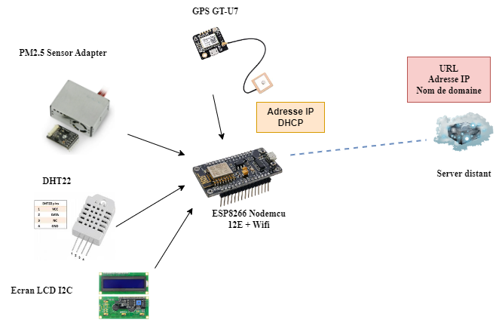

Fig.1. Schematic Diagram

To conduct measurements while mobile, the station can be installed on the roof of a car, as illustrated in Figure 2.

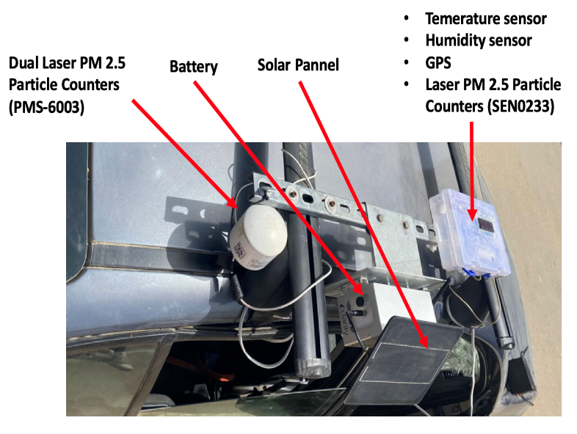

Fig.2. Image of the designed mobile station

To achieve a high spatial resolution, it is important to ensure a fine temporal resolution. Therefore, we have set this frequency to 12 measurement points per minute, resulting in a measurement interval of 5 seconds. The diagram in Figure 3 presents the overall architecture of the station, which was designed and deployed on the car's roof, emphasizing its key components.

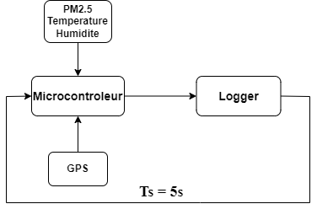

Fig.3. Architecture of the system

# Measurement campaign

As part of this study, we conducted a measurement campaign with the sensor installed on a vehicle for a period of nearly two months, from February 28 to April 26, 2023, in the Dakar region. Specifically, 30 distinct itineraries were pre-established to ensure optimal coverage of the region. They were selected to traverse areas with significant and varied pollution sources, such as:

* the routes with heavy vehicular traffic;
* industrial areas;
* areas with household waste incineration facilities.

These 30 routes (itineraries) are represented in the figure 5. The total distance covered by these 30 routes is 2668 km. Each day, the car must follow the pre-defined route between 9 a.m. and 7 p.m. These measurements are conducted every day of the week except Sundays. The image on the left, Figure 4 illustrates the vehicle on which the sensor was deployed during the measurement campaign.

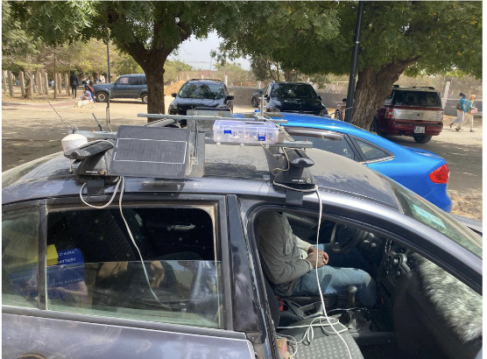

Fig.4. Image of the vehicle with the onboard sensor during the measurement campaign.

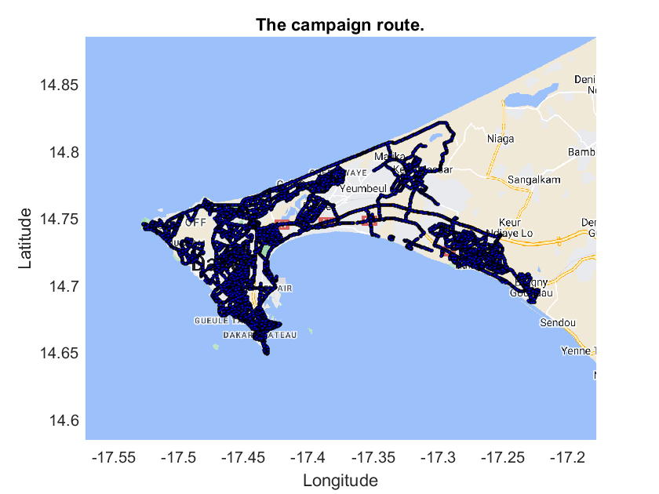

Fig.5. Map of the Dakar region with the 30 routes.

# Results and Discussion

## Methodological approach

This two-month measurement campaign generated a significant amount of data, including information on air quality and the GPS location of each measurement point. As explained in the previous section, these measurements were carried out daily between 9 a.m. and 7 p.m. while following pre-established itineraries. Therefore, to exploit this data, we adopted a two-step approach:

* Firstly, we analyzed the GPS positions and PM2.5 concentration to produce maps representing the distribution of fine particles throughout the Dakar region. This study allowed us to detect hotspots, which are the most polluted geographic areas in this city.
* In the second step, we focused on the daily evolution of fine particle concentrations in these hotspots. For this purpose, we utilized a geographic information system (GIS) to identify the hotspots at the municipality level. This allowed us to determine, for each hotspot, the time periods of the day when the emission source is most active.

## Spatial distribution of PM2.5

Based on the 30 itineraries carried out during the measurement campaign, we are performing a spatial distribution of PM2.5 throughout the Dakar region. The ordinary Kriging method was used as an interpolation tool to obtain complete spatial coverage of the region. Indeed, this interpolation method is often used in electromagnetics to determine radio coverage areas [12][13]. However, it is increasingly being used as a spatial interpolation technique in the domain of air quality and atmospheric sciences [14][15].

The figure 6 represents the spatial distribution of fine particles (PM2.5) in Dakar region during the measurement campaign. The results reveal an inhomogeneous spatial distribution, with certain parts of the region being significantly more polluted than others. This map also serves to highlight the main hotspots in the region in terms of PM2.5. In fact, five hotspots have been clearly identified, numbered from 1 to 5 in the figure 6.

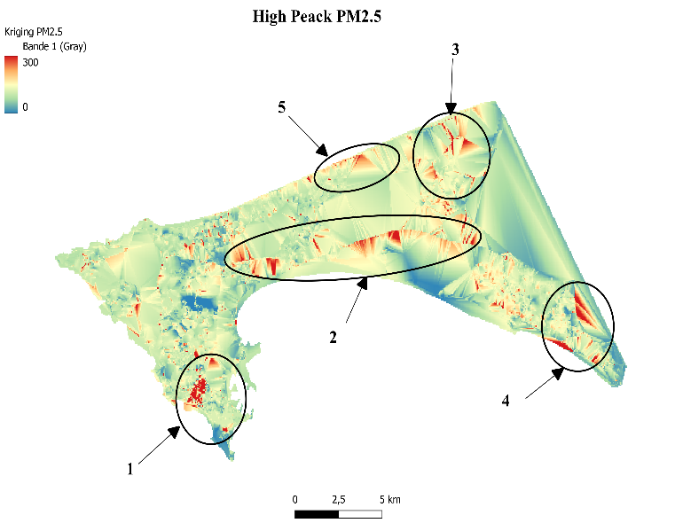

Fig.6. Identification of PM2.5 hotspots in the Dakar region

These results are in line with the types of anthropogenic pollution observed (activities) in Dakar:

* Zone 1 corresponds to the downtown of Dakar. It encompasses a significant portion of the country's economic and industrial activities (such as the Port of Dakar) as well as traffic.
* item Zone 2 covers the highway and the national road, which are the two main routes connecting Dakar to its suburbs and the rest of the country.
* Zone 3 encompasses the greater suburbs of Dakar, including neighborhoods such as Keur Massar and Malika. This area also houses the municipal waste incineration center for the entire Dakar region.
* Zone 4 covers another part of the suburb located in Rufisque, where the SOCOCIM INDUSTRIES cement plant has been installed since 1948.
* Zone 5 corresponds to the new Dakar bypass road (VDN) that runs along the sea. This road is increasingly used to connect Dakar and its eastern suburbs.

This initial result, which aimed to identify hotspots, will be highly valuable in determining the optimal locations for future fixed measurement stations for air quality monitoring. However, it is important to note that in this study, we focused solely on measuring the concentrations of PM2.5 and not their chemical composition. It is evident that the pollution in zones 1, 2, and 5 is largely due to traffic, while zones 3 and 4 are respectively impacted by waste incineration and the cement industry. An analysis of the chemical composition would allow determining the type of sensor to be installed in each zone.

# *C . Temporal distribution of PM2.5*

To study the temporal distribution (diurnal cycle) of particulate pollution (PM2.5), we focused on the municipalities that encompass the identified hotspots. Our vehicle repeatedly traversed these areas at different hours during the measurement campaign.

In order to study the temporal variability (diurnal cycle) of PM2.5, we focused on the municipalities housing the hotspots where our vehicle repeatedly traversed at different times during the measurement campaign. Figures 7, 8 and 9,

10 represent the average variation of PM2.5 concentration throughout the day for zones 1 and 4, which correspond to the municipalities of Dakar-Plateau-Medina-Colobane and Rufisque-Bargny, respectively. For each zone, we represent the map of municipalities covering the hotspot and the temporal distribution of PM2.5 in that area.

The results confirm that zone 1 figure 7 (downtown of Dakar) is the most polluted area in the Dakar region in terms of anthropogenic PM2.5. Indeed, Figure 8 highlights very high concentrations during rush hours, corresponding to traffic and activity peaks, between 11 a.m. and 2 p.m. Automobile traffic, economic activities, and industrial operations in the city are very dense during these hours.

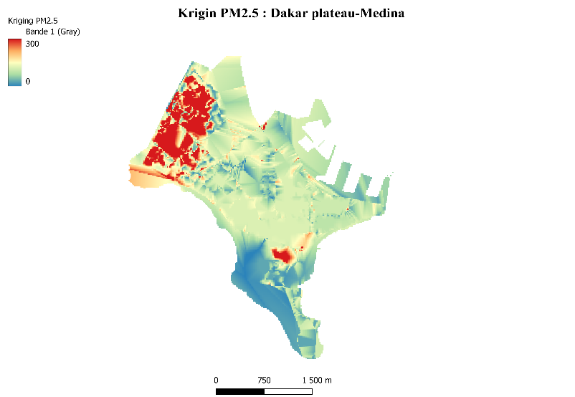

Fig.7. PM2.5 concentration levels in zone 1 (municipality of Medina, Dakar Plateau and Fass Colobane)

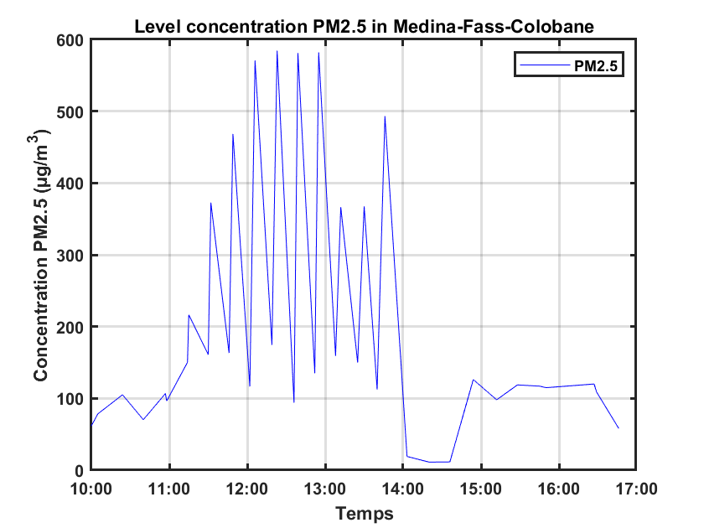

Fig.8. Diurnal cycle of PM2.5 in zone 1 (municipality of Medina, Dakar Plateau and Fass Colobane).

Unlike the downtown, zone 4 also exhibits pollution levels that remain relatively high throughout the day (see Figures 9 and 10). This is attributed to the continuous operation of the cement plant.

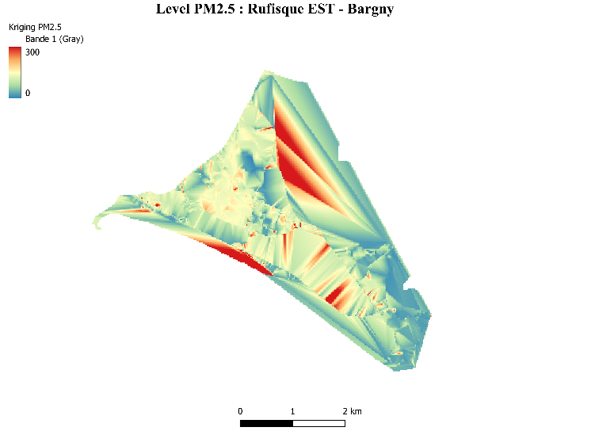

Fig.9. PM2.5 concentration levels in zone 4 (municipality of Rufisque and surrounding area).

In summary, this study demonstrates that there are two types of anthropogenic PM2.5 pollution sources in Dakar region. There are sources that produce very high quantities of fine particles during a specific period of the day, and others that produce relatively high quantities continuously.

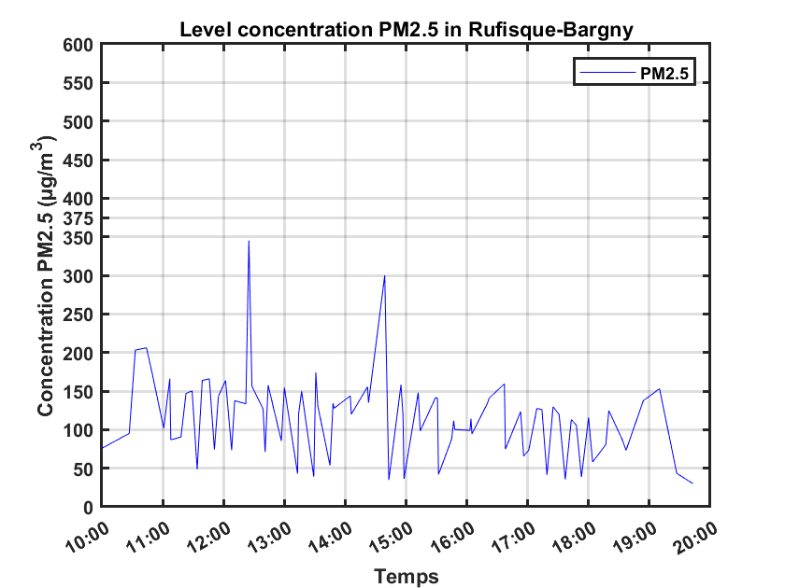

Fig.10. Diurnal cycle of PM2.5 in Zone 4 (municipality of Rufisque and surrounding area).

# Conclusion

This paper has presented the design of a mobile air quality monitoring station based on the Internet of Things (IoT) for detecting areas with high concentrations of fine particles (PM2.5) in the Dakar region. Through an intensive measurement campaign conducted with the designed sensors installed in a car, five hotspots were clearly identified, representing the primary anthropogenic sources of PM2.5 in the Dakar region. These sources include road and port traffics, industrial activities (such as a cement factory), as well as the main public landfill in the Dakar region, where waste is incinerated. Furthermore, the diurnal cycle of PM2.5 concentrations around these hotspots has allowed us to identify the most polluted periods of the day. Using a geographic information system (GIS) at the municipal level for data spatialization will allow for the future production of accurate information on air quality at a local scale.

##### Acknowledgment

This work is supported by Polytechnic School of Cheikh Anta Diop University and the University of Virginia..

##### References

1. Dr. Tedros Adhanom Ghebreyesus, "Air Pollution: The New Guidelines by the World Health Organization (WHO), UNRIC, 13 juillet 2022, https://unric.org/fr/Air Pollution_the-New-Guidelines-by-the-World-Health-Organization-(WHO)
2. P. Mehndiratta, A. Jain, S. Srivastava, J. E. Gupta, "Environmental pollution and nanotechnology," Environment and Pollution, vol. 2, no. 2, pp. 49--54, 2013.
3. Y. Huang, Q. Zhaodand, Q. Zhou, I. A. Jiang, "Air quality forecast monitoring and its impact on brain health based on big data and the internet of things," Environment and Pollution, vol. 6, no. 5, pp. 78678--78688, 2018.
4. B. Ngom, M. R. Seye, M. Diallo, B. Gueye, M. S. Drame, "A Hybrid Measurement Kit for Real-time Air Quality Monitoring Across Senegal Cities," in 2018 1st International Conference on Smart Cities and Communities(SCCIC)},pp.1--6,2022. https://doi.org/10.1109/SCCIC.2018.8584551
5. D. Rickerby, M. J. S. Morrison, T. O. Aly, "Materials, nanotechnology and the environment: A European perspective," Science and Technology of Advanced Materials, vol. 8, no. 2, pp. 19--30, 2007.
6. S. Diouf, M. Sarr, M. Sow, M. S. Sow, "Monitoring Air Pollution in Dakar using IoT technologies," in IEEE 6th Global Conference on Consumer Electronics (GCCE), pp. 159--163, 2019.
7. E. Bellinic, Z. Bonaventura, L. D'Angelo, L. Liberti, "An IoT Platform for Air Quality Monitoring: Design and Implementation," Sensors, vol. 19, no. 22, p. 4857, 2019.

https://doi.org/10.3390/s19224857

1. J. Smith, A. Johnson, R. Davis, "The Importance of Sensor Selection for Fine Particle Measurement,"Environmental Science Journal, vol. 25, no. 3, pp. 45--62, 2019.
2. L. Thompson, M. Roberts, K. Brown, "Optimal Measurement Intervals for Fine Particle Monitoring in Mobile Campaigns,"Atmospheric Environment, vol. 102, pp. 78--92, 2020.
3. E. Garcia, W. Chen, S. Lee, "Geolocation Strategies for Assessing Spatial Variation in Fine Particle Levels," Journal of Air Quality, vol. 45, no. 2, pp. 165--180, 2018.
4. R. Johnson, "Advances in Particulate Matter Monitoring: A Review of Recent Studies,"Environmental Monitoring and Assessment, vol. 150, no. 4, pp. 267--284, 2021.
5. C. E. García, I. Koo, "Extremely Randomized Trees Regressor Scheme for Mobile Network Coverage Prediction and REM Construction," IEEE Access, pp.65170--65180,2023. https://doi.org/10.1109/ACCESS.2023.3287103
6. A. Krause, P. Schulz, F. Burmeister, G. Fettweis, "Improving Radio Environment Maps with Joint Communications and Sensing: An Outlook,"IEEE Access, pp. 1--6, 2023. https://doi.org/10.1109/JCS57290.2023.10107465
7. X. Li, T. Zhang, Z. Yang, J. Chen, "2022 29th International Conference on Geoinformatics," pp. 1--5, 2022. https://doi.org/10.1109/Geoinformatics57846.2022.9963798
8. Y. Tong, Y. Yu, X. Hu, L. He, "Performance analysis of different kriging interpolation methods based on air quality index in Wuhan," in 2015 Sixth International Conference on Intelligent Control and Information Processing (ICICIP), pp. 331--335, 2015. https://doi.org/10.1109/ICICIP.2015.7388192