**Contributors**Ahmed Galal - 52001‬‬

Abdelrahman Almahdy – 52042

Abdelrahman Gamal - 52043

**Introduction**

In our project we aim to use a hospital information system to keep track of patients’ records during their admittance in the Intensive Care Unit. To apply this system, we used C++ language and object-oriented programming. Our code of system consists of 5 classes : patient, doctor, ICU, prescription, and Hospital. Each class has its properties and methods, where patient class contains unique ID for the patient, his personal information, medical history, allergies and medical status, doctor class contains unique social security number, his personal information and his professional information, ICU class contains unique code and number, manager, and a set of beds numbered according to its capacity, prescription class contains unique code, the directions for each medication, and finally hospital class we use to connect all of these class to solve the requirements of the project.

**Motivation :**

In general, we look forward to improving the health system and facilitating communication in hospitals and obtaining information that pertains to the patient and the patient's medical history. Personally, improving the skills of coding C++ and OOP.

**Tools**:

Visual Studio 2015 ,C++ ,Visual C++ compiler.

**Challenges and Problems:**

* learning a course of OOP.
* learning pointer and pointer to pointer and send by reference.
* Implementation of priority Queue.
* Searching for open source projects in GitHub to simulate them.

**User manual of the system for some cases**

When you run the code from the main.cpp file, you will be asked to

* Press 1 to assign new doctor
* Press 2 to add new patient
* press 3 to assign new ICU unit
* Press 4 to exit



If you want to assign new doctor Press 1, then you will be asked to enter the following information

* Name
* Major
* Degree
* Birthdate
* sex

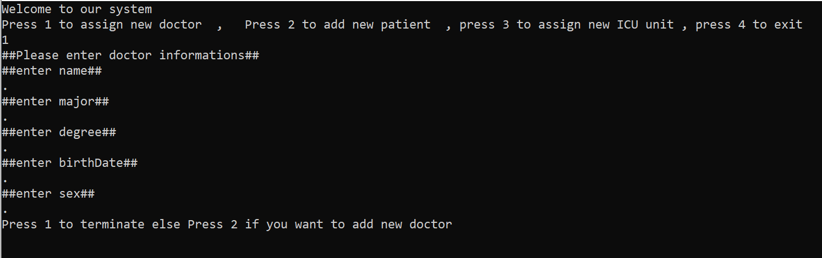

then you will be asked to press 1 to terminate or 2 to assign another doctor

If you press 1, doctor information will be displayed and you will return to the previous request to press 1 or 2 or 3 or 4.

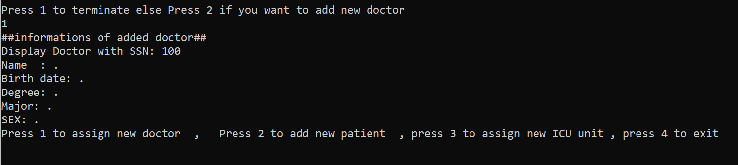

if you want to add new patient press 2, then you will be asked to enter the following information

* name
* Address
* Phone
* Birthdate
* Sex
* medical history

allergies be careful when you enter the allergy, press 0 if the patient does not have allergy and 2 if he has allergy.

* blood pressure
* heart rate
* temperature
* severity level

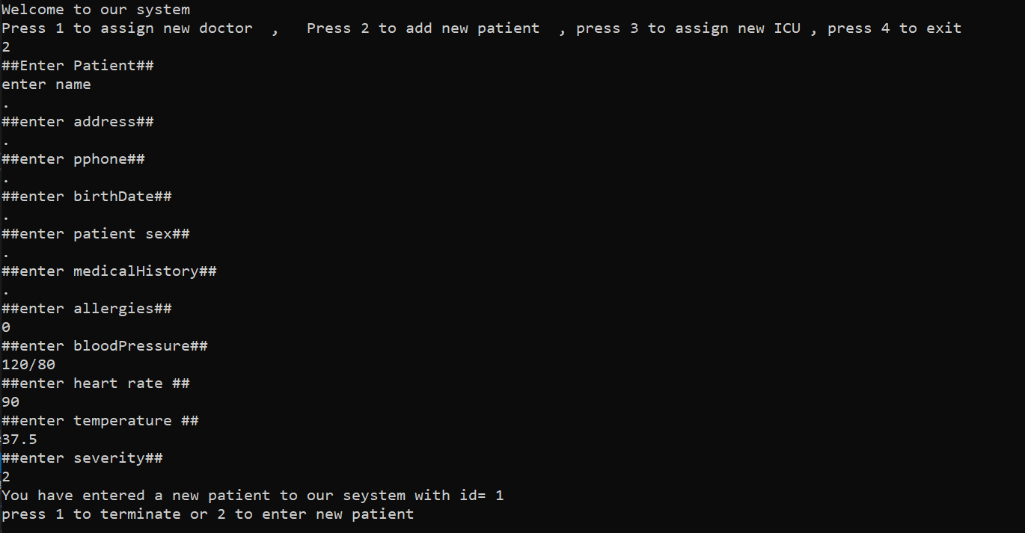

then you will be asked to press 1 to terminate or 2 to add another patient

If you press 1, patient queue counter will increase 1 and you will be asked to press one to dequeue this patient or 2 to terminate



if you press 1, the patient will be dequeued and patient information will be displayed .

then you will return to the first request to press 1 or 2 or 3 or 4 .

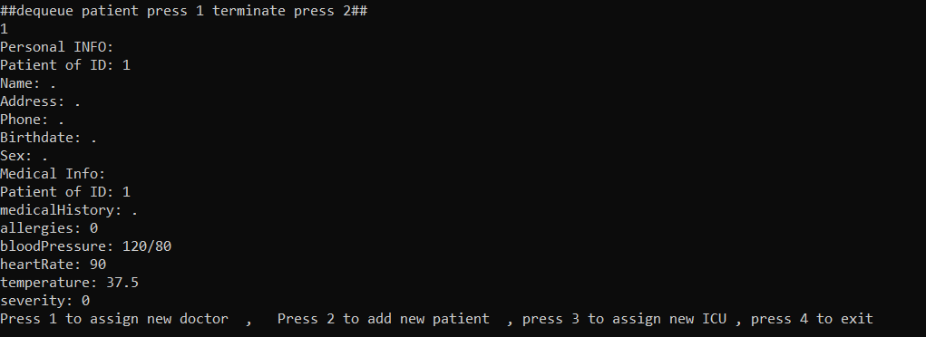

If you want to assign new ICU unit Press 3 , then you will be asked to enter the following information

* name
* Manager
* Code
* capacity

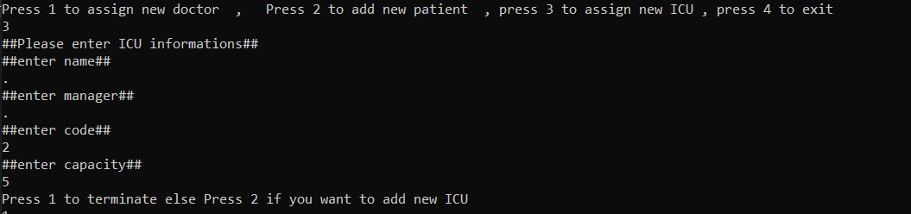

then you will be asked to press 1 to terminate or 2 to add new ICU

If you press 1 , the ICU information will be displayed and you will return to the first request to press 1 or 2 or 3 or 4 .

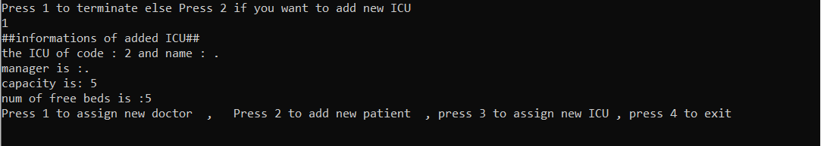

if you want to exit press 4

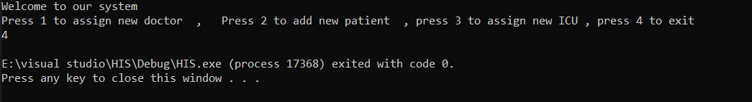

**Screenshots for running program**

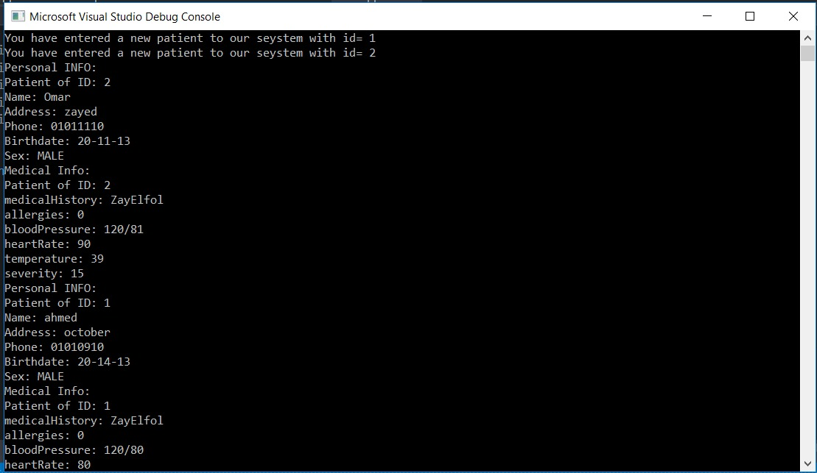

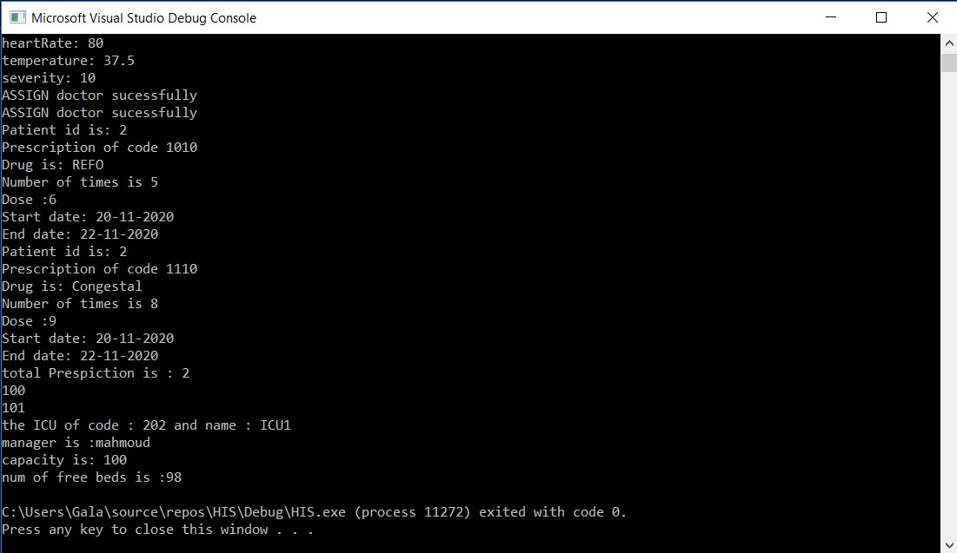

If we add two patients with the same severity level ,system will organize them according to the attendance time

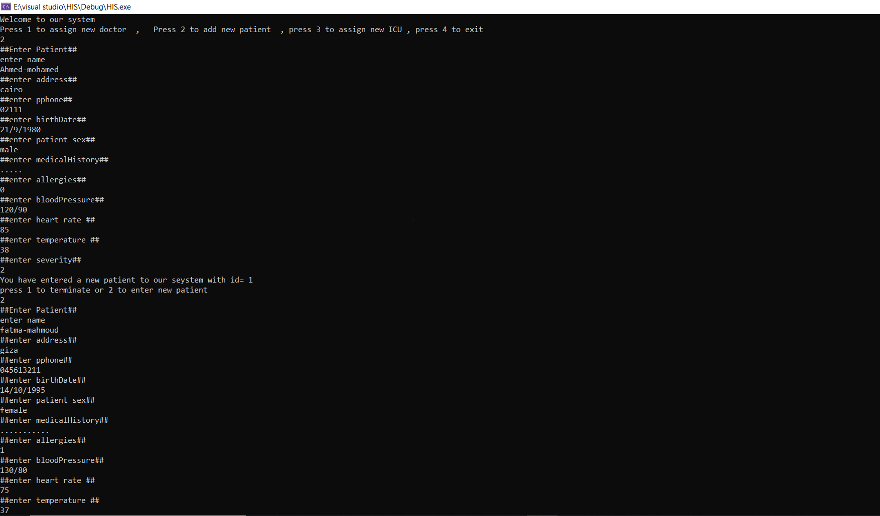

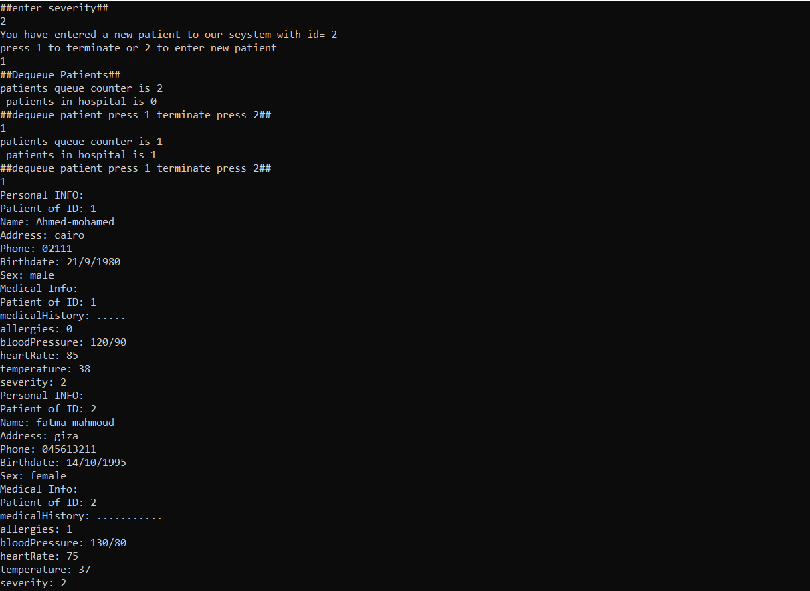

If we add two patients with different severity level ,system will organize them according to their severity not attendance time

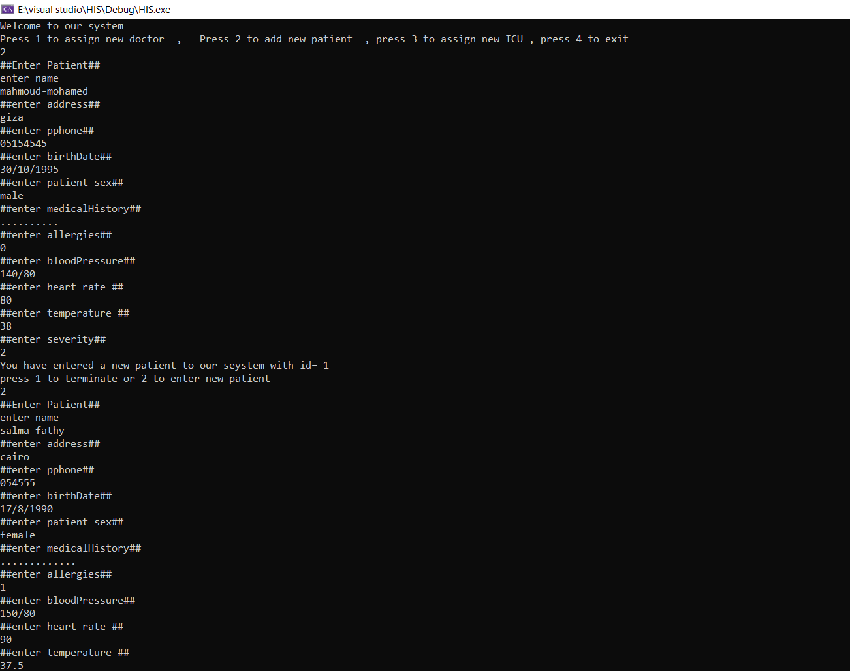

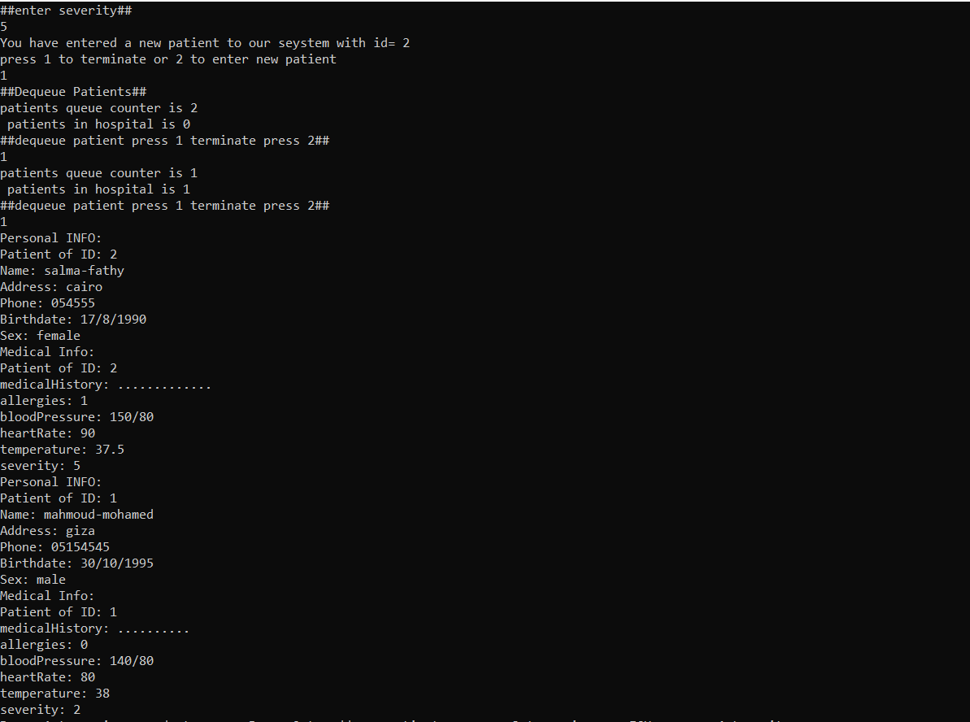

**Contribution**

Ahmed Galal coded Hospital files and main files  
Abdelrahman Gamal coded patient files and ICU Files  
Abdelrahman Almahdy coded doctor Files and prescription files   
we all helped each other in each file equally.

**References**

1. Object-Oriented Programming in C++ (4th Edition) by Robert Lafore.
2. [https://www.youtube.com/watch?v=iPlFOBEKSNM&t=571s](https://www.youtube.com/watch?v=iPlFOBEKSNM&t=571s&fbclid=IwAR1oepCX1SfMycHObFD3b2FyuJH9Z-CteV-BjI4Vpudf9KIEMAHLiSLSIf0)
3. [https://www.youtube.com/watch?v=6U6WtWG3NrA&list=PL1DUmTEdeA6KLEvIO0NyrkT91BVle8BOU](https://www.youtube.com/watch?v=6U6WtWG3NrA&list=PL1DUmTEdeA6KLEvIO0NyrkT91BVle8BOU&fbclid=IwAR1bTfOPVvhJUXgNHm3m5Tn0jG_G3nFzFJqVgQ3lJnjh_VNRYbEo8ZRdAp4)
4. [https://www.youtube.com/watch?v=d3kd5KbGB48&fbclid=IwAR39H9AR-mbAb-HKv5Wo-TYel-J_uUTtzb6cCj2ScqeXDdN1hrfQiPISelU](https://www.youtube.com/watch?v=d3kd5KbGB48&fbclid=IwAR2AzE2bdfhez-P0JSX0r0Rxh5h9cIuTM3NU6lWI4hiOS7zJY5ZKyKdG-2c)
5. [https://www.youtube.com/watch?v=38IG-UToeZ0&fbclid=IwAR0WtSUQa4eqMzHAK9dIR-1u_WUVDqt04cijSB6NwBhkDkgeWRDoQAur-2Y](https://www.youtube.com/watch?v=38IG-UToeZ0&fbclid=IwAR1Z4-x3qYdjzko9Pl3Q3_1x71zvmPO9IYts5McEjRF9f1MPdzdEldkwSbE)