How To Run the ETL Pipeline:

You must include the credentials in the configuration file (config.cfg). Afterward, you may run the etl_openflight.ipynb file, which will download the datasets, create the schema in the PostgreSQL database, and handle the queries related to data retrieval.

Business Intelligence:
- How could airlines reduce environmental impact?
- Using the routes data, airlines can identify and avoid inefficient routes with multiple stops, opting for direct flights where possible. Reducing stops minimizes fuel consumption and emissions.
- By examining equipment data in the routes table, we could identify older aircraft that consume more fuel and suggest replacing them with fuel-efficient models. This could lead to significant reductions in emissions.
- Based on airport location data, airlines can optimize ground operations, reducing engine idling time and taxiing distance at specific airports, leading to reduced fuel burn.
- Opportunities for a New Airline Venture:
- By analyzing route and airport data, we could identify regions with fewer flights or underserved routes (e.g., flights between secondary cities). Targeting these could offer a niche with less competition.
- Many large airports face congestion and high operational costs. By using secondary airports (found in the airports data) in major metro areas, a new airline could reduce fees, improve turnaround times, and offer competitive ticket pricing.
- Reducing Operational Costs for an Underperforming Airline:
We chose Eurowings due to its under-performance compared to other airlines, as it operates only one route from a single airport.
Establishing indirect routes can enhance the airline's popularity by attracting additional customers, thereby improving overall customer satisfaction,
- Improving Positioning for an Underperforming Airport:
Based on the data, we selected Tiree Airport as it received a route.
- Airports with underused capacity can attract LCCs by offering discounted landing fees, which can boost traffic and revenue.
- Many airports find additional revenue streams by focusing on air cargo. If feasible, underutilized airports can attract cargo airlines, improving overall utilization and financial health.

A brief report summarizing insights from the data analysis.
Data Overview
The OpenFlights dataset contains three primary tables:
- Airports - Details of over 7,000 airports globally, including geographical coordinates, country, city, and codes.
- Airlines - Information on airlines, including active status and country of operation.
- Routes - Data on over 60,000 flight routes, including source and destination airports, airline information, and codeshare details.
The data indicates a deficiency in indirect routes, as there are only 11 available.
The available data indicates that there is no transportation option other than the air terminal
Airline Coverage and Dominance
- Top Airlines by Route Count: Certain airlines, such as American Airlines and United Airlines, dominate the number of routes, especially in regions like North America.
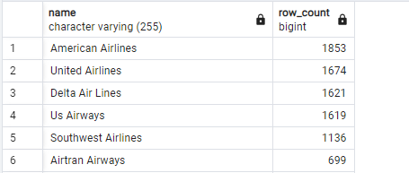

- Global Reach: Several airlines, including Ryanair, Easyjet, and American Airlines, maintain a high volume of international routes, connecting a diverse set of countries.
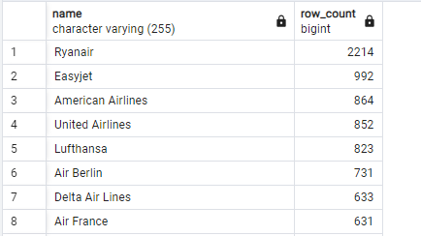
- Popular Routes: Analysis of the most frequently traveled routes reveals key corridors, such as domestic routes in the U.S. (e.g., Chicago to Atlanta) and Europe (e.g., London to Palma De Mallorca), along with international routes like New York to London.

