**This program about reader and writer problem and its solution**

**Free of race condition an, starvation and deadlock**

**Create class writer**

**create writer(parameter) {**

**Run()**

**while true**

**startWrite()**

**stopwriting()**

**}**

**Create class reader**

**create Reader (string){**

**run()**

**while true**

**startreading()**

**read()**

**stopreading()**

**}**

**Create class controller**

**Create StartWrite(){**

**While writing or readins >0**

**Add 1 to writers**

**wait()**

**writing equal true**

**}**

**create Write(string s){**

**print ”start writing”**

**SetText(s)**

**Print ”finish writing”**

**}**

**Create StopWriting(){**

**Print the name of method plus “stop writing”**

**notifyALL()**

**}**

**create StartReading(){**

**print ”request to read”**

**while writing or waiting writers > 0**

**print “wait’**

**wait()**

**add one to readers**

**}**

**create read(){**

**print “start reading”**

**print “reading”**

**print “finish read”**

**}**

**create stopreading(){**

**reduce reader by one**

**print “stop reading”**

**if readers equal 0**

**notifyAll()**

**}**

**__________________________________________________________________________________________________________________________________________________________**

**Code with starvation:**

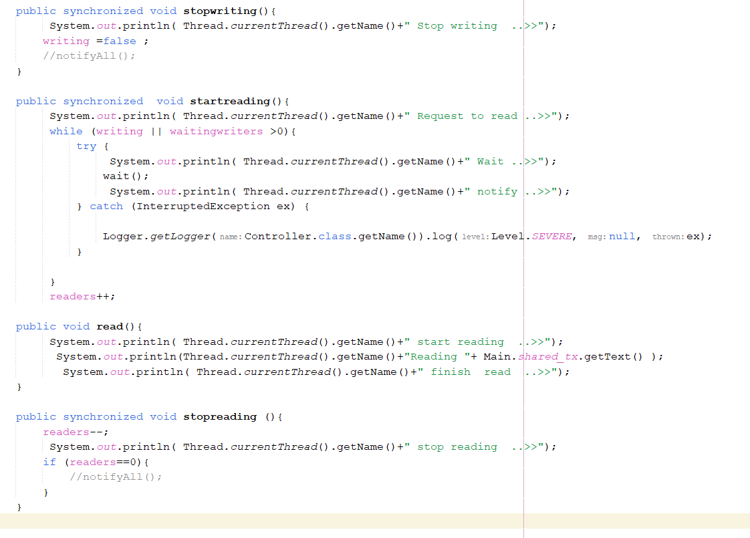

**Starvation output:**

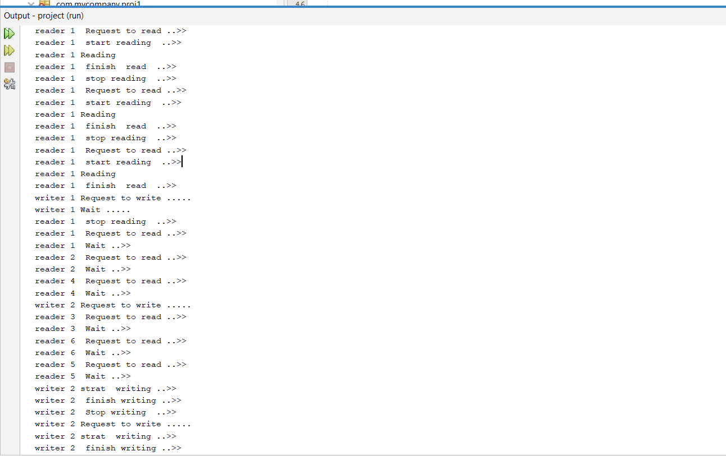

**Starvation output:**

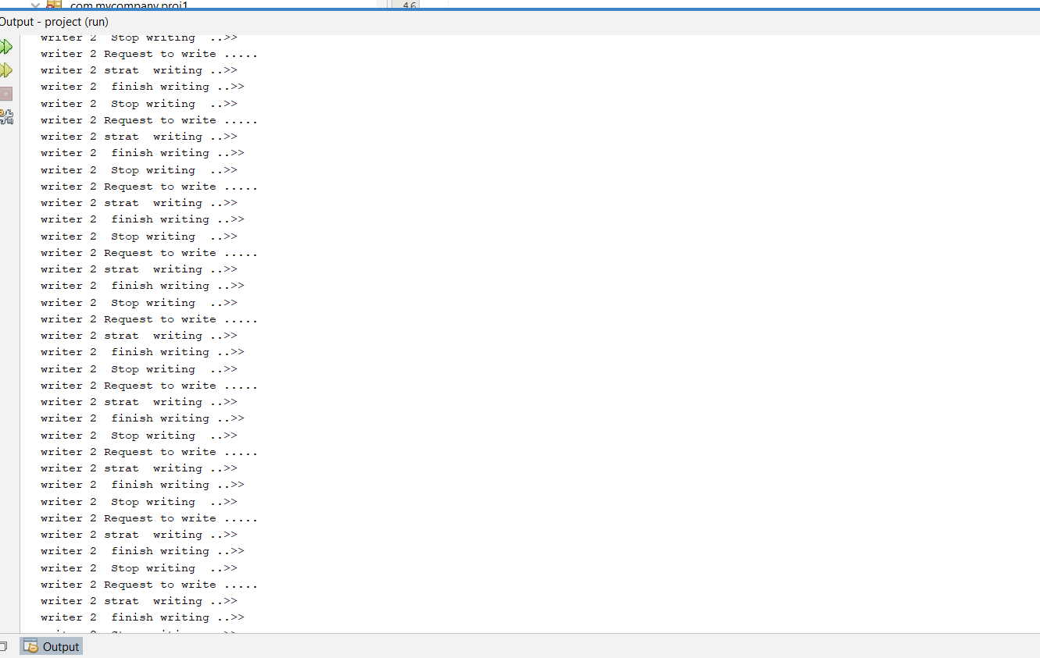

**Code without starvation:**

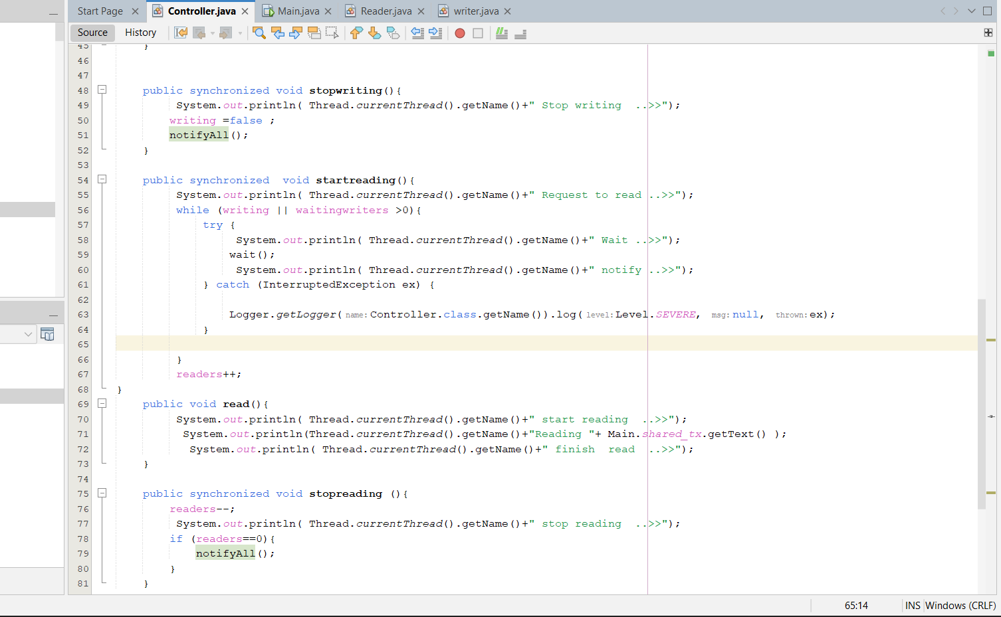

**Running the program:**

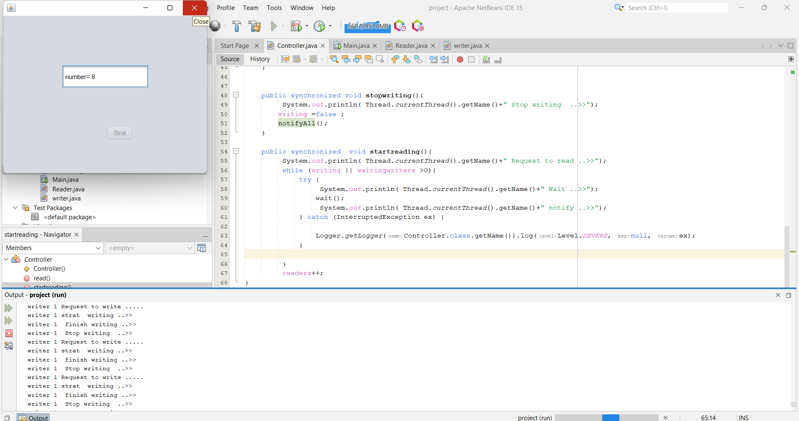

**Output without starvation:**

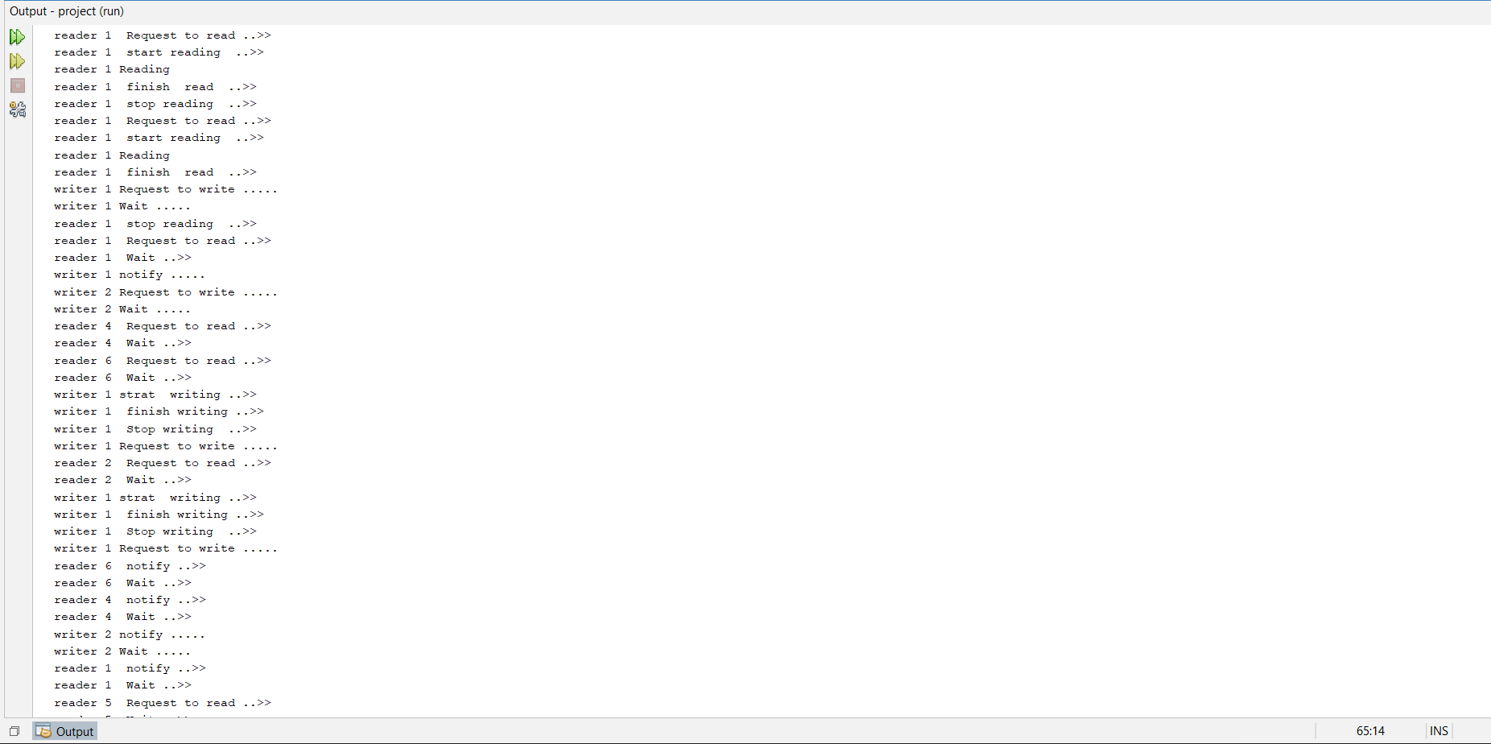

**___________________________________________________________________________________________________________________________________________________________________________________________________________________________________**

**code with deadlock:**

**code with deadlock:**

**Code with deadlock:**

**Running the code:**

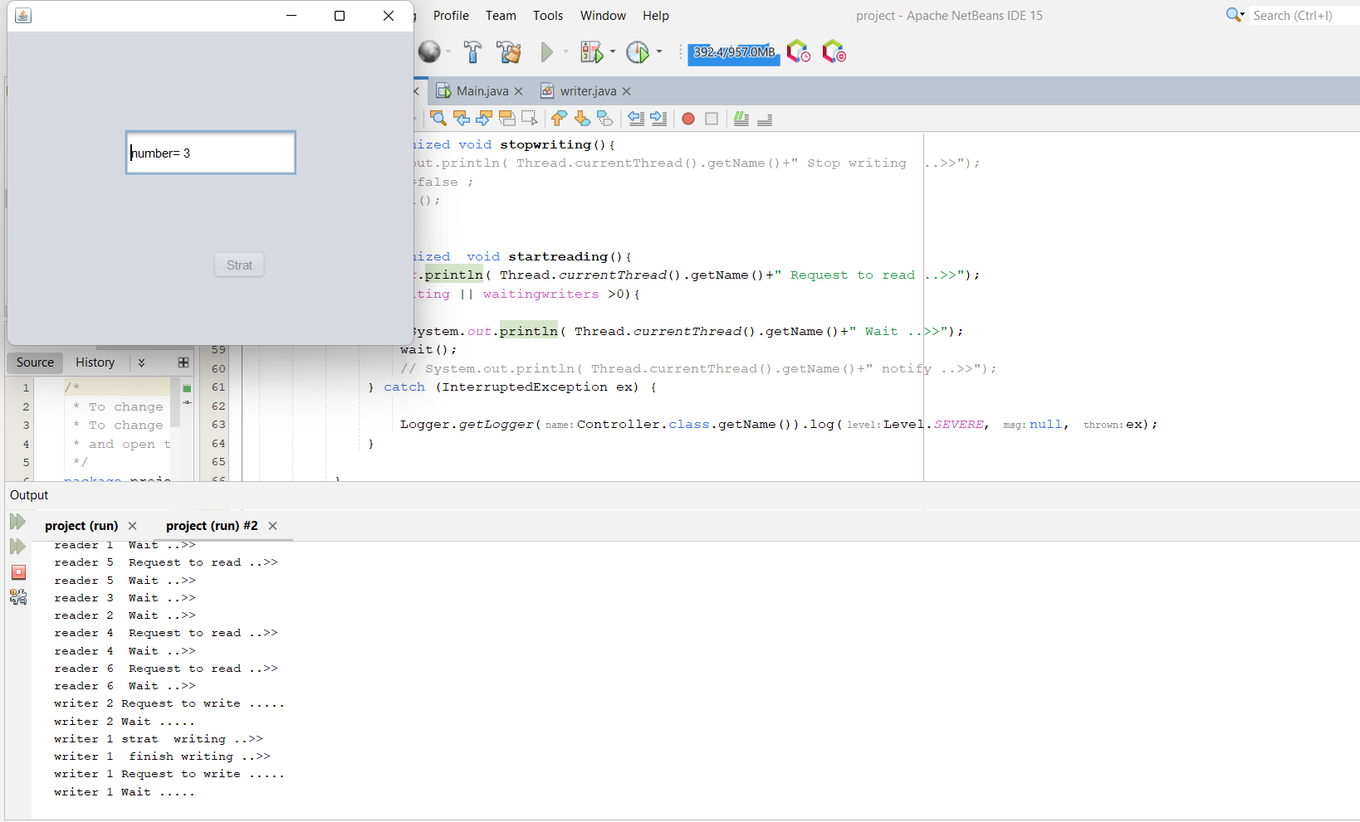

**Output with deadlock:**

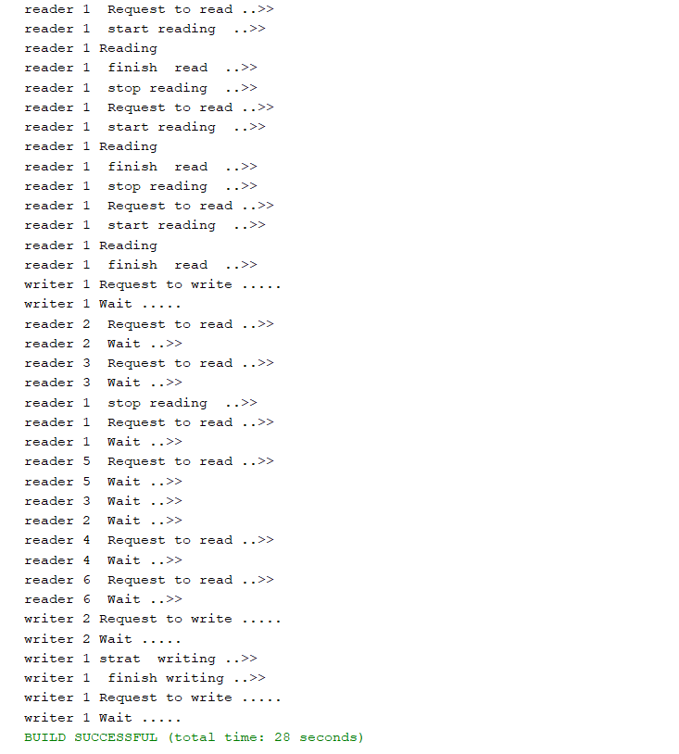

**Code without deadlock:**

**Code without deadlock:**

**Output without deadlock:**

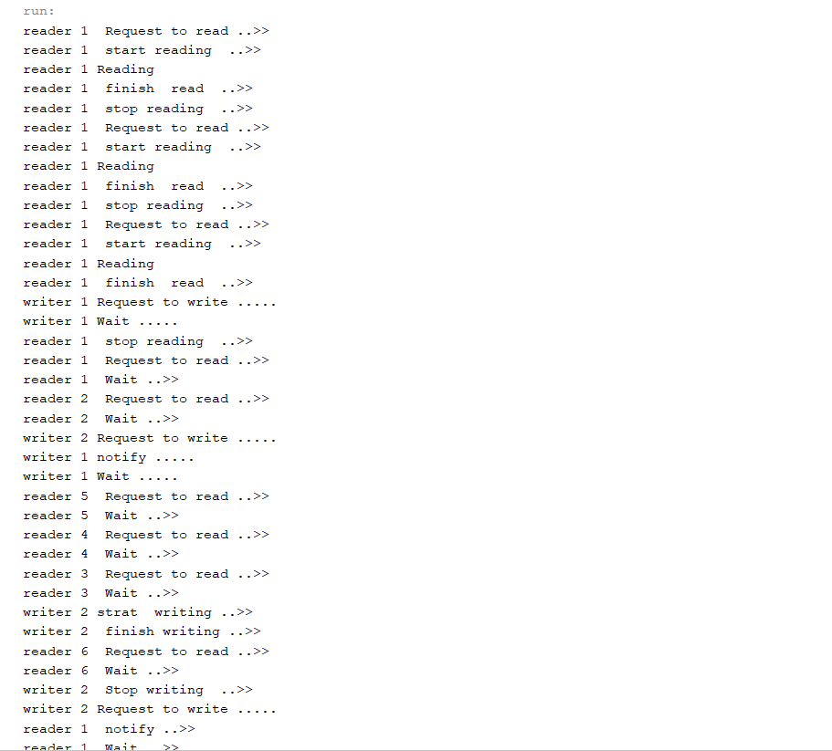

**Output withoput deadlock:**

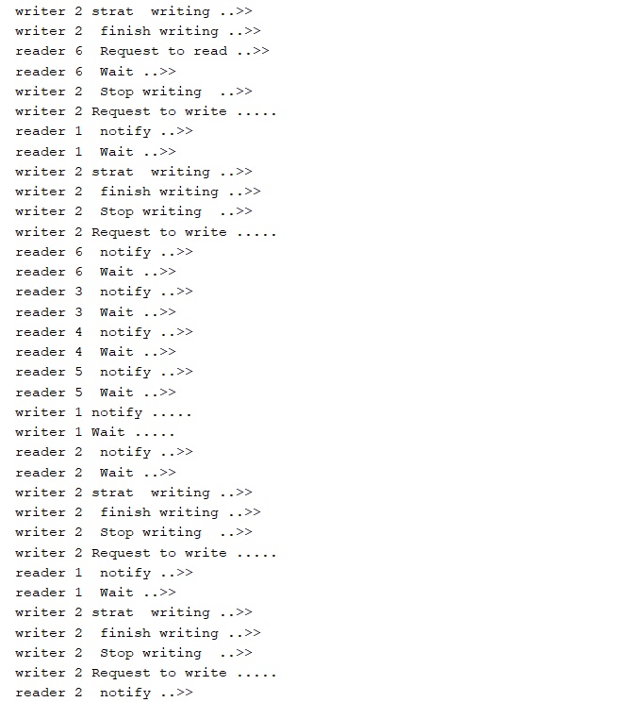

**Output without starvation:**

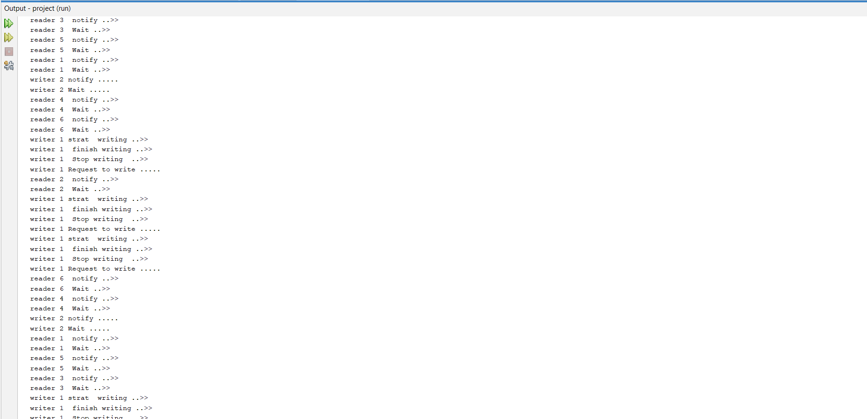

**__________________________________________________________________________________________________________________________________________________________**

**Real world application**

If we have one account and two persons have access on it .

If the first account try to access the account to check the balance (as a reader )And the second one try to access the account to deposit money in the account (as a writer) So we have one set of data is shared among a number of processes once the writer is ready he is the only one can access the account while processing and no other processes can read at time.

If the reader request to access while the writer is processing , will wait until the writer is completely done.

He will access the account after updates on it .

And we control this process among the two persons by the condition ( while (writing || readers >0)

So if we have any readers or writers (in case we have more than 2 persons can access the bank account)

Processing any other person cannot access the account. Also If we have a reader request to access the account so we have the condition while (writing || waitingwriters >0)

To prevent the reader to access the account if we have any writer processing.

Github link : [AlaaErfan/OperatingSystem2Project: Reader writer problem (github.com)](https://github.com/AlaaErfan/OperatingSystem2Project)