**Cloud computing:**

Cloud computing is the operation of deliver the compute services (such as virtual machine, storage, networking,) over the internet.

**Shared responsivity model:**

Model which tells you what are as a consumer or as a service provider responsible for

Let us start from traditional (on-premises):

At your company you responsible for the building of Data center, electrical, air-condition, servers, networking, security, software….

At the cloud some of these tasks take off from your side to service provider. There are three common model

**1-IaaS (infrastructure as a service)**

* Here the service provider responsible for all infrastructure like (servers, electrical, network, internet connection…)
* The consumer responsible for install OS and manage it, software, security, data, …

Example: when you move your work from on-premises to cloud

**2-PaaS (platform as a service)**

* Here the service provider responsible for all infrastructure plus platform such as (servers, electrical, network, internet connection...) plus (database, patch and update of OS and database...)
* The consumer responsible for manage data and configuration of platform

Example: development and test environment, …

**3-SaaS (software as a service)**

* Here the service provider responsible for everything
* The consumer responsible only on data

Example: office 365, email, google drive….

The following image illustrate the difference between the three model

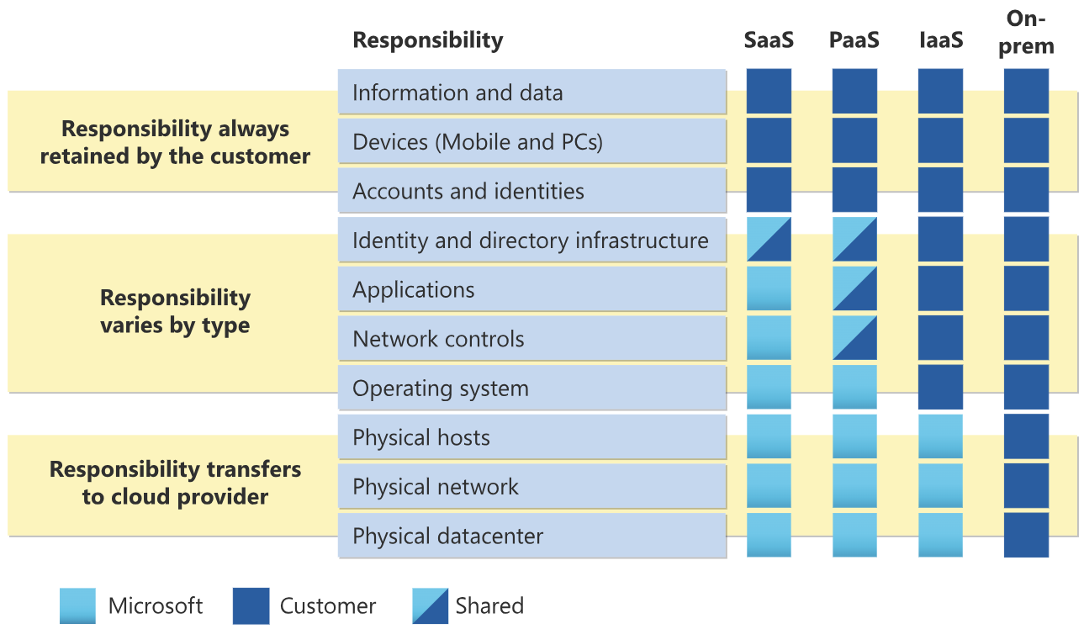

**Cloud Models:**

It is the deployment type of cloud resources and we have three types

**1-private Cloud**

Deliver the services of the company over the internet for its branches and employees (the datacenter owns by organization and sometimes the organization can rent dedicated data center from any service provider)

All control and management done by the organization

this solution considers costly

**2-Public Cloud**

The process of Purchase(rent) any services from service provider and you will pay only for what you used.

noticed that any customer and its data isolated from other customers

**3-Hybird Cloud**

Mixed between private and cloud such as company have its own data center and purchase specific service from the service provider

The following image show the difference between the three model

