**Azure subscription**

Allow you to logically organize you resource groups, when you use azure, you need subscription which represent you authentication and authorization to use azure services. azure subscription link to azure account which is consider identity at Microsoft Entra ID. Any azure account may contain more than one subscription.

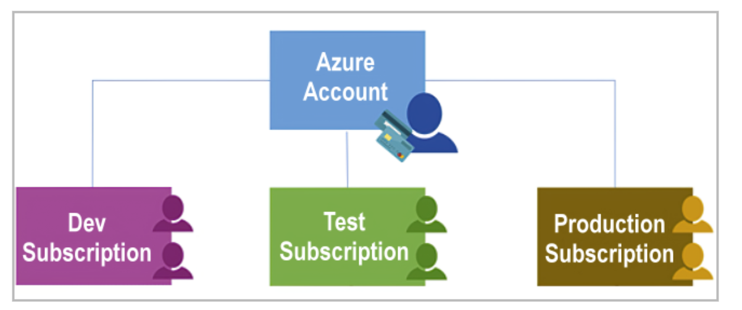

How to deploy subscription

1. Sign in to the Azure portal at [https://portal.azure.com](https://portal.azure.com/)
2. Navigate to subscriptions then choose add.
3. On the Basics tab of the Subscription, fill in the following information

Choose the subscription name, billing account, billing profile

(we cannot continue as my azure account is student for learning purposes only and needing to upgrade to allow me to add more subscription)

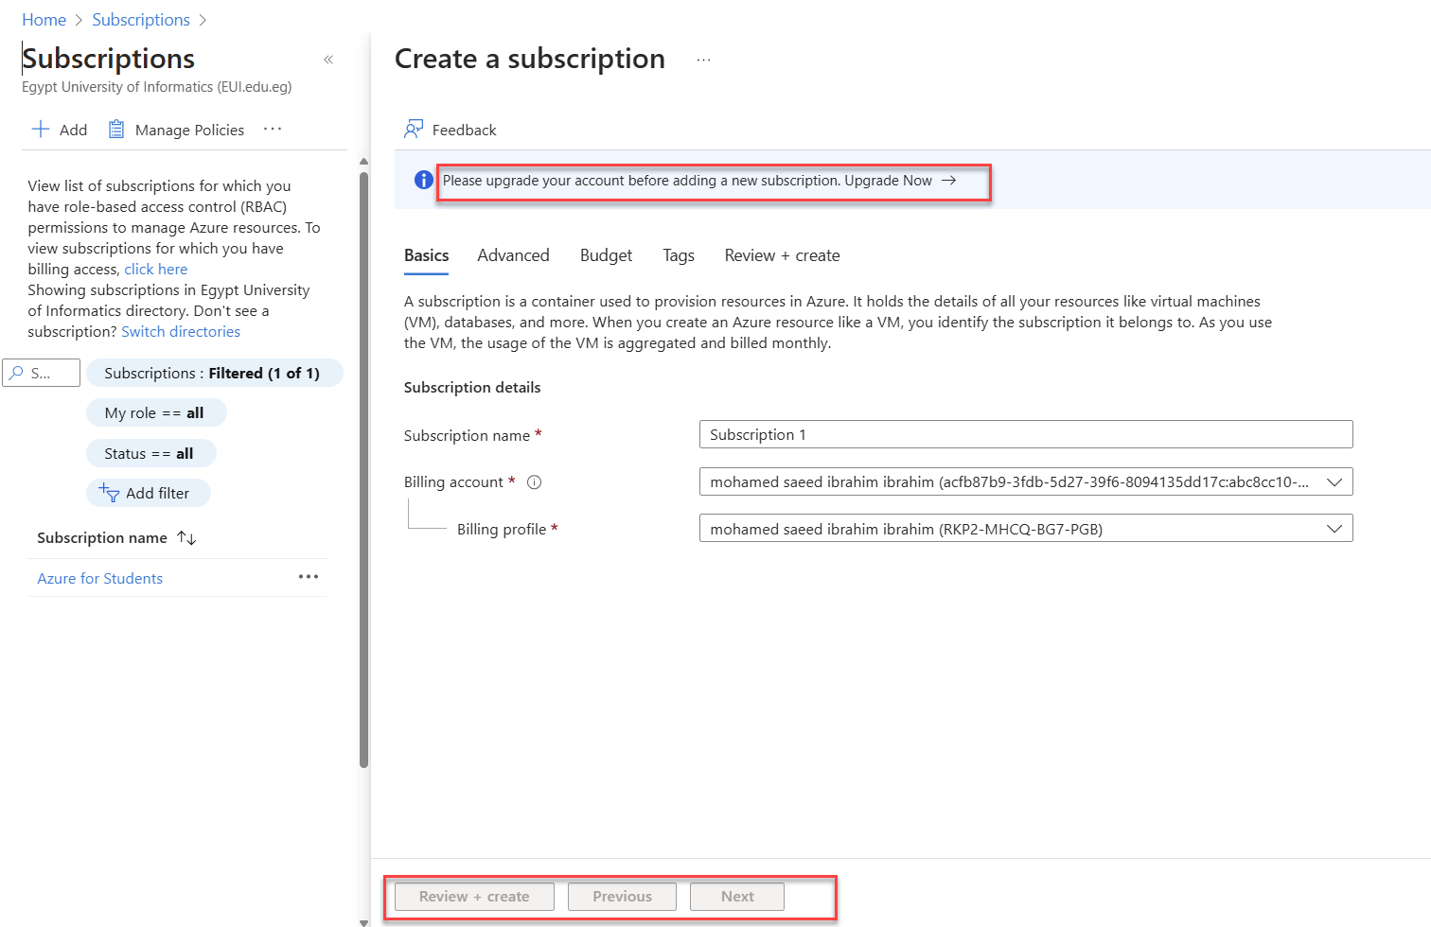

**Resource Group**

Is a logical container grouping resources (any service like Virtual network, Virtual machine, storage account considers resource) this is useful when you try to apply action to resource group it will apply on all resources inside resource group, when you delete resource group all resources within this resource group will be delete. any resource located at only one resource group and you can move it from resource group to another. resource group cannot be nested which is you cannot put resource group 1 inside of resource group 2

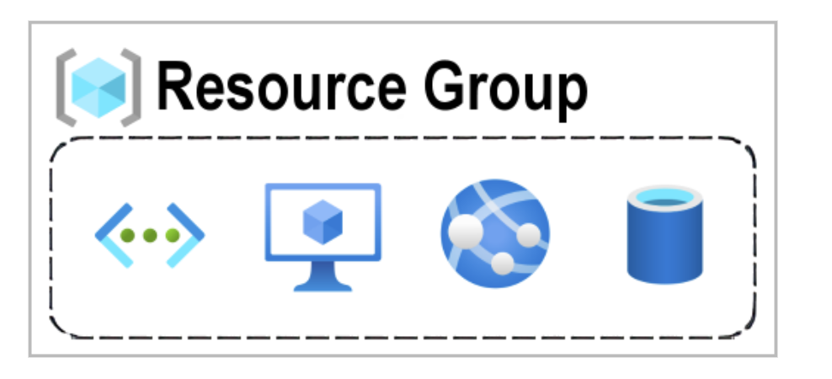

**How to deploy Resource Group**

1. Sign in to the Azure portal at [https://portal.azure.com](https://portal.azure.com/)

2. Select Create a resource.

3. Search for Resource group at the search services and marketplace title.

1. Under Resource group, select Create.

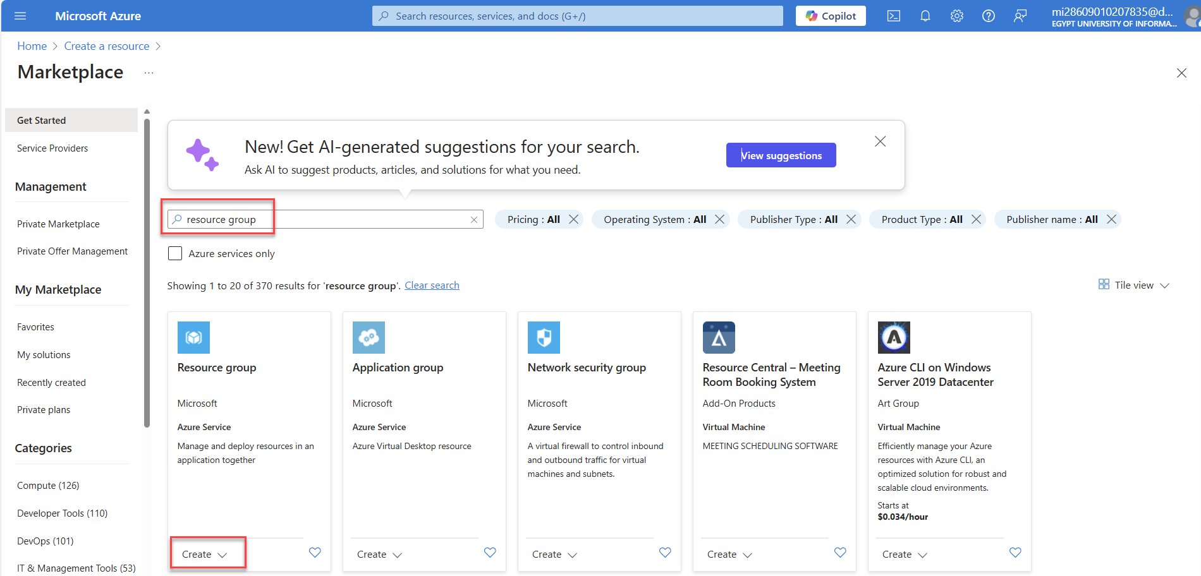

1. On the Basics tab of the Create resource group, fill in the following information

Choose the subscription, suitable name for resource group, region which the resource group will reside

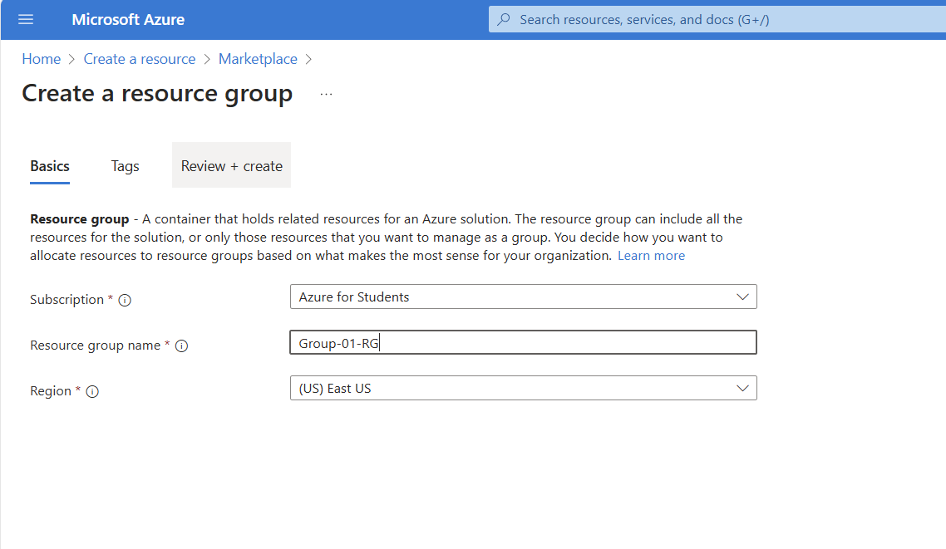

1. Choose suitable tags if you want then press preview + create to preview your configuration, then press create and wait till the deployment finish. then you can press on go to resource group if you want

