INTELLIGENT STUDENT
ACADEMIC PROGRESS MONITORING
& EARLY RISK PREDICTION
Machine Learning Project — OULAD · Day-28 Early Warning

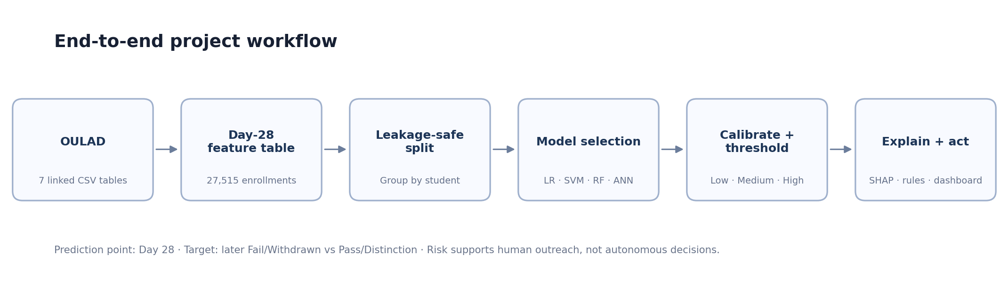
FINAL TECHNICAL REPORT
Prepared by: Project Team
September 2026

Executive Summary
This project builds a leakage-aware early-warning system that estimates whether a student who is still active at Day 28 will later finish as Fail/Withdrawn (At Risk) or Pass/Distinction (Not At Risk). The system combines four weeks of learning-platform engagement, early assessment behavior, course context, and background variables, then produces a calibrated risk probability, a relative risk band, explainability outputs, and support-oriented recommendations.
The engineered dataset contains 27,515 enrollment rows from 24,826 unique students. A persisted student-group-aware split isolates 22,011 development rows from a 5,504-row locked evaluation holdout with zero student overlap. Logistic Regression was selected by 5-fold StratifiedGroupKFold cross-validation over Linear SVM and Random Forest.
Final operating point Recall 83.2% · F1 70.1% · ROC-AUC 0.798 · PR-AUC 0.777. The recall-focused threshold intentionally catches more genuinely at-risk students at the cost of more false-positive support alerts.

Project Deliverables
- Reproducible Day-28 feature engineering from the seven linked OULAD tables.
- Full EDA with target-facing analysis restricted to the development split.
- Leakage-safe preprocessing pipelines: imputation, one-hot encoding, and model-appropriate scaling.
- Baseline models, 5-fold student-group-aware cross-validation, hyperparameter tuning, and documented model selection.
- Probability calibration, Low/Medium/High modeled risk bands, error analysis, and support/fairness audit.
- Global and local SHAP explainability plus Logistic Regression coefficient diagnostics.
- Rule-based recommendation engine using actionable academic and engagement signals only.
- Saved inference bundle, CLI predictor, reproducibility validator, and a modern local web dashboard.

Contents
1. Problem Definition 4
2. Dataset and Cohort Construction 4
3. Experimental Design and Leakage Prevention 5
4. Exploratory Data Analysis 5
5. Feature Engineering 7
6. Preprocessing 7
7. Candidate Models and Validation 7
8. Hyperparameter Tuning and Model Selection 8
9. Calibration and Risk Bands 8
10. Final Evaluation 9
11. Explainability 11
12. Recommendation Engine 12
13. Fairness and Sensitive-Feature Audit 12
14. Deep-Learning Extension 13
15. Progress Monitoring and Demo Dashboard 14
16. Reproducibility and Deployment 14
17. Limitations and Responsible Use 15
18. Conclusion 15
References 15
Appendix A — Reproduction Commands 16
Appendix B — Viva-Ready Key Points 16

1. Problem Definition
Educational early-warning systems are most useful when they identify risk before the final outcome is already known. This project therefore defines a fixed prediction point at Day 28 and restricts predictive behavior and assessment information to the period from Day 0 through Day 28.
Element | Definition
Prediction task | Binary classification
Prediction point | Day 28
Observation window | Day 0 through Day 28
At Risk (1) | Later final outcome = Fail or Withdrawn
Not At Risk (0) | Later final outcome = Pass or Distinction
Eligible population | Students registered by Day 28 and still active at Day 28
Intended action | Supportive outreach and academic assistance, with human review
Important distinction The model predicts association with a later academic outcome. It does not diagnose the reason for the outcome and does not establish causal effects.

2. Dataset and Cohort Construction
The project uses the Open University Learning Analytics Dataset (OULAD), a linked learning-analytics dataset published by Kuzilek, Hlosta, and Zdrahal. The original data is organized across course, assessment, student, registration, and virtual-learning-environment tables. The project creates one Day-28 modeling row per eligible enrollment.
Item | Value
Engineered enrollment rows | 27,515
Unique students | 24,826
Columns in engineered table | 61
Overall At-Risk prevalence | 44.11%
Development rows | 22,011
Locked evaluation rows | 5,504
Development unique students | 19,851
Holdout unique students | 4,975
Student overlap between splits | 0
Figure 1. End-to-end project workflow.

3. Experimental Design and Leakage Prevention
The central methodology rule is that no information occurring after Day 28 may be used to form predictive features. A persisted split manifest is also used so the same student never appears in both development and evaluation data.
- `final_result` is used only to construct the target and never enters the feature matrix.
- `id_student` is retained for joins and group-aware splitting but is excluded from model inputs.
- `date_unregistration` is used only to establish whether the student was still active at the prediction point.
- VLE interactions are clipped to Day 28.
- Assessment score features require the assessment due date and the student submission to be available by Day 28.
- Imputation, encoding, and scaling are fit inside the training/CV pipeline rather than on the full dataset.
Holdout caveat The current reproducible pipeline does not use locked-holdout targets during tuning, calibration, threshold selection, ANN diagnostics, or ablation. However, earlier iterative development viewed holdout diagnostics; therefore the packaged holdout is described as a locked evaluation holdout rather than a pristine external test.

4. Exploratory Data Analysis
EDA covers missingness, class balance, numeric distributions, categorical risk rates, IQR diagnostic flags, correlations, early assessment behavior, and the four-week engagement trajectory. Target-facing EDA is performed on development data only.
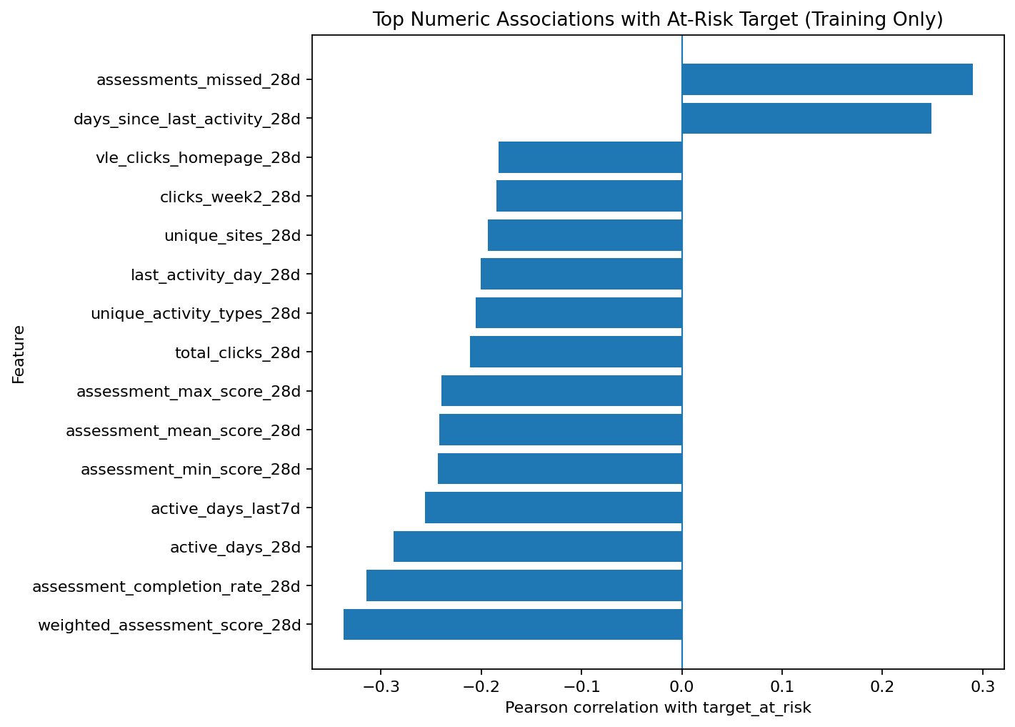
Figure 2. Strongest numeric associations with the risk target in development data.
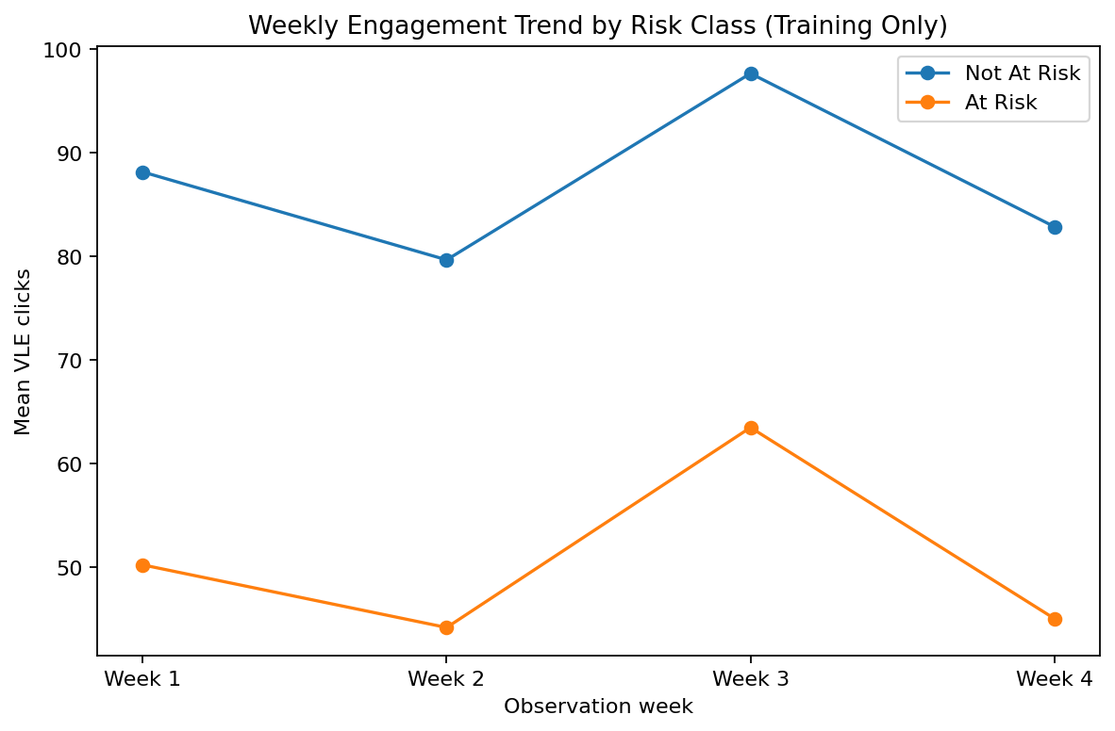
Figure 3. Weekly VLE engagement trend by risk group.
Descriptively, early assessment performance/completion, missed assessments, active days, and inactivity duration are among the strongest signals. These relationships are useful for prediction and monitoring but are not interpreted as causal effects.

5. Feature Engineering
The Day-28 feature table contains information that is available at or before the prediction point. Features are deliberately grouped so the project captures both static context and short-term progress.
Feature group | Examples
Background / context | gender, age_band, highest_education, region, imd_band, disability
Registration / history | num_of_prev_attempts, studied_credits, registration timing
VLE totals | total_clicks_28d, active_days_28d, unique activity/resource counts
Weekly progress | clicks_week1_28d … clicks_week4_28d, weekly_click_slope_28d
Recent engagement | clicks_last7d, active_days_last7d, days_since_last_activity_28d
Assessment progress | assessment_mean_score_28d, weighted_assessment_score_28d, completion rate, missed assessments

6. Preprocessing
Data type / model | Processing
Numeric | Median imputation
Categorical | Most-frequent imputation
Categorical encoding | One-hot encoding; unknown categories ignored at inference
Logistic Regression | Standardize numeric features
Linear SVM | Standardize numeric features
Random Forest | No numeric scaling required
Automatic per-column missing indicators are intentionally disabled for assessment-score variables whose missingness masks are duplicated by domain-level assessment-availability and submission features. This reduces redundant transformed features and makes interpretation cleaner.

7. Candidate Models and Validation
The candidate set was chosen to represent an interpretable linear probabilistic baseline, a margin-based classifier, and a nonlinear tree ensemble. A neural-network extension is evaluated separately as a course-aligned deep-learning experiment.
Model | CV F1 | CV Recall | CV ROC-AUC | CV PR-AUC
Logistic Regression | 0.670 ± 0.010 | 0.658 | 0.785 | 0.763
Linear SVM | 0.667 ± 0.010 | 0.648 | 0.785 | 0.763
Random Forest | 0.652 ± 0.008 | 0.610 | 0.777 | 0.758
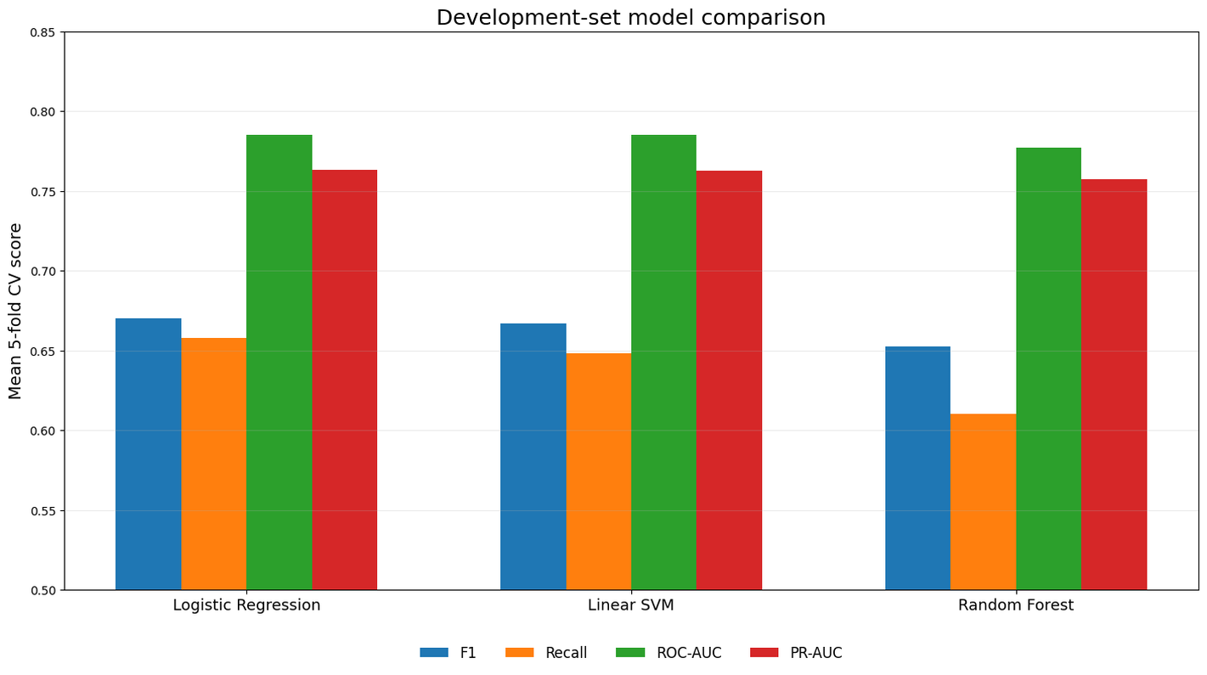
Figure 4. Development-set 5-fold group-aware model comparison.

8. Hyperparameter Tuning and Model Selection
Candidate hyperparameters are evaluated using 5-fold StratifiedGroupKFold on development data. Model selection uses mean CV F1 as the primary criterion, with recall and ROC-AUC used as tie-breakers. The selected model is Logistic Regression with C=0.05 and class_weight=balanced.
Why Logistic Regression? It achieved the strongest CV F1 while remaining interpretable, fast, easy to calibrate, and competitive in ROC-AUC. The result also demonstrates that a more complex model is not automatically better for structured tabular data.

9. Probability Calibration and Risk Bands
The selected model score is converted to a calibrated probability using a Logistic Regression calibrator fitted on student-group-aware out-of-fold development scores. Risk thresholds are derived exclusively from development OOF probabilities.
Band | Rule | Interpretation
Lower risk | p < 0.2509 | Lower relative modeled risk; not guaranteed success
Medium risk | 0.2509 ≤ p < 0.3197 | Intermediate modeled risk
Higher risk | p ≥ 0.3197 | Triggers the recall-focused support alert
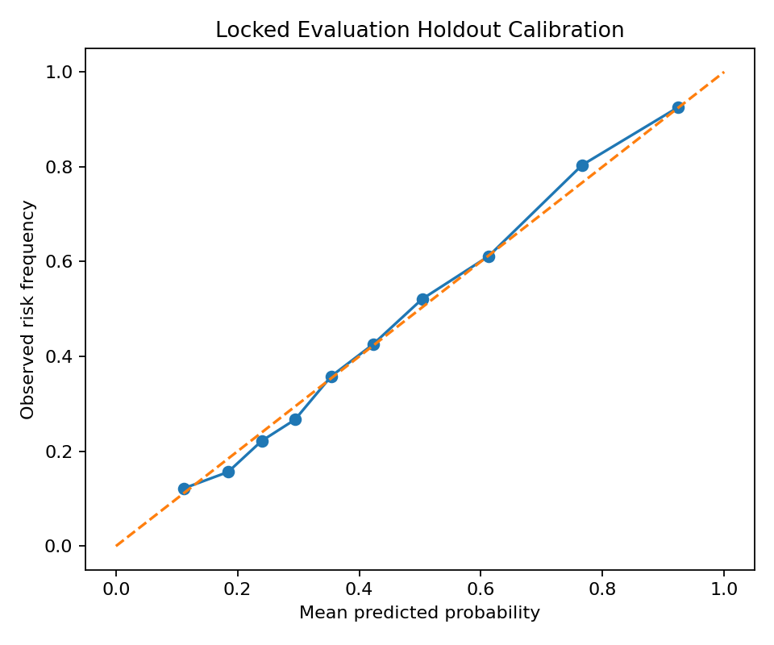
Figure 5. Calibration curve for the selected model.

10. Final Evaluation
Metric | Value
Accuracy | 0.687
Precision | 0.606
Recall | 0.832
F1 | 0.701
ROC-AUC | 0.798
PR-AUC | 0.777
Brier score | 0.179
ECE (10 quantile bins) | 0.015
Confusion matrix | TN=1762, FP=1314, FN=408, TP=2020
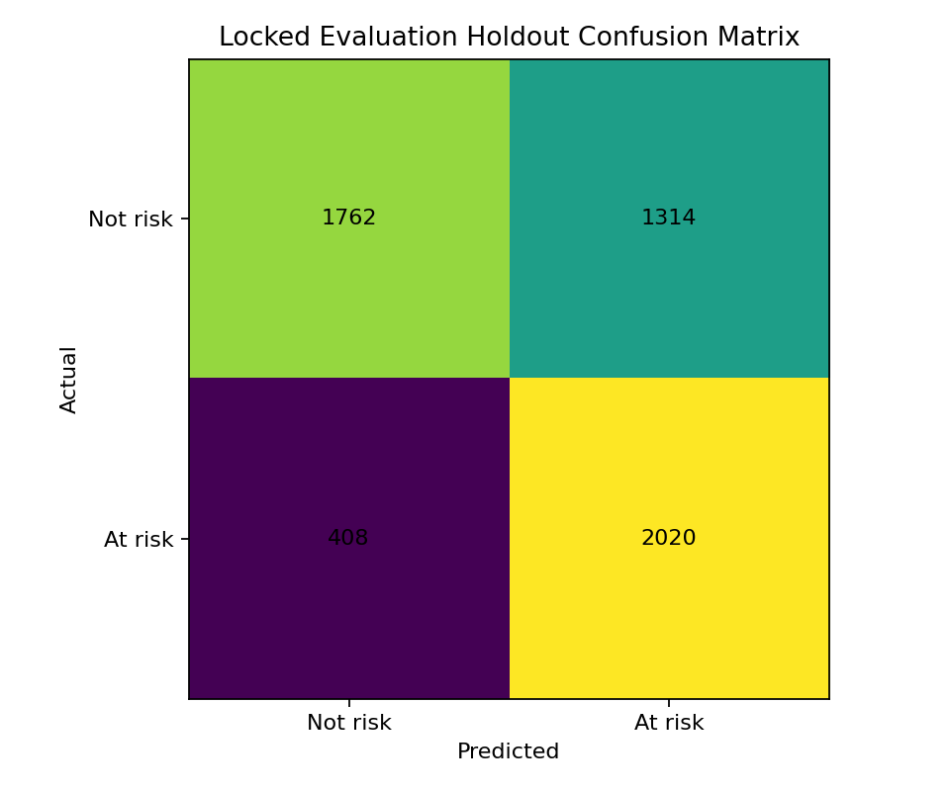
Figure 6. Confusion matrix at the development-selected operating threshold.
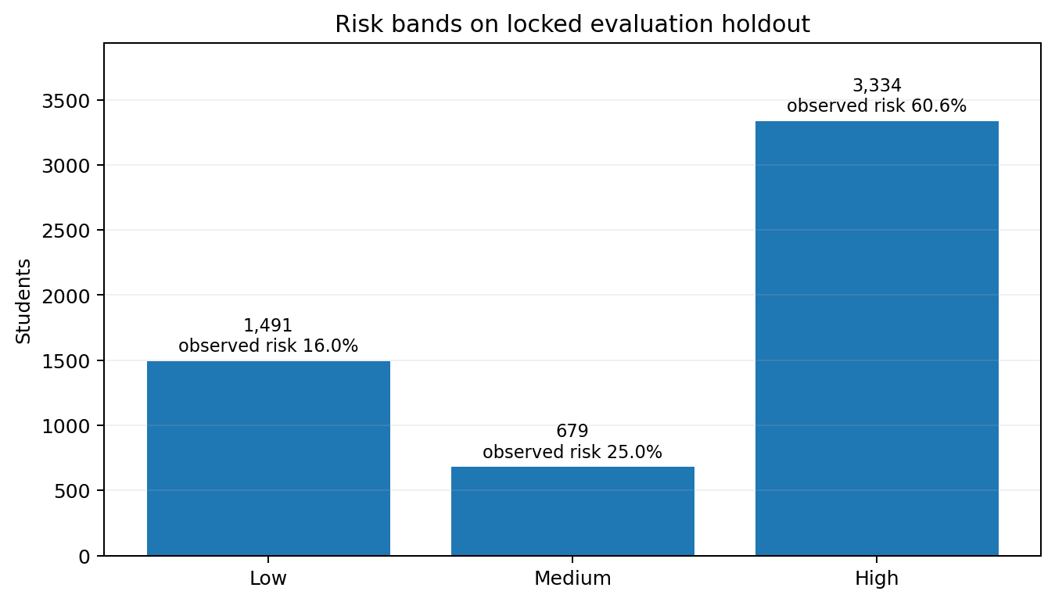
Figure 7. Distribution and observed outcome rate across modeled risk bands.
The operating threshold prioritizes recall. This reduces false negatives (students who later become at risk but are not flagged) while increasing false-positive support alerts. The trade-off is appropriate only if interventions are supportive and relatively low-cost.

11. Explainability
Global SHAP is used for importance magnitude (mean absolute SHAP) only. Local signed SHAP explains which transformed features raised or lowered an individual prediction. Logistic Regression coefficients provide model-direction diagnostics in the transformed feature space. None of these outputs are treated as causal evidence.
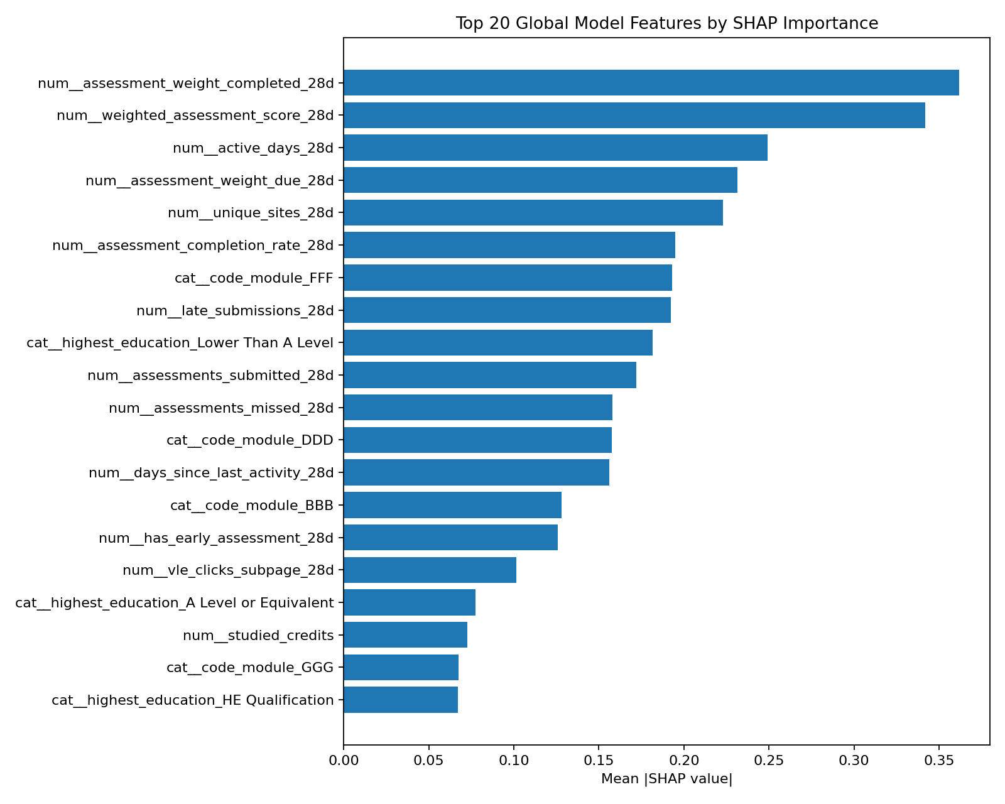
Figure 8. Global mean |SHAP| feature importance.
Top source feature | Mean |SHAP|
assessment_weight_completed_28d | 0.362
weighted_assessment_score_28d | 0.342
active_days_28d | 0.249
assessment_weight_due_28d | 0.231
unique_sites_28d | 0.223
assessment_completion_rate_28d | 0.195
code_module | 0.193
late_submissions_28d | 0.192

12. Recommendation Engine
Recommendations are generated from explicit rules over actionable academic and engagement signals rather than from sensitive demographics. Examples include missed assessments, low early scores, recent inactivity, low recent engagement, declining engagement, and previous-attempt history.
Trigger | Example supportive action
Missed early assessment | Review missed/overdue assessments and agree on a catch-up plan.
Low early assessment score | Schedule targeted academic review on covered topics.
Recent inactivity | Use a supportive check-in to re-engage with current learning activities.
Low recent engagement | Encourage a short, regular weekly study schedule and monitor activity.
Declining engagement | Check for barriers and agree on a recovery plan.

13. Fairness and Sensitive-Feature Audit
The project reports subgroup precision, recall, false-positive rate, accuracy, and prevalence for selected demographic groups. Small groups (n<200) are flagged because their estimates are unstable. A separate development-only ablation removes gender, age, disability, socioeconomic band, highest education, and region to quantify the predictive-performance trade-off.
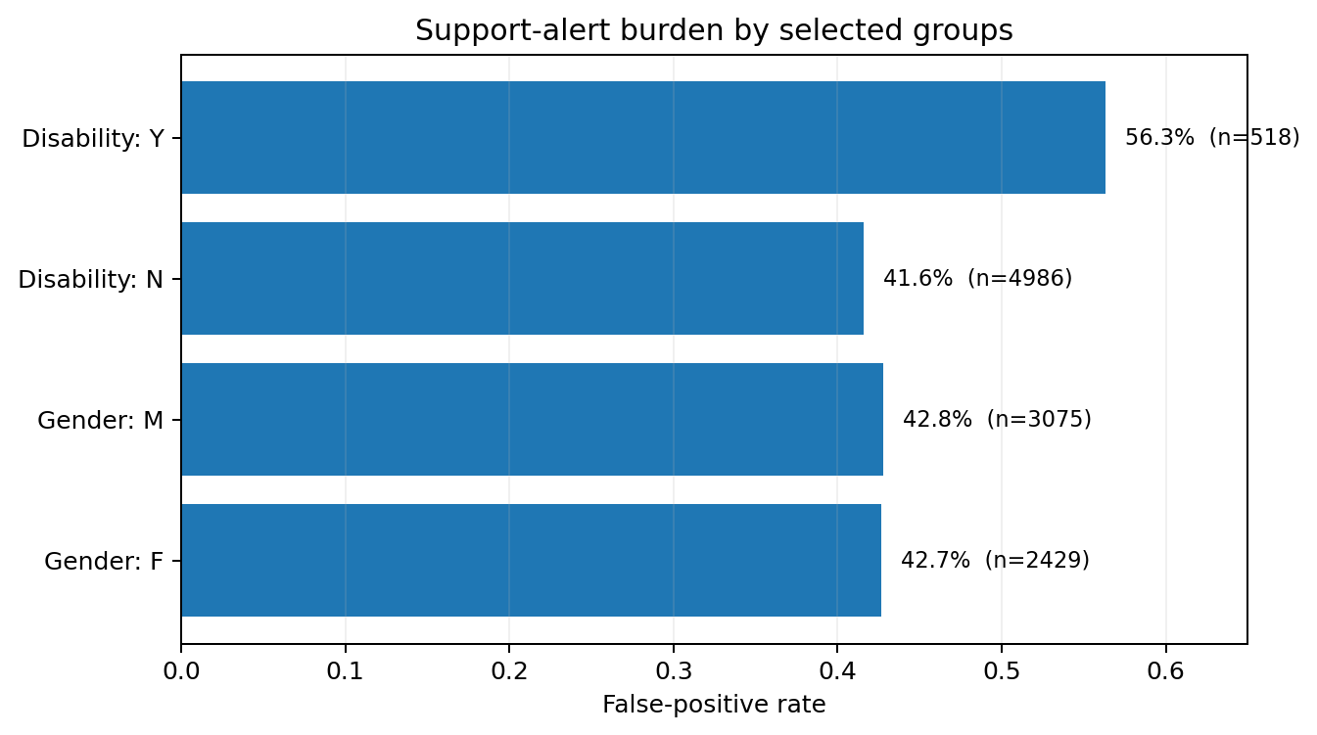
Figure 9. Selected subgroup false-positive rates. Differences require human interpretation and do not by themselves prove discrimination.
Variant | CV F1 | CV ROC-AUC | CV PR-AUC
all_features | 0.670 | 0.785 | 0.763
no_sensitive_demographics | 0.659 | 0.774 | 0.753

14. Deep-Learning Extension
A scikit-learn MLP is evaluated as a development-only 3-fold group-aware extension. It does not re-select the primary model. An optional Keras script demonstrates Dense layers, Batch Normalization, Dropout, Adam, binary cross-entropy, Early Stopping, and an explicit group-aware development validation split.
ANN metric | Development CV value
Accuracy | 0.700
Recall | 0.593
F1 | 0.636
ROC-AUC | 0.760
PR-AUC | 0.739
The ANN does not outperform the selected Logistic Regression in the current experiment. This is a scientifically useful result: deep learning is not guaranteed to dominate on medium-sized structured tabular data.

15. Progress Monitoring and Demo Dashboard
The project includes a four-week engagement/progress snapshot and a Day-28 risk estimate. The local demo dashboard allows the user to browse and sort evaluation students, inspect Week-1-to-Week-4 activity, view early assessment signals, read recommendations, compute and inspect an on-demand local SHAP explanation for any selected evaluation enrollment, view model/fairness summaries, and execute the saved preprocessing + calibrated model bundle live for a selected processed row.
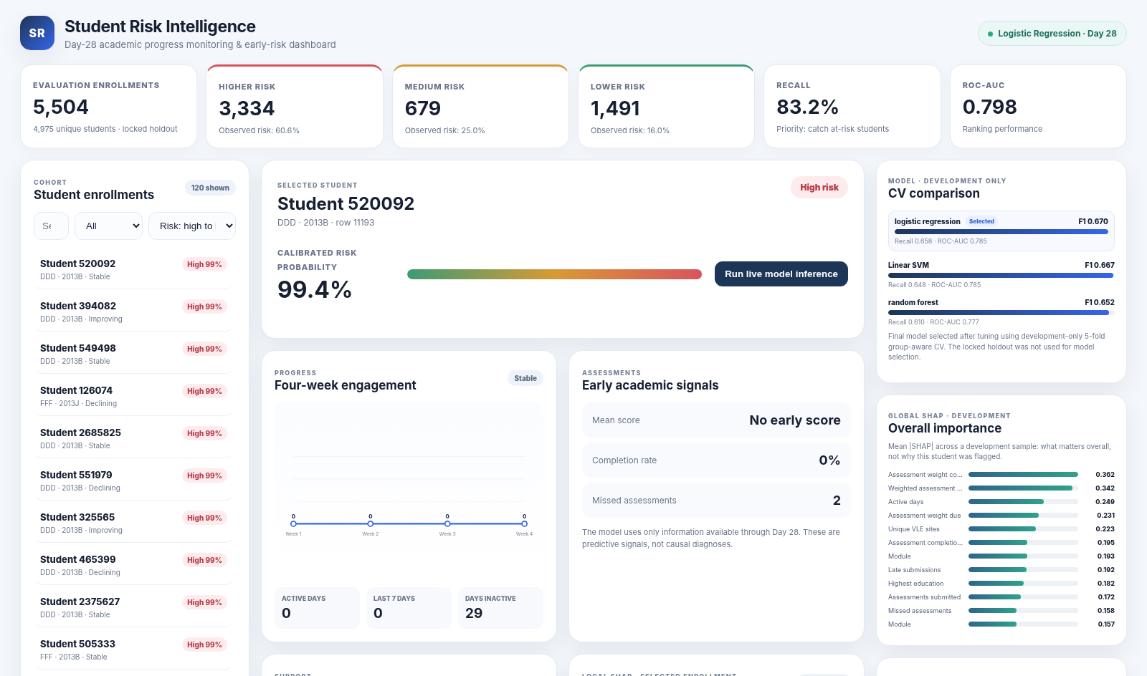
Figure 10. Local demo dashboard.
The current progress component monitors engagement and academic signals over four weeks; it does not yet produce a separate risk score every week. A future extension can train multiple prediction points (for example Day 14, Day 28, Day 42, and Day 56) to create a true longitudinal risk trajectory.

16. Reproducibility and Deployment
The saved final bundle stores preprocessing, the selected estimator, probability calibrator, risk thresholds, feature schema, prediction point, and recommendation configuration. The project also ships an inference CLI, exact tested core package versions, SHA-256 manifest, smoke-test input/output, and a validator that recomputes final metrics and checks split/SHAP/inference consistency.
Final QA gates include: reproducibility validator PASS; zero student overlap across the persisted split; live-inference smoke reproduction; dashboard API health checks; document/slide visual QA; and SHA-256 integrity manifests for the core and complete submission package.
Artifact | Purpose
reports/final/final_risk_bundle.joblib | Saved preprocessing + base model + calibrator + thresholds + schema
src/predict_risk.py | Batch inference CLI
src/validate_project.py | Project integrity and reproducibility validation
requirements-lock.txt | Exact tested core environment
SHA256_MANIFEST.txt | Package integrity hashes
demo/app.py | Local dashboard server with live inference

17. Limitations and Responsible Use
- OULAD reflects a particular UK distance-learning context; external or future-cohort validation is required before use elsewhere.
- Earlier project iteration viewed holdout diagnostics; the packaged evaluation holdout is locked for the current pipeline but is not a pristine external test.
- Risk is predictive association, not diagnosis or causation.
- A lower-risk classification does not guarantee success, and a higher-risk alert does not guarantee failure/withdrawal.
- The recall-focused threshold generates a material false-positive support workload.
- Demographic and socioeconomic variables may encode historical disparities; subgroup metrics must be reviewed alongside operational impact.
- The system is intended for supportive human-reviewed outreach, not autonomous grading, admissions, discipline, or exclusion.

18. Conclusion
The project demonstrates a complete, course-aligned machine-learning workflow: problem definition, EDA, leakage prevention, feature engineering, preprocessing, classical model comparison, group-aware cross-validation, hyperparameter tuning, calibration, evaluation, explainability, recommendations, fairness auditing, a neural-network extension, reproducibility controls, and a working demo dashboard. The selected Logistic Regression model achieves strong ranking performance and high recall at the chosen support-oriented operating point while remaining comparatively interpretable.
Final message The strongest contribution is not a single accuracy number. It is the disciplined design of an early-warning workflow that respects time, student identity, leakage boundaries, uncertainty, explainability, and human intervention.

References
[1] Kuzilek, J., Hlosta, M., & Zdrahal, Z. (2017). Open University Learning Analytics dataset. Scientific Data, 4, 170171. https://doi.org/10.1038/sdata.2017.171
[2] Pedregosa, F., et al. (2011). Scikit-learn: Machine Learning in Python. Journal of Machine Learning Research, 12, 2825–2830.
[3] Lundberg, S. M., & Lee, S.-I. (2017). A Unified Approach to Interpreting Model Predictions. Advances in Neural Information Processing Systems 30.
[4] Scikit-learn documentation. Model evaluation, cross-validation, LogisticRegression, calibration, preprocessing, and pipelines. https://scikit-learn.org/
[5] SHAP documentation. Model-agnostic and linear explainers. https://shap.readthedocs.io/

Appendix A — Reproduction Commands
python src\build_day28_dataset.py "path\to\archive.zip" --output data\processed\student_risk_day28.csv --report reports\day28_dataset_summary.json --dictionary reports\feature_dictionary.csv
python src\run_eda.py data\processed\student_risk_day28.csv reports\tuning\locked_split_manifest.csv reports\eda
python src\train_baselines.py data\processed\student_risk_day28.csv reports\tuning\locked_split_manifest.csv reports\baselines
python src\tune_models.py data\processed\student_risk_day28.csv reports\tuning
python src\finalize_model.py data\processed\student_risk_day28.csv reports\tuning reports\final
python src\validate_project.py
py demo\app.py

Appendix B — Viva-Ready Key Points
- This is binary classification because the target is At Risk vs Not At Risk.
- Day 28 is the fixed prediction point; future activity/assessment information is excluded.
- Student IDs are not predictive inputs; they are grouping keys that prevent cross-split identity leakage.
- Scaling matters for Logistic Regression and SVM; Random Forest is scale-insensitive.
- Recall is important because false negatives mean missing students who later become at risk.
- Accuracy alone would not capture the intervention trade-off.
- The final model is selected by development CV, not by the locked evaluation metrics.
- SHAP explains model behavior; it does not prove why a student will fail or withdraw.
- Recommendations use actionable academic/engagement signals and require human review.
- Deep learning was tested, but the simpler model generalized better in the current structured-data experiment.

