Literature review

Introduction
Chapter 1 established why gearbox condition monitoring matters economically, and the technical problem it leaves open: detecting degradation is of limited value if its output cannot be read across the coupled thermal signals through which degradation manifests, or connected to the physical mechanism responsible. Resolving whether these are genuine deficiencies of the current state of the art , rather than assumptions of this thesis , requires a critical review of the literature, and that is the purpose of this chapter.
The review proceeds from foundation to frontier. It first situates SCADA data within the condition-monitoring landscape and establishes it as the economically decisive monitoring foundation, then examines normal behaviour modelling as the established detection paradigm and considers how predictor–target structure shapes the residuals such models produce. It then evaluates, in turn, how the literature represents thermally coupled signals and how it interprets detected deviations, before assessing physics-informed and knowledge-based routes toward interpretation. Through this progression, the review systematically exposes two critical research gaps , one representational, one interpretive , and examines the approaches that come closest to addressing each. The concluding synthesis demonstrates that their combination remains unaddressed, and it is this finding that directly motivates and justifies the methodology presented in Chapter 3.

SCADA as the Economically Decisive Monitoring Foundation
The size and remote locations of modern wind fleets, particularly offshore, make reactive, run-to-failure maintenance economically unviable. This reality motivates condition-based strategies that schedule interventions based on actual component health. Adopting these strategies can reduce maintenance costs by approximately 20–25% compared to fixed-interval schedules(Pandit et al., 2023). However, their effectiveness depends entirely on the underlying monitoring data. Two primary approaches dominate this area.
Dedicated condition monitoring systems (CMS), typically based on high-frequency vibration measurements, are highly sensitive and well-established for detecting early-stage mechanical faults (Sheng, 2012). However, they require additional, intrusively installed sensors and high sampling rates. Furthermore, CMS are susceptible to environmental noise and add capital and maintenance costs to every turbine. These constraints limit their deployment across large fleets (Pandit et al., 2023; Santolamazza et al., 2021) .
In contrast, Supervisory Control and Data Acquisition (SCADA) systems are already installed on virtually all modern turbines. They record operational data continuously without requiring additional hardware (Santolamazza et al. 2021). This makes SCADA-based monitoring inherently low-cost and scalable. This scalability becomes a major advantage as fleets grow(Tautz‐Weinert & Watson, 2017) . It is also economically critical, given that operation and maintenance can account for approximately 30% of wind energy costs (Felgueira et al., 2019). Table 2.2 summarizes this trade-off.

Table 2.1. Comparative characteristics of dedicated condition monitoring systems and SCADA-based monitoring as fleet-wide foundations.
Dimension | Dedicated CMS (vibration-based) | SCADA-based monitoring
Installation | Additional, intrusively installed sensors (Santolamazza et al. 2021) | Already installed on virtually all modern turbines; no additional hardware (Santolamazza et al. 2021)
Data character | High-frequency vibration measurement acquired at drivetrain components (Sheng 2012) | Continuous operational records — wind speed, rotor and generator speeds, active power, pitch angle, nacelle and ambient temperatures, and drivetrain temperatures including gearbox oil and bearing — stored as ten-minute averages

(Tautz-Weinert and Watson 2017; Pandit et al.
2023)
Fault sensitivity | Sensitive and well established for incipient mechanical faults (Sheng 2012) | Component-level faults difficult to detect directly from averaged data (Pandit et al. 2023)
Cost | Adds capital and maintenance cost to every turbine (Santolamazza et al. 2021; Pandit et al. 2023) | Inherently low-cost; negligible marginal cost per turbine (Tautz-Weinert and Watson 2017)
Fleet scalability | Constrained by per-turbine cost and installation (Pandit et al. 2023) | Scalable across large fleets; advantage grows with fleet size (Tautz-Weinert and Watson 2017)
Key limitation | Environmental-noise susceptibility; deployment confined to a subset of assets (Santolamazza et al. 2021) | Diagnostic suitability not guaranteed by availability alone(Murgia et al., 2023)

Within SCADA-based monitoring, several methodologies are established, including trending, clustering, normal behavior modeling, damage modeling, alarm assessment, and expert systems. Among these, only methods proven on operational turbines carry practical weight (Tautz-Weinert and Watson 2017).
Consequently, SCADA is adopted less for its inherent diagnostic precision than for a universal presence and cost-effectiveness that dedicated systems cannot match at the fleet scale.
This widespread availability comes at the cost of data resolution. SCADA data is conventionally stored as ten-minute averages. This process discards the high-frequency content necessary for vibration diagnosis, making direct detection of component-level faults difficult. Although higher-resolution data provides a demonstrable advantage, its computational and storage requirements erode this benefit at the fleet scale (Pandit et al. 2023). Any SCADA-based method must therefore build upon an inherently low-resolution

foundation. This limitation is well-documented through review-level syntheses (Tautz-Weinert and Watson 2017; Pandit et al. 2023). While these reviews effectively map the consensus of the field, they are better suited for characterizing prevailing practices than for testing the absolute limits of what the data can support.
Testing these limits requires controlled studies, yet the available evidence is weaker than the field's general confidence implies. Diagnostic suitability is frequently claimed based on short observation windows and small turbine counts (Murgia et al. 2023). The most robust counter-example involves eight turbines monitored for over a decade. In this single controlled experiment, a normal-behavior model successfully identified every drivetrain failure months, or even years, in advance. The true limitation was the variability of the lead time, which restricts prognostic forecasting rather than initial diagnosis.
Relying on a single study to demonstrate this upper performance limit is a weakness of the current evidence base, but it is sufficient to shift the primary constraint of the field. The core issue is not that SCADA cannot detect degradation; rather, reliable detection depends entirely on how the data is modeled. Data availability alone guarantees nothing. Diagnostic value is created by the methodology, not simply supplied by the raw data.
Consequently, this review now turns to that methodology: the modeling of normal behavior and the interpretation of deviations from it.

Normal Behaviour Modelling as the Established Detection Paradigm
While SCADA provides the data foundation, normal behaviour modelling (NBM) establishes the associated detection paradigm. This approach uses semi-supervised learning. A model is trained on healthy operational data to establish a component's expected behaviour. The residual difference between predicted and measured values serves as the condition indicator; a sustained deviation signals an early-stage fault(Schlechtingen & Santos, 2014).

This methodology originates in statistical process control. Specifically, exponentially weighted moving-average control charts applied to model residuals,rather than to raw, autocorrelated observations,are established monitoring tools(Lu & Reynolds Jr., 1999) . The NBM residual inherits this rigorous statistical framework, including its smoothing techniques and control limits.
The residual-based principle is now standard practice rather than exploratory research. It has been validated by integrating alarm-log data to confirm that flagged deviations correspond to actual physical events (Cui et al. 2018).
Furthermore, this method builds upon early efforts to automate SCADA anomaly detection to minimize manual analysis (Zaher et al., 2009).
Crucially, NBM is highly suited to this specific research problem. Researchers have directly applied NBM to gearbox bearing temperatures using real onshore SCADA data, demonstrating that early signal deviations reliably indicate wear (Bangalore & Tjernberg, 2015). This provides a direct precedent for the specific component class targeted in this dissertation, rather than just wind turbines generally. As illustrated in Figure 2.1, the NBM condition indicator successfully detected a developing bearing fault before it was registered by the turbine's dedicated vibration monitoring system.
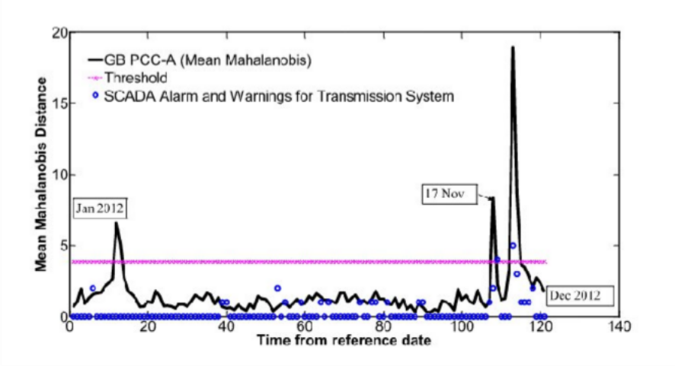

Figure 2.1. Normal behaviour model condition indicator for a gearbox planet-carrier bearing over one year of operation, with detection threshold and SCADA alarms overlaid (Bangalore and Tjernberg, 2015).

Figure 2.1 illustrates this paradigm's capability using real operational data. The indicator crossed its threshold on 17 November 2012, six days before the turbine's vibration-based CMS raised an alarm on 23 November. An inspection on 28 November confirmed bearing spalling (Bangalore and Tjernberg 2015). This represents early, verified detection on the exact signal class targeted in this dissertation, achieved solely from ten-minute SCADA data. However, the threshold crossing itself provides no information about the underlying physical cause.
The underlying regression algorithm is chosen for empirical fit rather than physical principles. Gradient-boosted trees, such as XGBoost, provide an effective, scalable option for tabular SCADA data (Chen and Guestrin 2016). However, this effectiveness strictly concerns predictive accuracy and provides no insight into the physical meaning of the resulting residuals.
The paradigm's maturity also reveals its limitations. Because the healthy baseline is learned directly from historical data, its reliability requires entirely fault-free training data. Unrecorded maintenance or malfunctions introduce change points that corrupt the baseline, which masks the exact deviations the model is designed to detect. Restoring this data integrity is costly. For instance, achieving robust change-point detection has required severe preprocessing, down-sampling ten-minute records to conditional daily averages via segment-based threshold heuristics. This approach sacrifices the temporal resolution necessary for sensitive fault detection (Letzgus, 2020).
More fundamentally, a universal limitation across NBM literature is that a successful model yields a residual, not a root cause. It confirms a deviation from expected behaviour without identifying the underlying physical mechanism.
Consequently, based on the evidence reviewed here, fault detection is largely solved; however, data representation and interpretation are not. The next section addresses the first of these remaining challenges: how the residual is generated and how predictor selection determines its diagnostic value.

Causal Structure and the Predictor–Target Relationship
Section 2.3 established the residual as this paradigm's primary output. However, generating this residual depends fundamentally on the selection of predictor and target variables, regardless of the algorithm used. Consequently, predictor–target specification is a core design decision that dictates model behavior, rather than a neutral preprocessing step. For example, input features that are highly correlated with the target can increase predictive accuracy but reduce fault-detection performance. This occurs because the model masks the specific variations a fault would otherwise introduce (Felgueira et al. 2019).
Similar conclusions are drawn from a different methodological perspective: if predictors share features with the target signal, a model may accurately predict measured values even as a fault develops. Therefore, inputs that are more independent of the target are better suited for fault detection (Wang et al., 2018).These two independent lines of evidence converge on a single principle. Specifically, the causal structure between predictors and the target determines whether a residual remains physically meaningful during component degradation
Based on this principle, there is a clear trend in the literature away from accuracy-maximizing feature selection and toward physically motivated criteria. These criteria include thermal physics(Bai et al., 2024), first-principle thermodynamic relationships to the target temperature(Hu et al., 2025), and correlation structures tied to specific operating conditions (Chen et al., 2021)
Despite this trend, the field lacks consensus. While there are several methods for principled feature selection, there is no agreement on the optimal approach. The argument for causal separation is currently viewed as a robustness measure for maintaining physically meaningful residuals, rather than an established standard. However, acknowledging that predictor–target structure is important immediately raises the question of which structure to use. For a gearbox, where degradation affects multiple thermally coupled signals, this question requires determining how those coupled variables are represented.
The next section addresses this representational challenge.

Applying this principle to the reviewed literature reveals a consistent pattern in how predictor and target sets are specified, as summarized in Table 2.2.

Table 2.2. Predictor–target design and residual reasoning in reviewed SCADA-based thermal monitoring studies. 'Coupled predictor?' denotes thermally coupled or target-derived signals among model inputs.

Study | Target(s) | Predictor characterisation | Coupled predictor? | Multiple targets? | Joint reasoning? | Mechanism mapping?
(Bangalore & Tjernberg, 2015) | Gearbox bearing temperature | Operational variables plus lagged target values (NARX) | Yes , target's own past values as inputs | No | No | No
(Dhiman et al., 2020) | Gearbox oil and bearing temperature | Each target predicted from remaining variables | Yes, by construction | Yes | No , separate residual streams | No
(Dhiman et al., 2020) | Gearbox oil and bearing temperature | Univariate per-signal series, adaptive thresholds | No , univariate | Yes | No , separate thresholds | No
Chen et al. (2021) | Working-condition classes (no regression target) | Correlation structure tied to operating condition | Not applicable , classification | No | No | No
Bai et al. (2024) | Gearbox oil temperature | Thermal-physics-grounded features | No | No | No | No
Hu et al. (2025) | Single temperature target | First-principles thermodynamic relationships | Yes , lagged target term (thermodynamic derivation) | No | No | No
(Jiang et al., 2022) | Multi-sensor temperature field | Inter-sensor relationships modelled as graph | Coupling modelled, not confounded | Yes | Yes | No
(Nogueira et al., 2025) | Reconstruction of monitored sensor set (autoencoder) | Failure-mode knowledge guides feature selection | Not applicable , reconstruction-based | Yes , reconstruction error per monitored feature | No | Upstream only
(Bindingsbø et al., 2023; Ghahfarokhi et al., 2025) | Fault classification / generator bearing | Attention with post-hoc attribution | Not applicable | Not applicable | Not applicable | No , feature attribution

This work (proposed) | Gearbox oil and bearing temperatures, jointly | Causally upstream operating and environmental variables | No , excluded by design | Yes | Yes | Yes , under investigation

Two observations emerge from this summary. First, when comprehensive predictor sets are used, they often include thermally coupled signals, even in studies utilizing multiple thermal targets. Second, when multiple targets are used, their resulting residuals are analyzed independently. Consequently, merely monitoring multiple targets does not equate to coordinating the analysis between them.

Thermal Coupling and the Limits of Isolated-Signal Analysis
While predictor–target structure determines the validity of a single residual, the gearbox presents an additional challenge because its degradation manifests across multiple signals. The drivetrain operates as a coupled thermal system. Thermophysical modelling demonstrates that a non-linear increase in gearbox oil temperature relative to wind speed and output power indicates efficiency degradation, typically attributed to mechanisms like gear-teeth wear.
Concurrently, electrical faults alter heat-transfer signatures throughout the machine (Qiu et al., 2016).
The physical basis for this thermal coupling is well-characterised (Qiu et al., 2014) . Heat generated by friction and transmission losses dissipates through the lubrication circuit. Figure 2.2 summarises this mechanism.

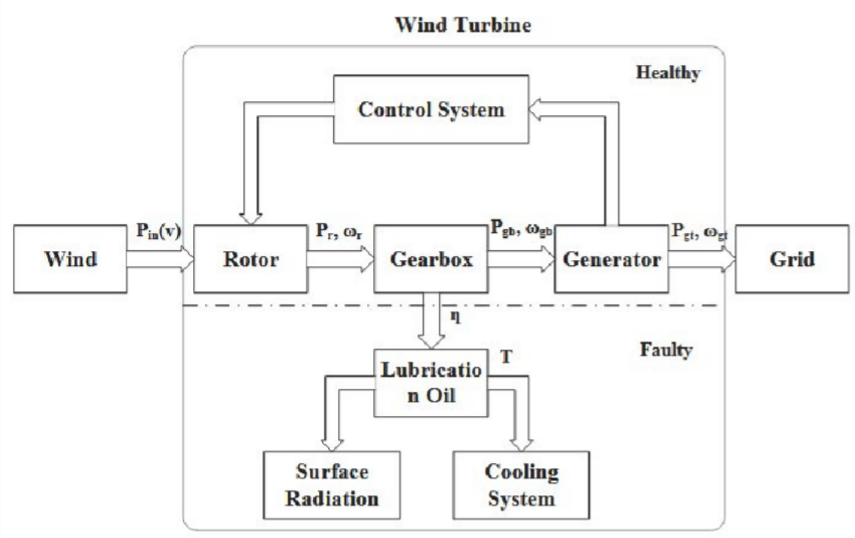

Figure 2.2. Power flow through the drivetrain and the thermal dissipation paths activated by gearbox efficiency loss (Qiu et al., 2016).
As Figure 2.2 shows, the efficiency term η marks where degradation converts transmitted power into heat: energy not transmitted mechanically enters the lubrication oil and is dissipated through the cooling and radiation paths of the machine. The schematic thus makes the representational stake of this section concrete: a single degradation event has one physical origin but several thermally coupled destinations, more than one of which is recorded as a distinct SCADA channel. Which of those channels a monitoring method reads — and whether it reads them together — is therefore not a modelling detail but a decision about how much of the event is visible. The coordinated pattern across these signals carries information that any single signal cannot fully convey.
Despite this, most current research evaluates thermal signals independently. For example, gearbox oil and bearing temperatures are often treated as separate targets, with each predicted from the remaining variables and monitored via independent residual streams (Dhiman et al. 2020). A similar approach tracks these same two temperatures using separate adaptive thresholds (Dhiman et al. 2021). While these are effective methods, and utilising two thermal targets improves upon single-signal monitoring, their validation relies on a limited set of labelled failure cases. Consequently, the broad
applicability of their detection performance remains unproven. More fundamentally, these methods still analyse residuals individually per target rather than jointly. Simply increasing the number of targets does not equal coordinating the analysis between them.

The strongest alternative to this isolated analysis directly models inter-sensor relationships. Specifically, a graph-based temperature model demonstrates that treating variables independently fails to capture interactions between subsystems and components. This independence leads to missed detections and false alarms, which a coupling-aware formulation successfully reduces (Jiang et al. 2022). This approach aligns closely with the core focus of this dissertation. It convincingly establishes the diagnostic value of signal coordination, although it was validated on only a single operational dataset.
However, its primary limitation is interpretability. Because the thermal coupling is mapped within a graph neural network, there is no clear way to trace a detected anomaly back to its underlying physical mechanism. This limitation is operationally critical. Effective maintenance decisions require more than just an alert that a coupled deviation has occurred; they require an indication of what physical fault that deviation represents.
Research focused on physics-based features reaches a similar boundary from the opposite direction. These methods successfully extract thermally meaningful features but stop short of conducting coordinated, multi-target residual analysis (Bai et al. 2024).
In summary, the literature confirms that drivetrain degradation is thermally coupled and that coordinating this evidence holds significant diagnostic value. Yet, prevailing practices still analyse residuals independently. Furthermore, the single method that successfully coordinates these signals lacks a clear path for physical interpretation. Therefore, a gap remains for a coordinated, multi-signal residual analysis that is also physically interpretable. The next section directly addresses this requirement for interpretability.

From Detection to Interpretation
While previous sections established robust methods for fault detection, data interpretation remains largely unaddressed. A normal-behaviour model, whether analysing independent or coordinated signals, only confirms a deviation from expected values. It does not identify the underlying physical fault. The distinction between anomaly detection and fault diagnosis is operationally critical. The end user is a maintenance decision-maker who must take physical action based on the model's output. Therefore, effective predictive maintenance requires human operators to trust the system(Cummins et al., 2024) . Trust relies on more than just predictive accuracy. When automated systems lack transparency, operators often misuse them through either over-reliance or complete disuse. Appropriate reliance requires the system to provide interpretable information regarding its internal state(Lee & See, 2004).
Consequently, an accurate but uninterpretable detector is not yet a practical diagnostic tool.
Researchers have addressed this by adopting explainability techniques, though these methods share a fundamental limitation. In wind-turbine monitoring, models combining attention mechanisms with post-hoc attribution tools, such as SHAP and LIME, successfully identify the specific features and time-steps that drove a classification (Ghahfarokhi et al. 2025). For example, these outputs can highlight which temperature signals triggered a fault decision over a given period. However, they fail to answer the core diagnostic question. They cannot specify whether those signals reflect gear wear, lubrication degradation, or a benign operational change. Figure 2.3 reproduces a standard explanation output, illustrating this exact limitation.

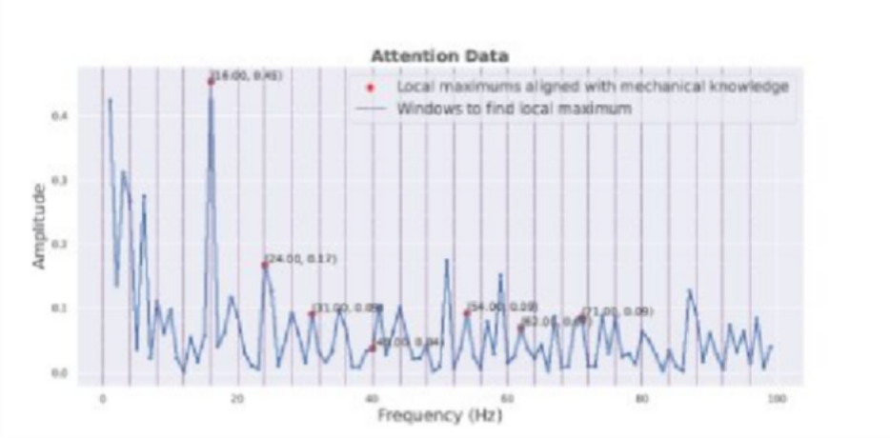

Figure 2.3. Explanation output of an attention-based explainable-AI framework: the contribution of each frequency to the classification decision, with local maxima (red) aligned against known mechanical fault frequencies
(Ghahfarokhi et al., 2025).

Figure 2.3 shows the explanation at its best: influential frequencies are identified, and many align with frequencies expected from mechanical domain knowledge. Yet where the output contains peaks that domain knowledge does not predict, the accompanying analysis responds by enumerating candidate physical causes , lubrication loss, overheating, assembly damage , among which the attribution itself does not distinguish. The example is drawn from higher-rate signals than the ten-minute SCADA data considered in this work; the boundary it illustrates, however, concerns what an explanation is , an account of influential inputs , and is independent of the data rate.
Shapley-based feature attribution has similarly been applied to generator-bearing fault detection , a method its proponents themselves describe as additive feature attribution (Bindingsbø et al. 2023). What these deliver is feature attribution , an account of which variables mattered , rather than an account of what is physically happening; and, tellingly, such attribution outputs are themselves rarely validated against physical ground truth, so even the explanation's correctness is generally untested. The shortfall is echoed from the modelling side by the observation that physics-informed feature schemes can still yield models of minimal interpretability(Wu et al., 2024) , and reinforced from structural-health monitoring, where the barrier to operational uptake of black-box models has been identified as precisely their lack of physical insight and the consequent lack of operator trust (Cross et al. 2022).

That this deficiency is practical rather than presentational follows from the operational cost of detection without interpretation. The scale of this burden is quantifiable: on real SCADA data containing 29,459 healthy observations against 29 faults, even an ensemble method designed specifically for imbalanced data achieved perfect sensitivity only at a precision of 8–22 per cent , the large majority of its alarms were false (Velandia-Cardenas et al.
2021). The implication this review draws is that when each such flag arrives without an indication of physical cause, the operator has no ready means of separating incipient fault from benign excursion, so the burden becomes a triage cost the system itself cannot help resolve , and interpretable health assessment, as recent work concedes, remains an open problem (Peng et al. 2022). What is missing across this literature is not detection, and not attribution, but the link from a flagged deviation to the physical process behind it , and it is that link, grounded in engineering knowledge of how faults manifest, that the next section examines as a route toward interpretation.

Physics-Informed and Knowledge-Based Routes to Interpretation
Because the critical missing element is a direct link between residual behaviour and physical mechanisms, codified engineering knowledge provides a logical bridge. Systematic failure mode and effects analysis (FMEA) for wind turbines already catalogues specific failure modes alongside their causes and effects (Shafiee and Dinmohammadi 2014). Furthermore, drivetrain thermophysics links specific failure mechanisms to distinct thermal signatures. For instance, a non-linear increase in oil temperature indicates efficiency loss caused by gear-teeth wear, while altered heat transfer patterns signal specific electrical faults (Qiu et al. 2016). The foundational data required to map residuals to physical mechanisms is therefore available. Table 2.3 synthesises this mapping using

published failure-mode inventories and the drivetrain thermophysics established in Section 2.5.
Table 2.3. Published failure-mode knowledge and drivetrain thermophysics assembled as a residual-to-mechanism mapping.
Failure mode | Mechanism rationale | Documented evidence | Signals per published practice | Hypothesised pattern
Gear-teeth wear | Increased friction and transmission loss adds heat to the oil circuit (Qiu et al. 2014) | Non-linear rise of oil temperature with wind speed and power indicates efficiency degradation from gear-teeth wear (Qiu et al. 2016) | Oil temperature | Sustained positive oil-temperature residual, load-dependent in magnitude, with bearing residuals rising in lag
High-speed shaft bearing failure | Localised friction generates heat at the bearing before bulk-oil effects (Qiu et al. 2014) | Early bearing-temperature deviation used as a wear indicator (Bangalore and Tjernberg 2015) | HSS bearing temperature | HSS bearing residual leads; oil residual smaller and later
Low-speed shaft or planetary bearing failure | As above, localised at the low-speed stage (Qiu et al. 2014) | Heat-path characterisation only (Qiu et al. 2014) | Oil temperature; bearing temperature where recorded | LSS bearing residual leading where instrumented; otherwise weak oil-only signature
Lubrication system degradation | Impaired dissipation reduces cooling of the whole circuit (Qiu et al. 2014); modes catalogued (Shafiee & Dinmohammadi, 2014) | Mechanism documented; direct signals not thermal | Oil condition indicators | Broad simultaneous positive residuals across oil and both bearing temperatures
Electrical or generator-side thermal influence | Electrical faults alter heat-transfer signatures across the machine (Qiu et al. 2016) | Machine-wide alteration documented (Qiu et al. 2016) | Generator-side temperatures | Generator-side residuals without gearbox-led ordering , an exclusion pattern

The assembled mapping demonstrates that individual thermal signatures overlap across different failure mechanisms. Consequently, fault differentiation depends on coordinated patterns across multiple signals rather than on any single residual. This signal overlap is an established feature of published practice rather than a construct of this review. Existing mappings of monitorable failure modes to signals show that three out of five gearbox failure modes share the same SCADA signature: oil temperature. Distinguishing between these specific modes currently relies on dedicated CMS channels, which are unavailable at the fleet scale (Table 2.4). Chapter 3 formalises these implied signatures into an operational rule base; therefore, this section must first establish whether using this engineering knowledge diagnostically is credible.

Table 2.4. Monitorable wind-turbine gearbox failure modes and the SCADA and CMS signals available to each; adapted from (Feng et al., 2013).
Gearbox failure mode | SCADA signal | CMS signal
Planetary gear failure | Gearbox oil temperature | LSS vibration; non-ferrous particle oil-debris counts
Planetary bearing failure | Gearbox oil temperature | LSS vibration; ferrous particle oil-debris counts
Intermediate-shaft (ISS) bearing failure | Gearbox oil temperature | LSS or HSS vibration; ferrous particle oil-debris counts
HSS bearing failure | HSS bearing temperature | HSS vibration (vertical, transverse, axial); ferrous particle oil-debris counts
Lubrication-system malfunction | Oil pressure level; oil-filter status | —
Additional operational signals recorded by SCADA across all modes: rotor speed, generator speed, nacelle temperature, and power output.

Two lines of evidence suggest this diagnostic approach is credible, though neither provides definitive proof. First, available studies indicate that grounding data-driven monitoring in physical principles improves performance. For example, one study combined thermal-network model losses with machine learning on SCADA gearbox data. The physics-derived loss emerged as the most critical feature in the health classifier, outperforming raw temperature data. However, the study tempers this finding, noting that agreement between physical and learned models varies depending on the specific failure mode and the sensor's distance from the fault (Corley et al., 2020).
Structural-health monitoring research reaches a parallel conclusion. In that field, grey-box models improve predictions when training data is sparse and offer greater interpretability than black-box alternatives (Cross et al., 2022).
While this evidence base is narrow,comprising one wind-energy study and one cross-domain source,it consistently indicates that physical knowledge provides diagnostic value that statistical features alone cannot.
The second line of evidence is the emerging practice of repurposing failure-mode knowledge for active diagnostics. An early expert-system established a precedent for this in wind turbines (Deng et al., 2017), serving as a conceptual foundation rather than a strict methodological template. More recently, Failure Mode and Effects Analysis (FMEA) has transitioned from a risk-ranking exercise into a predictive instrument. A data-driven FMEA implementation achieved high fault-prediction accuracy in aviation maintenance (Filz et al., 2021).
While this cross-sector study validates the repurposing concept, it does not confirm performance on wind-turbine data. Most relevant to this dissertation, failure mode and symptoms analysis has been integrated with an autoencoder-based normal-behaviour model using wind-turbine SCADA data. In this application, failure-mode knowledge guided feature selection and fault localisation(Nogueira et al., 2025).
However, carefully examining this closest precedent reveals the limitations of the current state of the art. The proposed framework was not fully executed.

The published validation analysed only a single failure mode, leaving a systematic analysis to future work. Furthermore, the framework uses engineering knowledge solely to select inputs and localise anomalies; it does not map coordinated residual patterns to candidate failure mechanisms.
Therefore, this approach is best described as emerging. It is theoretically sound and partially demonstrated, but it has not yet been implemented as an end-to-end interpretive layer. Nogueira's framework diagram confirms this structural limitation (Figure 2.4). The failure-mode analysis operates at the beginning of the pipeline, determining which turbine- and fault-specific models are built. There is no feedback loop from the models' outputs back to the knowledge base. Consequently, the engineering knowledge configures the detection process but is never used to interpret the final results.

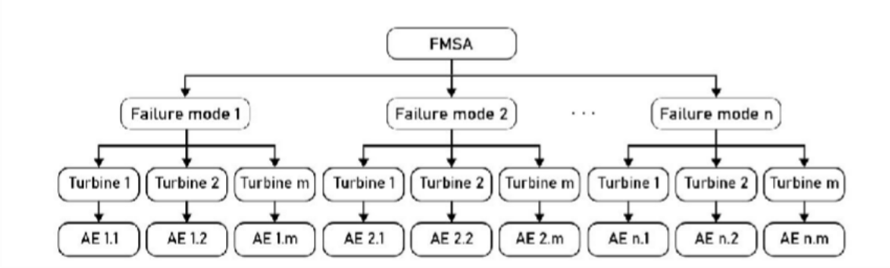

Figure 2.5. FMSA-guided development of turbine- and fault-specific autoencoder models in the framework of Nogueira et al. (2025)
These limitations extend beyond a lack of methodological maturity. The underlying knowledge base itself relies on subjective modelling decisions. The FMEA literature explicitly states that risk-priority numbers are subjective and cannot be meaningfully compared across different turbine configurations (Shafiee and Dinmohammadi 2014). Consequently, any diagnostic rule base derived from published failure-mode knowledge inherits this subjectivity.
Furthermore, validation presents a more fundamental constraint. SCADA records provide alarms and status codes rather than confirming exact physical mechanisms. Therefore, an interpretation layer built on this data can only be evaluated for the physical plausibility of its hypotheses, rather than their

absolute correctness. This limitation is inherent to SCADA data itself, not a flaw in any specific diagnostic methodology. Finally, hybrid modelling does not guarantee diagnostic insight. When machine learning is used merely to correct a physical model's error, the output remains difficult to interpret because the algorithm learns the mathematical discrepancy rather than the underlying physical system (Wu et al. 2024).
The current literature therefore supports a qualified conclusion. Knowledge-based interpretation represents a credible, physically grounded research pathway. It is theoretically better suited than standard feature attribution for connecting a data deviation to a physical mechanism. However, its rule base remains subjective, its current demonstrations are incomplete, and its validation is restricted by the inherent limits of SCADA data. Crucially, no published method currently combines this knowledge-based interpretive approach with the coordinated, multi-signal residual analysis highlighted in Section 2.5. The final section of this review will now verify whether this specific combination represents a definitive gap in current research.

Synthesis: The Unaddressed Combination
This review has identified two distinct requirements that current literature only addresses in isolation. Sections 2.2–2.4 established the methodological foundation: SCADA-based normal behaviour modelling is a mature detection paradigm where predictor–target structure dictates residual characteristics.
Section 2.5 defined the first requirement (R1): because gearbox degradation redistributes heat across coupled signals, residuals must be analysed jointly across multiple thermal targets rather than independently. Section 2.6 defined the second requirement (R2): monitoring outputs are actionable only when a detected deviation can be linked to its underlying physical cause, a link that standard feature attribution fails to provide. Section 2.7 demonstrated that engineering failure-mode knowledge provides a credible, albeit emerging and subjective, method for establishing this physical link. This section evaluates whether any existing methodology satisfies both requirements simultaneously (Table 2.4).

    - R1: Coordinated, multi-target residual analysis.

    - R2: Direct connection between residuals and physical failure mechanisms.

Table 2.4. Positioning of reviewed approaches against the two requirements established in sections 2.5–2.6.
 | R2 not satisfied | R2 satisfied
R1 | Jiang et al. (2022) , coupling | Unoccupied → this work
satisfied | modelled; no evident route from | (proposed)
 | flagged interaction to
 | mechanism
R1 not | Dhiman et al. (2020; 2021) , | Nogueira et al. (2025) ,
satisfied | plural targets, separate residual | partial: knowledge applied
 | streams; Bai et al. (2024); Hu et | upstream of residuals; one
 | al. (2025); Corley et al. (2021); | failure mode validated
 | attribution methods
 | (Ghahfarokhi et al. 2025;
 | Bindingsbø et al. 2023)

The three strongest candidates each satisfy one. The graph-based temperature model of Jiang et al. (2022) is the most complete answer to the first requirement: it models inter-sensor coupling directly demonstrates that treating variables independently produces missed detections and false alarms, and reduces both. Its contribution to coordination is not in question. What it does not attempt is the second requirement: its output is a detection, and , in this review's judgement of what the formulation affords , its graph representation offers no evident route from a flagged interaction to the failure mechanism responsible.
Dhiman et al. (2020) approaches from the opposite direction of complexity: by modelling gearbox oil and bearing temperatures as dual targets it recognises that degradation is not a single-signal phenomenon, and its residual streams

are individually interpretable in a way a learned graph embedding is not. But its targets are monitored through separate residual analyses; the coordination that Section 2.5 showed to carry diagnostic information is present in the target set and absent from the reasoning. Nogueira et al. (2025) is the only candidate to engage the second requirement directly, integrating failure-mode knowledge with a normal-behaviour model on wind-turbine SCADA , and it is therefore the decisive comparison. Read closely, its knowledge layer operates upstream of detection, guiding which features are selected and where anomalies are localised; the systematic failure-mode analysis was proposed rather than executed, and the published validation covers a single failure mode. Failure-mode knowledge is used to prepare the model, not to interpret coordinated residual behaviour after it.
The pattern extends across the remaining literature. Physics-guided and thermally grounded models appear, on the evidence established earlier in this chapter, to improve single-target monitoring without coordinating residuals (Hu et al. 2025; Bai et al. 2024); physics-as-feature hybrids strengthen detection without an interpretive layer (Corley et al. 2021); attribution methods explain classifications without identifying mechanisms (Ghahfarokhi et al. 2025). Each line advances one requirement; none crosses both. On the evidence assembled here, then , and the claim is deliberately bounded to the literature this review has examined , no published method couples coordinated multi-target thermal residual analysis with an explicit mapping from residual behaviour to candidate failure mechanisms. The position is unoccupied not because its elements are unavailable but because they have developed in separate lines: coordination has been pursued as a detection problem, and interpretation as a feature selection or attribution problem, with the interpretive reading of coordinated residual evidence falling between them.
This is a research opportunity of a specific and modest kind. It does not assert that coordination or failure-mode knowledge is new , Sections 2.5 and 2.7 credit both , nor does it rest on any choice of algorithm; it identifies their conjunction as untested. Chapter 3 follows as the direct construction of that conjunction: a

multi-target normal-behaviour model over coupled gearbox thermal signals, coordinated residual processing, and an interpretation layer that maps joint residual patterns onto candidate mechanisms drawn from published failure-mode knowledge. The constraints established in this review travel with it: the rule base inherits the documented subjectivity of its sources, and its outputs can be assessed for plausibility rather than verified correctness. Within those limits, the review's conclusion is that the method is a response the assembled literature specifically motivates , each phase answering a deficiency this chapter has evidenced, and the whole constructed to occupy the intersection the review has found unaddressed.

References

Bai, X., Han, S., Kang, Z., Tao, T., Pang, C., Dai, S., & Liu, Y. (2024). Wind turbine gearbox oil temperature feature extraction and condition monitoring based on energy flow. Applied Energy, 371, 123687. https://doi.org/10.1016/j.apenergy.2024.123687
Bangalore, P., & Tjernberg, L. B. (2015). An Artificial Neural Network Approach for Early Fault Detection of Gearbox Bearings. IEEE Transactions on Smart Grid, 6(2), 980–987. https://doi.org/10.1109/TSG.2014.2386305
Bindingsbø, O. T., Singh, M., Øvsthus, K., & Keprate, A. (2023). Fault detection of a wind turbine generator bearing using interpretable machine learning. Frontiers in Energy Research, 11, 1284676. https://doi.org/10.3389/fenrg.2023.1284676
Chen, B., Tavner, P. J., Feng, Y., Song, W. W., & Qiu, Y. (n.d.). Bayesian Networks for Wind Turbine Fault Diagnosis.
Corley, B., Carroll, J., & Mcdonald, A. (2020). Fault detection of wind turbine gearbox using thermal network modelling and SCADA data. Journal of Physics: Conference Series, 1618(2), 022042. https://doi.org/10.1088/1742-6596/1618/2/022042
Cross, E. J., Gibson, S. J., Jones, M. R., Pitchforth, D. J., Zhang, S., & Rogers, T. J. (2022). Physics-Informed Machine Learning for Structural Health Monitoring. In A. Cury, D. Ribeiro, F. Ubertini, & M. D. Todd (Eds), Structural Health Monitoring Based on Data Science Techniques (pp. 347–367). Springer International Publishing. https://doi.org/10.1007/978-3-030-81716-9_17
Cummins, L., Sommers, A., Ramezani, S. B., Mittal, S., Jabour, J., Seale, M., & Rahimi, S. (2024). Explainable Predictive Maintenance: A Survey of Current Methods, Challenges and Opportunities. IEEE Access, 12, 57574–57602. https://doi.org/10.1109/ACCESS.2024.3391130
Deng, X.-W., Gao, Q.-S., Zhang, C., Hu, D., & Yang, T. (2017). Rule—Based Fault Diagnosis Expert System for Wind Turbine. ITM Web of Conferences, 11, 07005. https://doi.org/10.1051/itmconf/20171107005
Dhiman, H. S., Deb, D., Carroll, J., Muresan, V., & Unguresan, M.-L. (2020). Wind Turbine Gearbox Condition Monitoring Based on Class of Support Vector Regression Models and Residual Analysis. Sensors, 20(23), 6742. https://doi.org/10.3390/s20236742
Felgueira, T., Rodrigues, S., Perone, C. S., & Castro, R. (2019). The Impact of Feature Causality on Normal Behaviour Models for SCADA-based Wind Turbine Fault Detection (arXiv:1906.12329). arXiv. https://doi.org/10.48550/arXiv.1906.12329
Feng, Y., Qiu, Y., Crabtree, C. J., Long, H., & Tavner, P. J. (2013). Monitoring wind turbine gearboxes. Wind Energy, 16(5), 728–740. https://doi.org/10.1002/we.1521
Filz, M.-A., Langner, J. E. B., Herrmann, C., & Thiede, S. (2021). Data-driven failure mode and effect analysis (FMEA) to enhance maintenance planning. Computers in Industry, 129, 103451. https://doi.org/10.1016/j.compind.2021.103451
Ghahfarokhi, A. F., Schäfer, J., Wagner, M. F., & Dorronsoro, B. (2025). Explainable Artificial Intelligence for Time Series Using Attention Mechanism: Application to Wind Turbine Fault Detection. IEEE Access, 13, 180613–180631. https://doi.org/10.1109/ACCESS.2025.3621003
Hu, X., Pandit, R., Zhao, Y., & Hong, J. (2025). Physics-Guided SCADA-Based Transformer Model for Robust Early Detection of Wind Turbine Gearbox Faults.
Jiang, G., Li, W., Fan, W., He, Q., & Xie, P. (2022). TempGNN: A Temperature-Based Graph Neural Network Model for System-Level Monitoring of Wind Turbines With SCADA Data. IEEE Sensors Journal, 22(23), 22894–22907. https://doi.org/10.1109/JSEN.2022.3213551
Lee, J. D., & See, K. A. (2004). Trust in Automation: Designing for Appropriate Reliance. Human Factors, 46(1), 50–80. https://doi.org/10.1518/hfes.46.1.50_30392
Letzgus, S. (2020). Change-point detection in wind turbine SCADA data for robust condition monitoring with normal behaviour models. Wind Energy Science, 5(4), 1375–1397. https://doi.org/10.5194/wes-5-1375-2020
Lu, C.-W., & Reynolds Jr., M. R. (1999). EWMA Control Charts for Monitoring the Mean of Autocorrelated Processes. Journal of Quality Technology, 31(2), 166–188. https://doi.org/10.1080/00224065.1999.11979913
Murgia, A., Verbeke, R., Tsiporkova, E., Terzi, L., & Astolfi, D. (2023). Discussion on the Suitability of SCADA-Based Condition Monitoring for Wind Turbine Fault Diagnosis through Temperature Data Analysis. Energies, 16(2), 620. https://doi.org/10.3390/en16020620
Nogueira, W. F., Melani, A. H. de A., & de Souza, G. F. M. (2025). Wind Turbine Fault Detection Through Autoencoder-Based Neural Network and FMSA. Sensors, 25(14), 4499. https://doi.org/10.3390/s25144499
Pandit, R., Astolfi, D., Hong, J., Infield, D., & Santos, M. (2023). SCADA data for wind turbine data-driven condition/performance monitoring: A review on state-of-art, challenges and future trends. Wind Engineering, 47(2), 422–441. https://doi.org/10.1177/0309524X221124031
Qiu, Y., Feng, Y., Sun, J., Zhang, W., & Infield, D. (2016). Applying thermophysics for wind turbine drivetrain fault diagnosis using SCADA data. IET Renewable Power Generation, 10(5), 661–668. https://doi.org/10.1049/iet-rpg.2015.0160
Qiu, Y., Sun, J., Cao, M., Wang, H., Feng, Y., Yang, W., & Infield, D. (2014). Model based wind turbine gearbox fault detection on SCADA data. 3rd Renewable Power Generation Conference (RPG 2014), 1–5. https://doi.org/10.1049/cp.2014.0820
Santolamazza, A., Dadi, D., & Introna, V. (2021). A Data-Mining Approach for Wind Turbine Fault Detection Based on SCADA Data Analysis Using Artificial Neural Networks. Energies, 14(7), 1845. https://doi.org/10.3390/en14071845
Schlechtingen, M., & Santos, I. F. (2014). Wind turbine condition monitoring based on SCADA data using normal behavior models. Part 2: Application examples. Applied Soft Computing, 14, 447–460. https://doi.org/10.1016/j.asoc.2013.09.016
Shafiee, M., & Dinmohammadi, F. (2014). An FMEA-Based Risk Assessment Approach for Wind Turbine Systems: A Comparative Study of Onshore and Offshore. Energies, 7(2), 619–642. https://doi.org/10.3390/en7020619
Sheng, S. (2012, January 7). Wind Turbine Gearbox Condition Monitoring Round Robin Study—Vibration Analysis (Report NREL/TP-5000-54530). National Renewable Energy Laboratory (U.S.). UNT Digital Library. https://doi.org/10.2172/1048981
Tautz‐Weinert, J., & Watson, S. J. (2017). Using SCADA data for wind turbine condition monitoring – a review. IET Renewable Power Generation, 11(4), 382–394. https://doi.org/10.1049/iet-rpg.2016.0248
Wang, Y., Ma, X., & Qian, P. (2018). Wind Turbine Fault Detection and Identification Through PCA-Based Optimal Variable Selection. IEEE Transactions on Sustainable Energy, 9(4), 1627–1635. https://doi.org/10.1109/TSTE.2018.2801625
Wu, Z., Li, Y., & Wang, P. (2024). A hierarchical modeling strategy for condition monitoring and fault diagnosis of wind turbine using SCADA data. Measurement, 227, 114325. https://doi.org/10.1016/j.measurement.2024.114325
Zaher, A., McArthur, S. D. J., Infield, D. G., & Patel, Y. (2009). Online wind turbine fault detection through automated SCADA data analysis. Wind Energy, 12(6), 574–593. https://doi.org/10.1002/we.319

