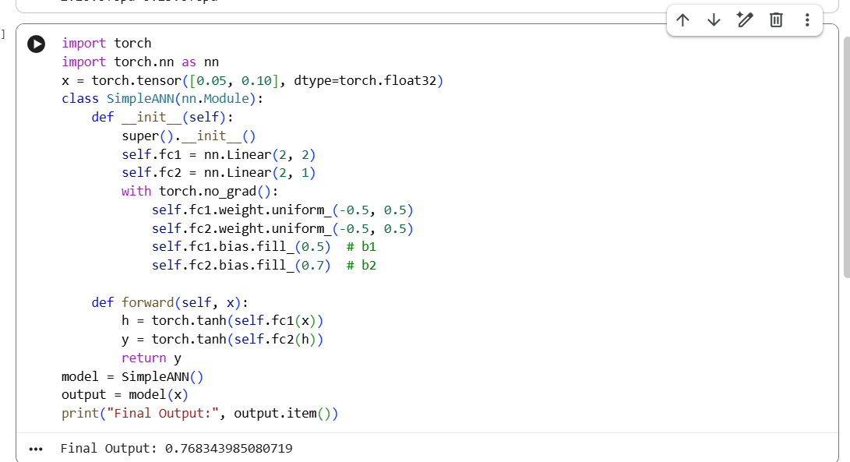

import torch
import torch.nn as nn
x = torch.tensor([0.05, 0.10], dtype=torch.float32)
class SimpleANN(nn.Module):
def __init__(self):
super().__init__()
self.fc1 = nn.Linear(2, 2)
self.fc2 = nn.Linear(2, 1)
with torch.no_grad():
self.fc1.weight.uniform_(-0.5, 0.5)
self.fc2.weight.uniform_(-0.5, 0.5)
self.fc1.bias.fill_(0.5) # b1
self.fc2.bias.fill_(0.7) # b2

def forward(self, x):
h = torch.tanh(self.fc1(x))
y = torch.tanh(self.fc2(h))
return y
model = SimpleANN()
output = model(x)
print("Final Output:", output.item())

