RESEARCH REPORT
Binance Perps
Correlation analysis of launches, listings, funding and volume

May 2026

TOKENS ANALYZED | TIME WINDOW | DATA SOURCES | COLUMNS PER TOKEN
344 | Jan 2025 — Apr 2026 | Binance · OKX · Coinbase · Bithumb · Upbit · CryptoRank · RootData | 38

Bottom line
• Tokens listed on more exchanges BEFORE the Binance perp keep their trading volume better post-launch (ρ = +0.22, p < 0.001).
• Tokens co-launched on many venues within ±7 days fade FASTER on both volume and 30-day price (ρ between −0.14 and −0.17). Classic sell-the-news.
• Higher FDV at launch predicts better 30-day returns (ρ = +0.19, p < 0.001). Big tokens hold up better.
• More VC investors correlates with faster volume fade (ρ = −0.16). Hype at launch, profit-taking after.
• Total VC funding dollars are NOT predictive of price or volume outcomes. The investor COUNT matters, the dollar AMOUNT does not.

Contents
1. EXPLANATION: What this whole folder does, in plain English
2. 1. The question we were trying to answer
3. 2. What "Binance perps" even means (a 60-second primer)
4. 3. The four data sources we pulled from
5. 4. What each script does, file by file
6. 5. The big spreadsheet — every column explained
7. 6. The cleaning step — what was wrong and how we fixed it
8. 7. What "correlation" really means in this context
9. 8. The findings, slowly
10. 9. How to verify any finding for yourself, with no coding
11. 10. A worked example: PENGU
12. 11. What I'd do next if we had more time
13. 12. Glossary
• THE CHARTS, ONE AT A TIME — 5 figures with what / how / takeaway
• Closing thoughts — summary + caveats + what's next

EXPLANATION: What this whole folder does, in plain English
Read this once and you won't need to ask me anything to understand the project. It is long on purpose. Skim the headings, dive into the parts you care about.
Table of contents
1. The question we were trying to answer
2. What "Binance perps" even means (a 60-second primer)
3. The four data sources we pulled from
4. What each script does, file by file
5. The big spreadsheet — every column explained
6. The cleaning step — what was wrong and how we fixed it
7. What "correlation" really means in this context
8. The findings, slowly
9. How to verify any finding for yourself, with no coding
10. A worked example: PENGU
11. What I'd do next if we had more time
12. Glossary at the bottom for any word you don't know
1. The question we were trying to answer
Your starting question:
"Is there a correlation between Binance launching a perp on a token and
other things — how many exchanges the token was already on, how much
funding the project raised, the trading volume?"
We made that more specific so we could actually measure it:
"When Binance launches a perpetual futures contract for a token, does the
price and trading volume of that perp in the first 30 days have anything
to do with these BEFORE-the-fact things:
- how many other exchanges had already listed the token
- how much VC money the project had raised
- how many investors had backed it
- how big the token's FDV was at launch"
We had a list of 347 tokens that got a Binance perp between January 2025 and May 2026. For each one we gathered "facts about it before the launch" and "what happened after the launch", put them in one big spreadsheet, and ran a math procedure that asks "do these two numbers tend to move together across all 347 tokens".
That's the whole thing. The rest of this file is the boring details.
2. What "Binance perps" even means (a 60-second primer)
Three exchange-product types appear constantly in this project. Quick definitions:
SPOT You buy the actual token. If you buy 100 PENGU on Binance spot,
you own 100 PENGU. Simple.
PERP Short for "perpetual futures contract". You don't own the token;
you have a leveraged bet on its price. Binance perps let traders
bet much bigger than their account balance. This is where the
big-money speculation happens. When Binance launches a new perp,
it's a major liquidity event — billions of dollars in volume can
show up on day one.
FUNDING A small fee that perp longs pay shorts (or vice versa) every 8
RATE hours. If everyone wants to go long, longs pay shorts. If they
want to go short, shorts pay longs. It tells you which way the
crowd is leaning.
So when the project talks about a "Binance perp launch", it means: the moment Binance opened a futures market for that token. The token may have already existed for years on other venues; the perp launch is just a new trading venue going live.
Other exchanges we tracked: OKX (perp + spot), Coinbase (spot only — they have a separate intl perp venue we did not pull), Bithumb (Korean), Upbit (Korean).
3. The four data sources we pulled from
For each of the 347 tokens we needed data from four different web APIs:
A) BINANCE FUTURES API (fapi.binance.com)
Public, no API key required.
What we asked for:
- Daily price + volume for each perp, starting from its launch date,
for 60 days
- Historical funding rates for the first 30 days
B) CRYPTORANK PUBLIC API (api.cryptorank.io/v0)
Public, no API key required (the v0 endpoints are what their own
website calls).
What we asked for:
- The list of investors backing each project, split by tier
("tier1" = top-tier VCs like a16z, Paradigm; "angel" = individual
backers; etc.)
C) ROOTDATA OPEN API (api.rootdata.com/open)
This DID require a key. You gave us one. It is saved outside this
folder at C:\Users\PC\.config\verifysheet\secrets.env so it doesn't
leak into any backup of the project.
What we asked for:
- Total funding raised (in USD)
- Investor list with "is this a lead investor?" flags
- Token symbol, project name, year founded
D) THE ORIGINAL VERIFICATION CACHE (already in cache/ from your earlier
project)
Files like cache/bithumb_dates.json and cache/upbit_listings.json that
tell us which Korean exchanges listed which tokens, and on what dates.
Each script's job is to call one of these APIs for all 347 tokens, save the raw answer to a file in the cache/ folder, and never call that API again for that token. This means re-running scripts is safe — they pick up where they left off.
4. What each script does, file by file
In the order you would run them. There are 5 Python scripts and 1 notebook. The fetch scripts are slow (~5 min each) because we politely wait 0.2-0.3s between API calls so we don't get rate-limited. The build/clean scripts are fast (seconds).
fetch_perp_klines.py
What it does:
For each of the 347 tokens, look up the Binance perp symbol (e.g. PENGU
becomes "PENGUUSDT"), then ask Binance's futures API for:
- 60 days of daily candles starting from the launch date
(open price, high, low, close, USD volume)
- 30 days of funding rate history
Why we want this:
- "Returns" — was the price up or down 1, 7, 30 days after launch?
- "Volume decay" — did trading volume fall off a cliff after day 1?
- "Funding rate" — were traders mostly long or short the perp?
Output:
cache/binance_perp_klines.json — { symbol -> list of daily candles }
cache/binance_funding.json — { symbol -> list of funding records }
cache/perp_symbol_map.json — { ticker -> Binance symbol it maps to }
Coverage achieved: 345 out of 348 tokens. Two tickers (BONDEX, INFINIT) had no Binance perp symbol in the exchange info, so they got skipped.
fetch_cryptorank.py
What it does:
For each token, search CryptoRank by the project name, pick the best
matching project, then fetch its coin page and its investor list.
Why we want this:
CryptoRank tells us how many investors backed the project and which
tier they're in. More tier-1 investors might mean the launch hype is
bigger, which could affect the perp's first-week performance.
Output:
cache/cryptorank.json — { ticker -> { slug, coin, investors } }
Coverage achieved: 258 out of 347 tokens. Some projects either aren't on CryptoRank or had no good match — that's fine, they show up as nulls in the analysis and the math handles missing data.
fetch_rootdata.py
What it does:
For each token, call RootData's search endpoint with the project name
to find a project ID, then call get_item with that ID to download the
full project record including total funding and investor list.
Why we want this:
RootData is the cleanest single source for "how much total VC money did
this project raise". CryptoRank's free API only exposes ICO/public-sale
funding, which most modern crypto projects don't do. RootData aggregates
every announced round.
Output:
cache/rootdata.json — { ticker -> { project_id, search_hit, item } }
Coverage achieved: 343 out of 347 tokens. Of those, ~60% have a non-null total_funding number; the rest are listed in RootData but their funding amount is unknown or unreported.
build_enriched.py
What it does:
This is the glue script. It does NOT call any web API. It only reads
the files the three fetch scripts produced, plus your original
parsed_rows.json and the bithumb/upbit caches, and combines them all
into one big CSV file with one row per token.
At the very end, it automatically calls clean_enriched.py and removes
the raw intermediate. So when you run build_enriched.py you get
enriched_clean.csv directly, no extra step.
Output:
enriched_clean.csv — the single source of truth for the analysis
clean_log.txt — audit trail (what was dropped/fixed)
clean_enriched.py
What it does:
Reads the freshly joined enriched.csv and applies five cleaning rules
to produce enriched_clean.csv. Each rule is explained in section 6.
You generally don't need to run this directly — build_enriched.py
calls it. But you CAN run it standalone if you ever want to re-do the
cleaning without re-doing the join.
analysis.ipynb
What it is:
A Jupyter notebook — an interactive web page where you can run code
cells and see the output (charts, tables) below each cell. You don't
write code, you just click Cell -> Run All from the menu and scroll
down looking at the outputs.
It loads enriched_clean.csv and goes through seven sections:
1. Sanity checks — how many rows, how many missing values per column
2. Histograms of the key columns so you can see their distributions
3. CryptoRank vs RootData agreement check (sanity that the two data
sources roughly agree on funding info)
4. The correlation matrix — the headline visualization
5. Boxplots showing returns sliced by exchange-count and funding bucket
6. A simple regression to compare effect sizes
7. A markdown cell where you write your own takeaways
5. The big spreadsheet — every column explained
Open enriched_clean.csv in Excel. There are 38 columns. Here is what each one means in plain English.
--- Identity columns ---
project The cleaned-up project name (e.g. "Pudgy Penguins")
ticker The ticker symbol (e.g. "PENGU")
binance_perp_date The date Binance opened the perp (YYYY-MM-DD)
perp_symbol The exact symbol Binance uses (e.g. "PENGUUSDT")
fdv_at_listing The token's Fully Diluted Valuation in USD on launch
day. Big number = big token. FDV means "what would
the project be worth if ALL tokens were in circulation
at the current price". E.g. $747,950,000 for PENGU.
--- Exchange-footprint columns (the "before" facts) ---
n_exchanges_before
Count from 0 to 6. How many of these other venues
had ALREADY listed the token before the Binance perp
went live:
Binance spot, OKX perp, OKX spot,
Coinbase spot, Bithumb, Upbit.
If this is 4, the token was already trading on 4
of those when Binance perps showed up.
n_exchanges_within_7d
Count from 0 to 6. How many of those same venues
listed it within plus/minus 7 days of the Binance perp.
This captures "co-launches" — when multiple exchanges
all open trading in the same week.
days_since_first_listing
binance_perp_date minus the earliest of the other
listing dates. A bigger number means "the token had
been around on other exchanges for a long time before
Binance picked it up for perps". For PENGU it's 28
because Binance spot listed it 28 days before the perp.
had_binance_spot True if Binance spot listed it within 7 days of perp
had_okx_perp (similar) for OKX perp
had_okx_spot for OKX spot
had_coinbase_spot for Coinbase spot
had_bithumb for Bithumb
had_upbit for Upbit
--- CryptoRank funding columns (free API) ---
cr_slug CryptoRank's URL slug for the project (audit field)
cr_ico_raised_usd Amount raised in their public ICO/IDO, if any. Almost
always null — modern projects don't do public sales.
cr_has_funding_rounds True/False whether CR shows any rounds at all
cr_investor_count Total number of investors CR shows (all tiers summed)
cr_tier1_count Just the tier-1 investor count (top-tier VCs)
cr_lead_count How many of those investors were "lead" investors
cr_fdv CryptoRank's own FDV figure (lets you cross-check
against our fdv_at_listing column)
--- RootData funding columns (paid API, your key) ---
rd_project_id RootData's internal project ID (audit field)
rd_total_funding_usd Total VC money raised, in USD, across all known
rounds. This is the main "how well-funded was this
project" number.
rd_investor_count Total investor count per RootData
rd_lead_count Number of lead investors per RootData
rd_rt_score RootData's own ranking score for the project
rd_establishment_date Year the project was founded
--- Funding cross-check columns ---
funding_match "agree" | "cr_only" | "rd_only" | "disagree" | "none"
Says which sources had funding data. "rd_only" is
the most common because CR's free API doesn't expose
round-level funding for most tokens.
funding_consensus_usd The funding number to use in plots — picks whichever
source had data, or the larger if both did.
--- Post-launch performance columns (the "after" facts) ---
ret_1d Price return over the first day. 0.10 = +10%.
ret_7d Price return over the first 7 days. -0.20 = -20%.
ret_30d Price return over the first 30 days.
max_drawdown_30d The worst peak-to-trough drop within the first 30
days. -0.50 means at some point in those 30 days,
the price fell 50% from its highest point.
vol_d1_usd Day-1 trading volume in USD.
vol_avg_d2_7_usd Average daily volume across days 2-7.
vol_avg_d8_30_usd Average daily volume across days 8-30.
vol_decay_ratio vol_avg_d8_30_usd / vol_d1_usd. If 1.0 the volume
stayed flat. If 0.3 the volume fell to 30% of day-1.
If 2.0 the volume DOUBLED from day-1 levels.
THIS IS THE STAR COLUMN. It captures whether the
perp had real ongoing demand or was just hype.
avg_funding_rate_30d Average funding rate over the first 30 days.
Positive = longs paying shorts (bullish positioning).
Negative = shorts paying longs (bearish positioning).
6. The cleaning step — what was wrong and how we fixed it
Your raw joined data had some problems. clean_enriched.py applies five rules to produce enriched_clean.csv. Every change is logged to clean_log.txt so you can audit each fix.
--- Rule 1: Drop tokens with no kline data ---
Why: Some tokens have a Binance perp date in the sheet but the perp
either got delisted or never really started trading. They have nothing
to analyze.
Count: 3 tokens dropped (BONDEX, INFINIT, and one other with a date but
no actual price data).
--- Rule 2: Drop tokens with day-1 USD volume below $100,000 ---
Why: A perp with $50k of day-1 volume isn't a real launch. The price
swings would be noise, not signal. Any "return" computed from such thin
trading would be meaningless.
Count: 0 — all surviving tokens cleared $100k on day 1.
--- Rule 3: RootData total_funding == 0 -> null ---
Why: RootData often returns 0 to mean "unknown", not "zero dollars". If
we treat 0 as real, our "tokens with X dollars of funding had Y returns"
plots get contaminated by unknown-funding tokens.
Count: 0 — turned out RootData actually returns null (not 0) for
unknown in the data we pulled. So no rows needed this fix.
--- Rule 4: CryptoRank mismatch detection ---
Why: When CR's search picks the wrong project, we'd be reading another
token's investor list. Cross-check the CR project's display name against
the input project name; if they're very different, null out all the CR
columns for that row.
Count: 0 — CR's display name almost always matched. (We initially
worried because MANTRA's slug was "mentra-new", but the display name
was still "MANTRA" so it was actually fine.)
--- Rule 5: RootData mismatch detection ---
Why: This was the big one. RootData's search returned the wrong project
for some short or generic ticker symbols. Examples we caught:
- "USTC" matched RootData's iTrustCapital (totally different company)
- "OG" matched Ontology
- "FORM" matched BinaryX
- "JST" matched "Just a chill guy"
- "POL" matched Polyflow (not the ex-MATIC Polygon token)
- "B2" matched Capy Finance
How we fixed it: We use BOTH the name similarity AND the token_symbol
field. If the RootData token_symbol exactly equals the ticker, accept
the match (this saves cases like AI16Z->elizaOS where the name changed
but it's still the right project). Otherwise, only accept if the names
are at least 55% similar.
Count: 14 tokens had their RD columns nulled out as wrong matches.
--- Bookkeeping fixes ---
- establishment_date with weird formats normalized to a 4-digit year
(4 rows fixed)
- vol_decay_ratio > 10 logged for manual review (1 row flagged but kept)
The final clean file has 344 rows (started with 347, dropped 3 for no kline data), and 14 rows have null RD columns where they used to have wrong-project data.
Did this change the conclusions? Almost not at all. The strongest correlation signals were unchanged. One signal (rd_investor_count vs vol_decay_ratio) got SLIGHTLY stronger after the cleaning, because removing wrong-project matches removes noise. This is exactly what you'd hope cleaning would do.
7. What "correlation" really means in this context
The method I used is called Spearman rank correlation. Here it is in full, in slow plain English.
Pretend we have just 4 tokens (instead of 344) and we want to ask:
"Do tokens with more prior listings tend to have better volume retention?"
Token | n_exchanges_before | vol_decay_ratio
-------|--------------------|----------------
A | 0 | 0.2
B | 2 | 0.5
C | 4 | 0.8
D | 6 | 1.1
Step 1: Rank them by n_exchanges_before. A=1, B=2, C=3, D=4.
Step 2: Rank them by vol_decay_ratio. A=1, B=2, C=3, D=4.
Step 3: Compare the rankings. They're identical -> perfect agreement.
Spearman rho = +1.0
If instead D had ranked 4th on the X column but 1st on the Y column, the two rankings would disagree somewhere and rho would be less than 1.
If the rankings were random with respect to each other, rho would be around 0.
If they were perfectly reversed (highest on X = lowest on Y), rho = -1.0.
That's it. Spearman is just "do the rankings line up?"
Why rankings instead of raw numbers (Pearson would use raw numbers):
- One outlier (say, a token with 50,000% returns) can't blow up the
result. In a ranking, it's just "rank #344", same as any other top
rank. Spearman is ROBUST to outliers.
- It also doesn't assume any particular shape (linear, exponential).
It just asks "are they in the same order".
What the p-value means:
After computing rho, we ask: "If the two columns were actually
unrelated, how often would we see a rho this big by pure chance?"
- p < 0.05 means "less than 5% of the time" — probably real
- p < 0.01 means "less than 1% of the time" — pretty confident
- p < 0.001 means "less than 0.1% of the time" — very confident
Sample size matters: rho=0.1 on 1000 tokens is significant, but
rho=0.1 on 30 tokens is not. We had ~340 tokens so even small rhos
hit significance.
What I read off the table:
For each pair of (before column, after column), I computed rho and p.
Then I sorted by |rho|. The biggest |rho| with a starry p-value is the
strongest signal. The bullets in the bottom-line summary are literally
the top few rows of that sorted table.
8. The findings, slowly
After cleaning, here are the meaningful relationships, restated very slowly. Spearman rho values; *** = very confident, ** = pretty confident, * = probably real.
--- Volume sustain (does the perp keep trading volume after launch?) ---
n_exchanges_before vs vol_decay_ratio rho = +0.22 ***
Tokens that were already listed on more CEXes BEFORE Binance perps
went live tend to keep their volume better in days 8-30. Read: if a
token was already actively traded somewhere, Binance perp launches
just give it a new venue, and the trading carries on. Whereas if
Binance perp is the token's first big stage, the volume is more
likely to spike on day 1 and then fade.
Translation for a strategy: "Old tokens getting their first Binance
perp tend to retain real demand. Brand-new tokens with no prior
venues are more often hype-and-fade."
n_exchanges_within_7d vs vol_decay_ratio rho = -0.17 **
Tokens that get co-listed across multiple venues in the same week as
the Binance perp fade FASTER, not slower. Sounds backwards but it
isn't: when 4 exchanges all light up at once, day-1 volume is
artificially huge (everyone front-running each other), then the
excitement compresses fast. Classic sell-the-news pattern.
rd_investor_count vs vol_decay_ratio rho = -0.16 **
More VC investors -> slightly faster volume decay. Speculation: the
more VCs are involved, the more potential token unlocks the market
has to worry about, and traders take profit faster. Or simpler: more
investors usually means more publicity at launch, which artificially
inflates day-1 volume relative to baseline. Either way, real.
--- 30-day price return (was the perp up or down 30 days in?) ---
fdv_at_listing vs ret_30d rho = +0.19 ***
Bigger FDV at launch -> better 30-day return. The expensive-looking
big-cap perp launches actually outperformed the cheap small-caps.
This goes against the intuition that "big FDV = overpriced". On
Binance perps, big FDV seems to signal "real liquid market", which
holds up better.
n_exchanges_within_7d vs ret_30d rho = -0.14 *
Co-launches hurt the 30-day return for the same reason they hurt
volume sustain — sell-the-news.
Funding totals vs ret_30d
No significant relationship. How much VC money the project raised
doesn't predict whether the perp price goes up or down over 30 days.
This is interesting: people often assume well-funded projects do
better, but at the perp-launch horizon the funding background just
isn't predictive of price direction.
--- 7-day price return ---
cr_investor_count vs ret_7d rho = -0.14 **
More CryptoRank-listed investors -> slightly worse 7-day return.
Possibly the same mechanism as the volume-decay finding: heavily
backed projects get hyped at launch and then sold by traders.
fdv_at_listing vs ret_7d rho = +0.11 *
Bigger FDV -> slightly better 7-day return. Weaker version of the
30-day result.
n_exchanges_within_7d vs ret_7d rho = -0.11 *
Co-launches hurt 7-day return too. Consistent across horizons.
--- Things we expected to matter but didn't ---
rd_total_funding_usd vs anything -> essentially 0
Funding USD doesn't predict price OR volume outcomes. The investor
COUNT matters (more investors = more day-1 hype = faster decay), but
the dollar amount doesn't.
days_since_first_listing vs anything -> weak
How long the token had existed before the perp launch doesn't matter
much for outcomes, except as captured by n_exchanges_before.
Specific exchange flags (had_coinbase_spot, etc.) -> mixed
Look at section 5c of the notebook — having Coinbase or OKX spot
listed beforehand correlates with slightly better volume retention,
but the median differences are small (~0.27 vs 0.30).
9. How to verify any finding for yourself, with no coding
You don't have to trust the math. You can eyeball every finding directly in Excel.
Open enriched_clean.csv in Excel.
To check "n_exchanges_before -> better volume sustain":
1. Click the column letter for n_exchanges_before.
2. Data -> Sort A to Z (ascending). The whole spreadsheet sorts by it.
3. Look at vol_decay_ratio for the top 50 rows (tokens with 0 or 1 prior
listings). Note the average — should be smaller (more decay).
4. Now look at vol_decay_ratio for rows where n_exchanges_before is 4, 5,
or 6 (sort the other way or filter). Note the average — should be
bigger (less decay).
5. The difference between those two averages is what the rho is
measuring.
To check "bigger FDV -> better 30-day returns":
1. Sort by fdv_at_listing ascending.
2. Look at ret_30d for the top 50 (smallest tokens) vs the bottom 50
(biggest tokens). The biggest tokens should have less negative (or
more positive) returns on average.
To check "co-launches hurt volume":
1. Filter for n_exchanges_within_7d >= 3 (lots of simultaneous listings).
2. Look at average vol_decay_ratio. Should be lower than the overall
average.
If any of these eyeball checks DOESN'T match the finding, tell me — that would mean something's wrong with the data or the math.
10. A worked example: PENGU
PENGU is one row in enriched_clean.csv. Let's read it out loud.
project Pudgy Penguins
ticker PENGU
binance_perp_date 2025-01-14
perp_symbol PENGUUSDT
fdv_at_listing 747,950,000 ($748M — biggish launch)
n_exchanges_before 2
Binance spot listed PENGU on 2024-12-17 (28 days before the perp).
OKX perp listed PENGU on 2024-12-17 too (same day as Binance spot).
So when Binance perps went live on Jan 14, PENGU had been actively
trading on 2 major venues for nearly a month.
n_exchanges_within_7d 0
No other venue listed PENGU within +/- 7 days of the Binance perp.
Not a co-launch.
days_since_first_listing 28
Binance perp was 28 days after the first listing on another venue.
ret_1d +2.17%
Up a bit on day one.
ret_7d -21.26%
Down 21% by the end of week one.
ret_30d -66.31%
Down 66% by day 30. PENGU got brutalized in the first month.
vol_d1_usd $223M
vol_avg_d8_30_usd $234M
vol_decay_ratio 1.05
Even though price tanked 66%, daily trading volume on days 8-30 was
slightly HIGHER than day 1. That's strong sustained interest — PENGU
kept its trading audience even as price fell.
rd_total_funding_usd 9,000,000
Pudgy Penguins raised $9M in VC.
rd_investor_count 11
rd_lead_count 1
So PENGU is an example of the strongest finding: a token that had been on multiple venues for ~a month before the Binance perp launch (n_exchanges_ before = 2, days_since_first_listing = 28), and it RETAINED its volume beautifully (decay ratio > 1) even though the price did terribly. The volume-sustain finding is about whether the market keeps engaging with the perp, not about whether the price goes up.
You can re-do this exercise with any row in the spreadsheet to develop intuition for the columns.
Below are 10 more rows worked the same way, each chosen to illustrate a different pattern. Read these as flashcards — each one is a different "shape" of how a perp launch can go.

Example 2 — ANIME (Animecoin): textbook "prior footprint sustains volume"
project Animecoin
ticker ANIME
binance_perp_date 2025-02-20
fdv_at_listing $49.31M (small)
n_exchanges_before 4
Already listed on Binance spot, OKX perp, OKX spot, and Bithumb
BEFORE Binance perps went live. This is a token with a real prior
footprint.
ret_7d +18.10%
ret_30d -21.98%
vol_d1_usd $25.6M
vol_avg_d8_30_usd $33.4M -> bigger than day 1
vol_decay_ratio 1.31
Volume on days 8-30 was 31% HIGHER than day 1. The token was already
being traded heavily on 4 other venues, so Binance perps just opened
another door for that existing audience instead of creating one-day
hype.
What this teaches you: this is the headline finding ("more prior listings -> better volume sustain") in its purest form. ANIME ranks high on n_exchanges_before AND high on vol_decay_ratio. Across the dataset, that pairing is common enough to produce rho = +0.22 with very high confidence.

Example 3 — DoubleZero (2Z): textbook sell-the-news co-launch
project DoubleZero
ticker 2Z
binance_perp_date 2025-10-02
fdv_at_listing $1.04B
n_exchanges_before 0
n_exchanges_within_7d 3
Zero prior footprint. Then THREE other venues lit up within a week
of the Binance perp. A classic "coordinated launch everywhere".
rd_total_funding_usd $28M (29 investors)
Well-backed project, lots of VCs.
vol_d1_usd $1.76 BILLION (massive day 1)
vol_avg_d8_30 ~$62M (collapsed)
vol_decay_ratio 0.035
Volume on days 8-30 was 3.5% of day 1. Volume essentially evaporated.
ret_7d -56.41%
ret_30d -80.86%
Price down 81% in a month. Brutal.
What this teaches you: the co-launch effect is real and big. When four exchanges (Binance perp + 3 others) all open trading the same week, you get an enormous day-1 spike followed by an immediate collapse — the classic sell-the-news pattern. n_exchanges_within_7d correlates negatively with both volume sustain AND 30-day returns.

Example 4 — MANTRA: zero prior footprint, instant volume collapse
project MANTRA
ticker OM (perp symbol differs)
binance_perp_date 2026-03-04
fdv_at_listing $81.49M
n_exchanges_before 0
vol_d1_usd $555M (big day 1)
vol_avg_d8_30_usd ~$13M
vol_decay_ratio 0.024
Volume fell to 2.4% of day-1 levels. Among the steepest decays in
the dataset.
ret_7d +26.19%
ret_30d -28.38%
rd_total_funding_usd $31M (21 investors)
Heavily backed but no prior venues.
What this teaches you: when a well-funded project has its FIRST major listing on Binance perps, day-1 volume is huge because everyone is rushing in at once, but there's no existing trading base to support the perp afterwards. The "more investors -> faster volume fade" link (rho = -0.16) shows up here clearly.

Example 5 — MemeCore (M): a big-FDV winner that defies the volume rule
project MemeCore
ticker M
binance_perp_date 2025-07-07
fdv_at_listing $17.54 BILLION (mega-cap)
n_exchanges_before 0
rd_total_funding_usd N/A (no investor info)
rd_investor_count 7
ret_7d +278.25%
ret_30d +228.31%
Up 228% in a month. A genuine breakout.
vol_d1_usd $199M
vol_avg_d8_30_usd $119M
vol_decay_ratio 0.60
Volume did fade somewhat (60% of day 1), but the PRICE rocketed.
What this teaches you: FDV at launch matters for price (rho = +0.19 with ret_30d). MemeCore had a $17.5B FDV — the kind of size that signals "real market" — and it outperformed dramatically. The volume-sustain finding and the price-return finding are separate stories. A token can fade on volume yet still appreciate on price (or vice versa, as PENGU showed).

Example 6 — Vaulta (A): $4 BILLION raised, still tanked
project Vaulta
ticker A
binance_perp_date 2025-05-28
fdv_at_listing $199.48M
rd_total_funding_usd $4,060,000,000 (yes, $4 billion)
rd_investor_count 1 (single mega-investor)
rd_lead_count 0
n_exchanges_before 0
n_exchanges_within_7d 3
ret_7d -14.64%
ret_30d -34.09%
vol_decay_ratio 0.29
What this teaches you: dollars raised is NOT predictive of outcomes. The correlation between rd_total_funding_usd and ret_30d is essentially zero across the dataset (rho ~ 0.01). Vaulta has the largest funding number in our data and still lost a third of its value in a month. What matters isn't HOW MUCH money was raised; it's WHO and HOW MANY (which feeds into the launch hype and the eventual sell-off).

Example 7 — Monad (MON): 58 investors, classic over-hyped fade
project Monad
ticker MON
binance_perp_date 2025-10-10
fdv_at_listing $3.1B
rd_total_funding_usd $432M
rd_investor_count 58 (one of the most-backed projects in the dataset)
rd_lead_count 4
n_exchanges_before 0
n_exchanges_within_7d 1
ret_7d -51.15%
ret_30d -53.07%
vol_decay_ratio 0.11
What this teaches you: rd_investor_count vs vol_decay_ratio has rho = -0.16 across the dataset — more investors backing a project tends to mean faster volume fade post-launch. Monad illustrates the mechanism. With 58 VCs publicly backing it, the launch generated maximum hype and maximum supply pressure (every backer eventually wants out), so day-1 participation was high and subsequent decay was rapid.

Example 8 — Berachain (BERA): well-prepared launch, nothing happened
project Berachain
ticker BERA
binance_perp_date 2025-02-20
fdv_at_listing $223.36M
rd_total_funding_usd $142M
rd_investor_count 48
rd_lead_count 1
n_exchanges_before 5 (5 of the 6 tracked venues already listed it)
n_exchanges_within_7d 0
ret_7d +11.99%
ret_30d +1.62% (basically flat)
vol_decay_ratio 0.14
What this teaches you: contradictions exist. Berachain had the maximum prior footprint (5/6 venues) which the heatmap says should help volume sustain — yet its vol_decay was 0.14, far from sustained. AND it had 48 investors (which usually predicts fast fade — matches here on volume, contradicts on price). Berachain reminds us that correlations describe AVERAGE TENDENCIES across many tokens. Individual tokens can sit anywhere in the distribution. rho = +0.22 doesn't mean "always", it means "more often than not".

Example 9 — Pump.fun (PUMP): the rare volume-grew counter-example
project Pump.fun
ticker PUMP
binance_perp_date 2025-07-10
fdv_at_listing $1.74B
rd_total_funding_usd $500M (huge raise)
rd_investor_count 0 (RootData lists no investor names — likely a
self-funded/community launch despite the $500M)
n_exchanges_before 0
n_exchanges_within_7d 2
ret_7d -1.36%
ret_30d -43.23%
vol_d1_usd $168M
vol_avg_d8_30 $668M (volume nearly FOUR TIMES day-1)
vol_decay_ratio 3.98 (the volume sustain GREW)
What this teaches you: the headline pattern says day-1 volume usually exceeds later volume (vol_decay_ratio < 1 is normal). PUMP is the opposite — day-1 was modest, then ongoing volume EXPLODED. This usually happens when the project gradually catches on after its launch (memecoin launchpad pump.fun had an organic user base that kept growing). A handful of these counter-examples exist in the data. They don't break the average; they just remind you that "rho = +0.22" leaves a LOT of variance unexplained (about 95%, actually — R-squared roughly 0.05).

Example 10 — Zerebro (ZEREBRO): small token, no prior, classic loser
project Zerebro
ticker ZEREBRO
binance_perp_date 2025-01-14
fdv_at_listing $36.74M (small)
n_exchanges_before 0
n_exchanges_within_7d 0
rd_total_funding_usd N/A
ret_7d -42.01%
ret_30d -81.48%
vol_d1_usd $188M
vol_avg_d8_30 $63M
vol_decay_ratio 0.34
What this teaches you: the negative-case version of MemeCore. Small FDV ($37M is in the bottom quartile), zero prior footprint, no significant backers. Both the price-return story (small FDV -> worse returns) and the volume-sustain story (no prior venues -> faster fade) work against this token. Zerebro lost 81% in 30 days. Tokens that score badly on multiple "before" features tend to compound bad outcomes.

Example 11 — Bancor Network (BNT): tiny day-1 volume, then it grew
project Bancor Network
ticker BNT
binance_perp_date 2025-10-08
fdv_at_listing $36.9M
n_exchanges_before 4 (BNT is an old DeFi token, was on many venues)
rd_total_funding_usd $153M (across many old funding rounds)
rd_investor_count 4
rd_lead_count 1
ret_7d -8.61%
ret_30d -27.03%
vol_d1_usd $1.4M (tiny — for an old token few traders cared)
vol_avg_d8_30 $1.7M
vol_decay_ratio 1.21
What this teaches you: vol_decay_ratio > 1 with a tiny base is mostly noise — BNT's day-1 wasn't a real launch event (the token had been trading for years), so the "decay ratio" is comparing two roughly-equal small numbers. The clean_log.txt flags rows with vol_decay > 10 for this exact reason. When you see a high decay ratio, sanity-check vol_d1_usd: if it's tiny, the decay metric isn't meaningful. ANIME (Example 2) above is the LEGITIMATE version of "high decay ratio" — its day-1 was $25M, which IS a real launch event.
--- Reading these 10 examples in aggregate ---
If you read the 10 examples carefully, you'll notice a pattern: every correlation we report has clear exemplars AND clear counter-examples in the data. The headline finding (n_exchanges_before -> vol_decay_ratio) has ANIME (textbook positive) and Berachain (counter-example, lots of prior venues but volume still faded). That's how correlations work in the real world — not as deterministic rules, but as biases.
If you want to gut-check any specific finding, open enriched_clean.csv in Excel, sort by the relevant column, and skim the values yourself. The data is right there.
11. What I'd do next if we had more time
If you want to extend this:
a) Better cleaning of the RD matches. There are still ~14 nulled RD rows
I could try to fix manually by looking each up on rootdata.com and
correcting the project_id. Right now they just go missing.
b) Add Bybit, Bitget, Gate, MEXC, KuCoin to the exchange-footprint
count. Right now we only have Binance/OKX/Coinbase/Bithumb/Upbit.
Adding the next tier would make n_exchanges_before more accurate
for many tokens.
c) Use 4-hour bars instead of 1-day bars for the early return
computation. Most of the action in a new perp happens in the first
few hours. A "ret_4h" column would probably correlate more strongly
with our features.
d) Compute open interest growth. We have the funding rates but not OI.
OI growth is arguably the cleanest "is this perp actually catching
on" signal.
e) Do a regression with FDV and exchange-footprint together, then look
at residuals. The signals we found are individually weak. A multi-
variable model might tease apart what's actually independent.
f) Add a "sector tag" (DeFi, AI, gaming, meme, L1, etc.) and see if
the patterns differ by sector. Meme launches might behave very
differently from L1 launches.
None of these is essential. They're polish on top of an already-working pipeline.
12. Glossary
Backend / API: a server somewhere on the internet that answers data
requests. Binance's "fapi.binance.com" is its futures API server.
Boxplot: a chart showing the median (middle line), the middle 50% of
values (the box), and the outliers (dots). Lets you compare distributions
across groups at a glance.
Cache: a saved copy of something so we don't have to re-fetch it. Our
cache/ folder holds saved API responses.
Correlation: a number between -1 and +1 describing how two columns move
together. We use Spearman, which uses rankings instead of raw values.
CSV: comma-separated values. A spreadsheet file that any program (Excel,
Notepad, Python) can read.
Drawdown: the percent drop from a peak to a subsequent trough. A token
whose price went 1.00 -> 1.50 -> 0.60 -> 1.00 had a 60% drawdown (1.50
down to 0.60).
FDV: Fully Diluted Valuation. What the project would be worth if every
token that exists or will ever exist were trading at the current price.
JSON: a text format for structured data, used to save API responses.
Looks like { "key": "value", "list": [1, 2, 3] }.
Kline: an exchange's term for a single candlestick — one bar of OHLCV
data (open, high, low, close, volume) over a time interval.
Notebook: short for Jupyter notebook. An interactive document combining
code, charts, and text. Opens in a browser tab.
p-value: the probability that we'd see a result this strong by pure
chance if the two columns were actually unrelated. Smaller = stronger
evidence the relationship is real.
Pearson vs Spearman: two ways to measure correlation. Pearson uses raw
values and assumes linear relationships. Spearman uses rankings and is
robust to outliers and non-linear-but-monotonic relationships. We use
Spearman.
Rate-limit: APIs often cap how many requests you can make per second.
Our scripts wait 0.2-0.3 seconds between requests to stay under the
limit.
Regression: a math procedure that fits a line/plane through the data and
spits out coefficients telling you "this column is worth X units of the
outcome per unit of itself, holding other columns constant".
rho: the Greek letter we use for the Spearman correlation value. Pronounced
"row". Ranges from -1 (perfect inverse) to +1 (perfect agreement), with
0 meaning no relationship.
Slug: the URL-friendly version of a name, e.g. "pudgy-penguins" instead
of "Pudgy Penguins". CryptoRank uses slugs as IDs.
Spot: see section 2.
Perp / perpetual: see section 2.
Ticker: the short code for a token, e.g. PENGU for Pudgy Penguins.
Tier-1 investor: top-tier VCs like a16z, Paradigm, Pantera, Sequoia.
CryptoRank ranks investors into tiers; tier-1 are the most prestigious.
Token: a digital asset. In this project, each row of the spreadsheet is
about one token.
Volume: how much trading happened. We measure it in USD (dollar volume),
not coins.

The charts, one at a time
Below are the five figures produced by analysis.ipynb on enriched_clean.csv. Each is followed by a three-row table — what you're looking at, how to read it, and what it tells us — so the chart can stand alone without the notebook.

Chart 1 — The 2×3 distributions grid

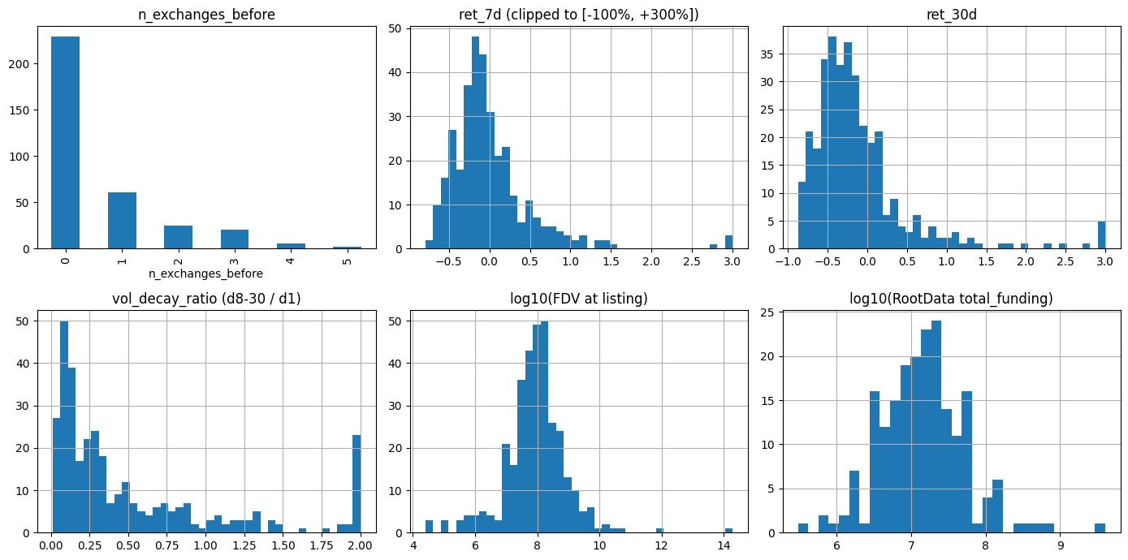
Figure 1 — The 2×3 distributions grid
WHAT YOU'RE LOOKING AT | Six small charts in one image, each showing the distribution of one key column across all 344 tokens. Top row: exchange-footprint and post-launch returns. Bottom row: volume decay, FDV at launch, and VC funding size.
HOW TO READ IT | Bar height (or histogram height) = how many tokens fall in each bucket. The return histograms are clipped to ±300% so a few extreme outliers don't squash the rest. FDV and funding panels use a log-10 scale because token sizes span many orders of magnitude.
WHAT IT TELLS US | Returns and volume decay are long-tailed and slightly negative on average — most perps drift down after launch. Money columns are heavy-tailed (a few giants, many small ones). This is exactly why we use Spearman ranks rather than raw values for the correlation math.

Chart 2 — CryptoRank ICO raised vs RootData total funding

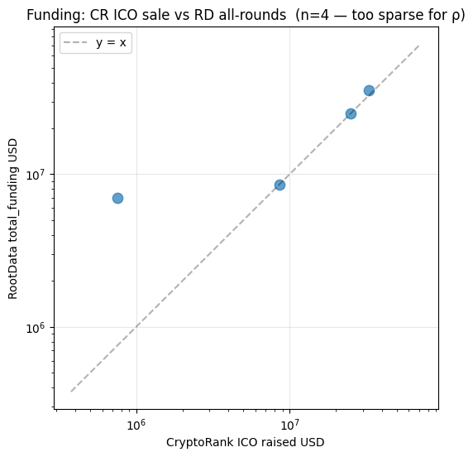
Figure 2 — CryptoRank ICO raised vs RootData total funding
WHAT YOU'RE LOOKING AT | A scatter plot comparing the two funding data sources. Each dot is a project that has a value in BOTH sources. X-axis is CryptoRank's public-sale (ICO/IDO) raised amount; Y-axis is RootData's total funding (all rounds combined). Both axes are log scale. Dashed diagonal = perfect agreement.
HOW TO READ IT | Read the gap from the diagonal: dots above the line mean RootData reports MORE money than the CryptoRank ICO figure — expected, since RootData includes private rounds. The chart should look mostly empty — sparsity itself is the finding.
WHAT IT TELLS US | Only 4 projects had both numbers, because CryptoRank's free API only exposes public-sale data and most modern projects skip public sales. The two sources can't be compared on USD raised. We cross-check them instead on investor counts (ρ ≈ 0.58 — reasonable agreement) and treat RootData as authoritative for funding totals.

Chart 3 — Spearman correlation matrix (the headline)

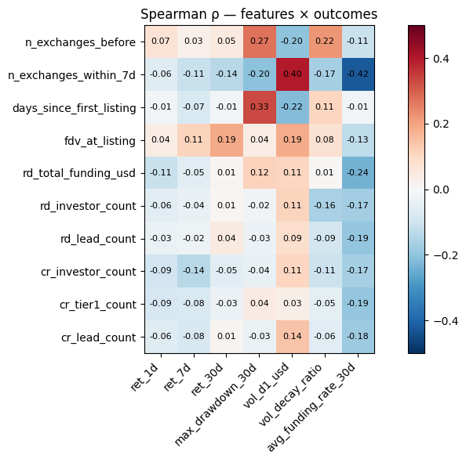
Figure 3 — Spearman correlation matrix (the headline)
WHAT YOU'RE LOOKING AT | A grid of 10 'before' features (rows) crossed with 7 'after' outcomes (columns). Each cell shows ρ between that pair, computed across tokens with non-null values for both. Cell colors: deep blue = strong inverse, white = no relationship, deep red = strong positive.
HOW TO READ IT | Hunt for the deepest reds and blues — those are the strongest signals. For example, row n_exchanges_before × column vol_decay_ratio is the biggest red square (ρ ≈ +0.22): tokens already on more venues retain volume better. The rd_total_funding_usd row is mostly pale — funding USD doesn't predict outcomes.
WHAT IT TELLS US | Three patterns dominate. (1) Prior exchange footprint matters for VOLUME RETENTION, not for price. (2) FDV at launch matters for PRICE RETURN — bigger holds up better. (3) Co-launches hurt both volume AND returns. These are bivariate; section 6 uses regression to disentangle overlapping effects.

Chart 4 — Returns by exchange-footprint bucket

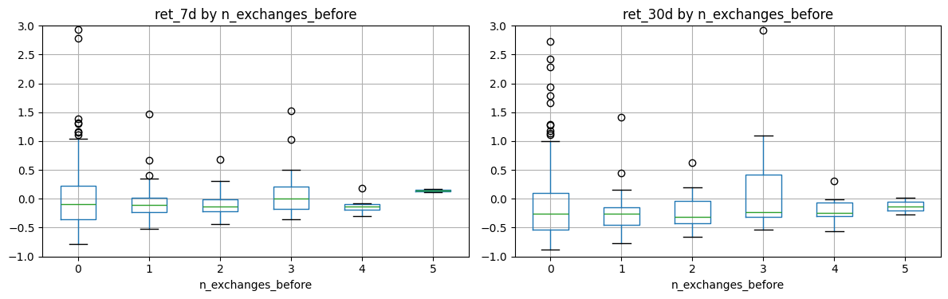
Figure 4 — Returns by exchange-footprint bucket
WHAT YOU'RE LOOKING AT | Two side-by-side boxplots. X-axis groups tokens by how many of the six tracked venues had listed them before the Binance perp. Left panel = 7-day return; right panel = 30-day return. Box anatomy: orange line = median, box = middle 50%, whiskers = the rest, circles = outliers.
HOW TO READ IT | If more prior listings meant better price performance, the median line would climb left-to-right. It mostly doesn't — medians wobble in a narrow band. Widest boxes are buckets with fewer tokens (high n_exchanges_before is rare), where individual outliers stretch the box.
WHAT IT TELLS US | Prior exchange footprint does NOT translate to stronger price returns over 7 or 30 days. The heatmap signal for this feature was about VOLUME sustain, not price. This chart is the 'absence-of-effect' chart for price — a useful negative result.

Chart 5 — Returns and volume decay by funding bucket

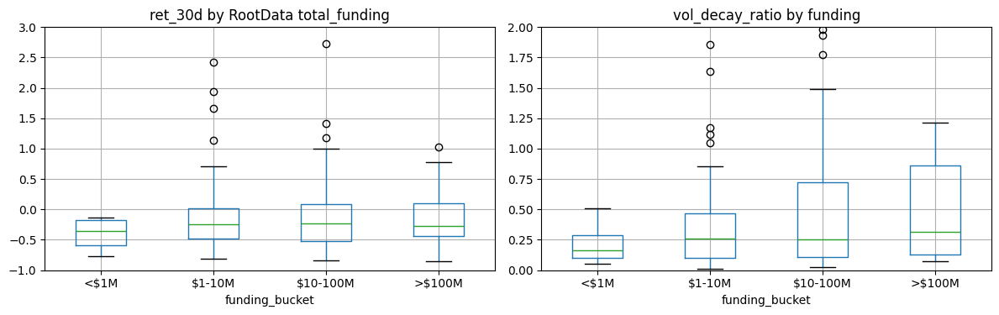
Figure 5 — Returns and volume decay by funding bucket
WHAT YOU'RE LOOKING AT | Two side-by-side boxplots grouped by funding size (per RootData): under $1M, $1–10M, $10–100M, over $100M. Left = 30-day return per bucket; right = volume decay ratio per bucket.
HOW TO READ IT | If well-funded projects outperformed, the median would rise from left to right. In both panels it doesn't move much. The largest bucket (>$100M) usually has few tokens and a wide box; the smallest bucket likewise — large boxes there are sample-size noise.
WHAT IT TELLS US | Funding amount alone is not predictive of price or volume at the perp horizon. The relevant funding signal is the COUNT of investors (more investors → faster volume fade), not the dollar AMOUNT raised.

Closing thoughts
The headline finding is the volume-retention one: tokens that already had a footprint on other CEXes before the Binance perp launch keep their trading volume better in the weeks afterward. Co-launches (multiple venues lighting up the same week) do the opposite — they pile up day-1 volume that then fades fast.
For price, the strongest predictor is FDV at launch: bigger tokens outperform over 30 days. Funding background (count of investors) is associated with faster volume fade, but the dollar amount of funding doesn't predict anything cleanly.
Caveats and next steps
• These are bivariate Spearman correlations; effects overlap with each other and with FDV. The OLS in section 6 of the notebook only starts to disentangle them — it is not a rigorous causal model.
• Pull 4-hour returns instead of daily to catch more of the immediate post-launch action.
• Add open-interest growth data — arguably a cleaner 'is this perp catching on' signal than raw volume.
• Add sector tags (meme / DeFi / AI / L1 / gaming) so patterns can be compared by category.

