Ahmed Haitham Amer 231000443
Question1
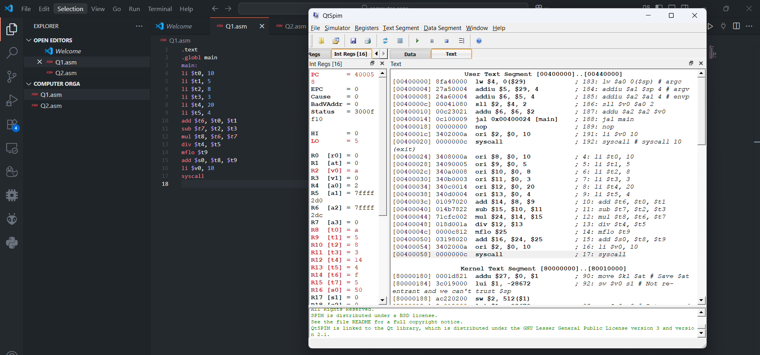
.text
.globl main
main:
li $t0, 10
li $t1, 5
li $t2, 8
li $t3, 3
li $t4, 20
li $t5, 4
add $t6, $t0, $t1
sub $t7, $t2, $t3
mul $t8, $t6, $t7
div $t4, $t5
mflo $t9
add $s0, $t8, $t9
li $v0, 10
syscall

Question 2
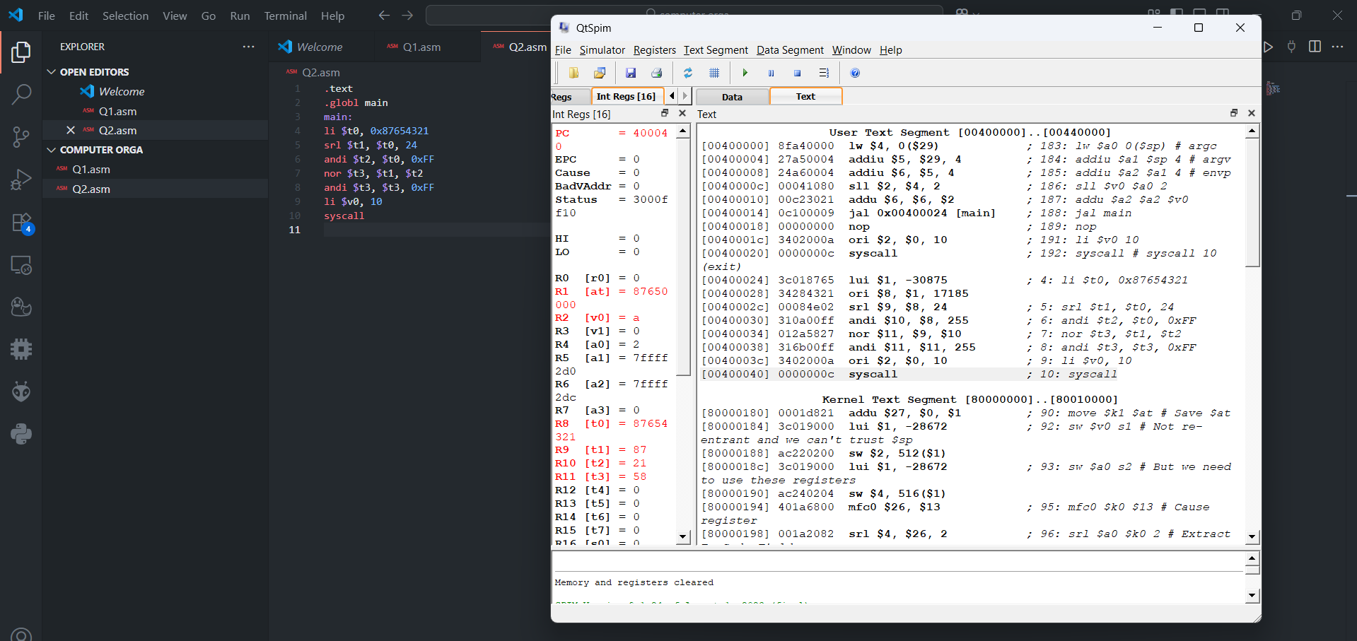
.text
.globl main
main:
li $t0, 0x87654321
srl $t1, $t0, 24
andi $t2, $t0, 0xFF
nor $t3, $t1, $t2
andi $t3, $t3, 0xFF
li $v0, 10
syscall

