Ahmed Haitham Amer

Fitbit Data Analysis - Bellabeat Case Study (Task 3)

This documentation presents the analysis of Fitbit data as part of the Bellabeat Case Study. The task was to extract 5 facts from the dataset using a combination of SQL and Python (Pandas). The analysis leverages both SQLite queries and Pandas DataFrame operations for insights.

1. Setup and Data Loading
The analysis begins by loading Fitbit datasets (daily activity, sleep, and hourly steps) using Pandas and storing them in a local SQLite database for SQL-based queries.
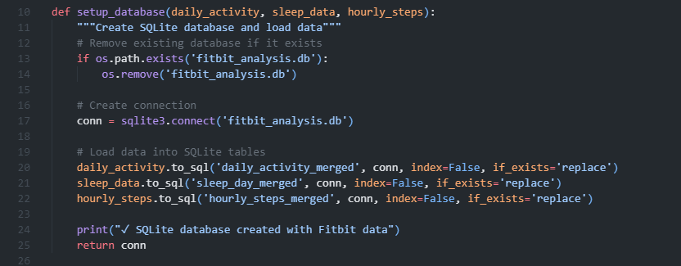

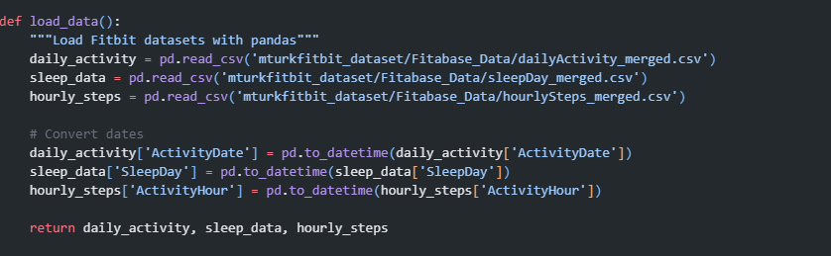

2. Fact 1: User Engagement Analysis
Using SQL, we count the number of days each user wore their Fitbit device and categorize them into Active, Moderate, or Light users. Pandas is used to summarize and calculate statistics.
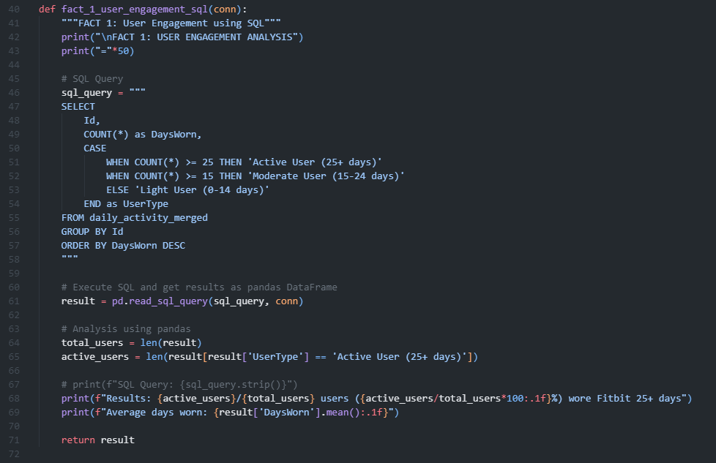

3. Fact 2: Activity Levels Analysis
SQL is used to compute the average steps and calories per user. Users are then classified into different activity levels based on their average daily steps. Pandas summarizes inactive and low-active users.
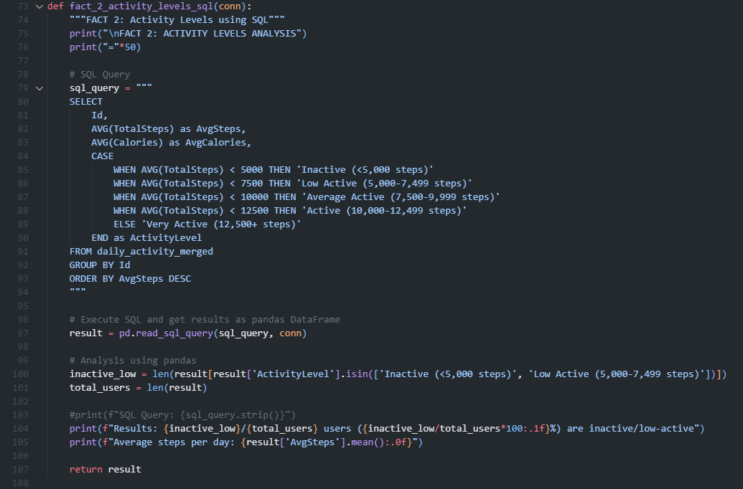

4. Fact 3: Peak Activity Hours
Hourly step counts are aggregated using SQL to identify peak hours of physical activity. The top 5 hours with the most steps are reported.
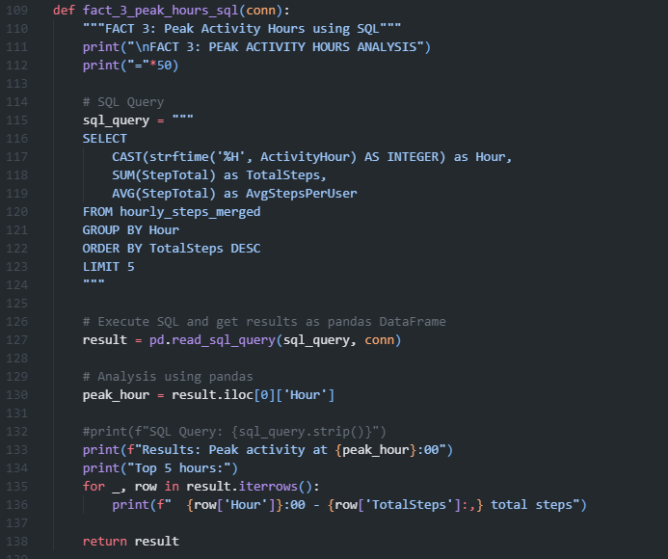

5. Fact 4: Sleep and Activity Correlation
By joining daily activity and sleep data, SQL computes average sleep hours alongside steps and calories. Pandas is used to calculate correlation between sleep and activity and to summarize sleep categories.
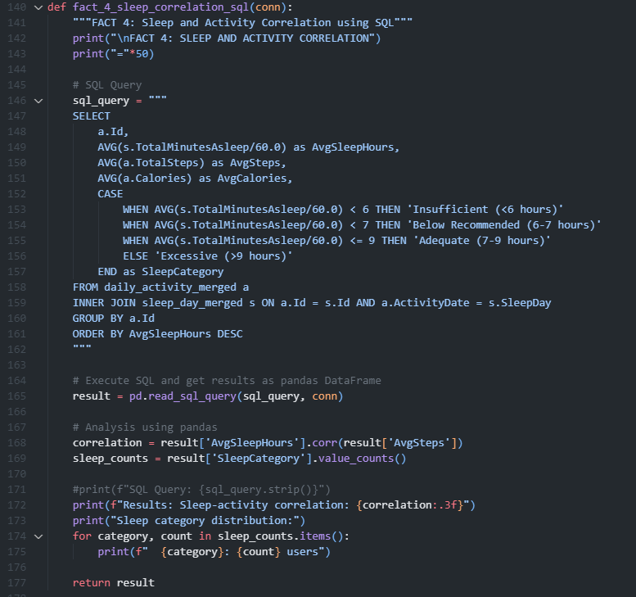

6. Fact 5: Weekly Activity Patterns
SQL is used to calculate average steps and calories by day of the week. Pandas highlights the most and least active days across the dataset.
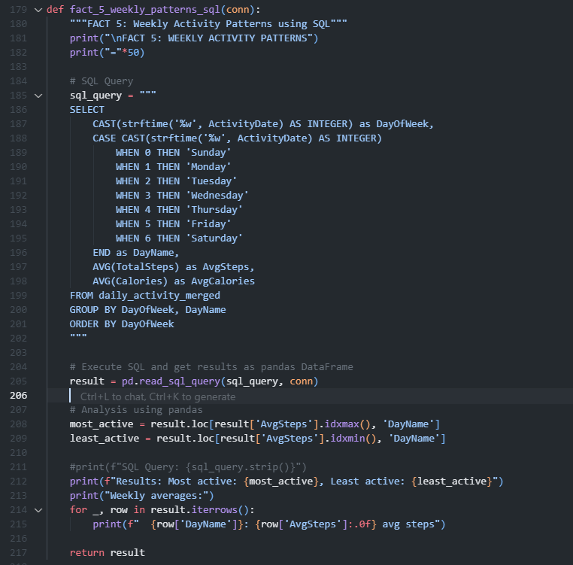

7. Main Execution
The main() function orchestrates the workflow by loading data, setting up the database, executing SQL queries, and performing Pandas analysis.
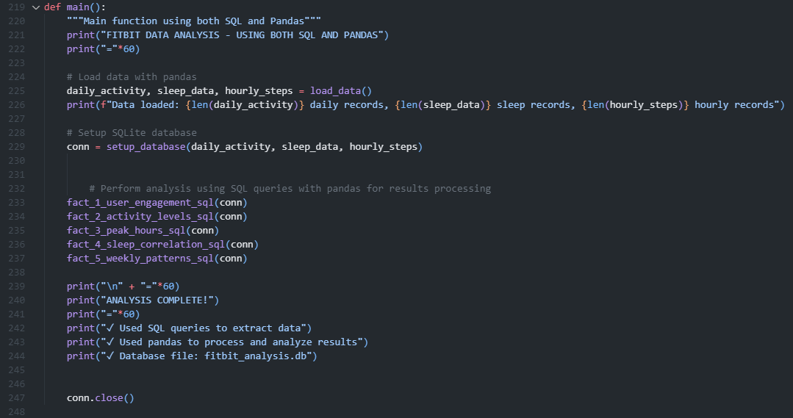

Conclusion&Output
This analysis demonstrates the combined use of SQL and Pandas for data exploration and insight generation. The extracted facts provide a foundation for understanding user engagement, activity patterns, and the relationship between sleep and activity in Fitbit data.
OUTPUT:
