GardianPro Admin Manual

**Login GardianPro**

Input the provided user name and password to enter GardianPro system

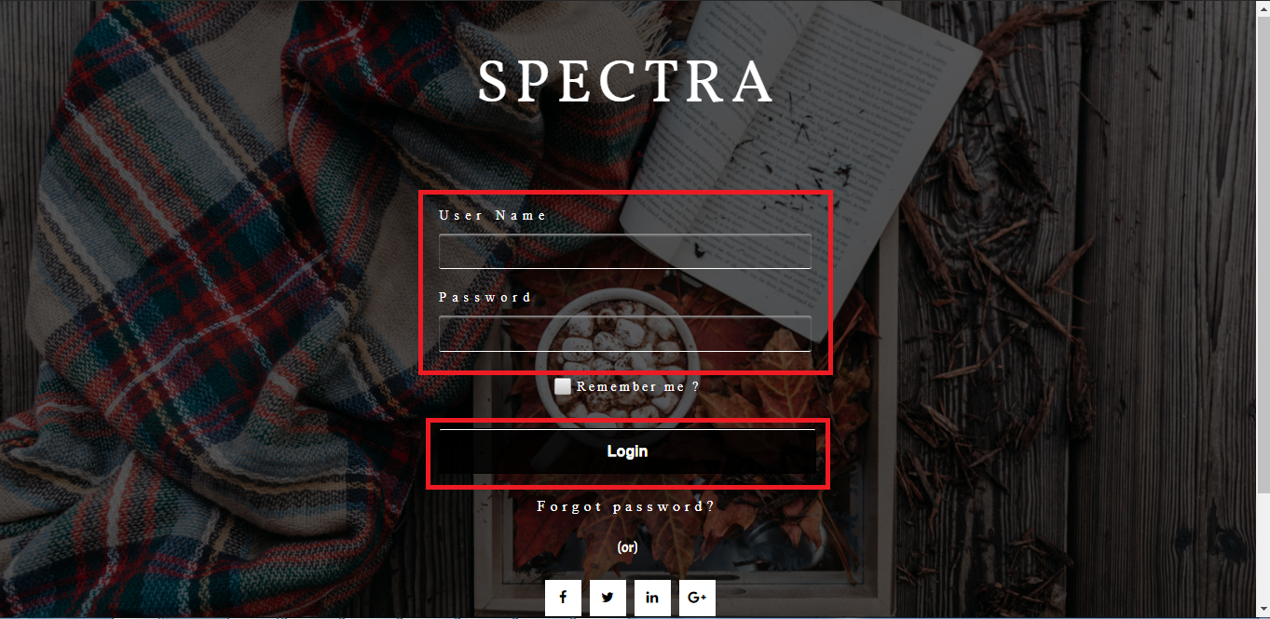

After login, it enters the Main page.

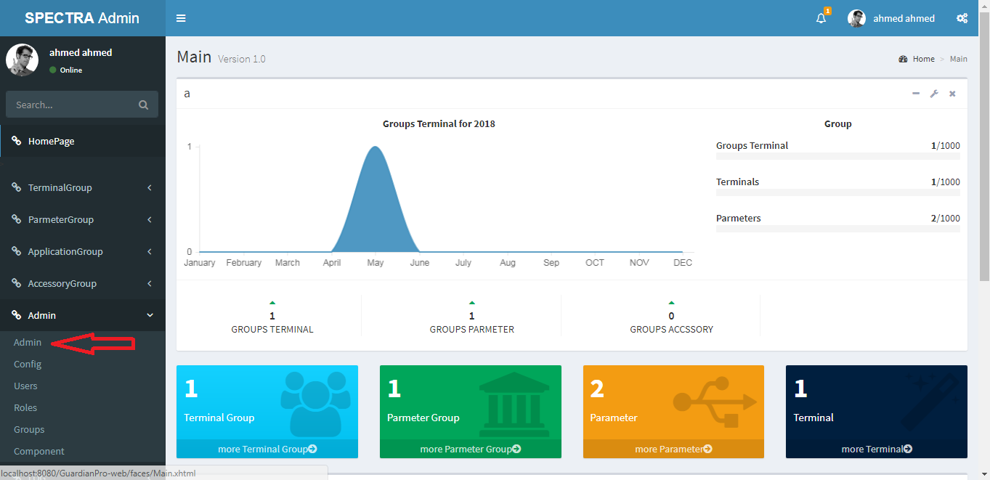

**Update System Configurations**

After login, it enters the Main page. To show or update System Configurations, press “config”

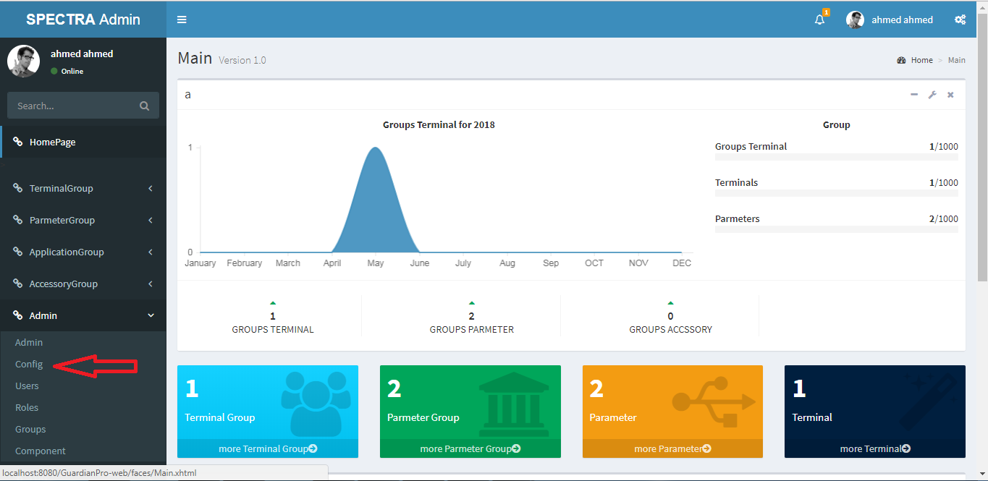

Then the following page will appear:

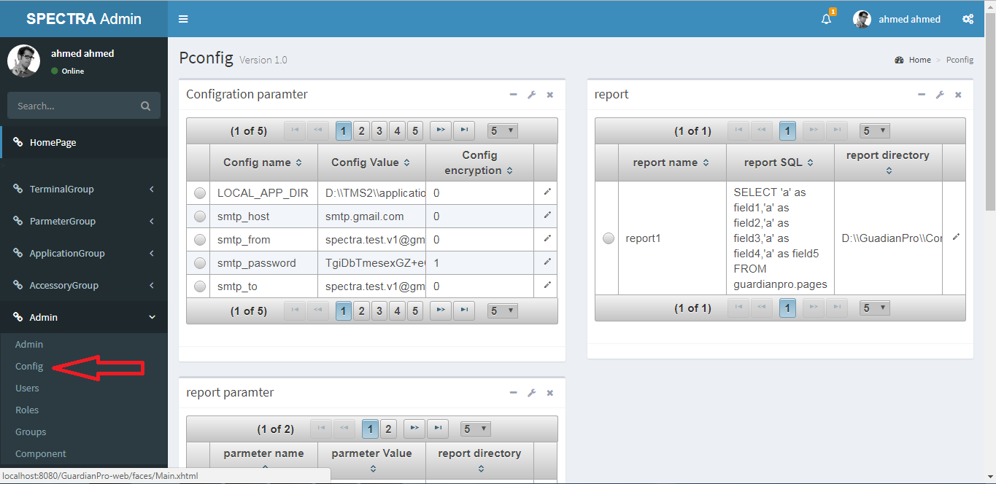

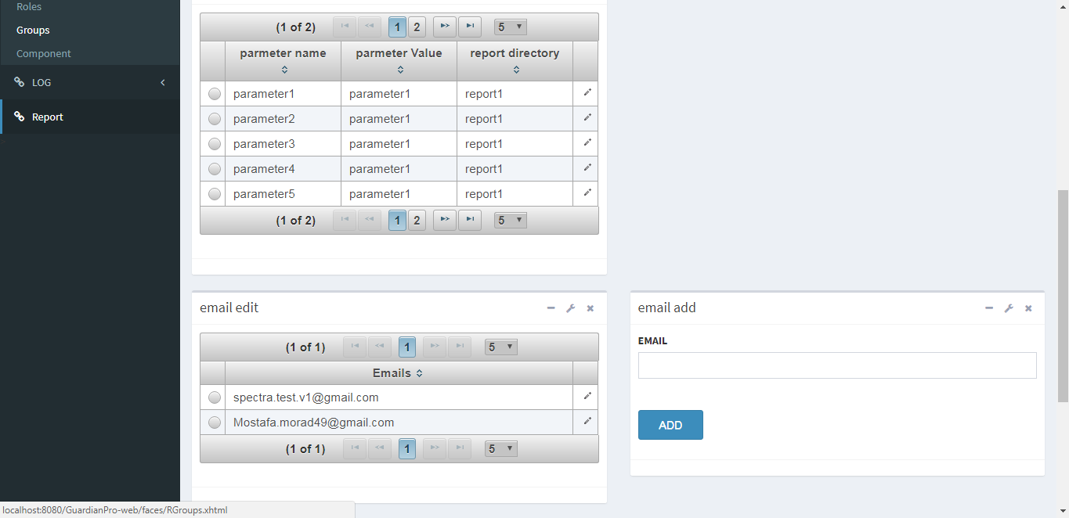

**To update existing configuration record.**

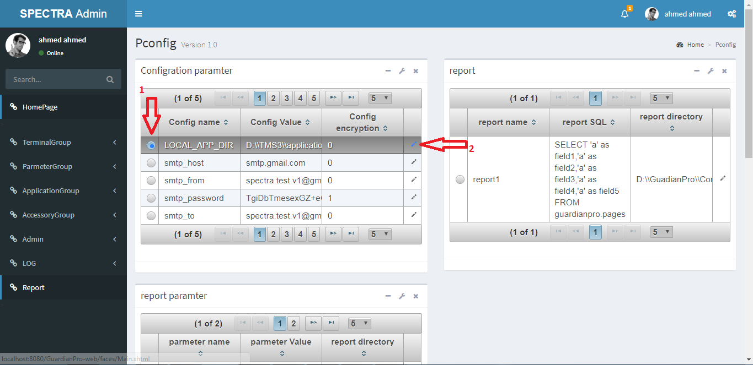

After choose the System configuration, press on right button then.

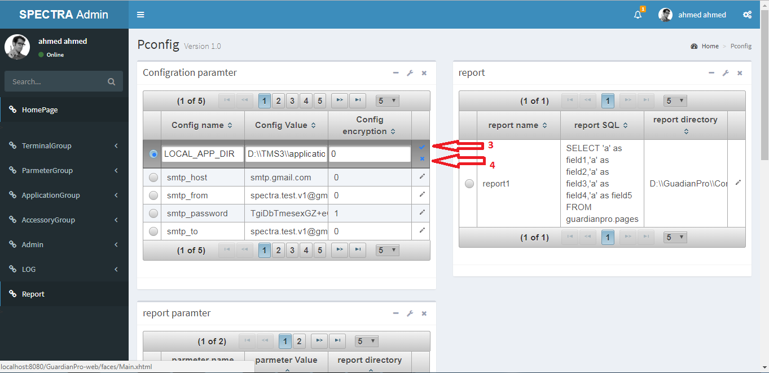

Press on correct button to save or false button to revert after updating current record.

**To add new Email.**

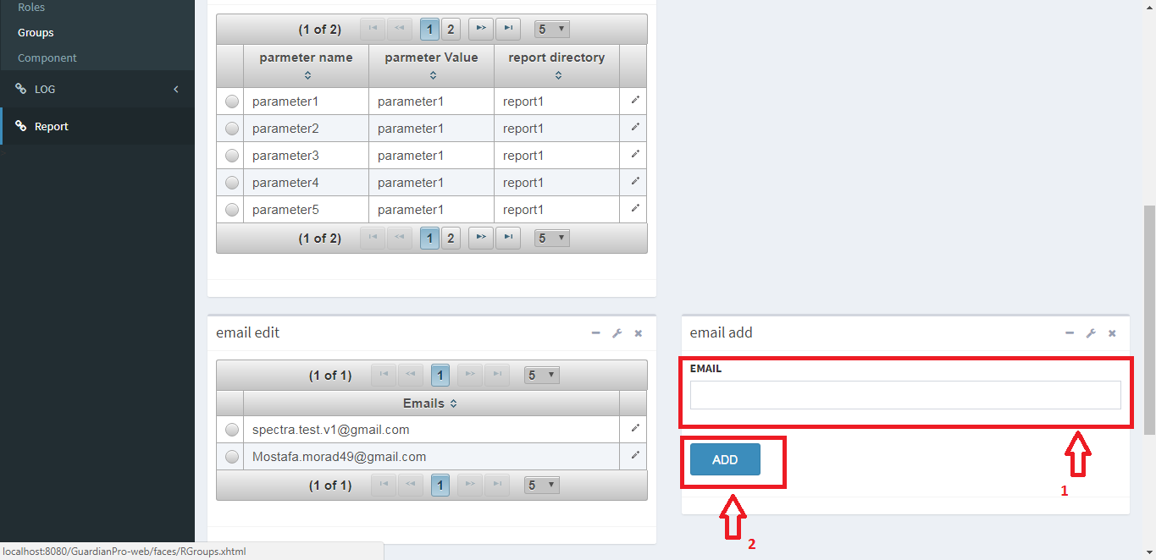

After enter Email, press “Add” button on the bottom to save.

**Create a new User**

To create a new User, press “Users”

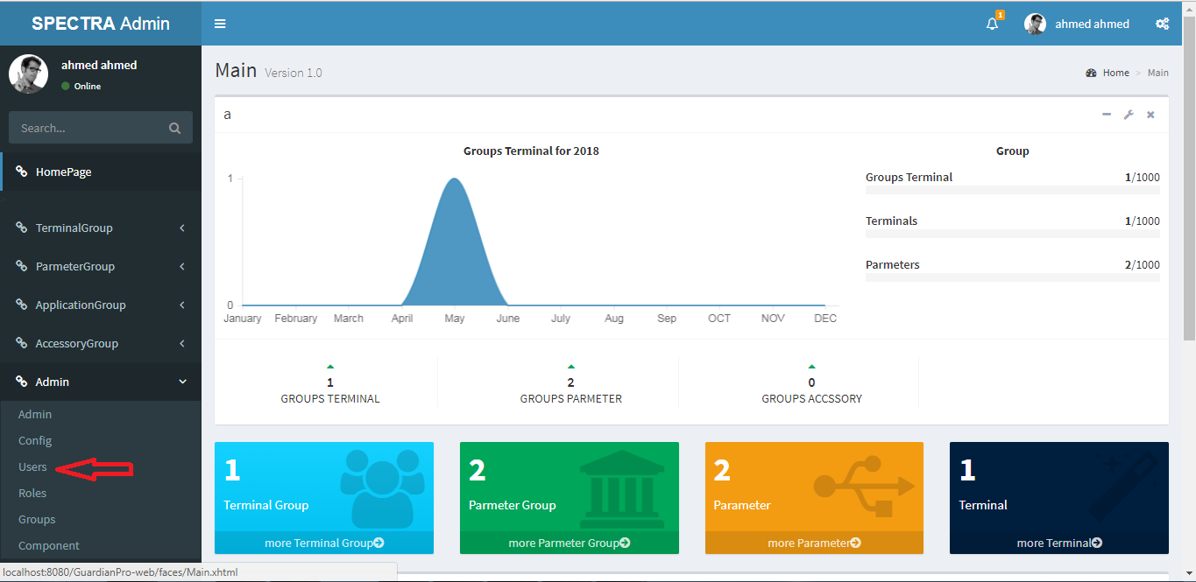

Then the following page will appear:

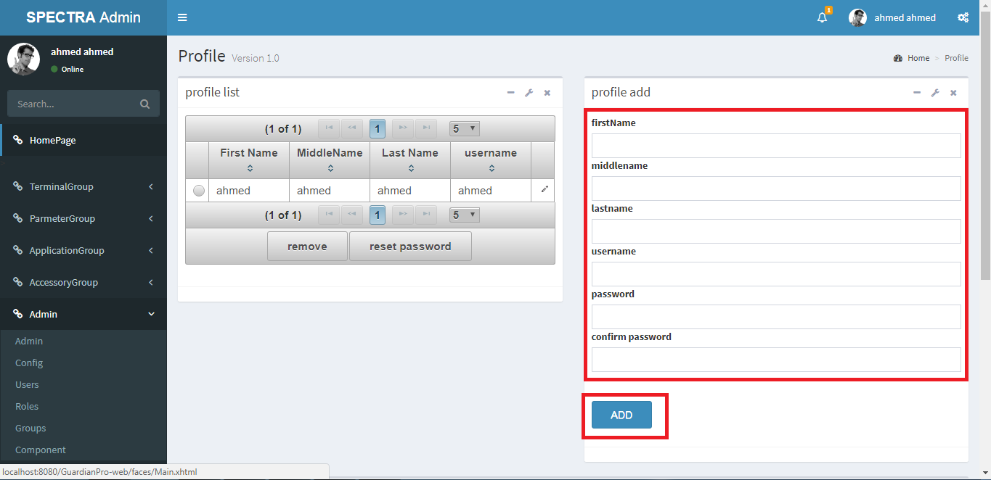

After finish editing all the parameters, press “Add” button on the bottom to save.

To remove existing User record.

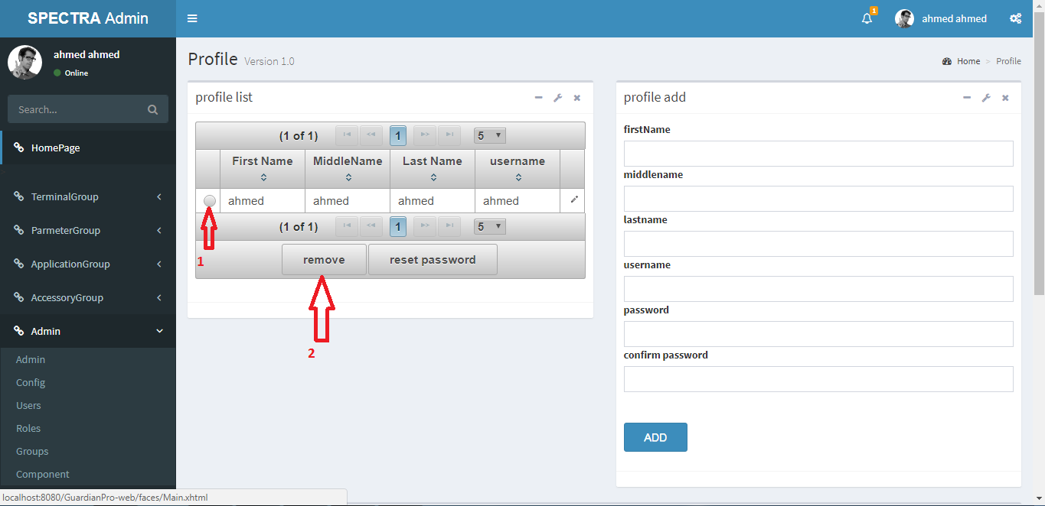

After choose the User, press “remove” button on the bottom to remove.

To reset existing User password.

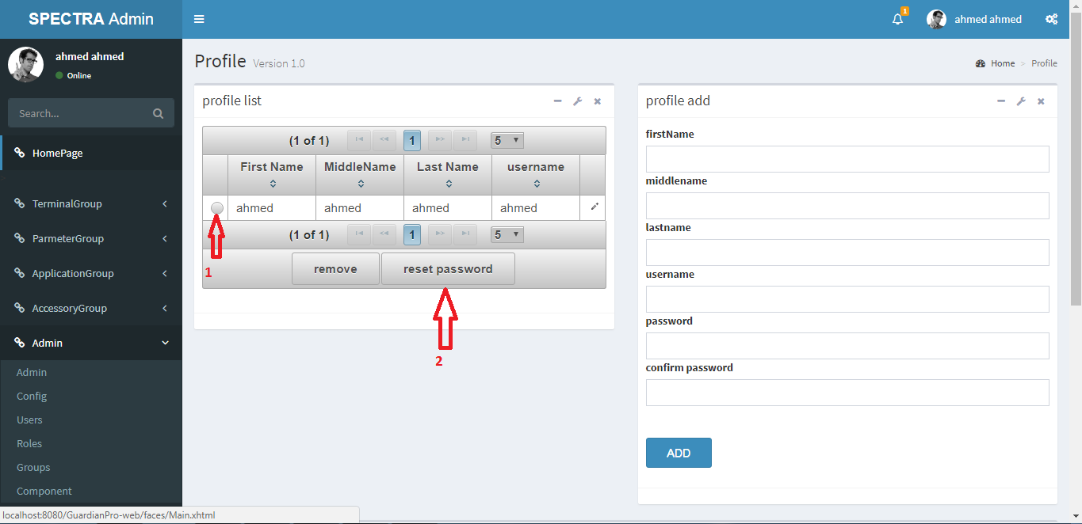

After choose the User, press “reset password” button on the bottom to start resetting.

To update existing User record.

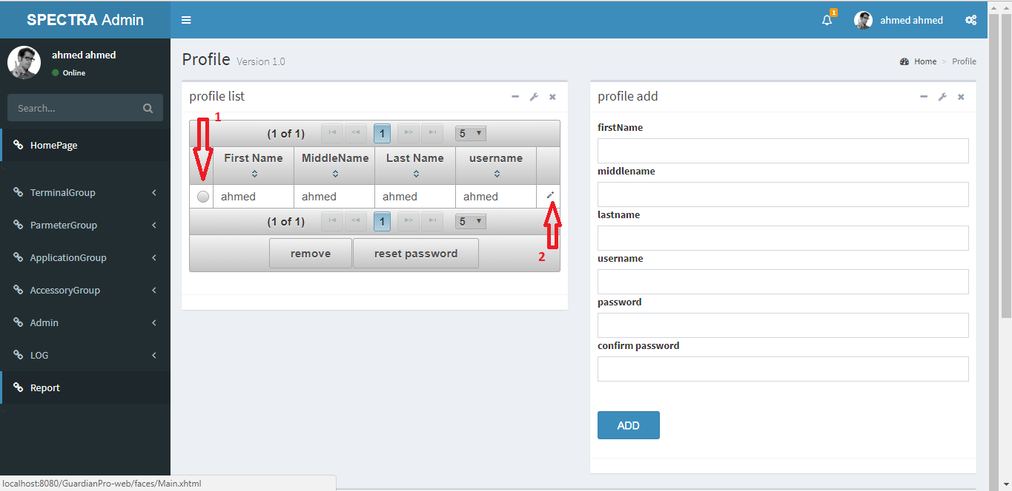

After choose the User, press on right button then.

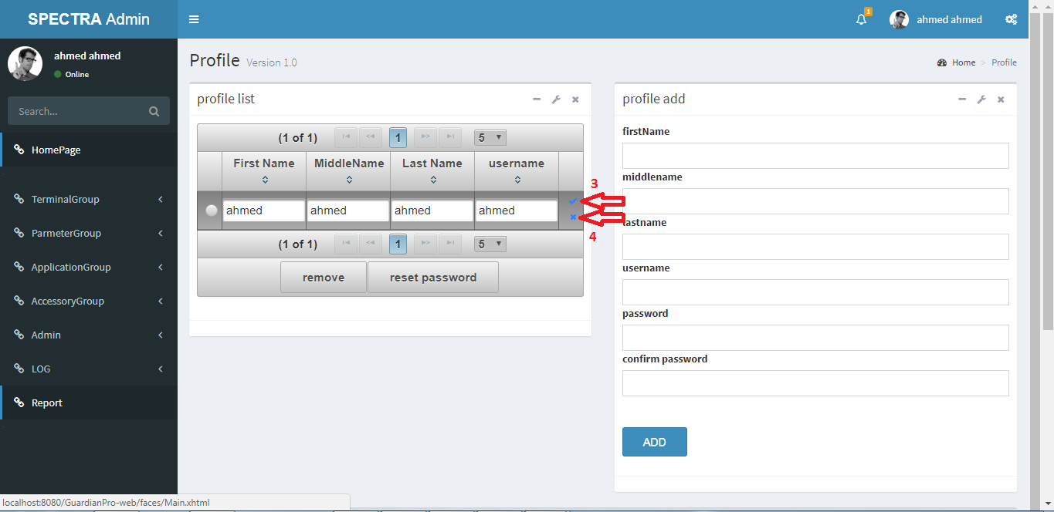

Press on correct button to save or false button to revert after updating current record.

**Create a new Role**

To create a new Role, press “Roles”

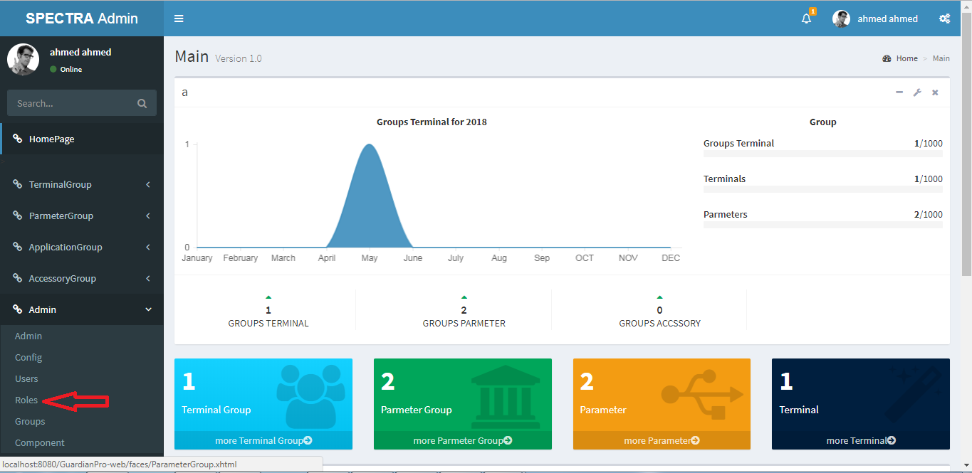

Then the following page will appear:

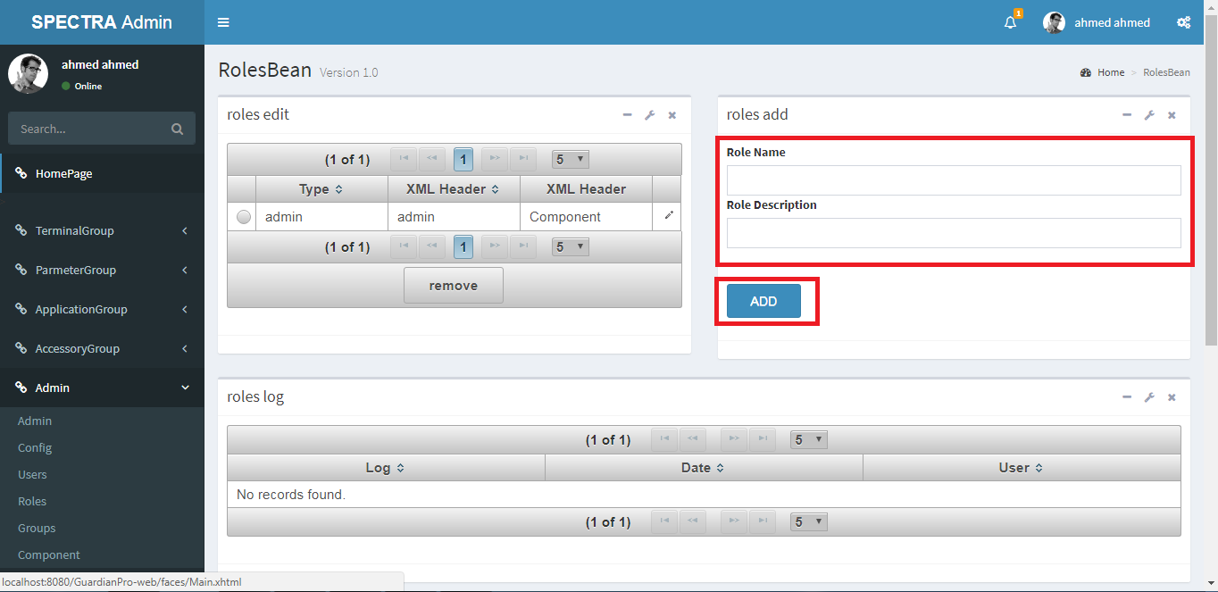

After enter Role Name and Role Description, press “Add” button on the bottom to save.

To remove existing Role record.

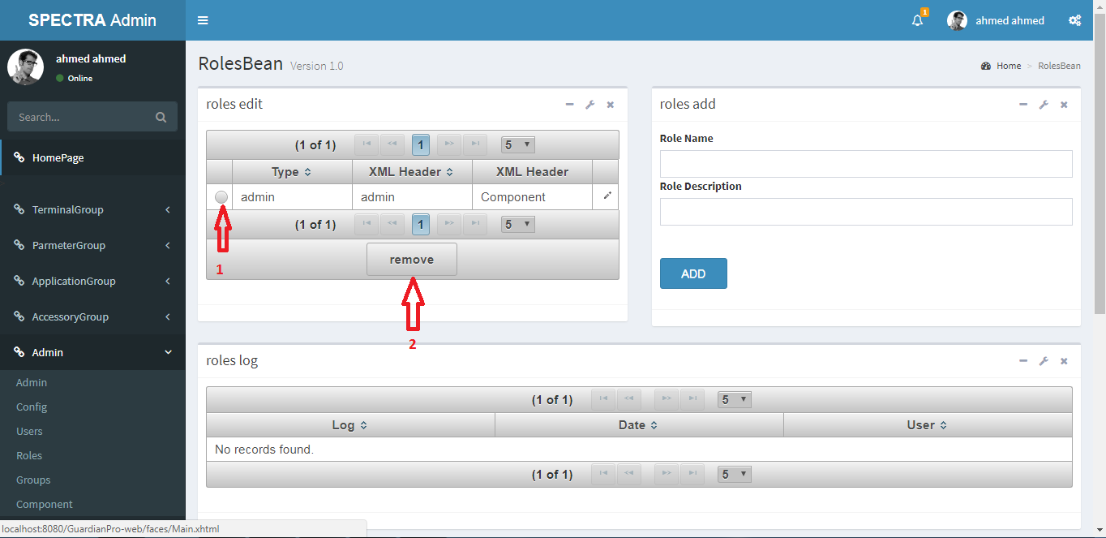

After choose the Role, press “remove” button on the bottom to remove.

To update existing User record.

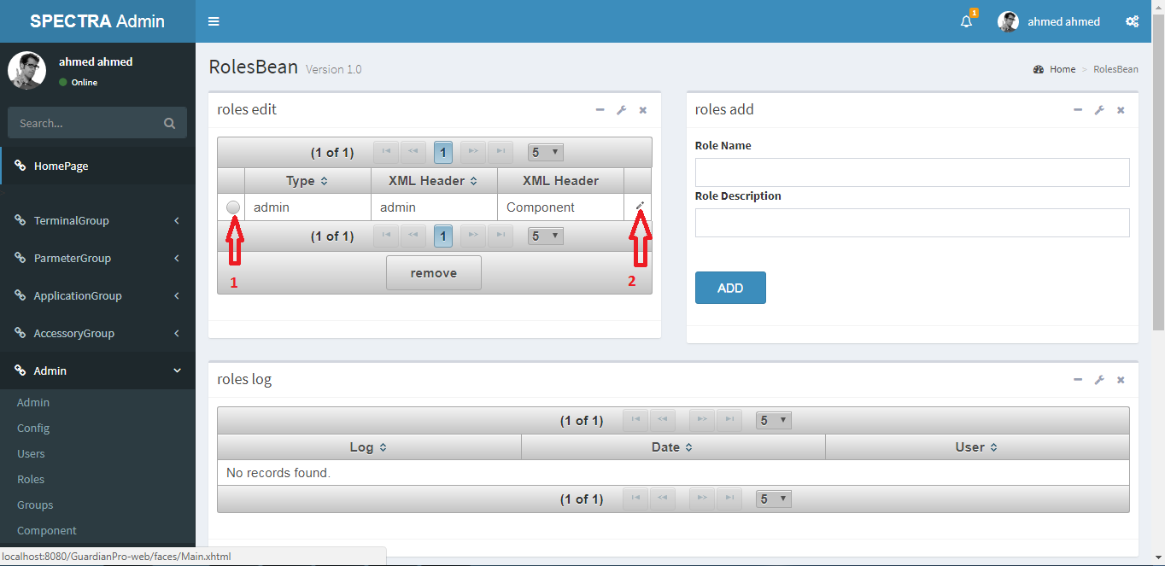

After choose the Role, press on right button then.

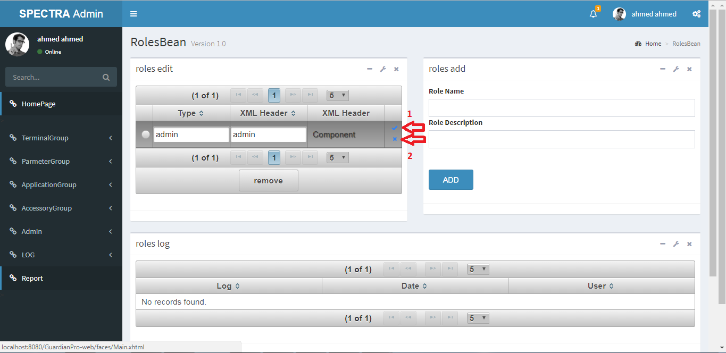

Press on correct button to save or false button to revert after updating current record.

**Create a new Group**

To create a new Group, press “Groups”

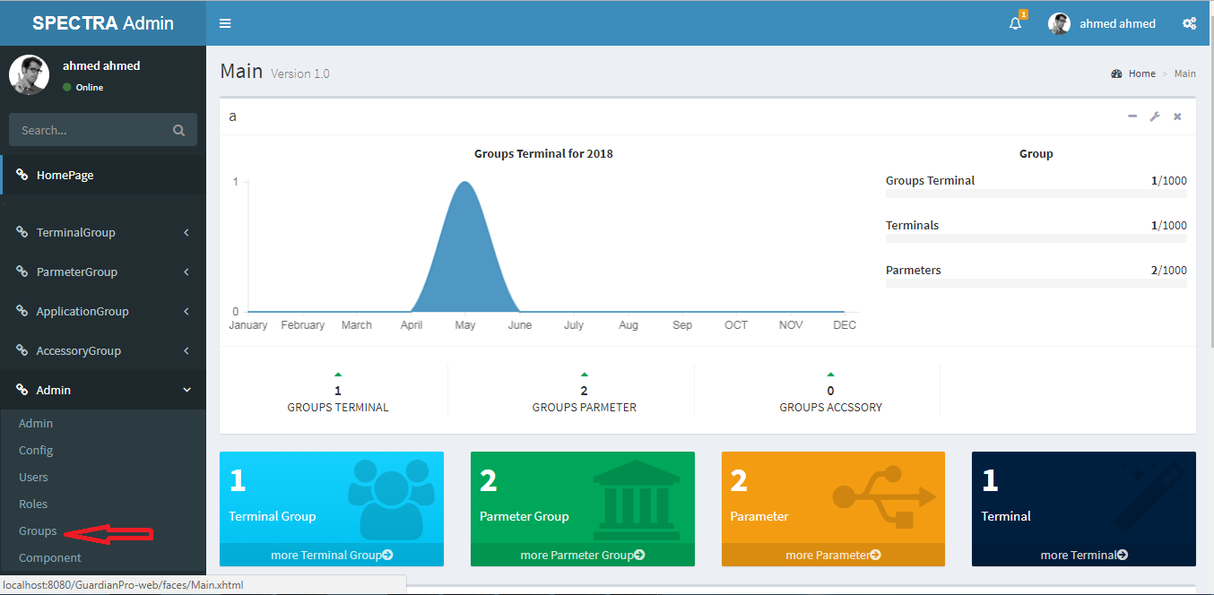

Then the following page will appear:

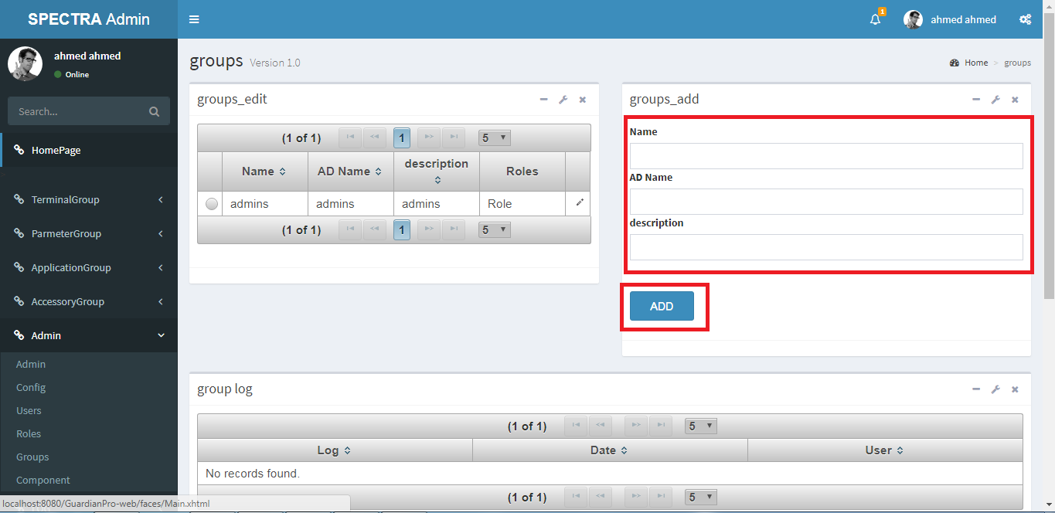

After finish editing all the parameters, press “Add” button on the bottom to save.

To update existing Group record.

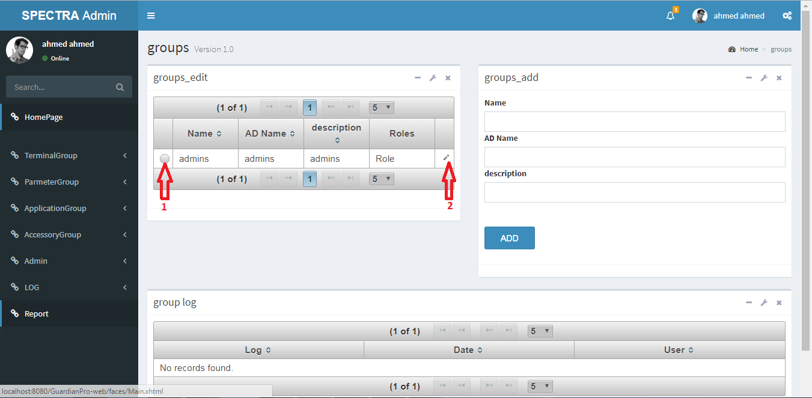

After choose the Group, press on right button then.

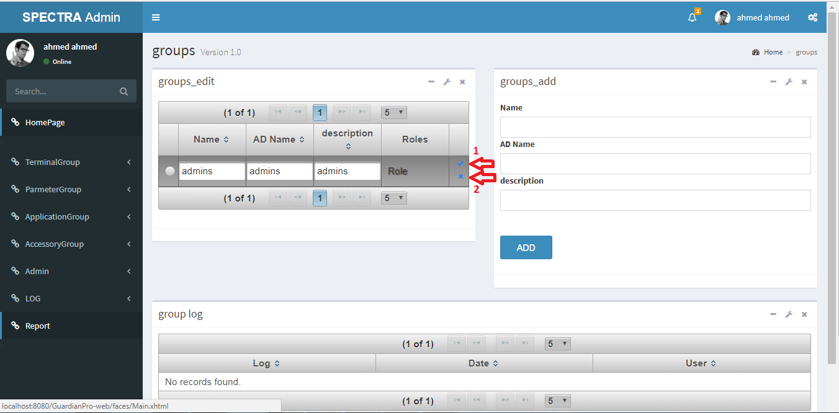

Press on correct button to save or false button to revert after updating current record.

**Show or Update existing component**

To Show or Update existing component, press “Component”

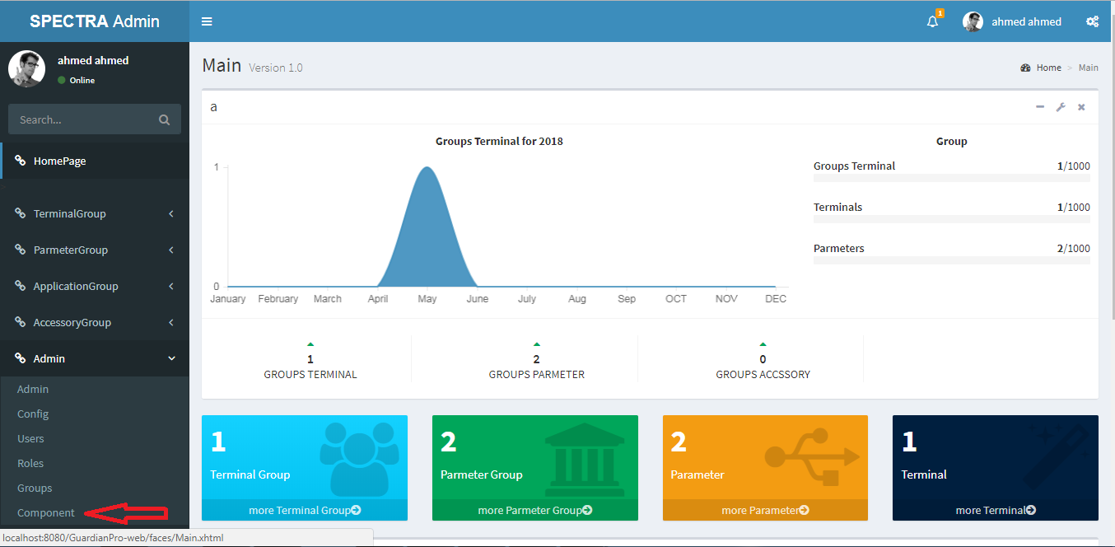

Then the following page will appear:

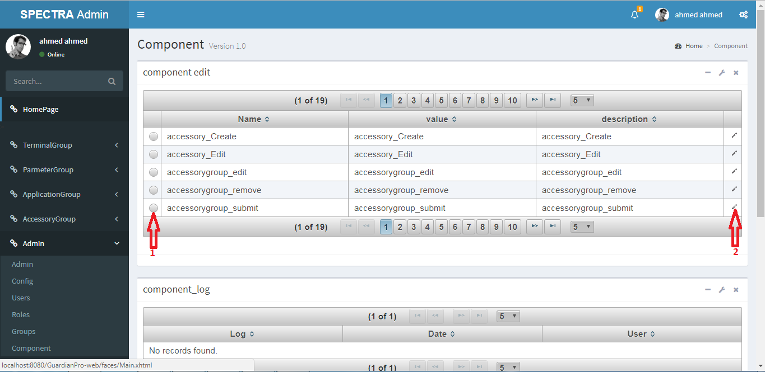

After choose the Component, press on right button then.

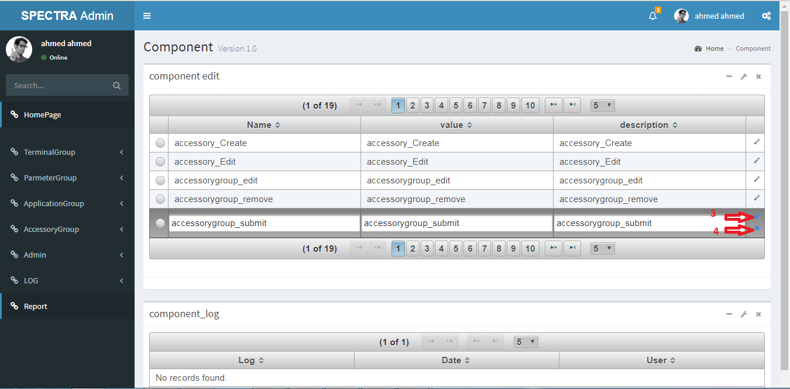

Press on correct button to save or false button to revert after updating current record.

**Show System Logs**

To show system log, press “Log”

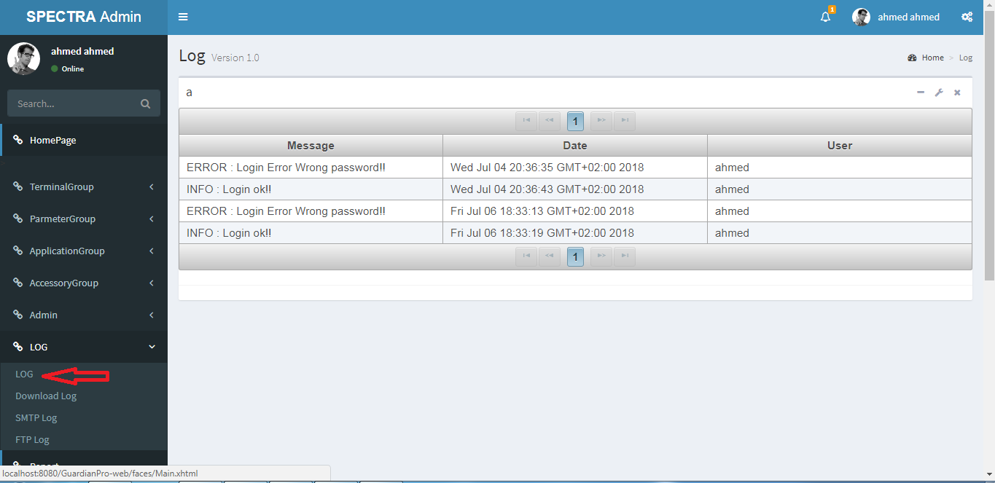

Then the following page will appear:

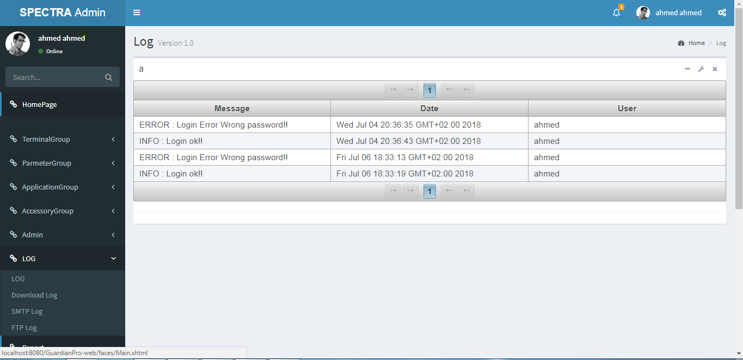

**Show SMTP Logs**

To show SMTP log, press “SMTP Log”

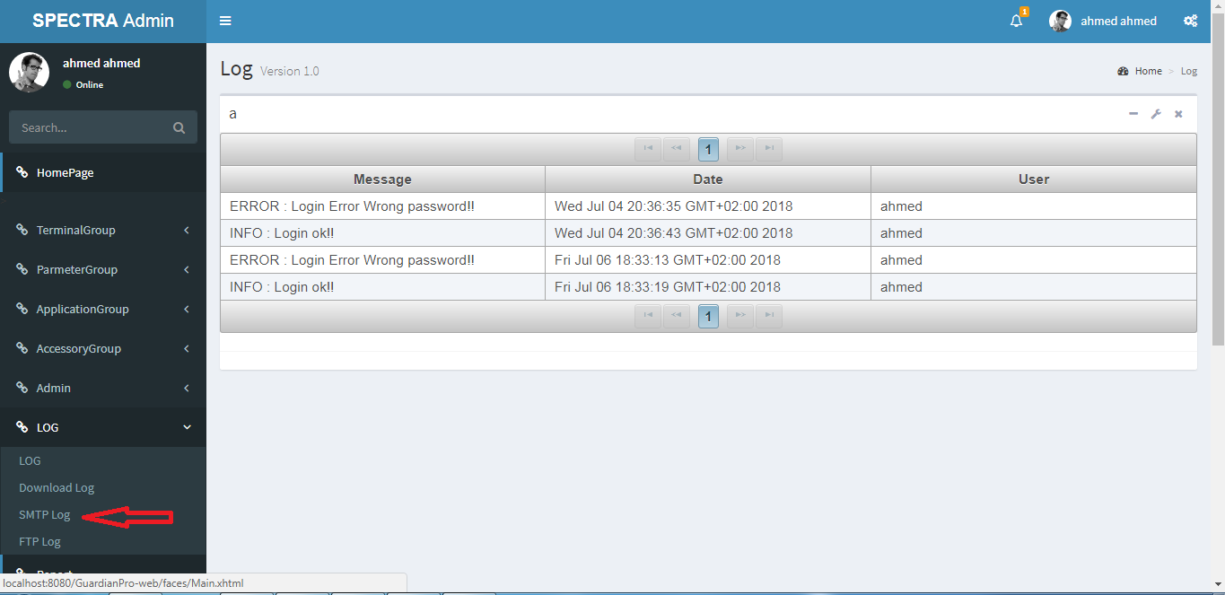

Then the following page will appear:

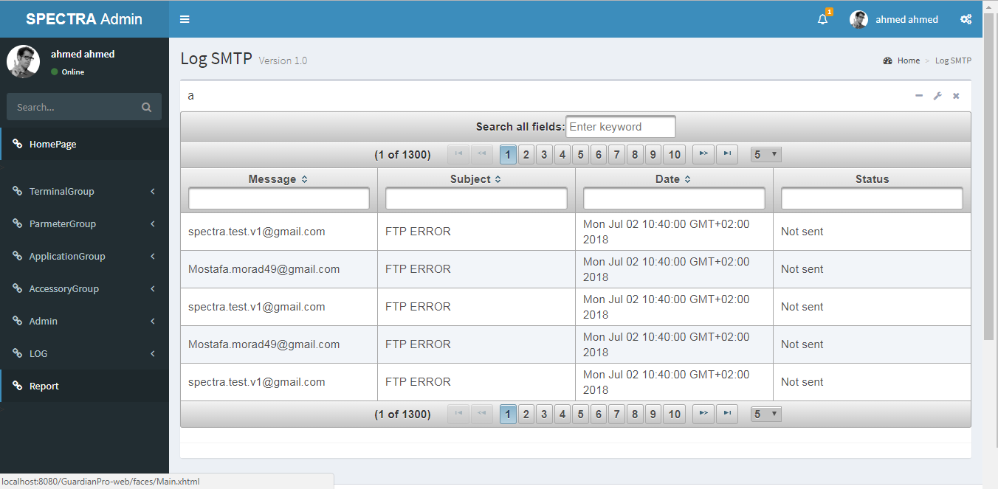

**Show FTP Logs**

To show FTP log, press “FTP Log”

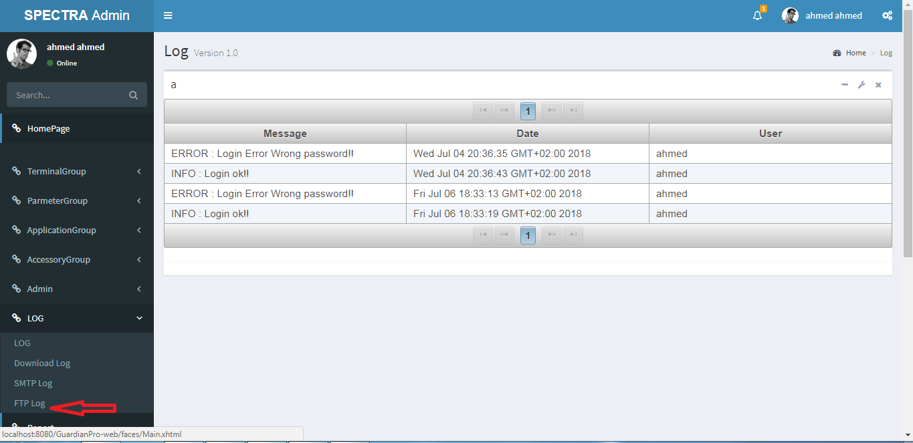

Then the following page will appear:

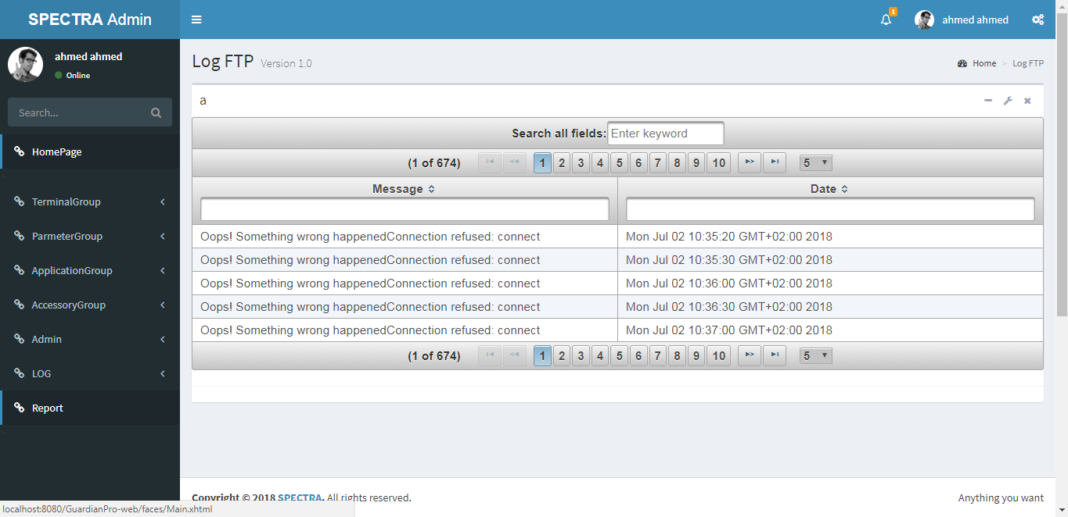

**Create a new Report**

To create a new Report press “Report”

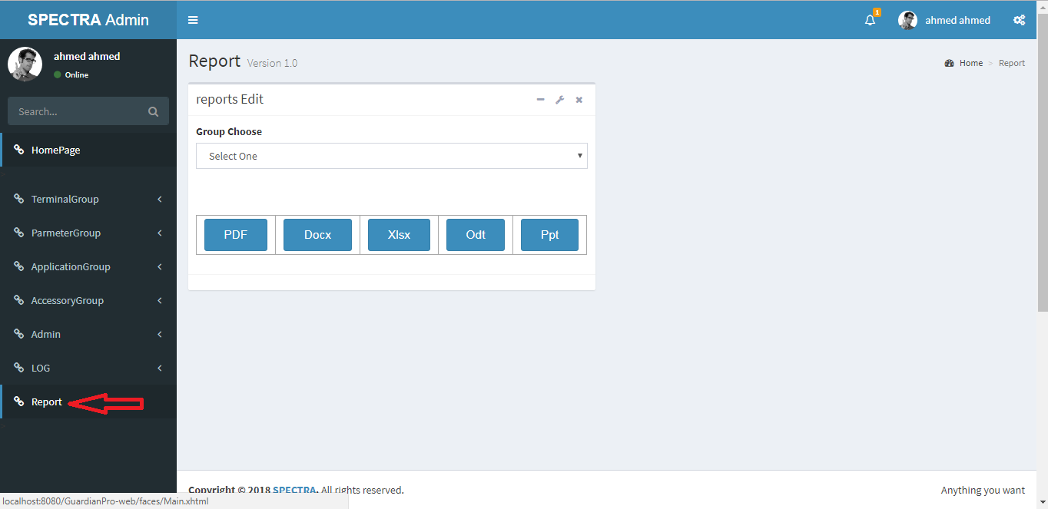

Then the following page will appear:

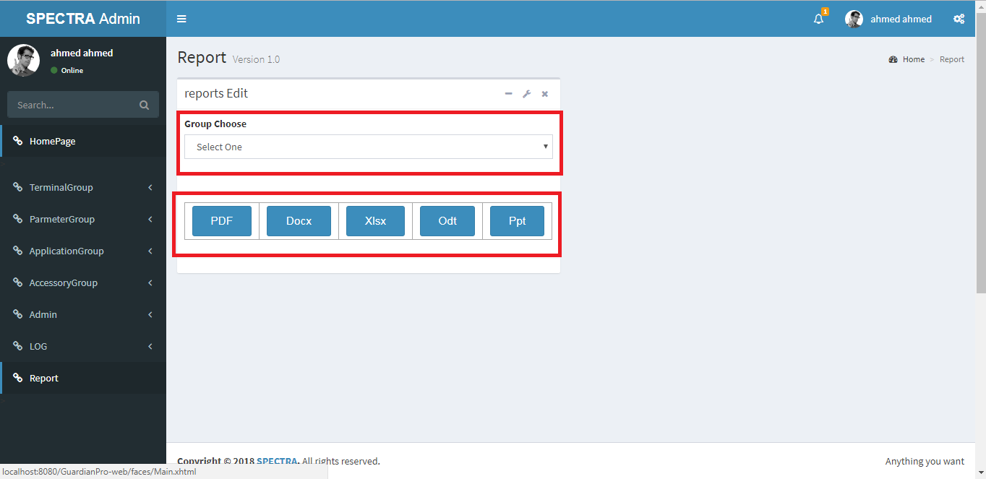

After choose the Group, press on the desired format button on the bottom to generate new Report.