AdaptiveEdu
Project documentation — DEPI Graduation Project
Live Telegram study bot for Egyptian 1st Secondary · Gemini lessons · Excel quiz · Gmail Pass/Fail
https://t.me/AdaptiveEdubot
https://github.com/ahmedhamedali82/AdaptiveEdu
1. Abstract
AdaptiveEdu is a live Telegram bot (t.me/AdaptiveEdubot) that registers a student by ID, lets them choose a subject, generates the next lesson with Google Gemini as a PDF plus ten MCQ model answers, emails the PDF as an attachment with the required Excel answer-file name, then grades the uploaded Excel file. Pass means grade greater than 6 out of 10. Fail means 6 or less — the same lesson stays open until Pass. n8n workflow ADAPTIVE_14 (about 46 nodes) orchestrates Telegram, three Google Sheets, Drive, Gmail, Gemini, and PDFShift (HTML → PDF). The student never opens n8n. Telegram and email are the student screens.
2. Problem
- One classroom, one pace, one book.
- A student who fails a lesson still moves on with the class.
- A teacher cannot follow every student by hand after school.
- We need a simple rule: finish this lesson — with a scored quiz — before the next one.
3. Objectives
- Register each student once and bind their Telegram chat ID.
- Send only the next unanswered / unpassed lesson for the chosen subject.
- Generate lesson content with Gemini (Markdown → HTML → PDF) and ten model answers.
- Accept answers only as Excel: one row, ten capital letters, no header, exact file name.
- Pass if grade > 6 / 10; Fail otherwise; block the next lesson until Pass.
- Email lesson materials and Pass/Fail results; log everything in student_progress.
- Keep the stack clear: Telegram + n8n + 3 Sheets + Gemini + Gmail + Drive.
4. Users
User | What they do
Student | Sends ST### ID, picks subject code 1–8, opens the emailed PDF attachment, uploads Excel answers.
Teacher / team | Checks Students_Data, Lessons_Data, and student_progress. Helps stuck students by hand.
System (n8n) | Registers, generates lesson, emails, grades Excel, updates progress, replies Pass/Fail.

5. How the student uses it (8 steps)
- Open https://t.me/AdaptiveEdubot
- Send student ID, example: ST005
- Bot replies with subject list 1–8 (and tip to upload an answers file).
- Send subject code, example: 4 = Philosophy & Logic
- Receive Telegram notice + Gmail with PDF attachment and required Excel name (example: ST005_4_1.xlsx)
- Study the PDF, then fill one Excel row: 10 capital letters A–D (or as required), no title row
- Upload the Excel file on Telegram with the exact name
- Receive grading confirmation on Telegram + result email: Pass or Fail
6. Architecture (three paths)
Telegram Trigger receives every message. The workflow branches on message type:
Path | Input | Main outcome
A — Register | Student ID text (ST###) | Bind telegram_chat_id, show subjects, set waiting flag
B — Lesson | Subject code 1–8 | Pick next lesson → Gemini → PDF → email + Telegram → append progress
C — Grade | Excel document | Validate name → parse row → compare ANS_1…ANS_10 → Pass/Fail email

If a previous lesson was delivered but not answered (or not passed), Path B blocks a new lesson and asks the student to finish the pending quiz first.
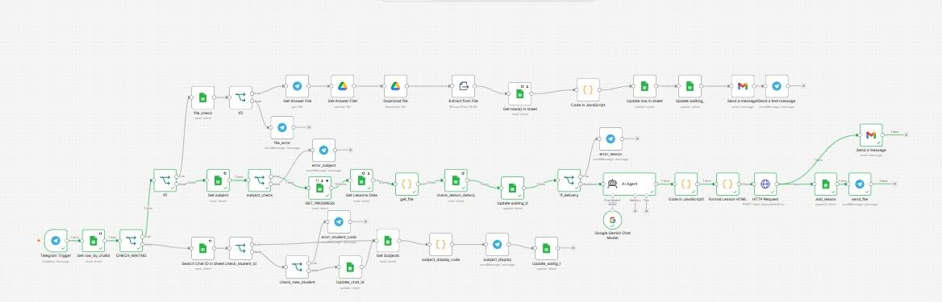
Figure 1 — Live n8n canvas: ADAPTIVE_14 (~46 nodes).
7. Tools and what each one does
Tool | Role
Telegram | Only student chat UI. Bot: AdaptiveEdubot.
n8n | Orchestration. Import AdaptiveEdu.json (workflow name ADAPTIVE_14).
Google Sheets ×3 | Students_Data, Lessons_Data, student_progress.
Google Gemini (AI Agent) | Writes Markdown lesson + 10 model answers.
PDFShift (HTTP Request) | Converts formatted lesson HTML to a binary PDF file.
Google Drive | Stores / moves answer files for extract-from-file.
Gmail | Sends lesson email with PDF attachment + Excel name, and Pass/Fail result emails.
GitHub | https://github.com/ahmedhamedali82/AdaptiveEdu
PowerPoint | AdaptiveEdu_Project_Plan.pptx — journey, n8n steps, live screenshots.

8. Data — Students_Data
https://docs.google.com/spreadsheets/d/1ddIwenYjiwKryP7Pogxe-7qsjKnTmtfCtAlDoplSn5Q
Tab name: Students_Data. n8n matches on student_id and telegram_chat_id.
Column | Who fills it | Meaning
student_id | Team (before demo) | Example ST005. What the student types.
student_name | Team | Used in emails (Dear …).
phone | Team (optional) | Contact.
telegram_chat_id | n8n | Saved on first successful register.
email | Team | Where lesson and result emails are sent.
otp | Optional | Not required for the main demo path.
status | n8n | Waiting flag (0/1): next message treated as subject/file vs register.

9. Data — Lessons_Data
https://docs.google.com/spreadsheets/d/1akeM65odle57kxtR7M5LqFMnxCsHX3M1cJKKltExFEg
Two tabs. Do not rename them.
Tab | n8n action | Columns / content
subject | Read | SUBJECT_CODE, subject — codes 1 to 8
Lessons_Data | Read | subject_code, subject, lesson_code, lesson_name, optional file_name

Code | Subject
1 | Arabic Language
2 | Mathematics
3 | Integrated Sciences
4 | Philosophy & Logic
5 | First Foreign Language / English
6 | Egyptian History
7 | Programming & Artificial Intelligence
8 | Physical Education

Demo lesson used in screenshots: subject 4 Philosophy & Logic → lesson_code 1 Thinking Principles.
10. Data — student_progress
https://docs.google.com/spreadsheets/d/1II6ckyiKFucKsC38PC_0a9tH1h8H0JZe3qaclLxCExY
History of delivered lessons and graded attempts. Column headers used by the live workflow: sudent_id and succed.
Column | Meaning
sudent_id | Student ID
subject_code | 1–8
lesson_id / lesson_code | Lesson number for that subject
date | Attempt / delivery date
grade | Number correct out of 10
succed | 1 = Pass, 0 = Fail
FILE_NAME | Expected Excel name, e.g. ST005_4_1.xlsx
ANS_1 … ANS_10 | Model answers stored when the lesson is generated

11. Quiz Excel file — exact style
- File name pattern: ST{student_id}_{subject_code}_{lesson_code}.xlsx
- Example: ST005_4_1.xlsx = student ST005, Philosophy (4), lesson 1
- One record (one row), ten columns, capital letters, no title/header row
- Wrong name → bot refuses the file (file_error path)
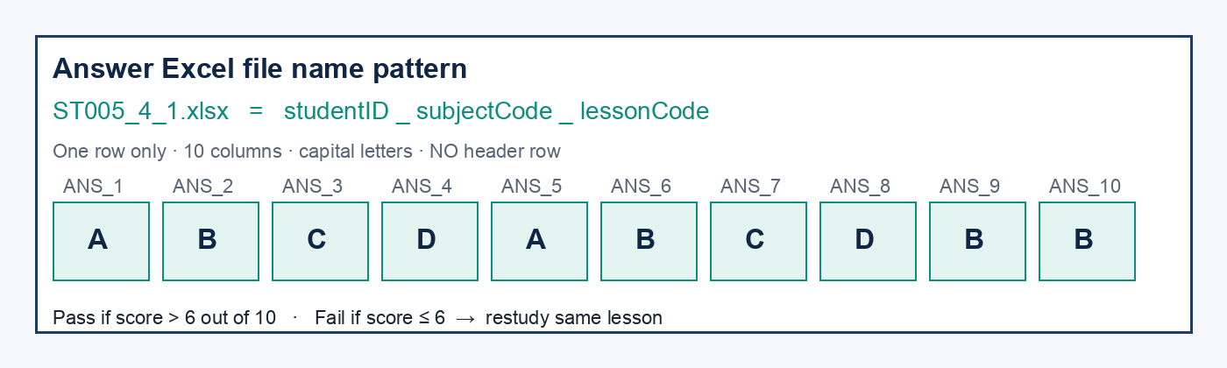
Figure 2 — Sample answer sheet style (ST005_4_1.xlsx).
12. n8n workflow — step detail
Workflow name: ADAPTIVE_14. Import file: AdaptiveEdu.json.
12.A Register path
Step | Node / action | Job
1 | Telegram Trigger | New message arrives
2 | Get row_by_chatid | Look up Students_Data by chat ID
3 | CHECH_WAITNG | If not waiting → register / menu path
4 | Search / check_student_id | Match text like ST005
5 | Update_chat_id | Save Telegram id once
6 | Get Subjects + subject_display | Show list 1–8 + upload tip
7 | Update_waitig_1 | status = waiting for subject or file

12.B Lesson path
Step | Node / action | Job
1 | subject_check | Text equals a SUBJECT_CODE
2 | GET_PROGRESS + Get Lessons Data | Find last passed / next lesson
3 | get_file (Code) | Pick next lesson_code / lesson_name
4 | check_lesson_delivry / If_delivery | Block if unanswered pending lesson
5 | AI Agent + Gemini | Markdown lesson + 10 answers
6 | Format Lesson HTML + HTTP Request (PDFShift) | Build binary PDF (property: pdf)
7 | Send a message (Gmail) | Email PDF attachment + required Excel name
8 | add_lesson + send_file | Append progress row + Telegram notice

12.C Grade path
Step | Node / action | Job
1 | If (document) | Message has a file
2 | file_check | Name must match ST###_sub_les.xlsx
3 | Drive + Extract from File | Upload / download / parse one row
4 | Code compare | Student letters vs ANS_1…ANS_10
5 | Score | grade = correct count / 10
6 | Pass rule | Pass if grade > 6 else Fail
7 | Update row in sheet | Write grade + succed flag
8 | Gmail + Telegram | Result email + restudy tip if Fail

13. Pass / Fail rule
- Pass: grade > 6 out of 10. student_progress.succed = 1. Email says “you are Pass”. Next subject request opens the next lesson_code.
- Fail: grade ≤ 6. succed = 0. Email says “you are Fail”. Telegram asks to restudy and resend answers. Same lesson stays open.
- Unknown student ID → Arabic error: student code incorrect / not registered.
- Unknown subject code → Arabic error: subject code does not exist.
- Wrong Excel name → file refused.
- Pending unanswered lesson → new subject request blocked until the open quiz is submitted.
14. Live evidence — Telegram bot
After a valid ID, the bot lists subjects and offers to send an answers file. Wrong codes prove the Sheets validation is live.
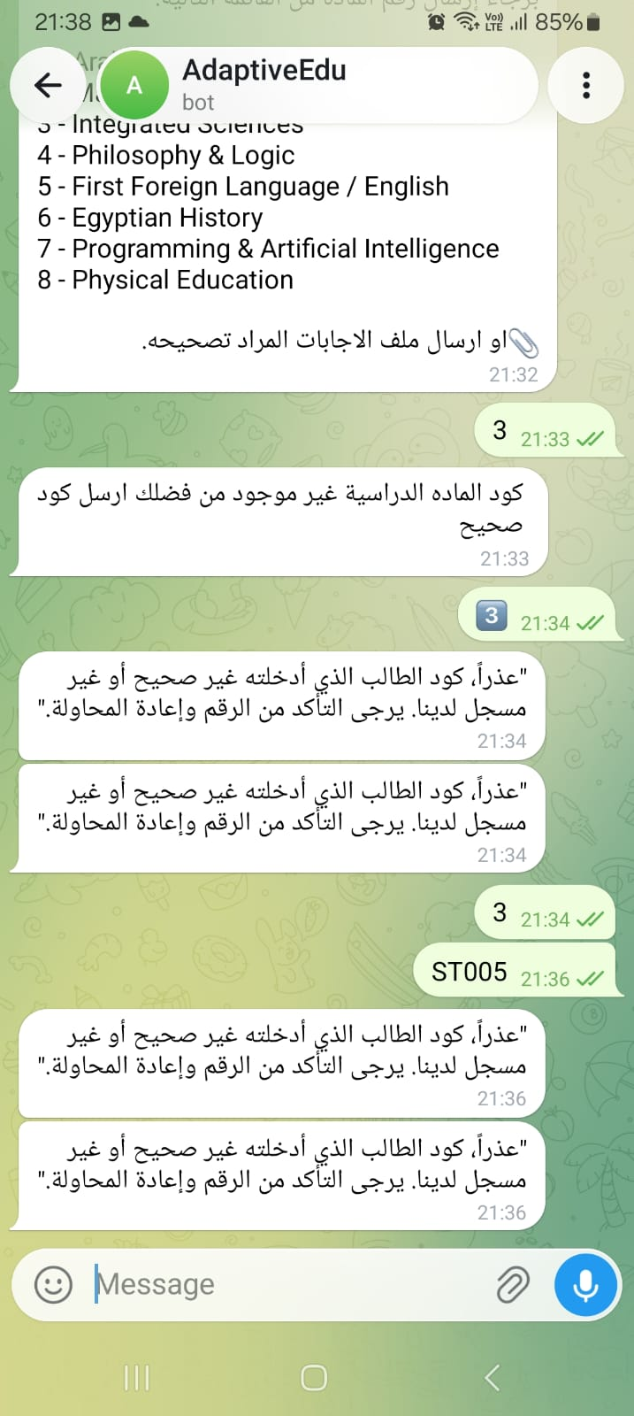
Figure 3 — Bot subject list after registration (partial list visible) + upload tip in Arabic.
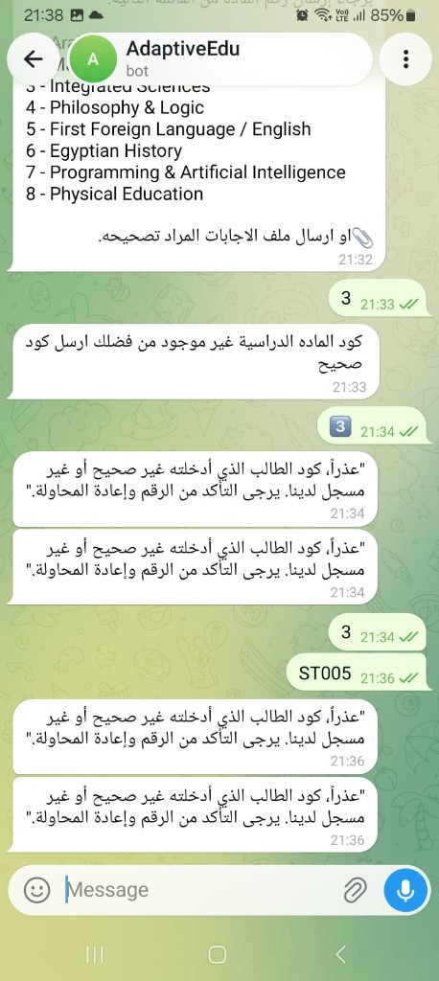
Figure 4 — Validation errors: wrong subject code, then wrong/unknown student ID (duplicate replies possible on retry).
Arabic — wrong subject
كود الماده الدراسيه غير موجود من فضلك ارسل كود صحيح
Arabic — wrong / unknown student ID
عذراً، كود الطالب الذي أدخلته غير صحيح أو غير مسجل لدينا. يرجى التأكد من الرقم وإعادة المحاولة.
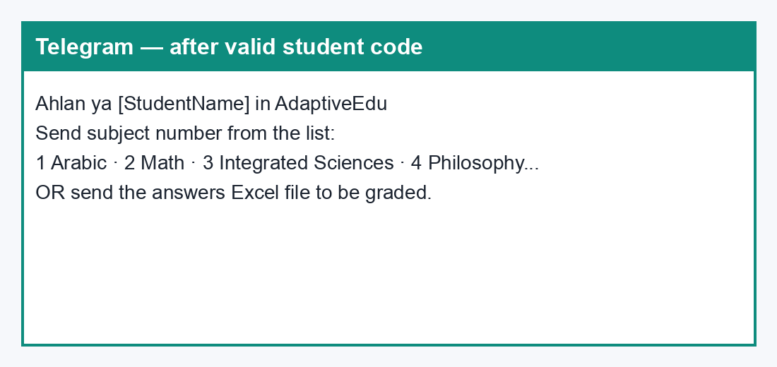
Figure 5 — Welcome / subject-list message card.
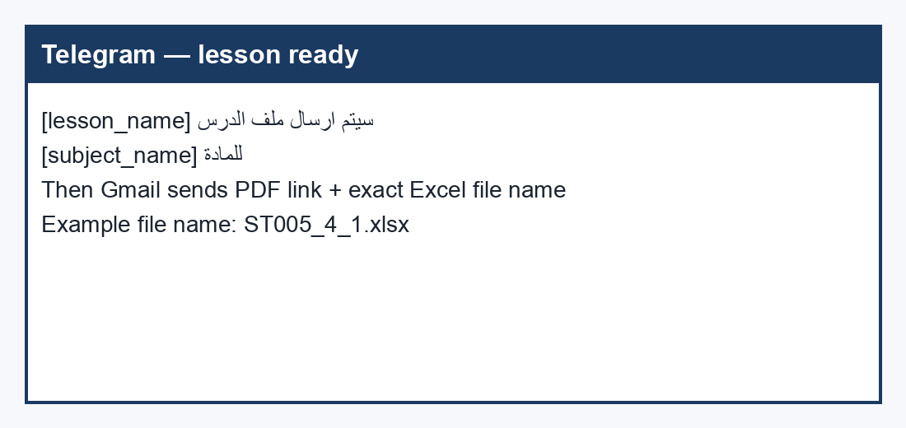
Figure 6 — Telegram notice after a lesson is generated.
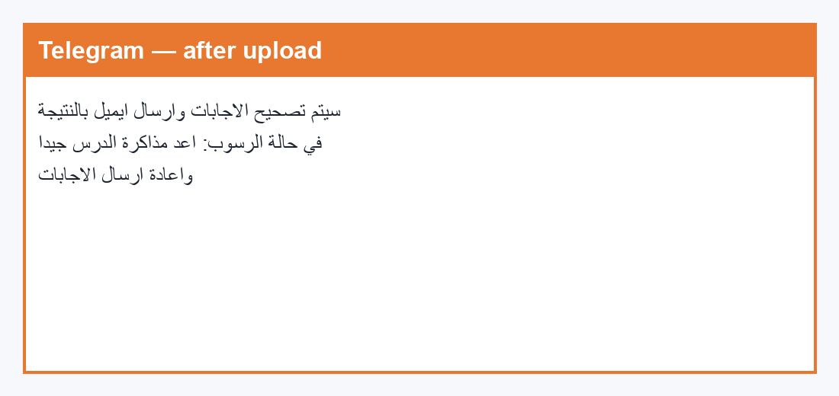
Figure 7 — Telegram confirmation after Excel upload (before / with result email).
15. Live evidence — lesson email
Subject line example: Thinking Principles
Email body (lesson delivery)
Dear Ahmed Hamed,
Kindly find the attached file from AdaptiveEdu system , regarding to
the subject : Philosophy & Logic
the lesson name is :Thinking Principles
please download this file first then
study it well and answer the attached quiz then send the answer in
excel file with the name ST005_4_1.xlsx to correct it otherwise it
will be refused
note that : the answer is with capital letter in one record and 10
columns in the excel sheet without title
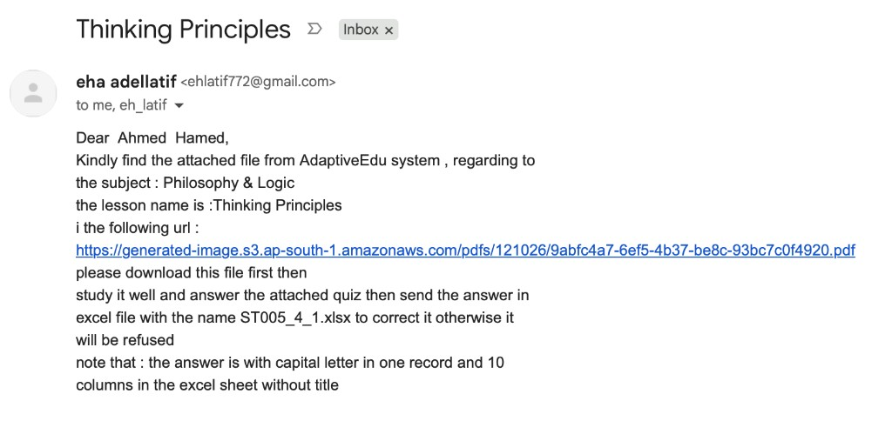
Figure 8 — Lesson delivery email (Philosophy & Logic → Thinking Principles → ST005_4_1.xlsx).
16. Live evidence — Fail result email
Subject line: ST005_4_1.xlsx_result
Email body (Fail — score 2 / 10)
Dear Ahmed Hamed,
your quiz is corected and your result is 2 from 10
and you are Fail
What happens next: student_progress.succed = 0; same lesson stays open; student must restudy and upload again.
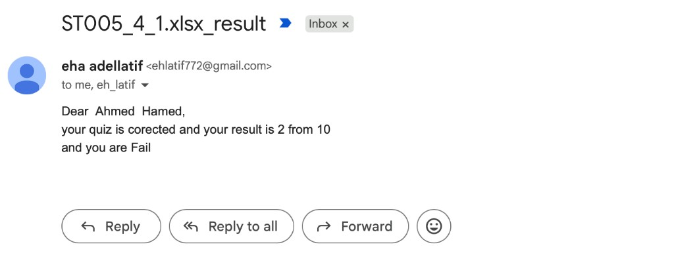
Figure 9 — Fail notification email (2 from 10).
17. Live evidence — Pass result email
Subject line: ST005_4_1.xlsx_result
Email body (Pass — score 9 / 10)
Dear Ahmed Hamed,
your quiz is corected and your result is 9 from 10
and you are Pass
What happens next: student_progress.succed = 1; next subject request can open lesson_code + 1.
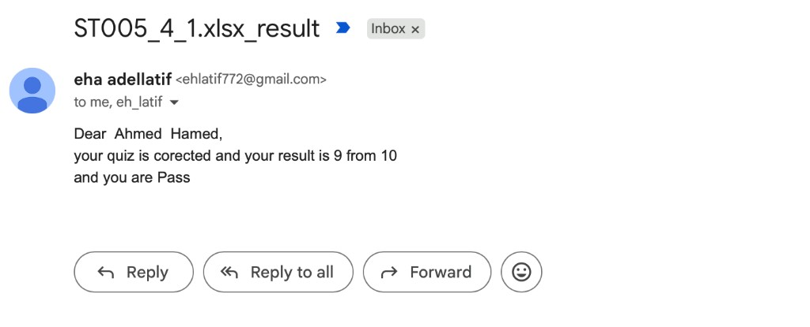
Figure 10 — Pass notification email (9 from 10).
18. How to run (setup)
- Create / use Telegram bot AdaptiveEdubot (BotFather token stays in n8n credentials — never in GitHub).
- In n8n: Import AdaptiveEdu.json (ADAPTIVE_14).
- Attach Telegram credential to Telegram Trigger and all Telegram send nodes.
- Attach Google Sheets credential to every Sheets node; confirm the three sheet IDs and tab names.
- Attach Gmail, Google Drive, Gemini, and set the PDFShift API key on the HTTP Request node.
- Activate the workflow. Send any message once so the Telegram Trigger registers.
- Demo student must exist in Students_Data (example ST005 / Ahmed Hamed) with a valid email.
19. Demo script (~3 minutes live)
Step | Do this | What the panel should see
1 | Telegram: ST005 | Subject list 1–8
2 | Telegram: 4 | Lesson generated notice
3 | Open Gmail | PDF attachment + required name ST005_4_1.xlsx
4 | Show Excel | One row, 10 capital letters, no header
5 | Upload Excel on Telegram | Grading confirmation
6 | Show Pass or Fail email | Then open student_progress row

20. Expected result
- A student can complete one full loop: ID → subject → lesson email with PDF attachment → Excel → Pass/Fail email.
- Pass and Fail both work and are visible in email + student_progress.
- Wrong ID / subject / file name produce clear rejection messages.
- The panel can open the bot, the PPT, the JSON, and the three live sheets.
21. What we built vs what we did not build
In scope (this delivery) | Out of scope
Telegram bot + n8n ADAPTIVE_14 + 3 Sheets | Mobile app, LMS, or school login portal
Gemini-generated lesson PDF + 10 MCQs | Full national exam bank authored by hand
Excel answer upload + Pass if grade > 6 | Voice answers or in-chat letter quizzes as the main path
Gmail lesson PDF attachment + Pass/Fail emails | Automatic teacher dashboard UI
Pending-lesson lock until Pass | Every subject fully authored as long textbooks

22. Deliverables checklist
- Working Telegram bot: https://t.me/AdaptiveEdubot
- n8n JSON: AdaptiveEdu.json (ADAPTIVE_14)
- Three sheets: Students_Data · Lessons_Data · student_progress
- Presentation: AdaptiveEdu_Project_Plan.pptx
- Documentation: AdaptiveEdu_Project_Documentation.docx
- Video demo steps: AdaptiveEdu_Video_demo_steps.docx
- GitHub: https://github.com/ahmedhamedali82/AdaptiveEdu
- Video 2–5 minutes following the demo steps
23. Project files
File | Purpose
README.md | Short landing page
AdaptiveEdu.json | n8n workflow to import (ADAPTIVE_14)
diagrams/demo/ | Bot, email, Excel, and canvas screenshots used in PPT + docs
AdaptiveEdu_Project_Plan.pptx | Panel slides
AdaptiveEdu_Video_demo_steps.docx | Video demo shot list
AdaptiveEdu_Project_Documentation.docx | This full document

24. Risks and simple mitigations
- Telegram Trigger not active: activate the workflow and send any message once.
- Wrong sheet / tab name: n8n fails — keep Students_Data, subject, Lessons_Data, student_progress exact.
- Gemini or PDFShift API key missing: lesson path stops before email.
- Student email empty in Students_Data: Gmail nodes cannot deliver.
- Bot token or API keys on GitHub: never commit secrets; credentials stay in n8n only.
- Duplicate Telegram error messages can appear on rapid retries.
25. Conclusion
AdaptiveEdu is a complete live loop: identify the student, choose a subject, generate the due lesson with AI, check understanding with a scored Excel quiz, then either continue or retry until Pass. Proof for the panel is the bot chat, the lesson email, and the Pass/Fail emails — plus the three Sheets and the n8n canvas.
https://t.me/AdaptiveEdubot
https://github.com/ahmedhamedali82/AdaptiveEdu

