Cairo University  
Faculty of Computers and Artificial Intelligent

**CS251**

**Software Engineering I**

Parking Garage

Software Design

Basel Mohammed, Ahmed Mohammed Hany, Mohammed Ayman, Abd El Rahman Tarek

Section: S23, S24

June 2022

# Team

|  |  |  |  |
| --- | --- | --- | --- |
| **ID** | **Name** | **Email** | **Mobile** |
| 20200110 | Basel Mohammed | 11410120200110@stud.cu.edu.eg | 01113677601 |
| 20200050 | Ahmed Mohammed Hany | 11410120200050@stud.cu.edu.eg | 01154951688 |
| 20200431 | Mohammed Ayman | 11410120200431@stud.cu.edu.eg | 01150371671 |
| 20200315 | Abd El Rahman Tarek | 11410120200315@stud.cu.edu.eg | 01020888206 |

# Document Purpose and Audience

- This document explains how the system can do its operations and how the objects of the system can be modeled

- This document is for my Doctor and my TA

# System Models

## Class diagrams

| **Class ID** | **Class Name** | **Description & Responsibility** |
| --- | --- | --- |
| 1 | VehicleOwner | It is a class that represents the all the Owner data as name and the vehicle data as model year and model name.  This class can set and get the values to its attributes |
| 2 | Vehicle | This class is about all vehicle information as model name, model year and its width and depth |
| 3 | Parking | This class is a boundary class which has a role in performing the parkin and parkout functions |
| 4 | ParkingController | It is the controller class which is an interface so, the classes that implement from ParkingController can perform its functions |
| 5 | FirstCome | It is a class which implements ParkingController, it checks the availability of the slots by using the first slot available from the parking garage slot and marks the arrival time of the vehicle |
| 6 | BestFit | It is a class which implements ParkingController, it checks the availability of the slots by finding the slot with the minimum dimensions to hold the vehicle and marks the arrival time of the vehicle |
| 7 | ParkingOut | It is a class which implements ParkingController, it marks the departure time of the vehicle and calculates the parking fees |
| 8 | GarageOwner | It is the class the has the garage owner information such as his/her name |
| 9 | Task | This class is a boundary class which has a role in performing garage owner tasks |
| 10 | TaskController | It is the controller class which is an interface so, the classes that implement TaskController can perform its functions |
| 11 | EnteringDetails | It is a class which implements TaskController, it has the responsibility of entering all slots information and the parkin method |
| 12 | Displaying_Slots | It is a class which implements TaskController, it has the responsibility of displaying all available slots |
| 13 | Displaying_TotalIncome | It is a class which implements TaskController, it has the responsibility of displaying the garage total income |
| 14 | Displaying_numofVehicles | It is a class which implements TaskController, it has the responsibility of displaying the number of vehicles |
| 15 | garageInfo | It is an entity class which has the information that the garage owner wants such as number of vehicles,  the total income and the garageslots |
| 16 | Slot | It is an entity class which has the slot information such as id , width ,depth and the availability of this slot |

### Important Algorithm

* execute function at FirstCome class: It checks the availability of the slots by using the first slot available from the parking garage slot and marks the arrival time of the vehicle
* execute function at BestFit class : It checks the availability of the slots by finding the slot with the minimum dimensions to hold the vehicle and marks the arrival time of the vehicle
* execute function at ParkingOut class : It marks the departure time of the vehicle and calculates the parking fees
* executeTask function at EnteringDetails class : It has the responsibility of entering all slots information and the parkin method
* executeTask function at Displaying_Slots class : It has the responsibility of displaying all available slots
* executeTask function at Displaying_TotalIncome class : It has the responsibility of displaying the garage total income
* executeTask function at Displaying_numofVehicles class : It has the responsibility of displaying the number of vehicles

## 

## II. Sequence diagrams

Park-in (Config one) – First Come

SeqId: 1

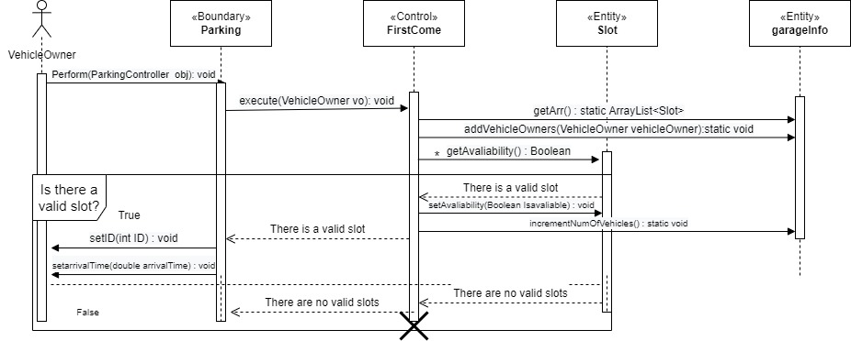

Park-in (Config two) – Best Fit

seqId: 2

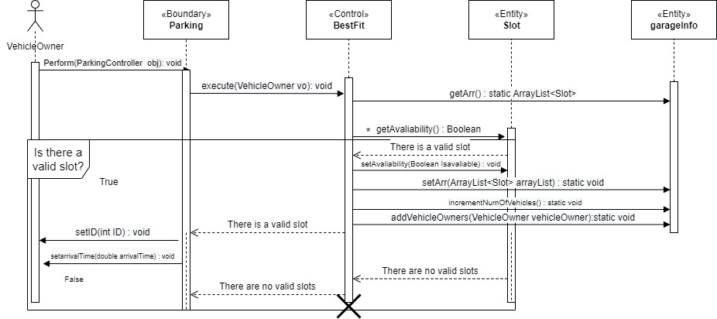

Park-out

seqId: 3

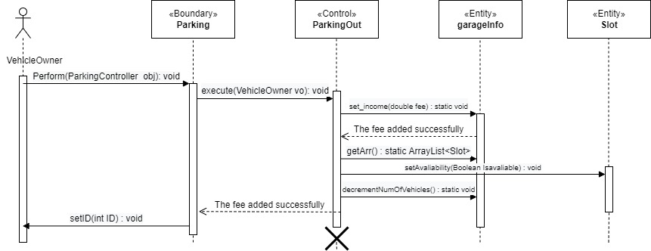

Add Details

seqId: 4

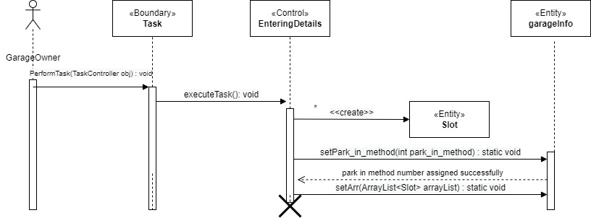

Display available slots

seqId: 5

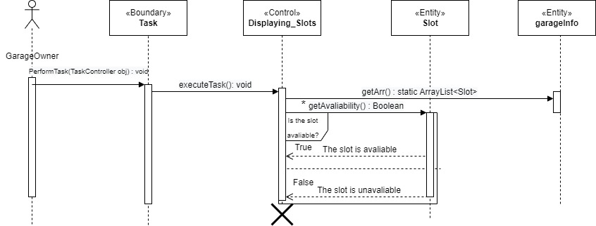

Display total income

seqId: 6

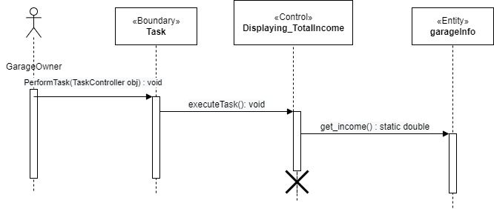

Get number of vehicles

seqId: 7

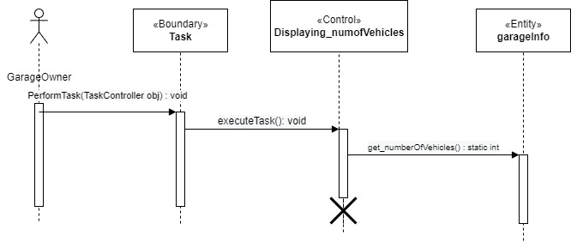

### Class - Sequence Usage Table

| **Class Name** | **Sequence Diagrams** | **Overall used methods** |
| --- | --- | --- |
| VehicleOwner | 1,2,3 | Perform,execute,getArr,  addVehicleOwners, getAvaliability,setAvaliability,  incrementNumOfVehicles,  setID,setarrivalTime,setArr,  decrementNumOfVehicles,  set_income |
| Vehicle | 1,2,3 because it is a part of vehicle owner class | Perform,execute,getArr,  addVehicleOwners, getAvaliability,setAvaliability,  incrementNumOfVehicles,  setID,setarrivalTime,setArr,  decrementNumOfVehicles,  set_income |
| Parking | 1,2,3 | Perform,execute,getArr,  addVehicleOwners, getAvaliability,setAvaliability,  incrementNumOfVehicles,  setID,setarrivalTime,setArr,  decrementNumOfVehicles,  set_income |
| ParkingController | 1,2,3 because, it is an interface so, the classes that implement ParkingController can perform its functions | Perform,execute,getArr,  addVehicleOwners, getAvaliability,setAvaliability,  incrementNumOfVehicles,  setID,setarrivalTime,setArr,  decrementNumOfVehicles,  set_income |
| FirstCome | 1 | Perform,execute,getArr,  addVehicleOwners, getAvaliability,setAvaliability,  incrementNumOfVehicles,  setID,setarrivalTime |
| BestFit | 2 | Perform,execute,getArr,  addVehicleOwners, getAvaliability,setAvaliability,  incrementNumOfVehicles,  setID,setarrivalTime,setArr |
| ParkingOut | 3 | Perform,execute,getArr, setAvaliability, setID, decrementNumOfVehicles,  set_income |
| GarageOwner | 4,5,6,7 | PerformTask,executeTask,  setPark_in_method,setArr,getArr,  getAvaliability,get_income,  get_numberOfVehicles |
| Task | 4,5,6,7 | PerformTask,executeTask,  setPark_in_method,setArr,getArr,  getAvaliability,get_income,  get_numberOfVehicles |
| TaskController | 4,5,6,7 because, it is an interface so, the classes that implement TaskController can perform its functions | PerformTask,executeTask,  setPark_in_method,setArr,getArr,  getAvaliability,get_income,  get_numberOfVehicles |
| EnteringDetails | 4 | PerformTask,executeTask,  setPark_in_method,setArr |
| Displaying_Slots | 5 | PerformTask,executeTask,  getArr,getAvaliability |
| Displaying_TotalIncome | 6 | PerformTask,executeTask, get_income |
| Displaying_numofVehicles | 7 | PerformTask,executeTask, get_numberOfVehicles |
| garageInfo | 1,2,3,4,5,6,7 | Perform,execute,getArr,  addVehicleOwners, getAvaliability,setAvaliability,  incrementNumOfVehicles,  setID,setarrivalTime,setArr,  decrementNumOfVehicles,  set_income, PerformTask,executeTask,  setPark_in_method, get_income,  get_numberOfVehicles |
| Slot | 1,2,3,4,5 | Perform,execute,getArr,  addVehicleOwners, getAvaliability,setAvaliability,  incrementNumOfVehicles,  setID,setarrivalTime,setArr,  decrementNumOfVehicles,  set_income, PerformTask,executeTask,  setPark_in_method |

# 

# 

# Ownership Report

|  |  |
| --- | --- |
| **Item** | **Owners** |
| Document Purpose and Audience, Class diagrams,Important Algorithm, Sequence diagrams,Class - Sequence Usage Table | *Basel Mohamed* |
|  |  |