 | 

AN ADAPTIVE INPUT IMPEDANCE RESHAPING STRATEGY for surface permanent magnet synchronous Motor with tight speed regulation

By
Hossam Mohammed Mahmoud Mohammed Ibrahim

A Thesis Submitted to the
Faculty of Engineering at Cairo University
in Partial Fulfillment of the
Requirements for the Degree of
MASTER OF SCIENCE
in
Electrical Power Engineering

FACULTY OF ENGINEERING, CAIRO UNIVERSITY
GIZA, EGYPT
2025

Abstract
Instability in cascaded systems, particularly in Surface Permanent Magnet Synchronous Motor (SPMSM) systems, is predominantly caused by the low-frequency negative input impedance of Constant Power Loads (CPLs). This instability becomes more pronounced at higher power levels and lower input voltages, highlighting the urgent need for effective and adaptive stabilization mechanisms. This thesis presents a novel power-adaptive par- allel virtual impedance control strategy that ensures system stability across a wide range of power and voltage levels.
The study begins by employing the Middlebrook feedback theorem to derive input impedance and sensitivity functions, laying the groundwork for the proposed control strategy. An adaptive parallel impedance is developed to dynamically reshape the sys- tem’s input impedance, suppressing frequency-specific instabilities while maintaining robust performance. To implement this virtual impedance, a compensation controller transfer function is designed with built-in adaptability to various operating conditions. Addressing the shortcomings of existing controllers—such as their reliance on exces- sive Bode plot analysis and intricate tuning efforts—this work introduces a simplified approach. By leveraging the open-loop characteristics of SPMSM CPLs, the proposed controller eliminates hardware dependencies and parameter sensitivities while ensuring dynamic performance. Stability analysis confirms that the negative components of the input impedance are effectively canceled, guaranteeing stability under all tested power and voltage conditions.
The proposed strategy is validated through real-time experiments on a 150W SPMSM prototype, demonstrating its ability to stabilize the system under varying DC link volt- ages (55V, 48V, 40V) and power levels. Oscillation suppression is achieved within a single resonance cycle, showcasing the controller’s adaptability and effectiveness. Un- like prior approaches, this method offers a universal stabilization mechanism applicable across diverse power and voltage levels, eliminating the need for extensive parameter tuning.
This thesis makes significant contributions by introducing simplified equations that improve practical implementation, ensuring robust stability through real-time adaptabil- ity. The results underscore the potential of this method for broader applications in mo- tor drive systems like capacitorless drives, establishing a solid foundation for reliable operation in diverse conditions. Through innovative theory and rigorous experimental validation, this work sets a new benchmark for SPMSM stabilization strategies.

Introduction

Constant Power Loads (CPLs) pose a significant challenge in Surface Permanent Magnet Synchronous Motor (SPMSM) systems due to their inherent negative impedance charac- teristics, which can lead to system instability under varying operating conditions. This chapter explores the interaction between SPMSMs and CPLs, emphasizing the impor- tance of stabilization techniques to ensure reliable and efficient operation. It provides a comprehensive discussion on SPMSM characteristics, the role and necessity of input filters, CPL-induced instability, and mitigation strategies, including advanced damping methods. Additionally, the chapter reviews various applications of CPLs in inverter and converter systems, highlighting their impact and the solutions developed to address asso- ciated challenges.

  - Overview
Surface Permanent Magnet Synchronous Motors (SPMSMs) have gained widespread use in various applications due to their unique advantages over other types of motors. SPMSMs are characterized by the placement of permanent magnets on the surface of the rotor, resulting in a simpler design and improved efficiency. These motors are particularly popular in applications requiring high efficiency, compact size, and precise control, such as electric vehicles, robotics, aerospace systems, and industrial automation [1, 2].
SPMSM motors are widely employed in several fields:
- Electric Vehicles (EVs): SPMSMs are commonly used in electric and hybrid ve- hicles because of their high efficiency and power density, which are essential for the dynamic requirements of EVs [3]. They are also used in auxiliaries in EVs like fans and pumps.
- Industrial Automation: In manufacturing and process industries, SPMSMs pro- vide accurate position and speed control, which is critical for applications such as conveyor systems, CNC machines, and robotic arms [4].
- Aerospace and Defense: Due to their reliability and performance, SPMSMs are also used in aerospace applications, where efficiency and weight reduction are paramount [5].
- HVAC Systems: Heating, Ventilation, and Air Conditioning (HVAC) systems commonly use SPMSMs due to their high efficiency, compact size, and energy- saving potential. SPMSMs help reduce power consumption in both residential and commercial buildings by providing efficient and reliable performance, particularly in variable-speed applications where energy savings are critical [6].
- Grid Connected Applications: They are widely used in grid-connected applica- tions, particularly in renewable energy systems like wind and hydroelectric power

plants, due to their high efficiency, reliability, and minimal maintenance require- ments. These motors are preferred for their superior torque density, ability to maintain high power factor, and ability to operate efficiently over a wide range of loads[7].
SPMSM motors offer several advantages that make them preferable in many applica- tions:
- High Efficiency: The use of permanent magnets reduces energy losses, resulting in higher efficiency compared to induction motors [1].
- Compact Design: SPMSMs offer a high power-to-weight ratio, allowing for a more compact motor size, which is ideal for space-constrained applications [2].
- Enhanced Torque Density: The configuration of SPMSMs enables high torque output, making them suitable for applications demanding quick acceleration and high starting torque [3].
- Precise Control: These motors provide excellent control over speed and position, which is beneficial for precision-dependent tasks [4].
An inverter is crucial in controlling SPMSMs, allowing precise management of motor speed and torque by converting DC power into AC power with adjustable frequency and amplitude. This flexibility enables SPMSMs to operate efficiently across a range of con- ditions, making them suitable for applications that demand high performance and relia- bility. The inverter regulates the power delivered to the motor, aligning the AC output frequency and phase with the motor’s requirements to maintain optimal speed and torque control[8].

  - Inverter System Drive Model Configurations
Various motor drive configurations could be used based on the intended application. The input filter is always used in input stage. Inverter and input filter circuits can be configured in various ways, with each configuration optimized for specific applications. Figure 1.1 illustrates the different typologies commonly referenced in the literature. Configuration 1, as studied in [9], [10], and [11], is applied to grid-connected applications where the motor is being driver from the grid. Similarly, Configuration 2, also intended for grid- connected applications, is examined in [12], [13], and [14].
The primary distinction between Configurations (a) and (b) lies in the approach to filtering. Configuration (b) relies solely on grid inductance for filtering, whereas Config- uration (a) incorporates both grid inductance and an additional filter inductance. Relying exclusively on grid inductance, as in Configuration (b), can pose challenges, particularly in weak grid scenarios where grid inductance may vary significantly [15]. By includ- ing an extra filter inductance, Configuration (a) offers greater stability and consistency in such conditions.

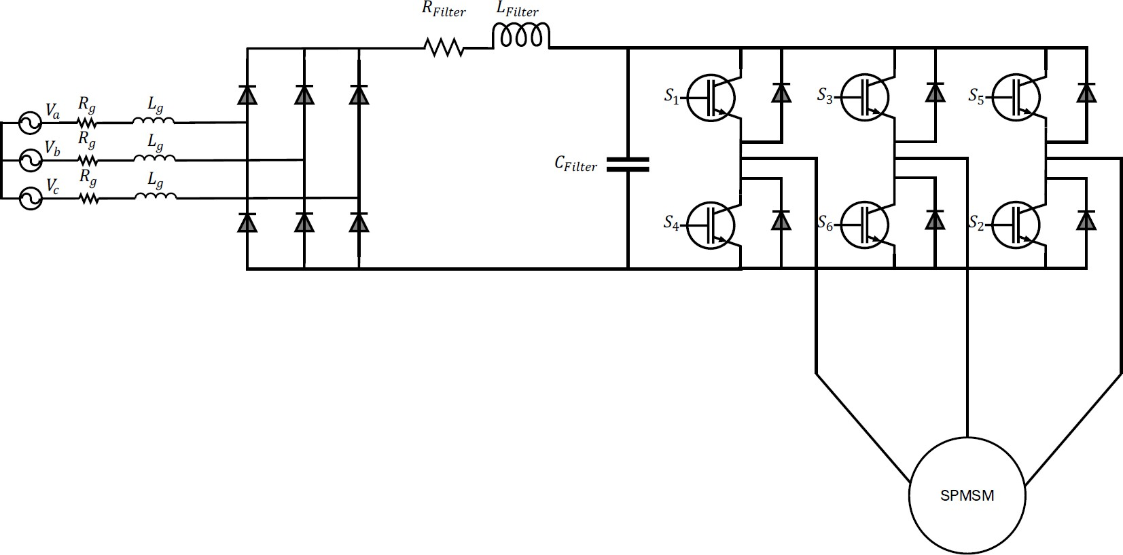
(a)

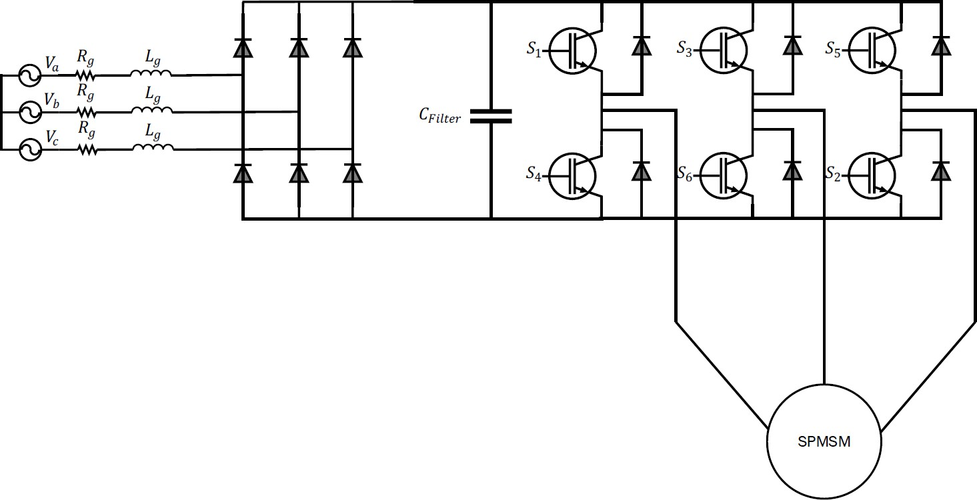
(b)
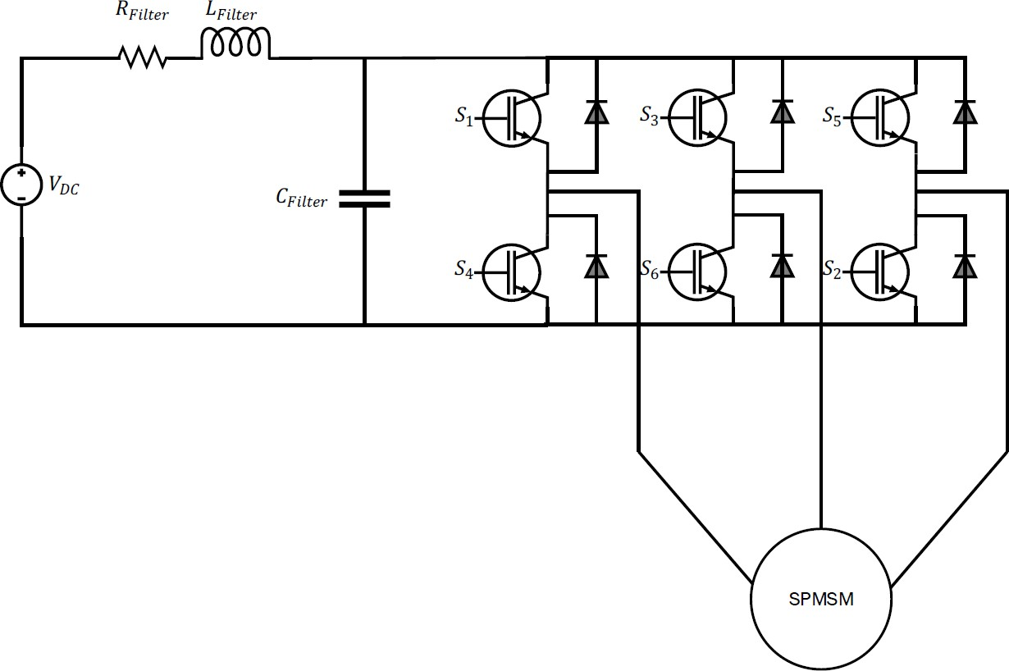
(c)
Figure 2.1: Configurations of drives with input filter (a) Grid-connected drives, includes an additional filter inductance for enhanced stability in weak grid scenarios. (b) Grid-connected drives, relies on grid inductance for filtering.(c) Battery-based drives, such as traction and auxiliary vehicle systems

  - Input Filter
The input filter plays an important role in ensuring compliance with various electromag- netic compatibility (EMC) and power quality standards required for different applica- tions. These standards, which may vary by industry and regional regulations, set limits on permissible electromagnetic interference (EMI) and harmonic distortion levels to min- imize the impact on surrounding electronic devices and power systems. By incorporating an input filter, the inverter system can effectively reduce EMI and harmonics, enabling it to meet stringent standards such as those specified by the IEC, IEEE, or regional bodies. This compliance is essential in applications where reliable, interference-free operation is critical, such as in industrial automation, automotive, and renewable energy sectors. Hence, based on the application, the driver system may vary in configuration as the input filter serves different purposes[16][17][18][19].
The input filter serves several key functions:
- Harmonic Mitigation:the input filter addresses issues related to the switching fre- quency components generated by inverters. As inverters are increasingly utilized to connect DC power sources or variable-frequency AC sources to the grid, their switching behavior introduces harmonics that can disrupt grid stability. Input filters effectively attenuate these components, ensuring that the current injected from the grid meets strict harmonic distortion and power factor requirements and improves overall power quality.[20][21].
- EMI Reduction: In DC-connected applications, where multiple systems share the same DC link, input filters play a crucial role in ensuring system stability, mitigating interference, and maintaining power quality across the interconnected systems. The primary function of the input filter in such scenarios is to reduce high-frequency noise and ripple currents generated by power electronic devices that could otherwise propagate across the shared DC link, such as inverters, con- verters, or other connected subsystems [22].
The LC filter consists of an inductor (L) and a capacitor (C) arranged to create a low- pass filter, allowing only the fundamental frequency to pass through while attenuating higher frequencies generated by the inverter’s switching actions. The selection of the capacitor for the LC filter is crucial for optimal performance. Different types of capacitors can be used, each with its own characteristics. In the hardware prototype, a switching frequency of 20 kHz, combined with the re- quired inductance and a power level below 1 kW, makes ferrite cores favorable for the inductor due to their efficiency and suitability in this operating range. Additionally, fer- rite cores can be extended to higher power levels with appropriate design considerations, further enhancing their applicability.

Filter inductors are generally more reliable and less prone to failure compared to ca- pacitors. Therefore, increasing the inductance value does not typically introduce signif- icant issues or reliability concerns [30]. However, increasing the filter inductance value while reducing the capacitance, particularly in systems where the inverter operates under tight speed regulation (Constant Power Load), may lead to system instability[31].

  - Constant Power Loads
Constant Power Loads (CPLs) are common in various power electronics applications, such as grid-connected inverters, traction inverters, DC-DC converters, and microgrids. CPLs exhibit a negative impedance characteristic, as shown in Figure 2.2. For constant power, a decrease in voltage causes an increase in current to maintain power. In the small-signal sense, this behavior can be modeled as a negative incremental resistance, potentially leading to system instability [32].
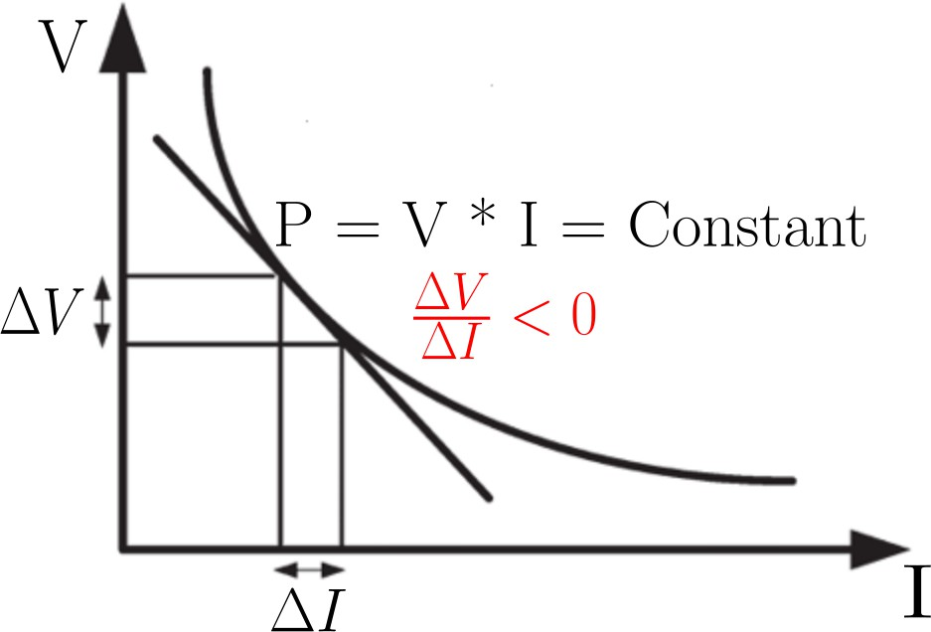

Figure 2.2: Negative Incremental Resistance

DC link damping is essential for preventing instability and reducing oscillations in the DC link voltage, as these issues can adversely affect system performance and longevity. Two primary approaches are commonly employed: passive damping and active damping.

  - Operating Point Discussion
One aspect that remains not explored is the variability in the nominal value of the DC bus voltage. According to [50], the DC-link voltage in power supply systems may vary between 0.85 and 1.15 times its nominal value. In battery-powered vehicles, this variation can be even wider, ranging from 0.7 to 1.2 times the nominal voltage. For grid-connected systems, input AC voltage fluctuations between 0.9 and 1.1 of nominal value have a direct impact on the operating DC-link voltage. In railway applications, power supply systems are expected to tolerate voltage variations up to 30%, without impacting operation, as specified in [51]. Systems powered by photovoltaic (PV) cells, fuel cells, or other dispersed generation sources may experience under-voltage trips as low as 0.75 times the rated voltage, and over-voltage trips up to 1.2 times the rated voltage [52]. Automotive standards, such as [18] and [19], further classify voltage levels according to different power capabilities, highlighting the necessity for stable operation across a wide voltage spectrum .
±

Aim of Work
The primary objective of this thesis is to extend and refine existing approaches to stabilizing Surface Permanent Magnet Synchronous Motors (SPMSM) by developing a novel control strategy that ensures stability across all operating voltages and power levels. This work seeks to address the limitations of previous methods by introducing a robust control mechanism that enhances the system’s stability without the need for extensive graphical analysis techniques such as Bode plots or Nyquist diagrams.
To achieve this goal, we begin by deriving the input impedance and sensitivity functions of the system using the Middlebrook Feedback Theorem. This analytical approach provides clearer insight into the influence of instability terms across varying operating points, facilitating a deeper understanding of how system dynamics shift under different conditions. The stability of the system is then rigorously evaluated using the Middlebrook stability criterion, which enables a more systematic assessment of how stability is affected by different power and voltage levels.
Building upon this foundation, we introduce a virtual parallel impedance that dynamically adapts to variations in power and voltage, effectively compensating for destabilizing factors within the system. This virtual impedance is designed based on the open-loop characteristics of the system, ensuring that it seamlessly integrates with the existing motor control framework. To implement this adaptive mechanism, we formulate a compensation controller transfer function that realizes the virtual impedance. Additionally, a simplified version of the controller is proposed for practical implementation, reducing computational complexity while maintaining effectiveness.
Following the development of the compensation controller, the stability and sensitivity of the system are reassessed using the Middlebrook Feedback Theorem. This reassessment validates that the proposed control strategy maintains system stability across all operating conditions without requiring extensive frequency-domain analysis techniques. The elimination of multiple graphical evaluations at various operating points significantly streamlines the controller's implementation process, making it more efficient and practical for real-world applications.
To validate the effectiveness of the proposed control strategy, we conduct a series of simulations using MATLAB/Simulink. These simulations provide an initial verification of the controller’s performance across different power and voltage conditions. Subsequently, the control scheme is implemented in real-time on a 150W SPMSM prototype system using a Texas Instruments C2000 F28379D microcontroller. Experimental results confirm that the proposed approach successfully stabilizes the system across various operational scenarios, demonstrating its robustness, adaptability, and practicality for real-world applications.
In summary, this thesis presents a novel control methodology that enhances the stability of SPMSM systems through the use of adaptive virtual impedance and a compensation controller. By leveraging analytical stability criteria rather than graphical methods, this approach significantly simplifies controller design and implementation while ensuring robust performance across a wide range of operating conditions.

Review

- Damping Techniques
Passive damping involves the addition of resistive components to the DC link to naturally dissipate oscillations. However, this approach increases system size and costs, while also introducing additional power losses due to the passive elements. Moreover, passive damping lacks the flexibility to adapt to varying power levels and DC voltage conditions. In contrast, active damping employs control techniques to achieve stability. This can be implemented either by integrating and controlling additional hardware circuits specifically designed to counteract oscillations or by making precise adjustments to the system’s control algorithms without the need for extra hardware. Active damping is generally preferred for its dynamic and adaptive nature, and ongoing research continues to highlight its advantages and explore potential improvements.
In the following section, both passive and active damping methods will be reviewed in detail.

    - Passive Damping
Passive stabilization techniques, such as the incorporation of damping circuits, are widely used to counteract negative impedance and stabilize Constant Power Loads (CPLs). How- ever, the addition of these passive elements can sometimes compromise the performance of the designed input filter. Passive damping circuits can be implemented in various con- figurations [33].

    - Active Damping
In recent years, active damping techniques have emerged as powerful and dynamic solutions to mitigate instability issues in multi-converter and motor drive systems. These techniques focus on modifying the input admittance by injecting damping signals into the controller, effectively counteracting negative admittance [34]. The objectives of active damping vary across applications, each designed to address specific challenges. The following subsection explores the implementation of active damping in various applications.

      - Grid connected Inverters
In grid-connected inverters, the interaction between CPLs and the grid can induce oscillations or resonance, especially in systems with high grid impedance [35]. In recent years, grid-connected inverters with reduced DC-link capacitance—often referred to as

capacitor-less drives—have become a significant focus of ongoing research. The reduction in capacitance is a result of using film capacitors instead of electrolytic ones, as film capacitors offer improved reliability and drive lifetime [12].
Grid-connected inverters can operate with either a single-phase or three-phase source, depending on the application and power level. Single-phase grid-connected inverters are typically used in low-power applications, such as home appliances[36][24][37], whereas three-phase inverters are employed in high power industrial drives[12][11].

      - Traction and Auxiliary Inverters
Traction inverters, used in electric vehicles, face challenges due to the dynamic nature of CPLs, which can exacerbate instability during rapid acceleration or deceleration [31].
Figure 1.14 illustrates different active damping strategies. In these approaches, the bus voltage is measured and processed through either a high-pass filter (HPF) or a band- pass filter (BBF), with a compensation gain applied. The resulting action is then fed forward to either Iq or Vq, depending on the configuration.
In Figure 1.14, additions to Iq are marked in blue, while additions to Vq are shown in red. Here, K represents a constant gain. Further details are discussed in the following section.
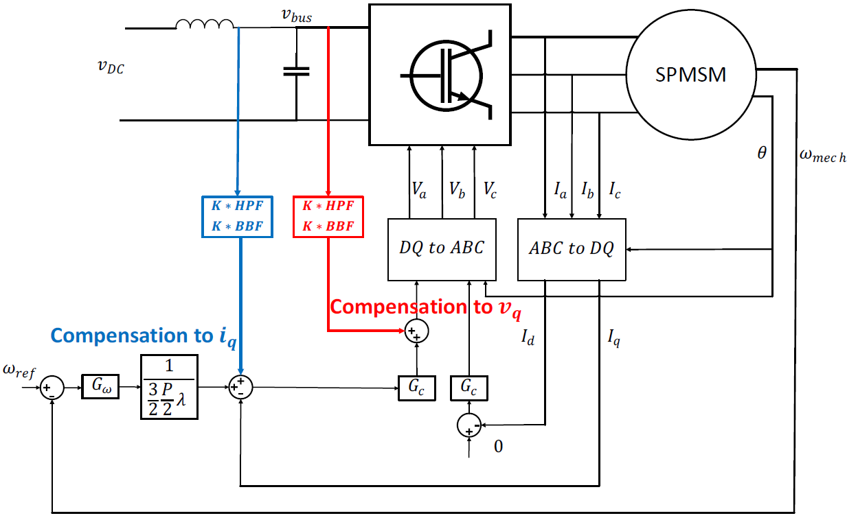
Figure 3.1: Active Damping Methods in Literature

        - Constant Gain Current Reference Compensation
In [9], a stabilization method based on a band-pass filter and gain added to the iqref reference current for a Surface Permanent Magnet Synchronous Motor (SPMSM) was proposed. Various gains were tested and validated using Bode and Nyquist plots based on the Mid- dlebrook stability criteria, and an optimal gain was selected through experimentation. However, this method requires extensive testing and validation using Bode and Nyquist plots, which necessitate precise modeling and accurate knowledge of system parameters under operating conditions. Additionally, the derived equations do not clearly identify the terms responsible for instability, and the controller lacks adaptability to changes in input voltage and power levels.
In [45], a band-pass filter and gain were used to calculate the required damping power, and the total inverter power was derived using a proportional-resonant controller to ensure the necessary inverter power for SPMSM systems. However, this approach does not address how the proposed controller modifies the system’s input admittance and, like the others, lacks the ability to adapt to changes in input voltage and power levels.

        - Constant Gain Current and Voltage Reference Compensation Comparison
Similarly, [31] explored different active damping structures, comparing a method that adds a high-pass filter and gain to the iqref reference current with a band-pass filter and gain added to the vqref voltage reference. A sensitivity function was derived to quan- tify the speed oscillation’s response to DC-link voltage oscillation in SPMSM systems. The addition of the vqref signal was justified based on this sensitivity function. How- ever, as with the previous method, validation relies on Bode and Nyquist plots, requiring accurate modeling and parameter knowledge under operating conditions. The resulting equations are overly complex and fail to highlight the key terms driving instability, and the controller also lacks adaptability to varying input voltages and power levels.
In [8], an active damping approach for Brushless DC (BLDC) motors was introduced, drawing comparisons to [31] but for BLDC motors. The motivation for adding signals to the voltage reference was similarly based on system comparisons. However, this method also lacks adaptability to varying input voltage and power levels.
        - Other Methodologies on Different Systems
In [46], an adaptive approach to stabilize the dc links is proposed based on tunable active damping where it tunes the values of the virtual resistance and capacitance which is realized by hardware current source. This method needs extra hardware circuit to be implemented. In [47], an adaptive stabilization block is used based on curve fitting where the stabilization gain changes with power showing the importance of having gain that changes with power level. However, this was done for different system and it lacks the input voltage adaptability.
In [48] an MPC for grid connected LCL inverters are proposed but the implementation approach is complex.
In [49],[34] an adaptive stabilization for powers and input dc voltage is proposed, a simple structure is used based on analytical modeling. However, it was done for dc dc converters not for SPMSM motor.

Summary
The primary objective of this thesis is to extend and refine existing approaches to stabilizing Surface Permanent Magnet Synchronous Motors (SPMSM) by developing a novel control strategy that ensures stability across all operating voltages and power levels. This work seeks to address the limitations of previous methods by introducing a robust control mechanism that enhances the system’s stability without the need for extensive graphical analysis techniques such as Bode plots or Nyquist diagrams.
To achieve this goal, we begin by deriving the input impedance and sensitivity functions of the system using the Middlebrook Feedback Theorem. This analytical approach provides clearer insight into the influence of instability terms across varying operating points, facilitating a deeper understanding of how system dynamics shift under different conditions. The stability of the system is then rigorously evaluated using the Middlebrook stability criterion, which enables a more systematic assessment of how stability is affected by different power and voltage levels.
Building upon this foundation, we introduce a parallel virtual impedance (ZVIR(s)) that dynamically adapts to variations in power and voltage, effectively compensating for destabilizing factors within the system. This virtual impedance is designed based on the open-loop characteristics of the system, ensuring that it seamlessly integrates with the existing motor control framework without compromising system dynamics. A bandpass filter is incorporated to ensure stability around the oscillation frequency. Two implementation options for ZVIR(s) are proposed: compensation through iq (current reference) and vq (voltage reference). Simplified expressions for these compensations are derived to reduce hardware and parameter dependencies. The selected approach achieves robust stability by canceling the negative impedance component responsible for oscillations. The two proposed solutions are illustrated in Figure 4.1.

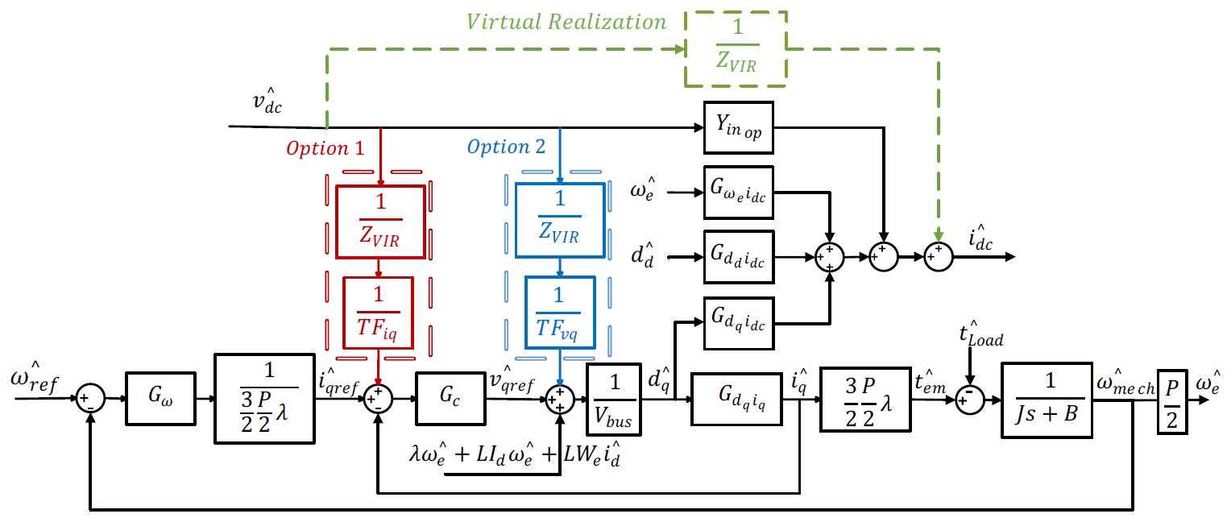
Figure 4.1: Proposed Compensation scheme
Following the development of the compensation controller, the stability and sensitivity of the system are reassessed using the Middlebrook Feedback Theorem. This reassessment validates that the proposed control strategy maintains system stability across all operating conditions without requiring extensive frequency-domain analysis techniques. The elimination of multiple graphical evaluations at various operating points significantly streamlines the controller's implementation process, making it more efficient and practical for real-world applications.
To validate the effectiveness of the proposed control strategy, we conduct a series of simulations using MATLAB/Simulink. These simulations provide an initial verification of the controller’s performance across different power and voltage conditions. Subsequently, the control scheme is implemented in real-time on a 150W SPMSM prototype system using a Texas Instruments C2000 F28379D microcontroller. The experimental setup consists of a three-phase inverter that controls a motor-generator set, managed by the TI C2000 F28379D Microcontroller. Current and voltage measurements are acquired using Hall effect sensors, while position and speed are obtained via an incremental encoder. The generator is loaded by a DC electronic load connected through a three-phase rectifier. To simulate potential DC link variations as discussed before, the power supply is adjusted to three different voltage levels. The system is tested under three configurations: without compensation, with conventional compensation, and with the proposed compensation. A sudden change in speed reference under maximum loading conditions is used as the testing scenario to evaluate dynamic stability and steady-state performance. The drive system setup is illustrated in Figure 4.2.

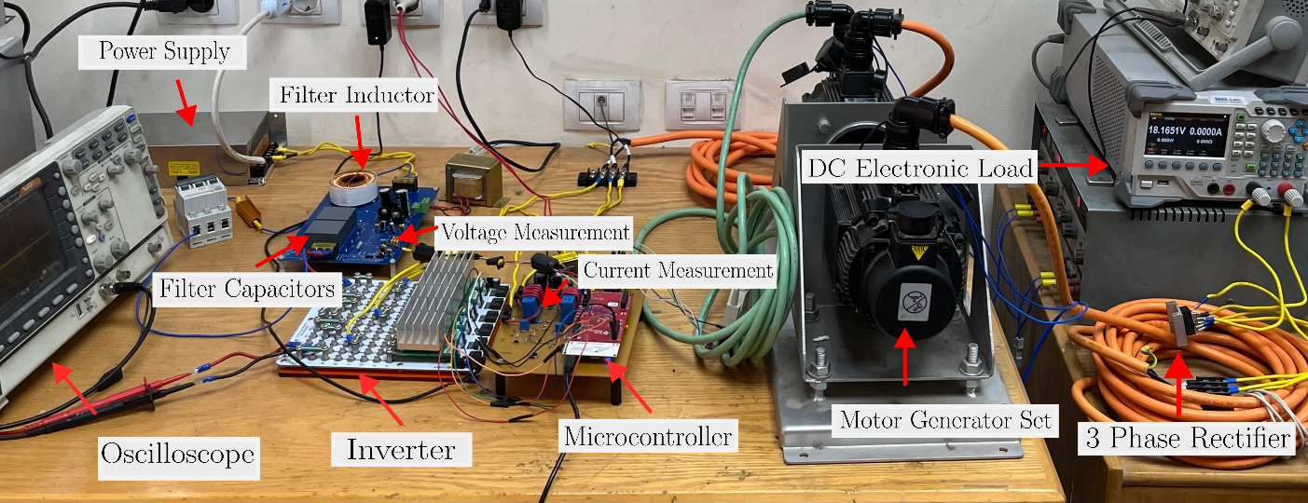
Figure 4.2: Test Setup Description
The complete drive model is simulated under three configurations: without compensation, with conventional compensation, and with the proposed compensation. The testing scenario is considered to evaluate performance under various operating conditions. These tests provide a comprehensive comparison of the three configurations, highlighting their respective performances in both dynamic and steady-state conditions. Simulation results demonstrate the superior performance of the proposed compensation method compared to conventional techniques. Experimental validation further confirms that the novel control approach effectively mitigates instability challenges posed by Constant Power Loads (CPLs) in SPMSM drive systems, ensuring robust and adaptive stability across different voltage and power levels. The findings of this research contribute to the development of more reliable and efficient motor control strategies, with potential applications in industrial automation, electric vehicles, and renewable energy systems.

Conclusions

- Conclusion
This thesis presents a novel control strategy for Surface Permanent Magnet Synchronous Motors (SPMSMs) that addresses key challenges in motor drive systems. By dynamically adapting to power and voltage variations, the proposed approach ensures robust perfor- mance, surpassing limitations in existing methods such as [11] and [31], which rely on static or purely analytical techniques.
The simplified implementation of the compensation controllers reduces hardware re- quirements compared to the complex decoupled damping approaches in [31]. Unlike [34], the proposed controller design is parameter-agnostic, eliminating the need for pre- cise parameter measurements and enhancing its practicality. Furthermore, real-time hard- ware experiments validate the control strategy, demonstrating its effectiveness across a wide range of operating conditions, which is a significant advancement over simulation- only validations seen in works like [11].
The applicability of this method extends specifically to SPMSMs, filling an important gap in motor drive research. Unlike studies focused on DC-DC converters, such as [34], this work targets motor systems, providing a tailored solution for SPMSMs under varying operating conditions. However, it is important to note that the proposed methods may require significant modifications to generalize to other motor types, such as Brushless DC (BLDC) motors.
Despite its strengths, the system demonstrates sensitivity trade-offs at higher power levels, similar to [31]. Stability is maintained, but this comes at the cost of slightly degraded speed dynamics in such conditions.
Overall, this paper introduces an adaptive impedance reshaping method for SPMSMs that balances simplicity, robustness, and practicality. Key contributions of the proposed method include:
1. The design of a second-order band-pass filter with adjustable gain, operating in- dependently of LC and control parameters, ensuring reliability and ease of imple- mentation.
2. Real-time adaptability to power and voltage changes, maintaining stability across diverse operating conditions.
3. Precise tuning of the drive system’s input impedance around the system’s oscilla- tion frequency, minimizing negative impacts on dynamic performance.
4. Versatility in handling a wide range of voltage and power levels.
The proposed strategy has been validated through experimental testing, demonstrat- ing its robustness and applicability. By addressing both theoretical and practical chal- lenges, this paper advances the field of SPMSM motor drive systems, surpassing many

contemporary studies in adaptability and stability. The combination of theoretical in- novation, practical validation, and implementation simplicity positions this work as a significant contribution to motor drive stability research.
- Future Work
The proposed control strategy has demonstrated robust stability and adaptability across varying operating conditions. However, there remain several areas for potential improve- ment and further research. The following points outline possible future directions:
1. Mitigation of Unmodeled Dynamics Frequencies: Investigating advanced meth- ods to address unmodeled dynamics at higher or unpredictable frequencies, en- suring system stability and performance even in the presence of unforeseen reso- nances.
2. Adaptability and Damping for Direct Torque Control (DTC): Extending the proposed strategy to direct torque control systems by incorporating adaptive damp- ing mechanisms. This would enhance stability and performance under dynamic torque demands and varying operating conditions.
3. Replacement of the Band-Pass Filter with Adaptive PLL: Exploring the feasi- bility of replacing the current band-pass filter with an adaptive phase-locked loop (PLL). An adaptive PLL could provide better resonance frequency tracking, partic- ularly under scenarios with wide and rapid resonance frequency changes.
These proposed directions aim to enhance the adaptability, robustness, and versatility of the control strategy, paving the way for broader applications and improved perfor- mance in future motor drive systems.

