Software Design Specification

<Hospital Management System>

Project Code:
Capstone 1

Internal Advisor:
Talha Randawa

External Advisor:

Project Manager:
Dr. Saad Razzaq
Project Team:
Ali Hassan (BCSF18E013)
Muhammad Ahmed Hassan(BCSF18E018)

Submission Date:
10 January 2022

_____________________
Project Manager’s Signature

Document Information

Category | Information
University | UOS
Project | Online Hospital Management System
Document | Software Design Specification
Document Version | 2.0
Identifier
Status | Draft
Author(s) | <Ali Hassan, Muhammad Ahmed Hassan >
Approver(s) | PM
Issue Date | 18th January 2022
Document Location
Distribution | - Advisor  - PM  - Project Office

Definition of Terms, Acronyms and Abbreviations
This section should provide the definitions of all terms, acronyms, and abbreviations required to interpret the terms used in the document properly.

Term | Description
ASP | Active Server Pages
DD | Design Specification
GUI | Graphical user interface
HMS | Hospital Management System

Table of Contents

1. Introduction 4
1.1 Abstract 4
1.2 Background And Justification 4
1.3 Project Methodology 4
1.4 High Level Project Plan 4
1.5 Purpose of Document 4
1.6 Project Overview 4
1.7 Scope 4
2. Overall System Description
2.1 User characteristics 4
2.2 Operating environment 4
2.3 System constraints 4
3. External Interface Requirements
3.1 Hardware Interfaces 5
3.2 Software Interfaces 5
4. Functional Requirements
5. Non-Functional Requirements
5.1 Performance Requirements 5
5.2 Safety Requirements 5
5.3 Security Requirements 5
6. User Documentation 4

7. Design Considerations 5
8. System Architecture 6
9. Design Strategies 10
4.1. Web System Prototype: 10
4.2. Case study: 10
4.3. Responsive system designs: 10
4.4. Maintain consistency: 11
4.5. Use responsive images: 11
4.6. Make the work of your users easy: 11
4.7. Make your website easy to access: 11
4.8. Test: 11
10. Detailed System Design 17
11. References Error: Reference source not found
12. Appendices Error: Reference source not found

Introduction

Abstract
Online doctor appointment is a smart web system, In which provide the login and registration for both patients and doctors. Doctor simply registered by filling the given required details like timings, fee, category, etc. After registration, doctors can easily login by entering username and password. Doctor can view the request of patients for booking if he takes the booking then status will be shown as booking confirmed to patient. Doctor can also able to view the feedback given by patient. Patient can also registered and login for book a doctor on the base of category and problem type of patient with the help of location. The search results will show the list of doctors matching patients necessary
criteria and patient can select one of them and send a request the request will be gone to admin first then admin forward to doctor. If doctor is available he respond the admin then admin update the request and send confirmation message to patient. Patient can view the status from status tab and he
will also get massage by mail about confirmation.

Background and Justification
In the current system the patient needs to visit the doctor for booking first or need to wait and the booking will be done physically by token so to keep everything is always a problem. In this system the doctors patients are carried to website will allow patients to be more flexible they can register and search for the doctors basing on the location the list of doctors will be shown and patient can book by choosing the time slots and the admin will check the booking so everything is computerized and done very easily which will save time .

1.3 Methodology

- Waterfall Model
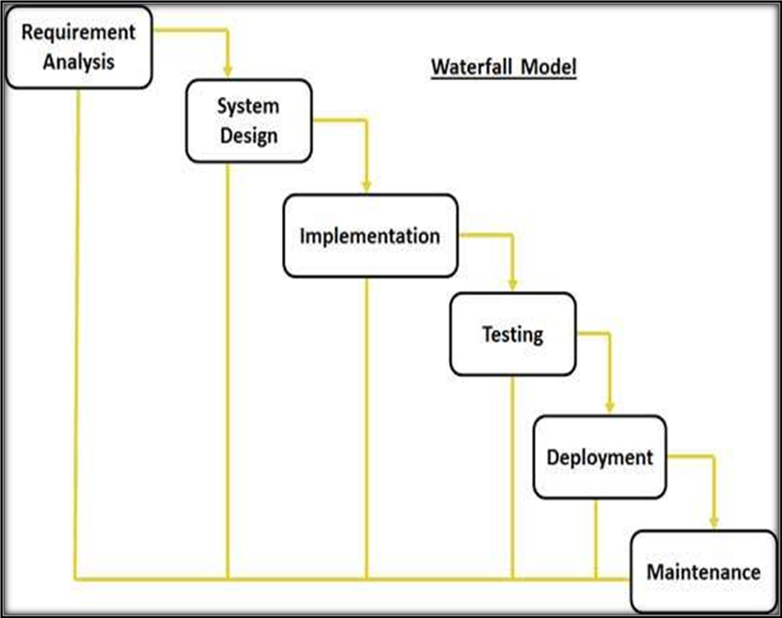
Fig. 3.0 Methodology

- Justification of Methodology
Every software developed is different and requires a suitable SDLC approach to be followed based on the internal and external factors. Some situations where the use of Waterfall model is most appropriate are:
- Requirements are very well documented, clear and fixed.
- Product definition is stable.
- Technology is understood and is not dynamic.
- The project is short.
- Simple and easy to understand and use
- Easy to manage due to the rigidity of the model . each phase has specific deliverables and a review process.
- Phases are processed and completed one at a time.
- Easy to arrange tasks.
- Description of Methodology
The sequential phases in Waterfall model are:
- Requirement Gathering and analysis: All possible requirements of the system to be developed are captured in this phase and documented in a requirement specification doc.
- System Design: The requirement specifications from first phase are studied in this phase and system design is prepared. System Design helps in specifying hardware and system requirements and also helps in defining overall system architecture.
- Implementation: With inputs from system design, the system is first developed in small programs called units, which are integrated in the next phase. Each unit is developed and tested for its functionality which is referred to as Unit Testing.
- Integration and Testing: All the units developed in the implementation phase are integrated into a system after testing of each unit. Post integration the entire system is tested for any faults and failures.
- Deployment of system: Once the functional and nonfunctional testing is done, the product is deployed in the customer environment or released into the market.
- Maintenance: There are some issues which come up in the client environment. To fix those issues patches are released. Also to enhance the product some better versions are released. Maintenance is done to deliver these changes in the customer environment.
All these phases are cascaded to each other in which progress is seen as flowing steadily downwards (like a waterfall) through the phases. The next phase is started only after the defined set of goals are achieved for previous phase and it is signed off, so the name "Waterfall Model". In this model phases do not overlap.
- Modules
The application has following modules
- Admin
- Doctor
- Patient
Admin
Admin can login with username and password in the admin section. He can able to view basic functionalities of admin. Admin can able to view registered doctors and patients. He can also manage the request system from both doctors and patients.
Doctor
Doctor need to be registered by giving the required details like skill, timing, fees etc. After registration he need to login and into the home screen and can view the some functionalities according to him. He can also view the patient request sending by admin and he can accept. He can view the feedback given by patients.
Patient
The patient needs both to be registered and login after logging on he can able to search for the doctor by giving the location and the problem. Base on the doctor confirmation the admin will check the appointment booking request and will send to mail that the booking for appointment is confirmed. He can also view in the status Tab and also give feedback on the base of doctor performance.

1.4 High level Project Plan
.
Activity | Oct-2021 | Nov-2021 | Dec-2021 | Jan-2022 | Feb-2022 | March-2022 | April-2022 | May-2022
Collection of Literature
Study of Literature
Analysis of proposed Scheme
Preparation of schemes/Model
Implementation of Schemes/Model
Analysis
Result Formulation
Final Write-up & FYP Report Submission

  - Purpose of Document
In this document, we have explained the design with the help of diagrams and graphs. To provide the understanding that how the system will be designed or expected to be designed. The purpose of this document to get information about the design of the whole project, which strategies for better work, and also strategies for the future to add some functionalities. We study the existing system and get an overview to make the best strategies for our design.

  - Project Overview
It is an online hospital management system whose purpose is to give a patient a convenient method to fix his/her appointment from this web and much more. In this web system, doctors are registered, log-in, the administration will log-in, a database section to store their history, laboratory, doctor-patient portal, online scheduling, feedback, and fees section are also included.
The patient doesn’t need to make an effort for his/her appointment like go to a hospital and check for doctor either doctor are available or not. To confirm his/her appointment and came again on the due date. it makes a lot of affording for a patient. we give a web system which less the affords like patient visits our website and checks the doctor for an appointment and fix the appointment available.
It manages all systems of the hospital like ward information and staff duty scheduling .it also manages the accounting system of the hospital patient can pay the fee of the appointment.
An important benefit of the system is data of the patient, doctor, and hospital are well protected.
It helps as a decision support system for hospital control for developing broad health care policies. Hospital Management System is easy to use and get rid of errors caused by handwriting. The latest technology gives an ideal performance to pull up information from anchor or cloud servers. It glooms the overall health care event in a healthcare facility. It improves the communication and relation of doctors with their patients. It lowers the expenses of an organization because of less paperwork, better safety, and reduced replication of testing.

  - Scope
Due to massive growth in population health system also need improvements in the online appointment system.
- The HMS module contains all doctor’s available time slots of appointments.
- The system will involve admin, doctor, patient, user, and other people (registered).
- The doctor would check the patient's detail and give the proper time, while management can see all the records.
- The doctor will create his/her account, register, login, edit, update, make appointments, view appointments also check his/her profile detail, and logout.
- The patient will log-in, booked an appointment, view an appointment, search doctor by his/her ability, and also saw the doctor specification registered on the system.
- User can see doctor abilities or specifications and also view appointment time of them.
- Management would see all the detail of the doctor and patient, the time date of appointment, and much more.
- The online system will not notify the patient or doctor that, today is his/her appointment, the doctor and the patient have to check his/her appointment manually.
- The doctor will identify the patient’s problem and give medication and management will view the daily report.
- The doctor will also give a prescription report to the patient.
- Laboratory in which the patient gave tests for their illness etc.
- It is monitors the patient bill, while it is operation cost, meditation cost, pharmacy bills, and lab test bill.
- It also consists of payment modules.
- Feedback will be conducted by the user.
- Overall System Description
Three main module in this system, Admin can login username and password and see the basic functionalities of admin . Admin can add Doctor and User, view feedback ,user requests etc.Doctor register by necessary details like fee , timings etc .Able to view feedback of users and appointments etc. User after login can search and request for appointment.
  - User characteristics
Provide the various user classes that you anticipate will use this system. Distinguish the most important user classes for this system from the less critical ones.

  - Operating environment
This portal will work on each cell phone and personal computer that is connected to the internet.
We can access this portal through any web browser. The only thing we need is just to have a
good internet connection to benefit from this portal. There is no need to install special applications
or software to portal use this.
  - System constraints
Identify any constraints or limitations on the system. Constraints may include the following:
- Software constraints
- Hardware constraints
- Cultural constraints (includes language etc.)
- Legal constraints
- Environmental constraints (e.g., the environment where the software will be installed, It could be a noisy environment, which may require that there is no sound event in the project).
- User constraints (e.g., the project is developed for children, so it may be required that the project has more graphic controls rather than textual controls).
- Off the shelf components that might be used in the project may have their constraints that are consequently transferred to the project.
3 External Interface Requirements
This section is intended to specify any requirements that ensure that the new system will connect
properly to external components. Place a context diagram showing the external interfaces at a
high level of abstraction.
3.1 Hardware Interfaces
There is no particular hardware device that we need to buy for this project. We can use our
Smart phones or personal computers to benefit from the portal.
  - Software Interfaces
The system will give location of nearby hospitals, clinics , medical stores. To manage these things we will use the Django module known as Geo Django. To store data records, classes, schedule events and other records we will use SQ Lite database.
For building user interface (UI), we will use HTML, CSS, JavaScript and J Query. To make it
responsive or mobile friendly we will use the open source framework of CSS known as Bootstrap.
To manage backend activities we will use python based framework Django. Also all other
activities related to backend we will use PHP and different modules of PHP. To send
important notifications we will use Simple Mail Transfer Protocol ().SMTP
4.Functional Requirements

Overview of system: User can get basic over view of our services without signup or logging in.
- User Registration: User can register on website to make appointment and for getting information related to hospital management system.
- User login: can login from his/her account and get information about related activities
- Locations: User will be able to select hospital that is suitable according to his/her location.
- Book his/her Time Slot: User can book available time slot through portal confirmation via admin and doctor.
- Emails: Admin will be able to share important notifications related to hospital or appointment
through e-mails using SMTP.
- Payment: User can pay through his/her bank account, easy paisa and jazz cash.
- Contact US: User can contact hospital management or concern doctor form and through calls and SMS.
- Feedback: user can give feedback about concern doctors and related to our facilities and doctor can also view the feedbacks of patients.
- Doctor login: Doctor can login from his/her account and get information about related activities.
- Services: Provides different services like Laboratory, Feedback , Payment module, medication, patient report, monitors the patient bill , operation cost ,pharmacy bills etc
- Admin : admin is a person whose responsibility is to maintain the database that contains update and every data regarding all the User and Doctor. Admin of the system can list new requests , time schedules and other notifications and can also remove, delete, and each
records.
.
5.Non-functional Requirements
  - Performance Requirements
The performance of the system depends on the device of the user and average response time
varies with internet speed or connection. The system will be able to maintain thousands of users
at the same time. All the information related to the user will be kept private. System Swill provide
precise information; everything listed on the portal will be managed by the Hospital.
  - Safety Requirements
The system can be affected if we use unethical or third party extensions. So, it is better to prevent
such extensions that can be harmful and can get the user's data without his/her permission. Also,
this web will be secure through SSL certificate

  - Security Requirements
Doctor Appointment system requires only such information that is related to booking activities. Also, all the personal information related to the user will be kept private and can only be seen by the user himself/herself. All other personal information related to contact like personal contact number and email will be kept private.

6. User Documentation
. Doctor appointment s user interface is user friendly and one can easily understand and use this.
Whoever, later if we update any module that is not easily understandable by the user. We can
help users by using tutorials. Tutorials will also be provided on the same portal. Sometimes it’s difficult for the user at the certain stages of usage to overcome different type of issues. To overcome those issues contact us form will displayed on the website for the users. User can communicate with admin 24/7.
7. Design Considerations
7.1 Assumptions and Dependencies
- Doctor can cancel an appointment before 24 hours and the patient too.
- Patient medical history can be shared with the consultant doctor and the doctor can check it any time.
- Hospital is protected by insurance or any other policies which help in an emergency.
- All the Staff is stricter to given rules while using the system which avoids system errors.
- All HMS users have some basic as well as some standard computer skill.
- Admin has authorized to change or update data.
- HMS design should be simple and easy to use.
- The HMS data is not case sensitive
- All users have to remember their id and password to log in and further detail.

  - Risks and Volatile Areas
- How much confidence you are about your project?
- Which framework used?
- Expert on this technology?
- How much expert in your skills?
- Wrong budget estimation.
- Security issues
We have study our existing system and make our project more secure and easy to use
. We have study our system reliable and flexible to make changing according to
feedback .We have make different strategies to make project better and avoid from
risks of new technology and systems.
We will have to update our project according to new technology and also have backup
plan to avoid new system risks.

System Architecture
In the project, different modules work together for the overall function of the system. First of all, a doctor registered in the system then he/she added to doctor module and information stored in the management system and same as the patient has its module and information stored in management system all information stored in the database of our system. The laboratory has its module. When the doctor registered then he/she have to login first for any activity, after login he/she can see the appointment which he/she has and also confirm the appointments and it straightly goes to the database.
Now, patient login and see appointments only patient have no further concern in the system he/she has no further access of anything except his information which he/she gave to the system for his appointment, etc. The administration has all the access to information or anything in the system especially, a compliant section for further action. So, the patient's login gives his information including illness information then the administration takes the information of that patient to the appointment section and then a doctor visits the appointment section and books the appointment of an appropriate patient.
The date given to the patient in the patient module by administration and record will be maintained in the database. The complain section contains complaints and issues of anyone and would be solved by the administration. The visitors only visit and saw the information which is shown to everyone by the system and no further access to the visitors. The laboratory contains tests of patients only and records will maintain in the database.

  - System Level Architecture
All modules in the system work as a body. Like, doctor module link with a patient if the patient needs a doctor then a doctor will be needed and also if the doctor is available then patient concern needed and likewise, laboratory if any patient requires test then laboratory work starts. If the doctor or patient give is information for registration the database start its work so, all modules or component are work as a body.
If any user accessing restricted areas like patient want to book an appointment or patient want to see complaint areas something like that then an error message will be shown to him/her.

- UML DIAGRAM
UML is an acronym that stands for Unified Modeling Language. Simply put, UML is a modern approach to modeling and documenting software. In fact, it’s one of the most popular business process modeling techniques.

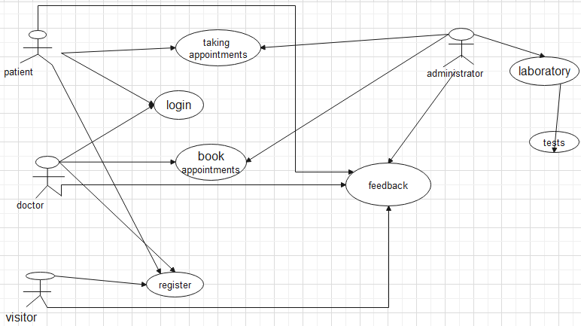

- COMPONENT DIAGRAM
- Component diagrams are essentially class diagrams that focus on a system's components that often used to model the static implementation view of a system.
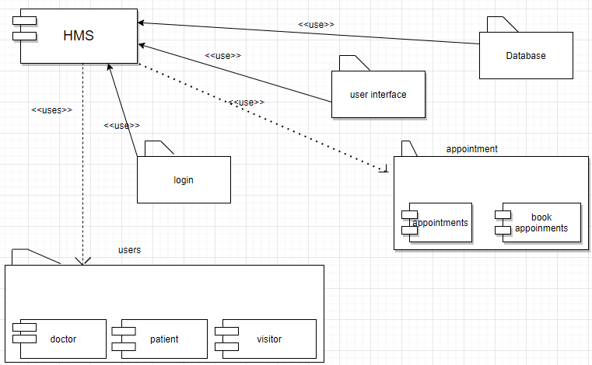

  - Sub-System / Component / Module Level Architecture
Different modules in the system depending on each other.
- Doctor module
Doctor register then login and book appointments gives feedback.
- Patient module
Patient register then login and give his/her information for appointments and confirm his/her appointments.
- Laboratory module
Test or patients and their records.
- Visitor module
Visit the website and register if he/she wants.
- Feedback module
Anyone has the right to gives feedback.
- Administration module
Right of everything in the system. Like watch appointments, laboratory tests, watch feedbacks or take actions, etc.
- Database module
Manage the record of data in the system.

- Appointment module
Appointments of patients and schedule of those appointments.
- Login module
Every user needs a login for better security.

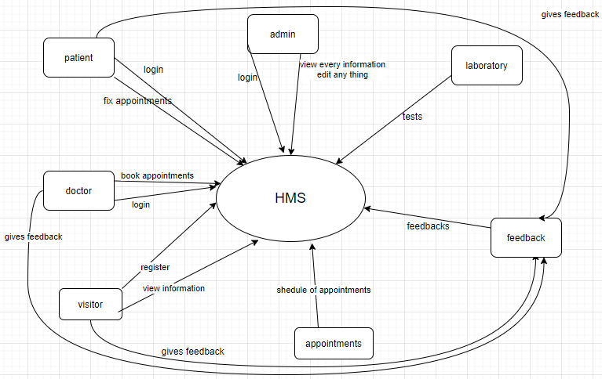

  - Sub-Component / Sub-Module Level Architecture
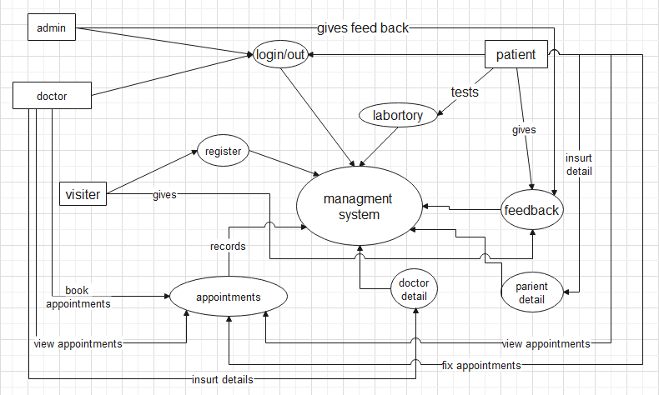

9.Design Strategies
We have so many strategies to design our web system. We explain some of the main strategies that make our project effective.
9.1 Web System Prototype:
The website prototype is like the demo version of the original site. These are must be used to collect feedback from the user before the project development is completed.
We will use a web system prototype in our hospital management system (in our project) firstly we make a demo version of our website to get feedback from the audience for changes in design, functionality errors, and adding and enhancing our options.

Case study:
We must interview the existing system audience about their errors and functionality we will make case study than analyze and make a report to avoid these type of errors and add functionalities what the audience needed.

Responsive system designs:
Nowadays not everyone has a computer or laptop so we will design a responsive system that works on both mobile and computer. We will ensure that our content of the system is easy for both computer and mobile users.
All the patients can check their details on both computer and mobile.

Maintain consistency:
We will ensure that every element we use on our system must be consistent. Including color, design, and font (style size) that we decided to use all must be consistent. Every page and font combination will be the same as the first page.
Appointment, login, information, and doctor’s information page all designing are the same.

Use responsive images:
We have a lot of information that is stored in our system some of the information in image forms like a doctor’s image on the doctor bio page so we use responsive images, especially for the mobile user because they use a small screen.

Make the work of your users easy:
We make users' work easy like easy to get an appointment of doctor and easy to check doctors schedule and fields.

Make your website easy to access:
We have so many websites about the hospital on the internet but they are no accessible masses so we make our hospital management system accessible for both new and old patients and users.

Test:
Our last strategy is web testing every web should be testing before launching on the internet. This is the only way we check our web is work properly or everything is perfect according to users.

.Detailed System Design

SEQUENCE DIAGRAM

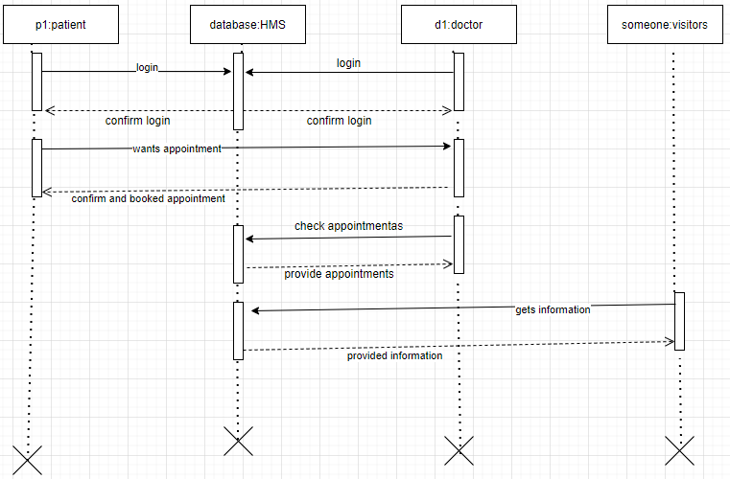

ER MODEL
ER model represent the relationship of entities with system intended objects and their behavior upon specific tasks.

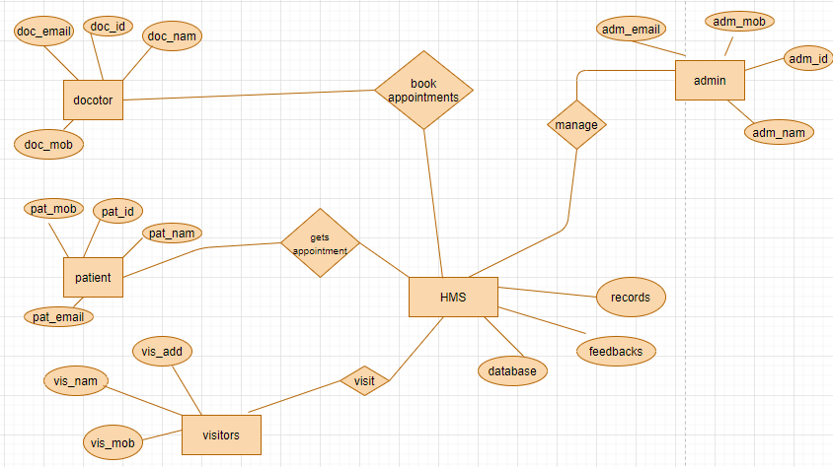

CLASS DIAGRAM
Class diagram in the Unified Modeling Language (UML) is a type of static structure diagram that describes the structure of a system by showing the system's classes, their attributes, operations and the relationships among objects

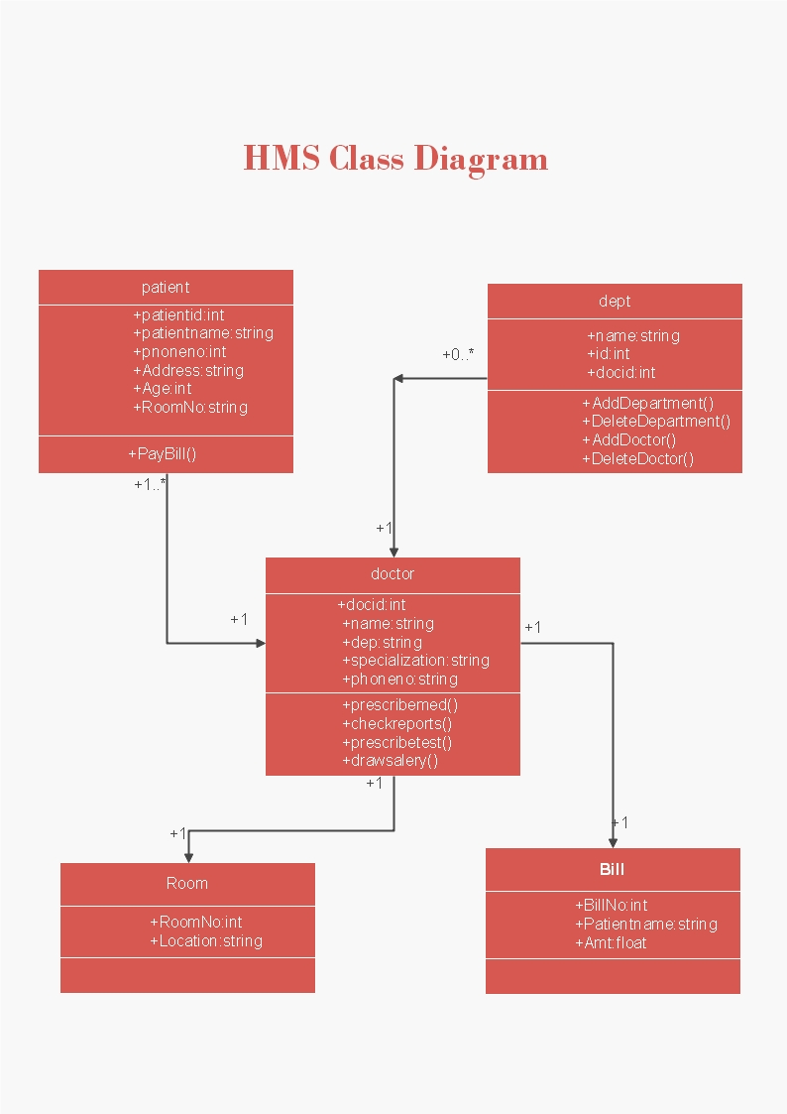

STATE TRANSITION DIAGRAM
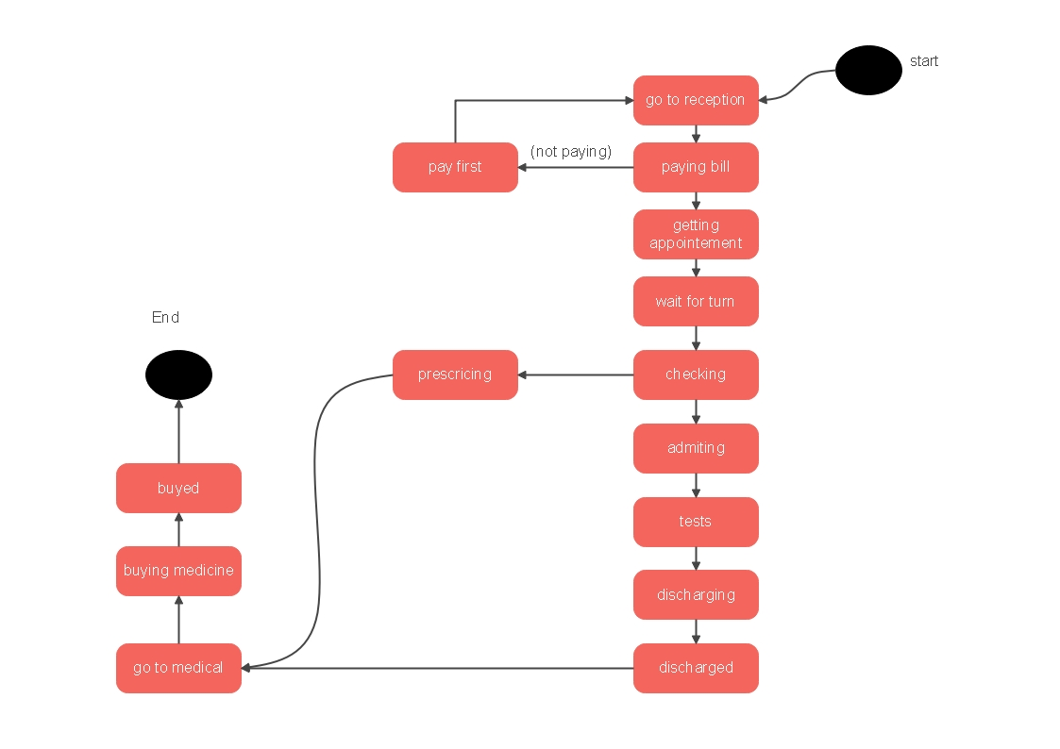

- EXISTING SYSTEM GUI
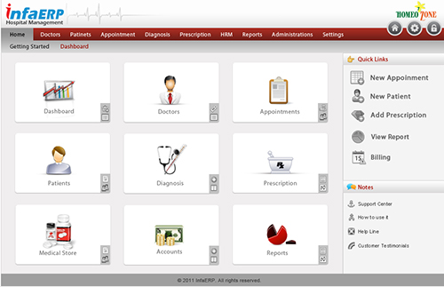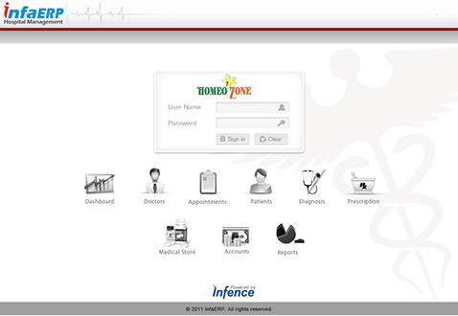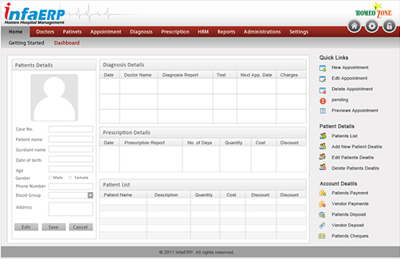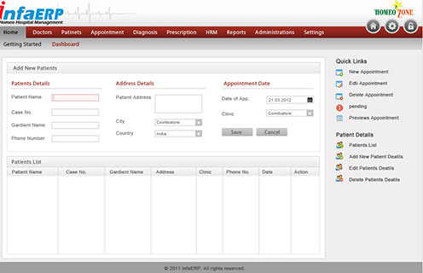

References
This section should provide a complete list of all documents referenced at specific point in time. Each document should be identified by title, report number (if applicable), date, and publishing organization. Specify the sources from which the references can be obtained (This section is like the bibliography in a published book).

Ref. No. | Document Title | Date of Release/ Publication | Document Source
pp.70-130l | Project Proposal | Oct 20, 2003 | <Give the path of your Project repository/Folder>
PGBH01-2003-FS | Functional Specification | Oct 20, 2003 | <Give the path of your Project repository/Folder>
pp. 625-630 | Application of Smart Agents in Hospital Appointment Planning System | 4, August 2012 | Arthur Hylton III and Suresh Sankaran arayanan Application of Smart Agents in Hospital Appointment Planning System, International Journal of Computer Model and Engineering, Vol. 4, August 2012, pp. 625-630.
pp.1-5 | Health Monitoring and Prognosis System using Wearable Sensors”, IEEE International Conference on Advances in Engineering & Technology Research | 2014 | Jagannath Aghav, Smita Sonawane, and Himanshu Bhambhlani “Health Track: Health Monitoring and Prognosis System using Wearable Sensors”, IEEE International Conference on Advances in Engineering & Technology Research 2014, pp. 1-5.

12.Appendices
Appendix A: Glossary
1. 7Zip
a. Highly commended and functional, multi-platform, FOSS compression file format standard
b. Uses GNU LGPL License
c: case http://www.7-zip.org/ for extra information
2. Baud rate
a. Rate of transfer of data through the internet/network
b. Measures in bit per second (bps)
3. Bit
a. Binary Digit
b. one zero (0) or one (1) \
4. Classic style
a. Refers to the type of GUI style in the RIS software that is like Microsoft Office XP,
b. With static menu bars and dialog boxes.
5. Database
a. Big memory address block which covers a large set of data
b. With subsets and grounds that can search for by filter, read, and writing.
6. HMS
a. Hospital Management System (HMS).
7. Ribbon
a. Refers to the Windows GUI element that animatedly changes the items in a menu bar
8. Intranet
a. A network that is local to a geographical location or specific institution’s network
9. SRS
a. Software Requirements Statement.
b. Statement clarifying what a software project is imaginary to be engineered to do
c. Specifies the limits, constraints, and big-picture, non-concrete plan of the software engineering
10. TLS
a. Transport Layer Security (TLS).
b. High-encryption security protocol for internet connection

