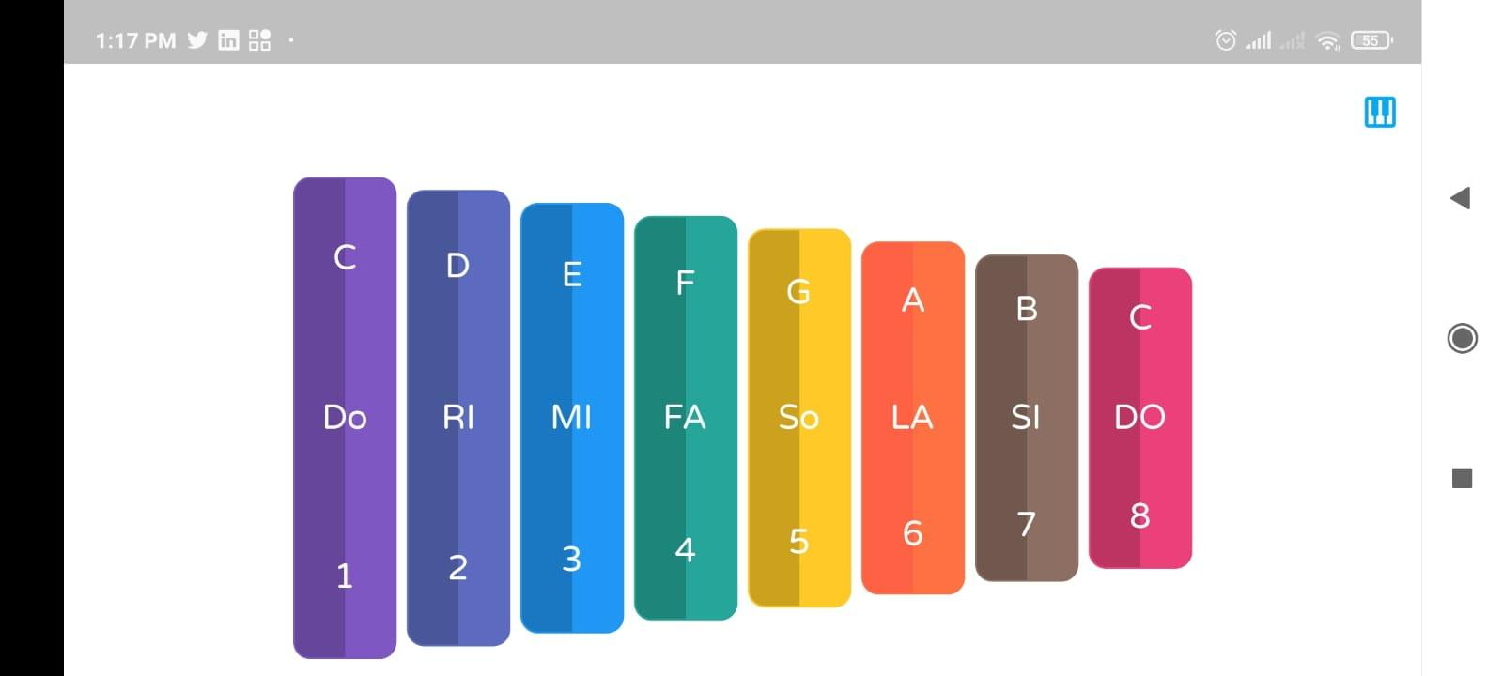

Design this ui using :  
Container, ,Row , column,SizedBox…..etc

Make sure the design in safe area

Make the ui in center as you can using row and column properties

Make sure avoiding overflow

Use linear gradient to make like these colors