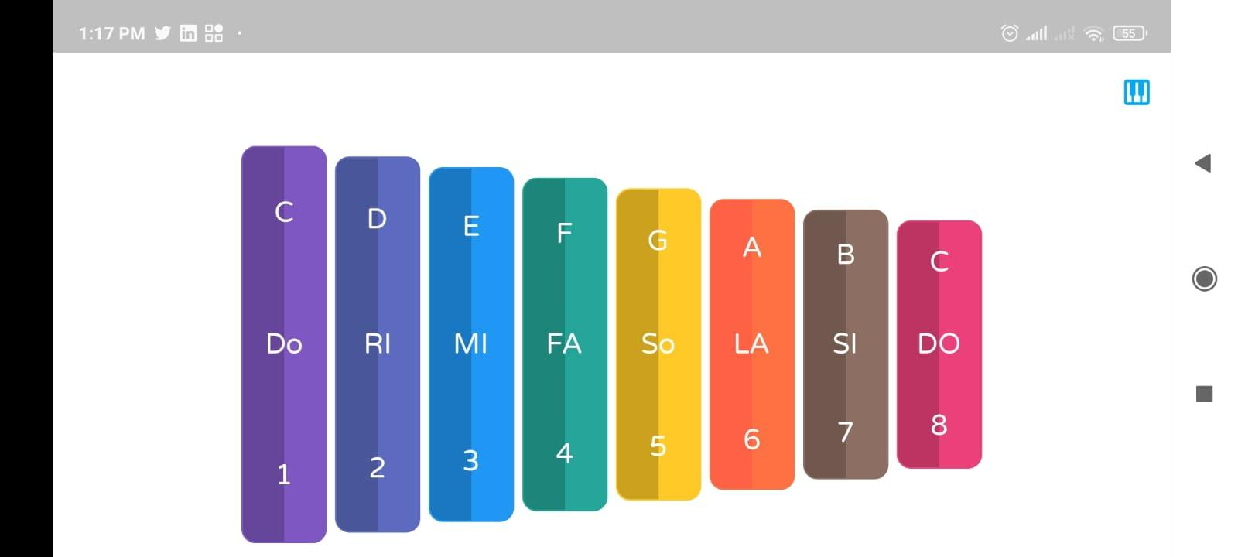

Edit previous task -> Replace “copied “ container to custom widget

Extract properties like color ,key name , height …etc as variables with handling null safety

Make app icon using this image :

